MSU College of Business
Windows XP Backup Instructions
July 8, 2010

Backing up your files is an important part of maintaining your data. In the event that your hard drive fails or your computer becomes infected with viruses to the point that it must be rebuilt, the backup becomes the only way to recover your files.
The backup process requires your domain password in order to function. Thus the act of changing your domain password will interrupt the backup of your local files. Note that the backup will not fail with an error message; it will simply cease to function.
Each time you change your password you must reset the backup operation. To reset your backup follow the instructions below:
Step 1: Make all files and folders visible
Go to: My Computer/Local Disk C:/Tools/Folder Options/View
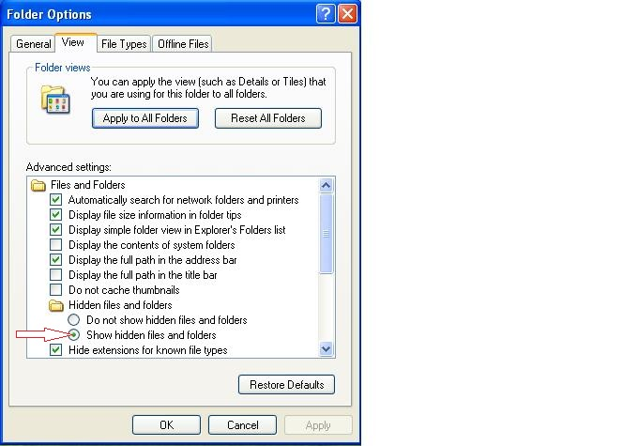
Make sure that Show Hidden Files and Folders is checked

Step 2: Initiate the backup
Go to: Start/All Programs/Accessories/System Tools/Backup

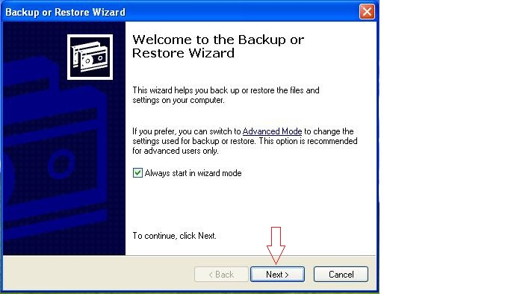
Click Next

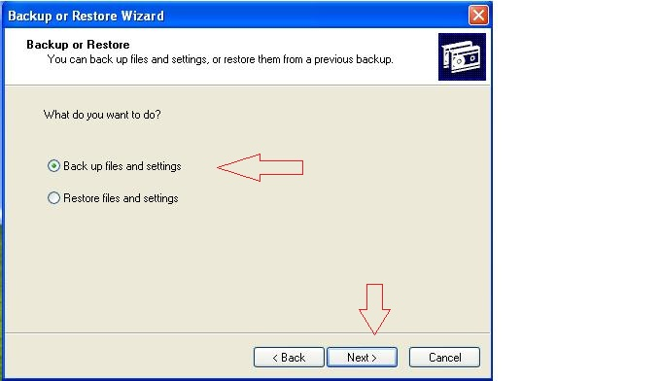
Choose Back up files and settings
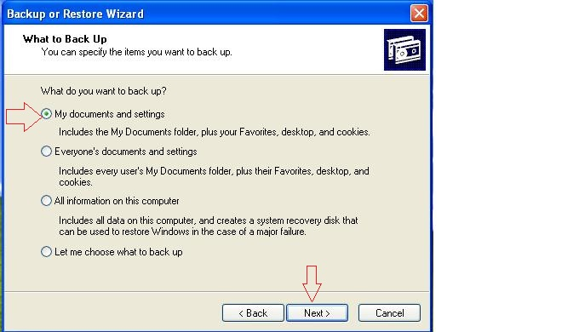
Choose My documents and settings
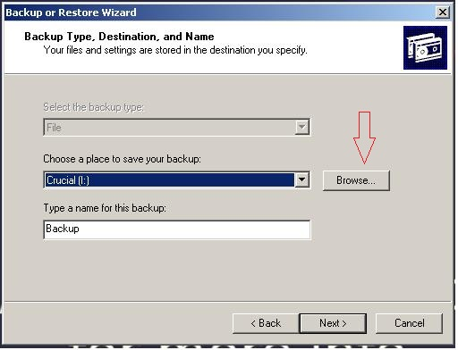
Click Browse
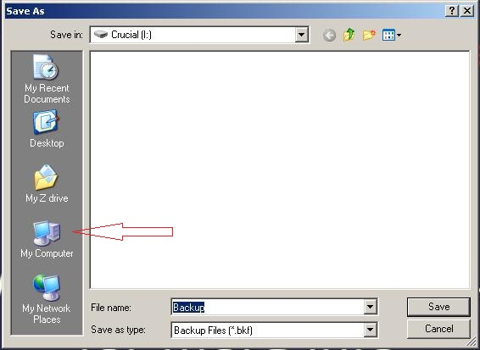
Click My Computer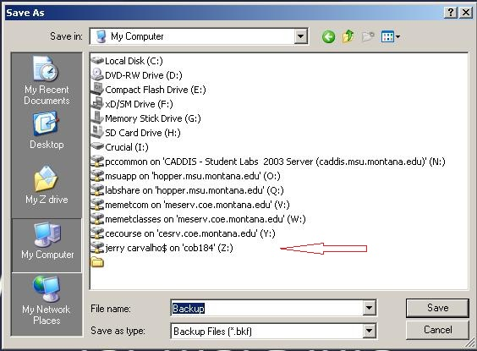
Find and click the drive that is mapped to your name (it may not be drive z:). If you do not have a drive mapped to your name contact Jerry or Cory.

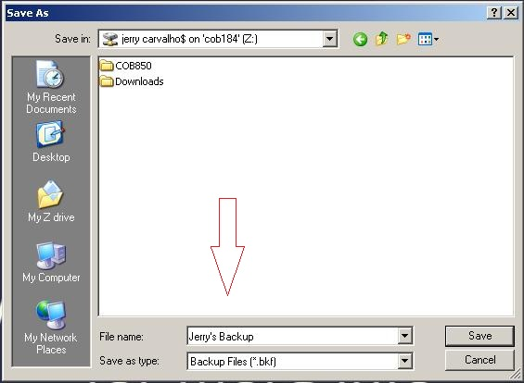
Name your backup file
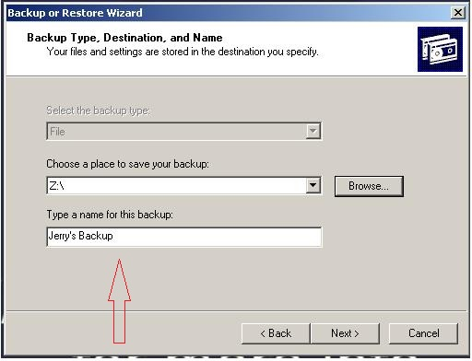
Name your backup job
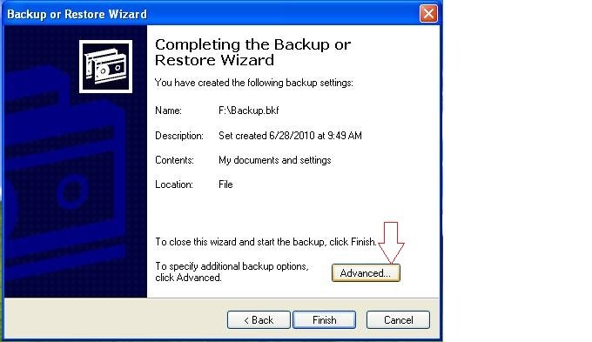

Click Advanced

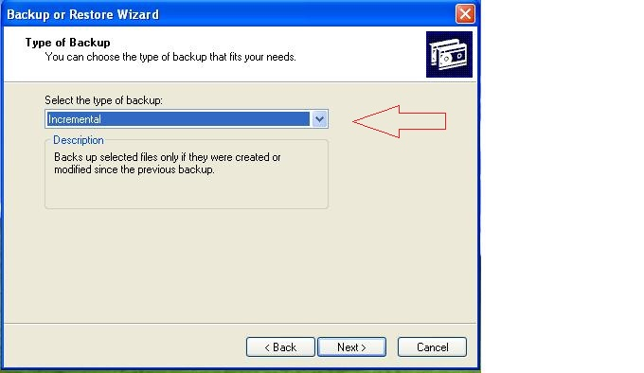
Choose Incremental
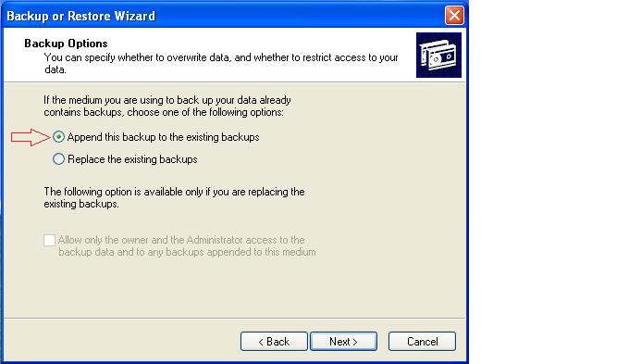
Choose Append
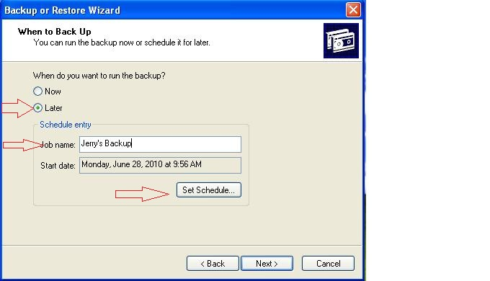
Choose Later, Enter a Job name Click on Set Schedule
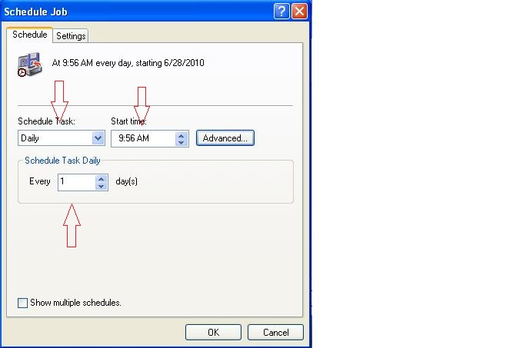
Choose Schedule Task Daily, Choose Start time (set a time when you typically are in class which will spread out the backups for the entire college), Choose Every 1 day
Enter and confirm your password twice

