The best method to date for acidifying soil samples for removal of carbonate is to do direct addition of 1-2N HCl.

Other groups use fumigation to remove inorganic carbon. We ran into issues with fumigation leading to over acidification that 'ate' the silver capsules. Our samples tend to vary with carbonate content from 'low' in shallow depth samples to 'high' in deeper samples. All samples being fumigated are exposed to the same amount of acid. In order to have confidence that we had completely reacted the carbonate, the samples were left in the HCl atmosphere long enough that the lower carbonate samples would eat the silver capsules and all silver capsules became brittle and very difficult to roll. With direct addition we can control the HCl concentration to better match individual samples. We did not run into capsule degradation with direct addition.

Method:
- Weigh ~30mg soil sample into silver capsule. More sample (~50mg) tended to erupt out of the capsule. Less sample led to insufficient N and (sometimes C) for analysis. Flare sides to make an upside down 'top hat' and place in every other location in a 96-well tray. Capsule sides will hold the capsule suspended above the bottom of the cup.
- Add 50ul ~1N HCl to start acidification and moisten the soil. Sample tray can be covered.
- Wait ~4 hours, add remaining required ~2N HCl to complete acidification. Sample tray should be uncovered and placed in a blue tray with a food tray on top. Each acid addition should be ~30ul in volume and should completely wet the soil. Monitor fizzing with acid addition. Verify that last acid addition results in no bubbling (generation of CO2). The reaction can be delayed, check every 30 minutes up to 2 hours for fizzing. A plastic weigh boat with a single layer of sodium hydroxide pellets should be placed in the blue tray. Allow samples to react and dry over night. Do not add more liquid than the capsule can hold. Liquid should not overflow the capsule.
- Add 50ul DI water to each sample and allow to dry. Add a second 50uL DI and allow samples to dry for a minimum 48 hours. Sample tray MUST be uncovered. Replace NaOH pellets when about half the weigh boat is liquid and the other half is still in pellet form. Replace NaOH pellets before last drying cycle. The blue tray MUST be covered with a food tray.
- Roll sample in silver and over wrap in tin capsule.

To determine amount of acid needed to acidify a sample
Assume all carbon is present at carbonate. Calculate amount of HCl needed to convert all carbonate to carbon dioxide. For low carbonate samples as low as 1x %TC is sufficient. For high carbonate samples add at least 2x %TC to ensure complete acidification and removal of carbonate.

For example, with 50mg soil that has 4%TC you will need 333ul of 1N HCl for acidification.
50 mg soil x 4mg C/100 mg soil
$$50mg soil * \frac{4 mg C}{100mg soil} * \frac{1mmol C}{12mg C}*\frac{2mmol HCl}{1mmol CO3} *\frac{1 ml sol^{'}n}{1mmol HCl}*\frac{1000ul}{1ml}=333ul$$

That is assuming that the soil is low in carbonate. For a high carbonate (low organic carbon) soil I recommend at least 666ul of 1N HCl, but that volume becomes problematic. The cups can hold ~50ul of liquid plus the 30 mg of soil. For a high carbonate soil, weigh a smaller sample, use a higher concentration of acid, and double the amount of acid relative to the amount of carbon.
$$30mg soil * \frac{4 mg C}{100mg soil} * \frac{1mmol C}{12mg C}*\frac{2mmol HCl}{1mmol CO3} *\frac{1 ml sol^{'}n}{2mmol HCl}*\frac{1000ul}{1ml}*2=200ul$$

**We ran into issues using higher concentration of acid (>3N) due to bubbling of the high carbonate samples. Be aware that the acid/base reaction in the soils can be delayed. Even if you don't see any bubbles forming, you should wait ~2hrs before adding additional acid.

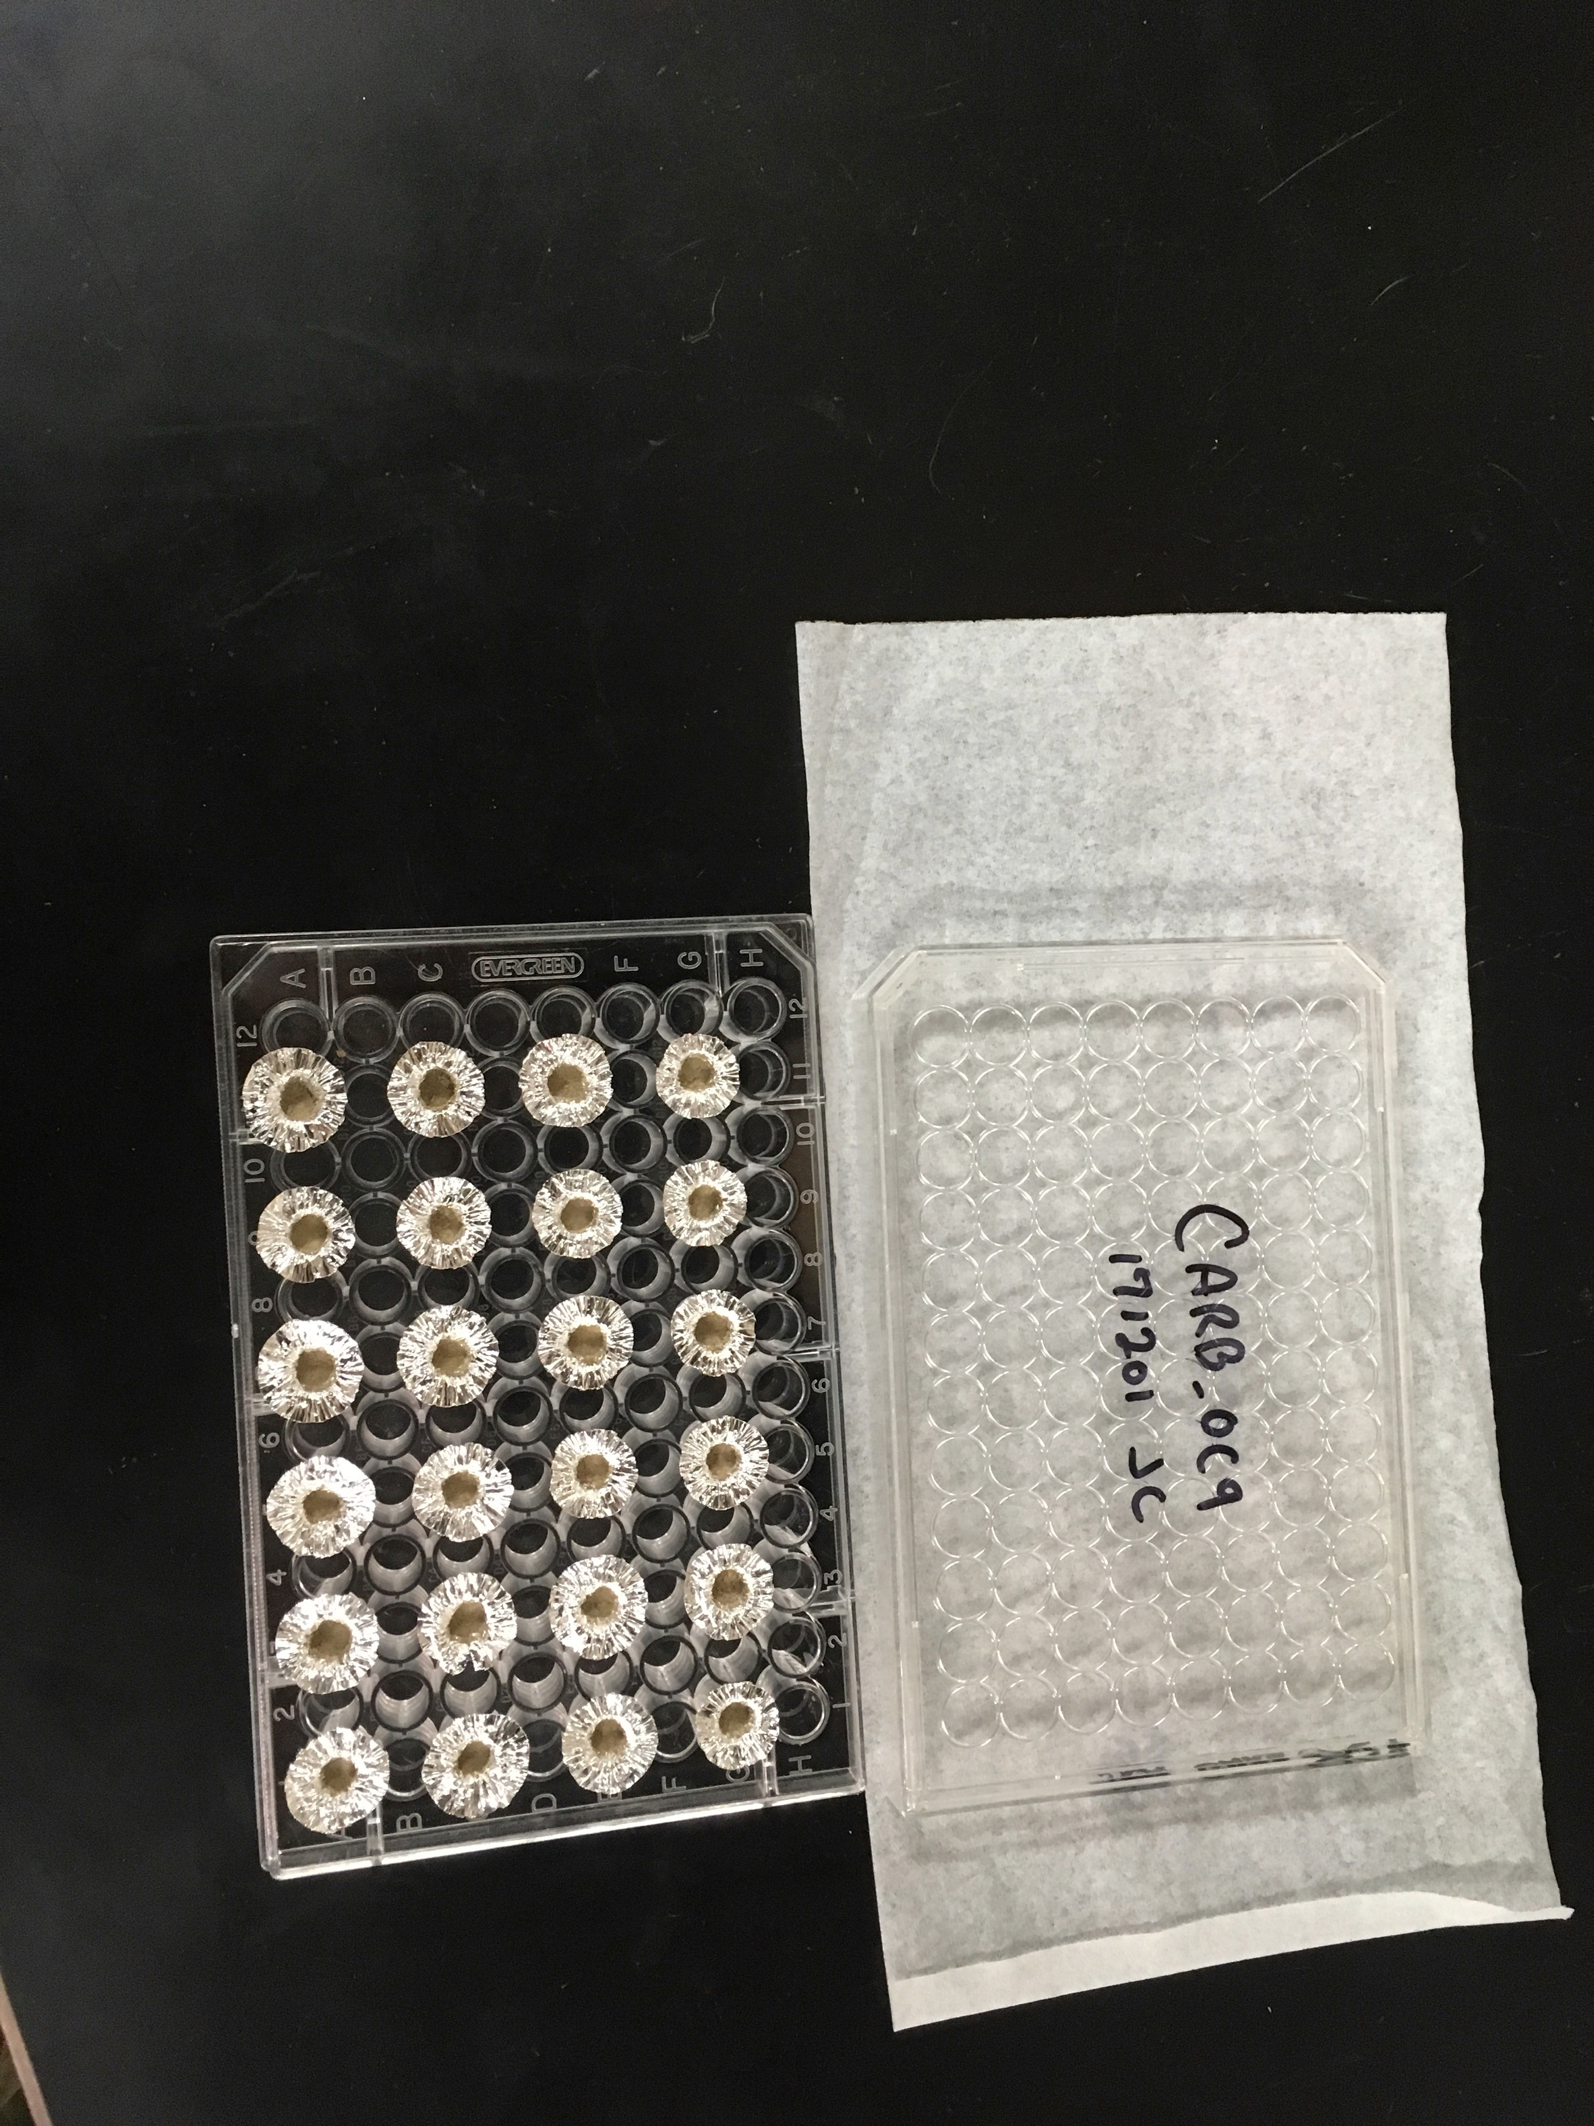

**Make sure to label both the lid and the tray.

**The sodium hydroxide is used to both neutralize any excess volatile acid AND act as a dessicant and absorb water. Used sodium hydroxide must be disposed of properly: Dilute, neutralize with acid (sulfuric acid will produce fewer fumes than HCl or Nitric acid) to a pH greater than 2 and less than 10 and flush down the sink with more water. If you over shoot the pH you can use calcium hydroxide to neutralize your solution to a higher pH.

