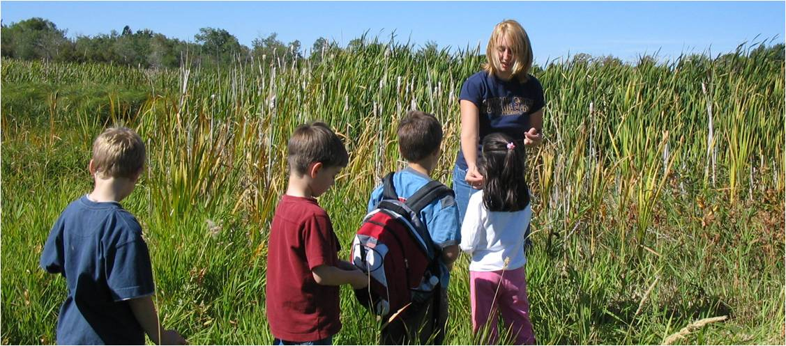

What: Volunteer to teach K-3 science in a field setting during Longfellow Elementary School’s Wetlands Festival in Bozeman!
Who: We need approximately 30 MSU Education student volunteers for the Festival. This is a great event to put on your resume.
When & Where:
Monday, 9/30, 8:30 am – 12:00 pm, Grade K-1 students
at Langhor Park
and/or
Tuesday, 10/1, 8:45 am – 1:30 pm (ish), Grade 2-3 students
at Cherry River Fishing Access (N. 7th, over the Interstate)
How: Lesson topics/outlines and much of the materials will be provided. You will do some planning to make the lessons student-ready.
A mandatory preparation session will be held at Longfellow Elementary School, 516 S. Tracy, on Tuesday, September 24, 6:00-7:30 pm
(details will be emailed after you sign up).
Registration is now closed!
A letter for your cooperating teacher or instructor can be downloaded here.
Contact Dr. Mary Leonard, 994-2336, mleonard@montana.edu
with questions or for more information.

