NAVIGATION MANUAL

Welcome to MSU’s applicant tracking system (ATS) Select Suite 7 supported by People Admin a division of Power School. Select Suite includes an online recruitment system Hire, commonly referred to as (ATS) and a position management system Positions.
Positions is a library to store all position descriptions, so departments can have positions descriptions at their fingertips to update as needed. Hire posts and collects all applications with the capability for the search committee to evaluate applications online.
This manual will help users navigate through the system.

Included in this manual are:
- LOGIN INSTRUCTIONS
- USER GROUP CHANGE
- UPDATING PROFILE
- HOME PAGE NAVIGATION
- SEARCHES IN THE SYSTEM
- WATCH LIST – ADD/REMOVE
- SUBMITTING AN ISSUE TO ATSHelpDesk@montana.edu

LOGIN

HR Webpage link to Login Page
- http://www.montana.edu/hr/index.html
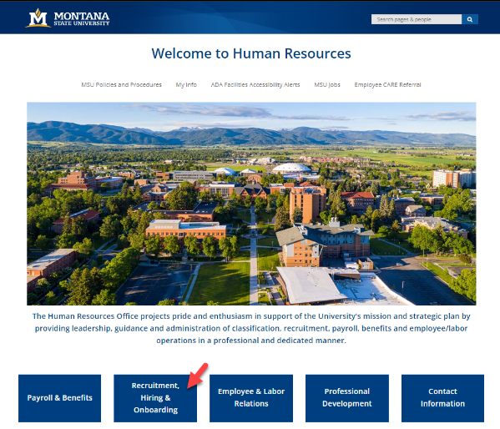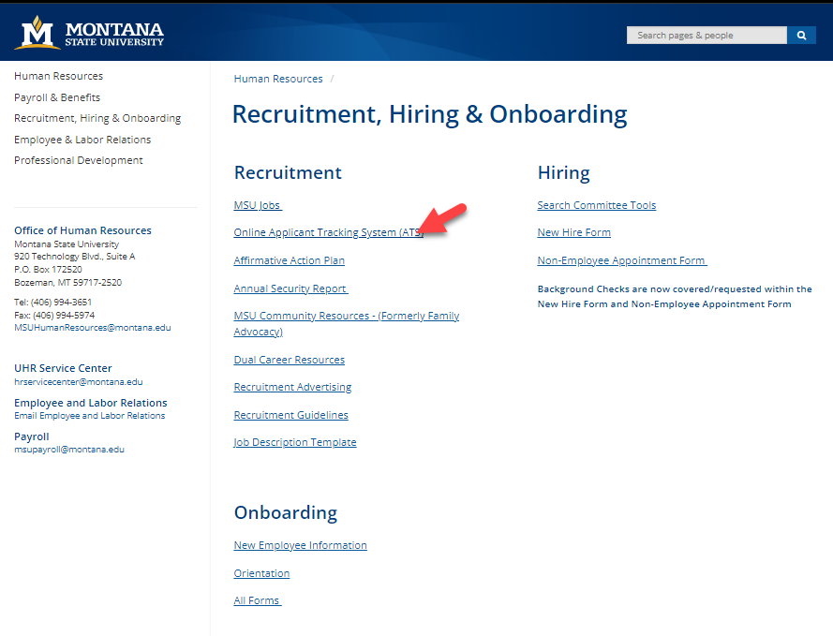

Login Page
- https://jobs.montana.edu/hr

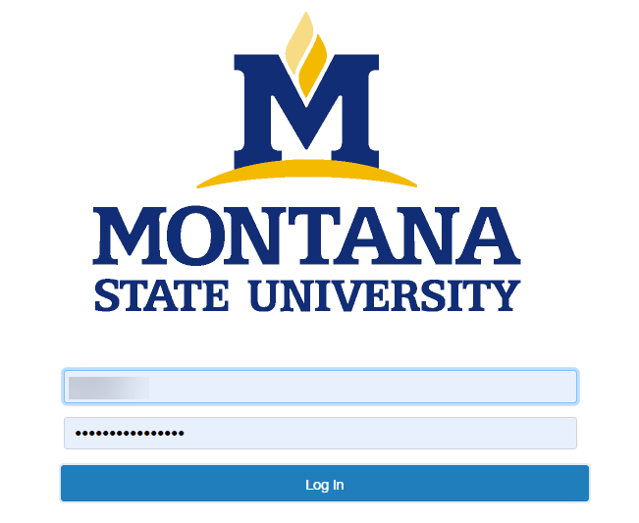
User Name: NetID
Password: password associated with NetID

*Error message of “LDAP Credentials Failed” go to the UIT link and update you NetID password, for the network: http://www.montana.edu/uit/ids-services/portal.html

NOTE: The platform works best with Chrome, Firefox, or Safari (5 or higher).
It is recommended that you utilize one of these Internet Options.

Inactivity of 15 minutes will time out the system and any unsaved data will be lost.
Clicking “Next” on any page will automatically save the page and move you to the next page. “Save” saves the current page without advancing to the next step.

USER GROUP CHANGE
The default login Home page is the Hire module with blue band appears:

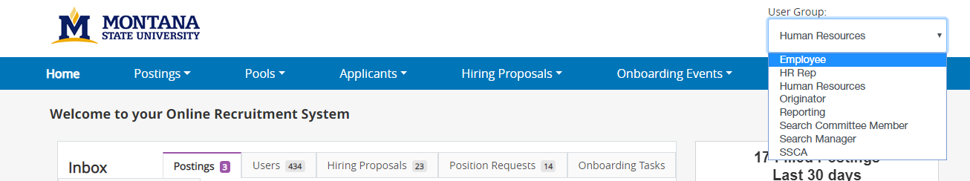
- The first-time logging in the default role will be “Employee”
- If the desired user group does not appear in the box when first logging in, click the drop-down arrow and select the desired User Group.

UPDATING PROFILE
For ease of future use update your profile with whatever “Role” you use the most.

- Select My Profile by clicking on the tab
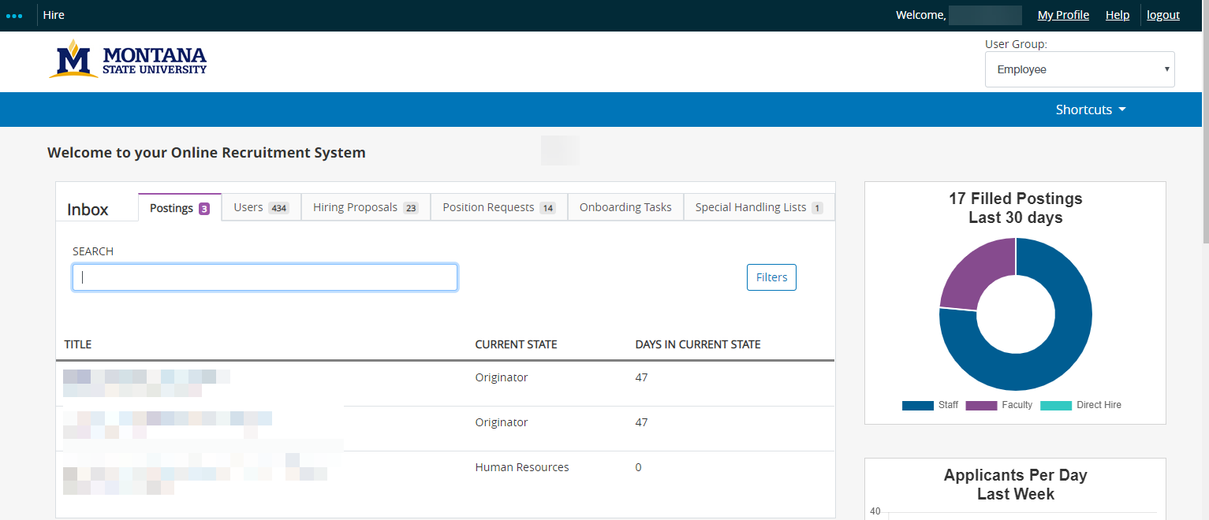
- Select Edit Profile
- Select your Preferred Group from the dropdown, then click Update User.
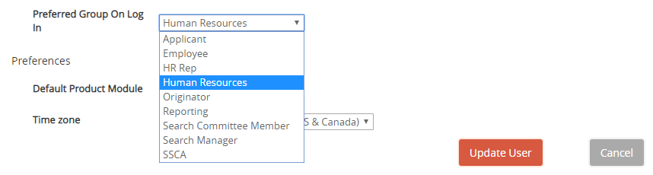

HOME PAGE NAVIGATION
The home page is standard regardless which part of the system being used – Position Management (orange) or Applicant Tracking System (blue). There are multiple ways to navigate the system, here are some useful tools that are available for use.
Positions
Hire
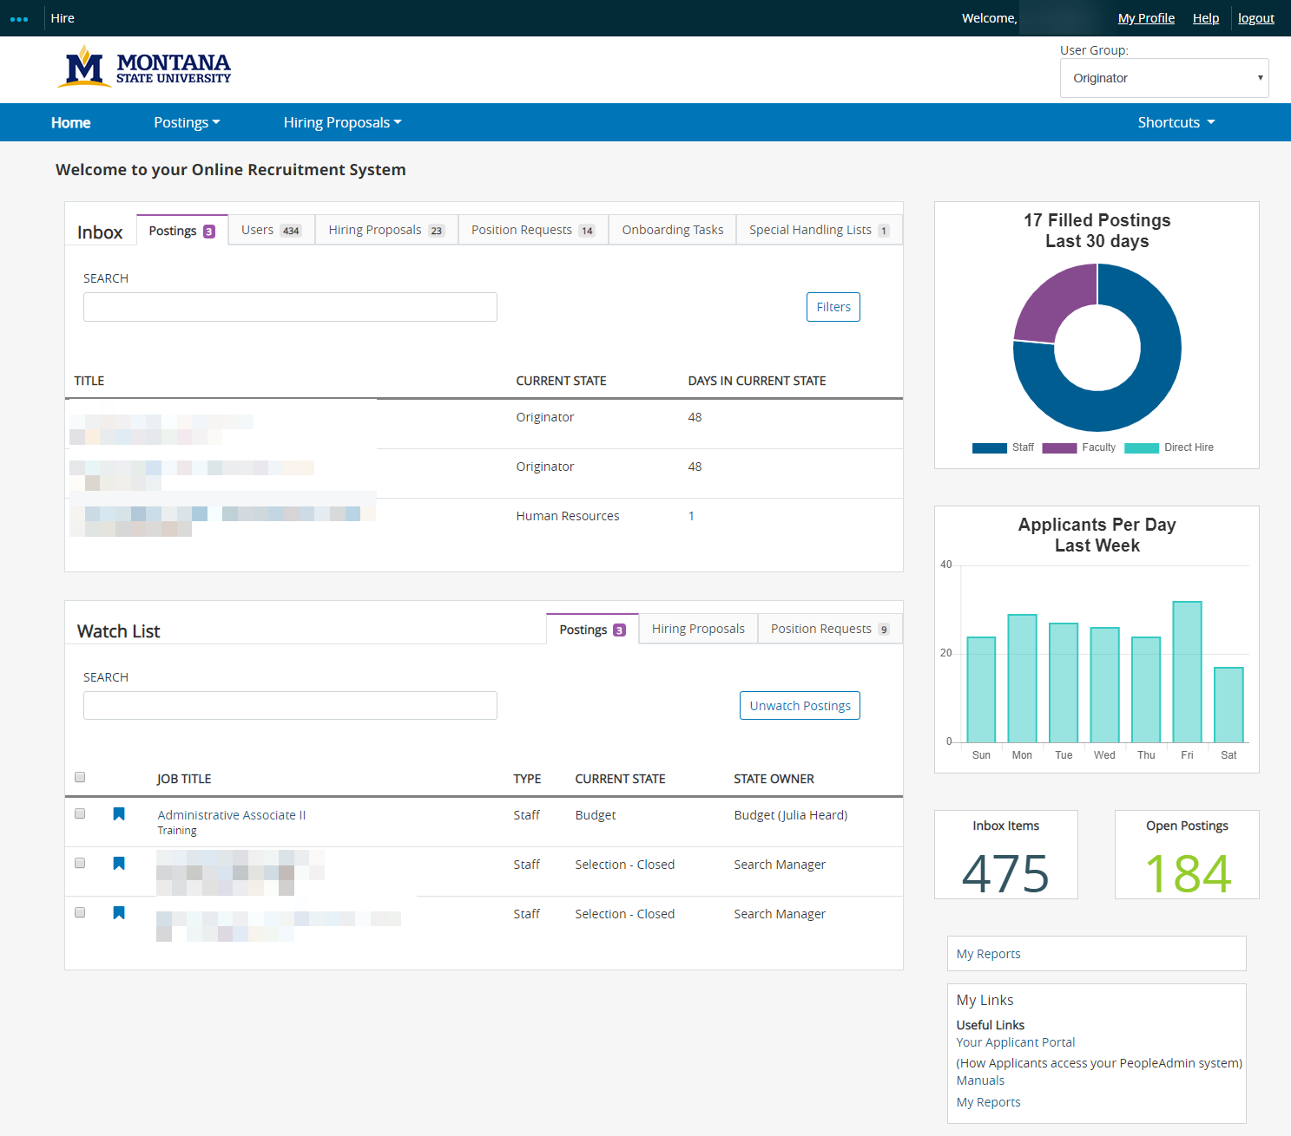
Online Manuals Link
Any Blue text will function as a hyperlink to a record, position or applicant.
The Home Screen can be navigated to from any screen in the system using header menu.
- To navigate to a specific module use collapsed menu … and select module this will open Home Screen view in that module
- Our logo or Home will return to Home Screen view in the current module

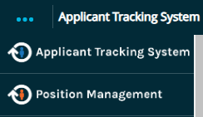
The front-page inbox shows any actions that require attention and the User Group assigned to. The system allows the user to see actions based on User Group authority. For optimal results log in with the highest authority level.
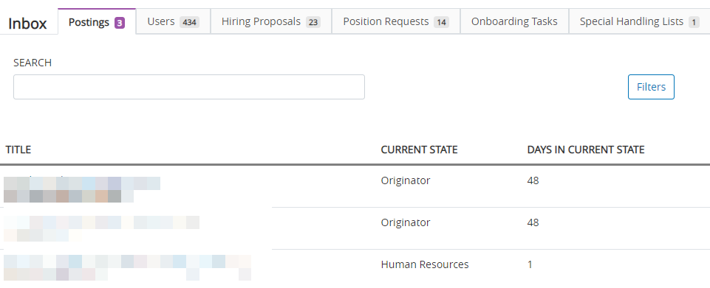
User Group
Tabs indicate the form that requires an action and the number of actions assigned to your user groups
Posting
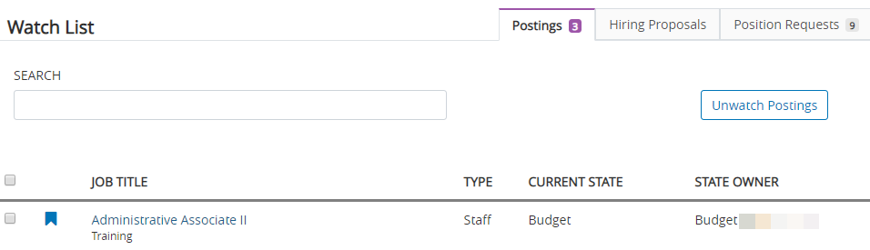

- To access the item requiring action click on job title. This can all be done from the Inbox or Watch box.
Warning: Inbox link will change your User Group to the User Group listed under Current State!

SEARCHES IN THE SYSTEM
Search is available for all major items in the system, i.e., postings, position descriptions, hiring proposals, applications, applicants, users, etc.
Searches allow you to assemble information in a report-like format. After you define and run a search, you can export the search results as a spreadsheet.
If you expect to need the same set of information repeatedly, you can save a search after you set it up. This allows you to use it whenever you need to, without reconstructing it.
If you search for an item that your permissions do not allow you to see, it will not appear in your search results.

Search tips
- Text search is not case sensitive.
- Searches normally return items that contain all your search terms. For example, if you enter facilities manager, the search returns items that contain both these words.
- Type keyword you want to search
- Use the “More Search Options” to filter with more options, i.e., Workflow State, Department, Close Date, Open Date, Working Title, and Classification Title.
- If a posting or information you need is not showing, first check the role logged into is correct.

APPLICANT TRACKING SYSTEM MODULE SEARCHES
- Select Staff or Faculty to bring up any positions assigned to your current role
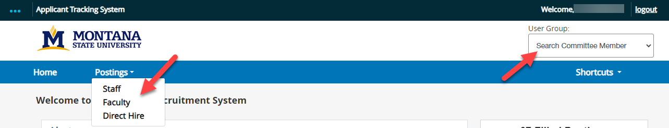

- Enter position title, vacancy number, or keyword in Search field (i.e. Program Coordinator or 15279, do not use “– “or special characters system will error out.)
OR Select More search options to expand the search tools area.
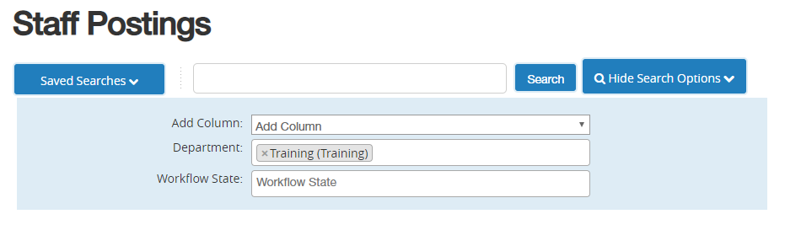
- Use the searching and filtering tools to narrow down the results that the system presents:
  - Add Columns if the information you need is not included on the page
  - Use Department or Workflow State fields to narrow down the results
  - Use the column controls to organize and sort the search results:
    - To see controls hover over column header
    - Move a column to the left “< “or to the right “>”
    - Delete a column using its delete “X” control if you do not want to display it. If you need to add it back later, use the add columns control to do so.
    - Order the search results by sorting a column in ascending or descending order using its up and down controls. ^ v

Selecting a posting
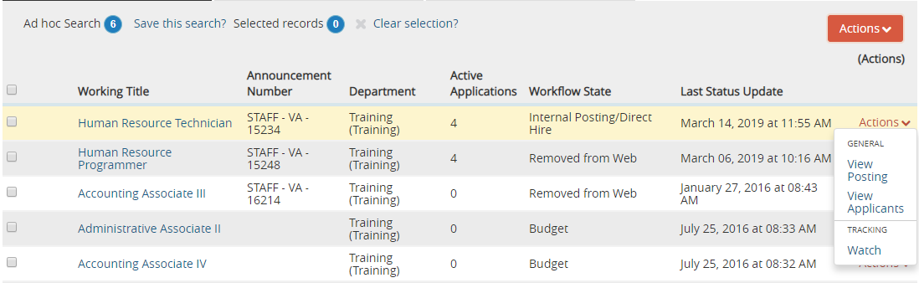
- Select the appropriate position
- Click on the Actions tab
- Select View Posting or View Applicants
- OR the Working Title is a hyperlink and will bring up the vacancy announcement.

Searching for Applicants (Search Manager role)
- Select Applicant Search from the Applicants tab.
- Select More search options to expand the search tools area.
- Use the searching and filtering tools to narrow down the results that the system presents:
  - You can add columns if the information you need is not included on the page.
  - You can select workflow states of interest.
Search for applicants by name, search results will bring any applicant with the name whether it is their first or last name. Sorting the results by applicant name can help you find the person you are searching for.
Exporting search results
- Set up the search or open a saved search.
- From the Actions menu, select Export Results. The search results are saved in .xls format. Depending on your browser, the file may automatically download to your computer's download folder, or you may be prompted to choose whether you want to open or save the file.

Saving a search
When you save a search, you have the option to set it as your default search. This is your only opportunity to set it as the default search.
- After you have used the search and filtering controls to present the search results the way you want to see them, select Save this search. The Saved Search area expands.
- Give the search a name that will help you remember its purpose.
- Select Personal Saved Search (Group and Global are available to HR only):
  - Personal Saved Search – Only you will have access to this search.
  - Group Saved Search – The search will be available to all users within a User Group (HR set up)
  - Global Saved Search – The search will be available to all users within the organization.
- If this search presents the information you will normally want to see when you navigate to this page, you may want to select Make this the default search.
- Select Save this search. The search tab refreshes to present the name you have given the search. This tab remains available for the rest of your session. The next time you log in, the search is available from the list of saved searches in that area.
*You can delete your personal saved searches when they are no longer useful to you.

Using a saved search
From the Open Saved Search menu, select the search you want to run. A new tab presents the search results.

Deleting a saved search
- From the Open Saved Search menu, select the search you want to run. A new tab presents the search results.
- Select the Delete (X) control placed just after the name of the search and the number of search results returned. A message asks you to confirm that you wish to delete the saved search.
WARNING: HUMAN RESOURCES DO NOT DELETE ANY GROUP OR GLOBAL SAVED SEARCHES!

WATCH LIST – ADD/REMOVE
Manage and find positions without performing a search to be accessible from the Home Screen.
Add the position to your Watch List
Or Stop Watching
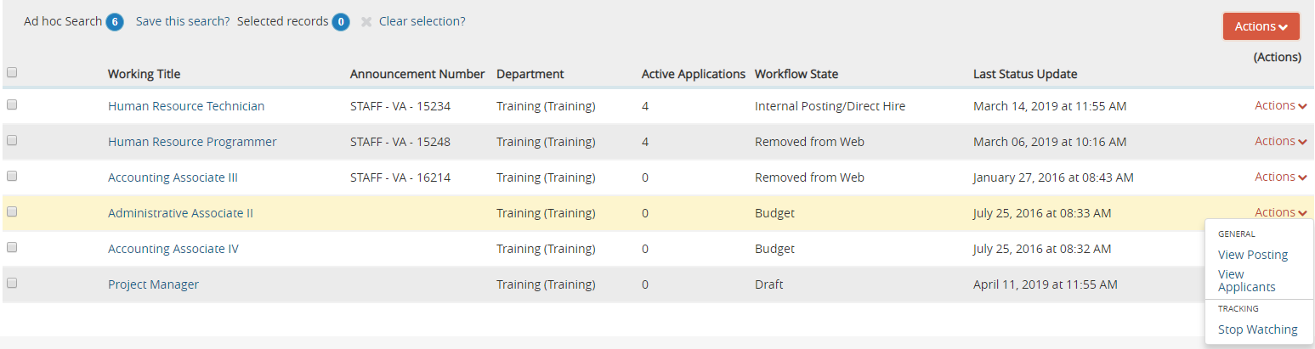

Home page Watch List.
Position titles are hyperlinks to Posting, Hiring Proposal or Position Requests (PM).
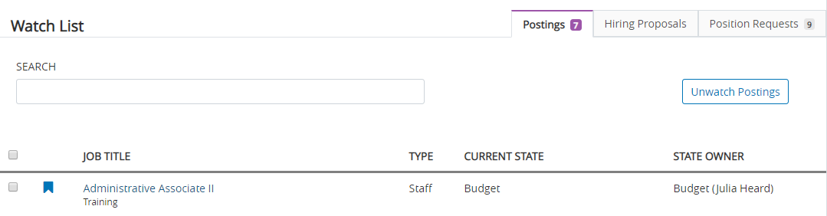
- Items can also be removed from watch list by checking off the item and clicking Unwatch Postings

SUBMITTING AN ISSUE to ATSHelpDesk@montana.edu
- Make a screen shot that includes the URL
- If there is a warning or error message, make an additional screen shot of that as well.
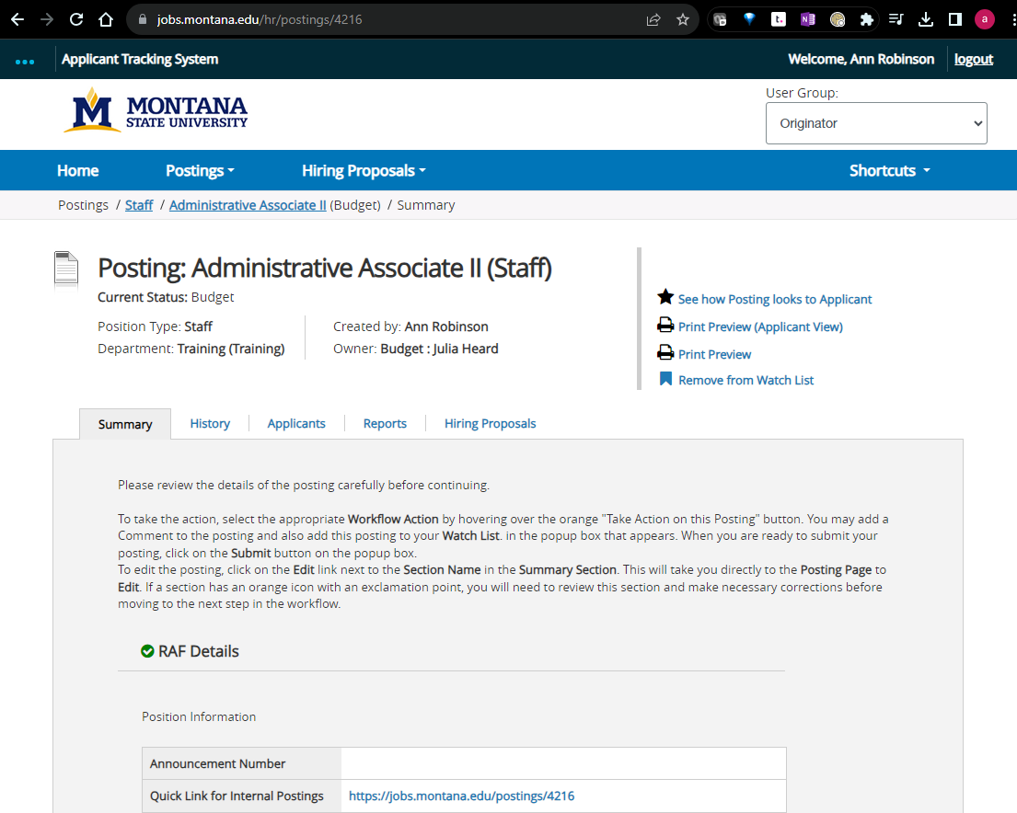
- Write a problem statement.
  - Include Action being taken when problem occurs.
    - Example: “When creating a posting…”
  - Include isolated error conditions.
    - Example: “…from a template as the HR user group in the Faculty position type…”
  - Include Error (problem) being received.
    - Example: “…the user receives an error that a form is not assigned and is redirected back to the homepage.”

Email all information to the ATShelpdesk@montana.edu for initial testing. If further assistance is needed then the information sent will be forwarded to People Admin for advice or resolution.

