Quick Reference - ATS Applicant Pool Process for NTTs

NTT Applicant pools are posted for two years after which they are refreshed and the applicants need to reapply. The instructions below cover the process of posting, hiring and refreshing the pool.

Preparing the Vacancy Announcement – See attached Template Guide
A template has been set up in ATS with the standard language that is required to create the posting. More detailed instructions are in the ATS Manuals http://www.montana.edu/hr/ats/index.html or from the Manuals hyperlink on any Select Suite home page.

Process to Notify the Current Pool to Apply for the Position
For ease of applying the department contact can send the e-mail below to the current pool once the position is posted. HR will provide the link to the position to make it easier for the applicant to access the system.

E-mail example to send to current applicants re-applying to the pool. (HR will provide the link to insert in the e-mail.)
You are currently in the applicant pool for the [NTT Position Title] which has been refreshed. If you are still interested in remaining in the pool your application will need to be re-submitted following the instructions below. This position can be accessed in our system at: [http://jobs.montana.edu/postings/1798].
Key points when applying to a position:
- Access the system at https://jobs.montana.edu or the link provided above
- Log In using your personal UserID and password established when previously applying (not the NetID)
- Click on Faculty; search for position (or use the link to position provided above)
- Click “Apply for this job” button
- Complete the Personal Information of the application; if previously applied within the system most of this information will be pre-populated
- Applicant can opt in or out of the voluntary demographics in the application
- Education History must be completed for all completed degrees
- Click on “Add References Entry” to add the 3 Professional references
- Upload any required documents (i.e., Resume/CV, Cover Letter)
- Answer any Supplemental Questions if applicable
- Check for errors and Submit your application
  - If there is a red error, applicant will need to go back to correct what is missing by clicking on the red bar
  - In submitting, an electronic signature (applicant’s initials) is required to certify the application
- When applicant has completed the application an e-mail from the system acknowledging the submission (donotreply@montana.edu) will be sent to email address in the application
- Applicants can call our ATSHelpdesk (x4103) or e-mail at ATSHelpdesk@montana.edu for technical support.

Creating or Refreshing NTT Pools
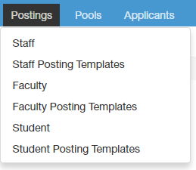
Step 1

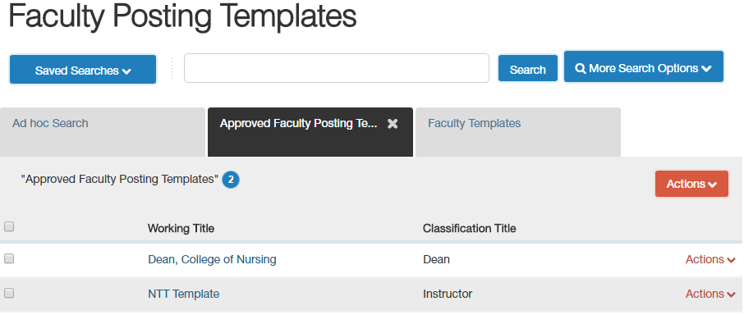
Step 2

Step 3

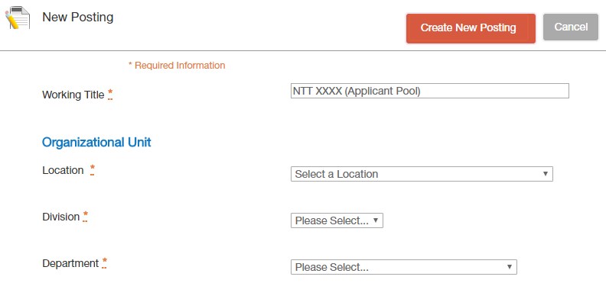
Step 4
Update
Update
Update
Update

Posting Template: NTT Template (Faculty)
- Position Type: Faculty
- Organizational Unit: Montana State University
RAF Details
Position Information
Announcement Number | FAC - VA – 16XXX
For questions regarding this position, please contact: | Departmental Contact  406-994-XXXX  <a href="mailto:xxxxxx@montana.edu">xxxxxxxxx@montana.edu</a>  **Add the HTML to make the email address a hyperlink to easily email contact person
NBAJOBS Title | Instructor
Classification Title | Instructor  Use classification table for titles  Use this format for the Working Title; this is viewable to the applicant
Working Title | XXXXXXXX Non-Tenure Track Faculty (Applicant Pool)
Brief Position Overview | This should be a couple of sentences (400 characters) to attract candidates to apply. Use this area to add Keywords that candidates may use to search for this type of position.
Faculty Tenure Track | No
Faculty Rank | Non-Tenure Track
Previous Employee | Pooled Position
Justification of Need | Pooled Position or additional rationale if needed.
Justification of Need Comments | N/A
Position Number | Pooled
Department | Department Name
Division | Division Name
Appointment Type | Non-Tenure Track (Pooled)
Contract Term | Semester  Choose this menu pick since vacancy is posted for 2 years.
Semester | Fall or Spring
If other, specify From date
If other, specify End date
FLSA | Contact HR for Determination
Union Affiliation | Contact HR for Determination
FTE | List “Varies” if unknown or list approximate FTE
Benefits Eligible | Depends on FTE (please contact Human Resources - 406-994-3651)
Salary Range | Could be left blank : Sample: $xxx month / $xxxx semester per 3 credit class- this is not viewable to the candidate; for approval purposes only (For approval purposes only – this box will not be viewable to applicant.)
Salary | Salary commensurate with experience, education, and qualifications  (Viewable to applicant; other options available in drop down menu (as below).)
Salary Options  (Salary language options for “Salary” box.) | - Salary commensurate with academic rank, experience, and qualification  - $_____________ annually, commensurate with experience, education, and qualifications  - Salary range of $______ to $_______ annually, commensurate with experience, education, and qualifications
Contract Type | LOA
If other, please specify
Recruitment Type | Open
Pre-Employment Background Check charge to Index # | XXXXXX  (List the correct Index to bill for the background check.)
Advertising Bozeman Chronicle Funding (Complete for any position advertised in the local paper)
Index
Acct
Dist %
Additional Advertising Resources
Additional, discipline-specific advertising resources, click here.
Charges are the department's responsibility.
Please indicate which publications will be used for this recruitment | Chronicle of Higher Education, Other  (May be unknown initially; search manager can go back and indicate advertising later.)
If Other, please specify

Position Details
Areas highlighted in yellow are areas where diversity language can be used in the vacancy announcement; department can choose where to use.
General Statement  The first 4 paragraphs are standard on each vacancy announcement; If changes are needed, please contact the Recruitment team. | Montana State University seeks qualified individuals to provide non-tenurable level instruction and/or related functions. Instructors are needed to teach classes depending upon need and available funding.  Applications are accepted on a continual basis (unless otherwise indicated) and will be maintained in pool for two years. After two years, candidates will be notified to re-submit materials for continued consideration.  The department or program search committees or hiring authority will review and evaluate the submitted application materials. Applicants will be notified if their application is being retained in the non-tenure track faculty hiring pool.  Appointments are on a part-time basis and vary in duration, a couple weeks, a semester or an academic year, depending on the specific needs of the department/program. Salary is dependent on number of courses taught and duration.  We seek individuals who work professionally and effectively with diverse individuals, possess effective interpersonal, written and verbal communication skills and have the ability to contribute positively to the academic success of the students and the mission of Montana State University.  And/Or  Montana State University values diverse perspectives and is committed to continually supporting, promoting and building an inclusive and culturally diverse campus environment. MSU recognizes the importance of work-life integration and strives to be responsive to the needs of dual career couples.  And/Or  Because increasing the diversity of the XXXXXX profession is one of our strategic priorities, women and underrepresented minorities in XXXXXXX are particularly encouraged to apply.
Duties and Responsibilities  Short paragraph about the duties and responsibilities. This can be in paragraph form or a bulleted list. (Bulleted list to right is only an example). | We hope to attract applicants who can teach in a diverse University community and have demonstrated ability in helping students from diverse backgrounds succeed.  Example of Duties and Responsibilities:  - Teaching on-campus or online courses.  - Advising, evaluating and assisting students.  - Curriculum and/or course development.  - Participating in weekly faculty meetings.  - Meeting regularly with, collaborating with, and evaluating peer leader, if one is assigned to your section.  **HTML for a bulleted list – Type * and a space before the item.
Required Qualifications – Experience, Education, Knowledge & Skills  (Required Qualifications should be the minimal required for the position to be able to broaden the announcement. Specifics should be listed in Preferred or Successful Candidate section.) | Example of Required Qualifications and diversity language:  - Master’s Degree [or minimum degree required to teach] in a [relevant] field or a related field  - Demonstrated experience working with and engaging diverse students and colleagues within and outside the department  **HTML for a numered list – Type # and a space before the item.
Preferred Qualifications – Experience, Education, Knowledge & Skills | Example of Preferred Qualifications and diversity language:  - Academic/professional experience.  - Demonstrated experience teaching interdisciplinary courses  - Demonstrated knowledge of college student development  - Promote the advancement of diversity. OR Demonstrated commitment to student, faculty, and staff diversity.  **HTML for a numbered list – Type # and a space before the item.
The Successful Candidate Will | Example of Preferred Qualifications and diversity language:  - Have the ability to relate to freshmen and to develop classroom rapport with students  - The ability to mentor and inspire a diverse student body.  - Have effective interpersonal skills including the ability to collaborate successfully with faculty and staff  - Possess excellent written and oral communication skills  - Be skilled in utilizing engaging pedagogy that involves students in the learning process  - Take initiative and work well independently  - The potential to provide leadership and to assume responsibility for organizational and program activities.  - Have an appreciation of diverse constituencies and add intellectual diversity to the department.  - Dedication to supporting and enhancing Montana State University’s initiative for diversity, equity and inclusiveness  **HTML for a bulleted list – Type * and a space before the item..
Position Special Requirements/Additional Information | The position for which you have applied MAY BE a Union position. Union affiliation is determined by job duties and the collective bargaining unit.  - Non-Tenure Track Faculty – Any position that is .5 FTE or more is represented by the Associated Faculty of Montana State University (AFMSU). Faculty covered by AFMSU must begin paying either membership dues or representation fees within thirty (30) days of hire. This is a condition of employment. Additional information can be found at AFMSU or by emailing AFSMU .  - Any position less than .5 FTE is not represented by the Union and is not required to pay dues.  - If the FTE changes during employment, the representational status of this position could be impacted.  - Exceptions: Anyone having successfully completed a PEI exam or any faculty working in Extension are exempt from the Union  This job description should not be construed as an exhaustive statement of duties, responsibilities or requirements, but a general description of the job. Nothing contained herein restricts Montana State University’s rights to assign or reassign duties and responsibilities to this job at any time.
Physical Demands | To perform this job successfully, an individual must be able to perform each essential duty satisfactorily with or without reasonable accommodations. The requirements listed above are representative of the knowledge, skill, and/or ability required.
The Program | Optional
The Department | The Department xxxxxxxx invites applications for a non-tenure track position in xxxxxxxxx.  The xxxxxx Department offers …..Information about the department.
The College | The College xxxxxxx …..Information about the department
Z-Org Position Reports To | Zxxxxx (This is the Timesheet Approver’s number)
Time Entry | Web Time Entry or Departmental
This position has supervisory duties? | No
If Yes, please indicate the number of FTE and PTE supervised.
Posting Detail Information
Number of Vacancies | Multiple Positions
Desired Start Date | Review of applications will be on a continual basis and will continue until the position(s) are filled. Applicants will be notified if their application is being retained in the hiring pool for up to two years.
Is there a Start-Up package? | No
If yes, please specify Amount and Source (College/Department) of Start-Up Funding
Office Space required? | No
If Yes, Bldg/Rm# Identified
Lab Space Required | No
If Yes, Bldg/Rm# Identified
Position End Date (if temporary)
Originator | Person creating position in ATS.
Search Manager | Search support can also be the Search Chair
Hiring Authority | Person approving hire for the department. Position will be sent on to the Provost for approval.
Open Date | Please do not indicate a date here – HR use only.
Close Date | Please do not indicate a date here – HR use only.
Applications will be: | Applications will be accepted and screened for the duration of this pool.
Special Instructions | This section needs to be in HTML. This box appears at the top of the vacancy announcement on the website.  Review of applications will be on a continual basis and will continue until the position(s) are filled. Applicants will be notified if their application is being retained in the hiring pool for up to two years.
Posted By | For Human Resources Use Only
LABOR DISTRIBUTION
- All positions MUST have appropriate approvals prior to posting.
- Dist % totals must add up to 100%
Index | XXXXXXX
Acct | 61123N
Dist % | 100
ORG | XXXXXX
Applicant Documents
Required Documents
Typically a CV/Resume is required. Other types of documents are available to be indicated for the applicant to upload.
Please note: Separate document of references not required as the ATS system requires applicant to provide number specified prior to submitting application.

Optional Documents
Posting Specific Questions (This section is optional)
Applicants can answer questions online instead of addressing in a cover letter. If a department has several courses listed in the vacancy announcement each one can be listed as a separate question. A report can then be pulled by the department of the applicants and listing their area of interest for teaching.
Posting Documents Any document pertinent to the search can be uploaded here.
- Additional Documents 3 (PDF | 53.9 KB)

Guest User Use this section if someone needs to review the position outside the department.
There is no guest user set up for this posting.
Search Committee List search committee here if using a committee to review the applications.
Name | Email | Chair? | Status

Scoring Criteria Edit
- Tiered Ranking System – overall score of the application
State: Search Committee Review
Weight: 1
  - Candidate exceeds the qualifications (3.0 points)
  - Candidate meets the qualifications (2.0 points)
  - Candidate somewhat meets the qualifications (1.0 points)
  - Candidate does not meet the qualifications (0.0 points)

Letters of Recommendation
References (Indicate number of references applicant needs to provide. If Letters of Recommendation are required, indicate on the “Settings” page and here the last day a reference can upload a letter and any instructions to the reference provider.)
** If more than 3 references are required make sure HR is aware and adds a message in Special Instructions

Accept Recommendations | Yes
Minimum Requests | 3
Maximum Requests
Last Day a Recommendation Provider Can Submit Reference
Provider Special Instructions

