**SEARCH COMMITTEE/SEARCH CHAIR GUIDE**

Role of **Search Committee Member** in ATS:

* View the Posting Summary – this is the vacancy announcement.
* Evaluate Applicants – this provides the ability to review and evaluate (or rank) the applicants.
* Print Preview – provides the ability to view the posting as one document which can be printed.

Included in this manual are:

* LOGIN INSTRUCTIONS
* SEARCH FOR A POSTING
* VIEW SUMMARY AND APPLICATIONS
* PRINT OR DOWNLOAD APPLICATIONS
* EVALUATE APPLICANTS
* SEARCH CHAIR INSTRUCTIONS

Role of **Search Committee Chair**:

* Assist the Hiring Authority to determine the members of the Search Committee.
* Serves as the Search Committee spokesperson.
* Discuss the role and scope of the position to foster understanding of the duties and responsibilities.
* Ensure that the Hiring Authority’s charge is conveyed to the Search Committee and answers any questions or concerns regarding the charge.
* Ensure Search Committee Members actively participate in the recruitment process and all members have the opportunity to provide feedback and observations.
* Actively participate as a Search Committee Member as well as the Chair.
* Communicate the Search Committee recommendations for advancing applicants to the next phase(s) of the recruitment process to the Hiring Authority.  Search Committee recommendations may include the Search Committee’s assessments of the finalists’ strengths and weaknesses, observations, ranked or unranked list (as determined by the Hiring Authority), etc.
* Consult with the department/college and in a timely manner if/when:
  + The candidate pool surfaces only one qualified candidate;
  + Problems regarding the search process are reported;
  + If the recruitment process may be compromised due to interference, disputes, etc.
  + Other extenuating circumstances warrant intervention.
* Foster compliance with MSU, State, and Federal recruitment and selection policies and procedures.

Role as a **Search Manager** in ATS:

* Confirming all search committee members have scored the applications
* Seeing the overall score on the applicant page
* Downloading a matrix (optional)

**LOGIN**

# HR Webpage link to Login Page

* https://www.montana.edu/hr/index.html

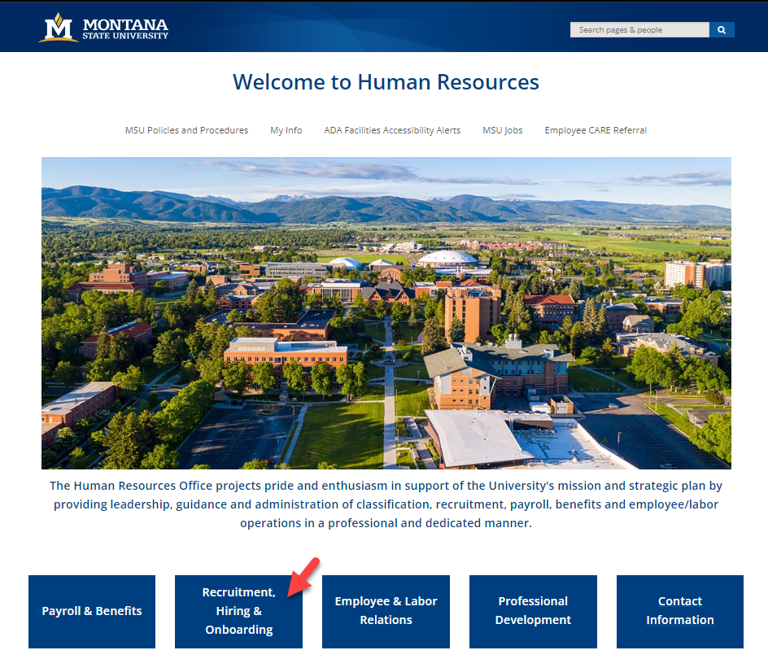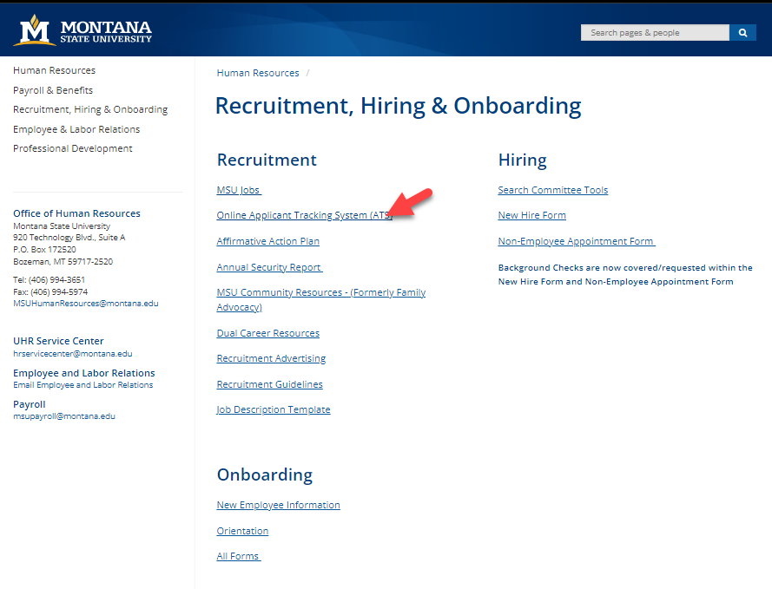

# Login Page

* <https://jobs.montana.edu/hr>

# 

**User Name**: NetID

**Password:** password associated with NetID

*\*Error message of “LDAP Credentials Failed” go to the UIT link and update you NetID password, for the network:* http://www.montana.edu/uit/ids-services/portal.html

**NOTE:** The platform works best with Chrome, Firefox, or Safari (5 or higher).

*It is recommended that you utilize one of these Internet Options.*

**Inactivity of 15 minutes will time out the system and any unsaved data will be lost.**

**Clicking “Next” on any page will automatically save the page and move you to the next page. “Save” saves the current page without advancing to the next step.**

**SEARCHING FOR A POSTING**

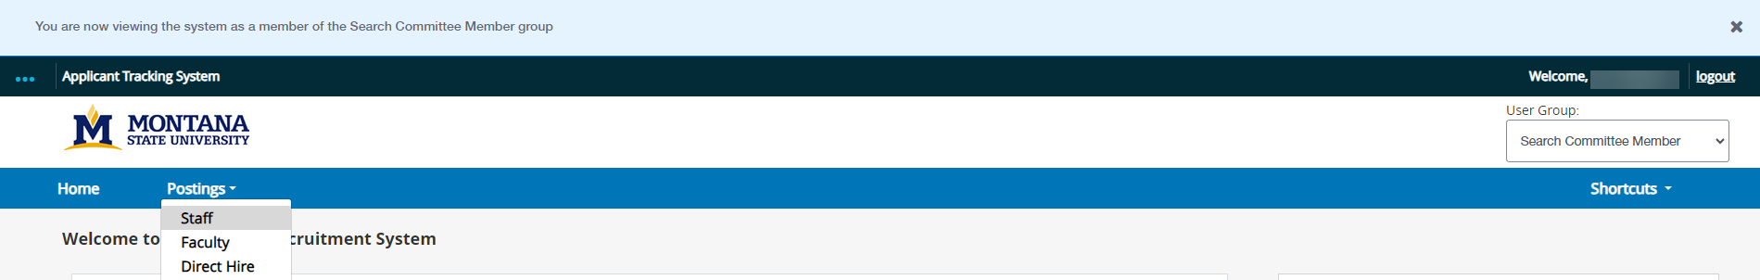

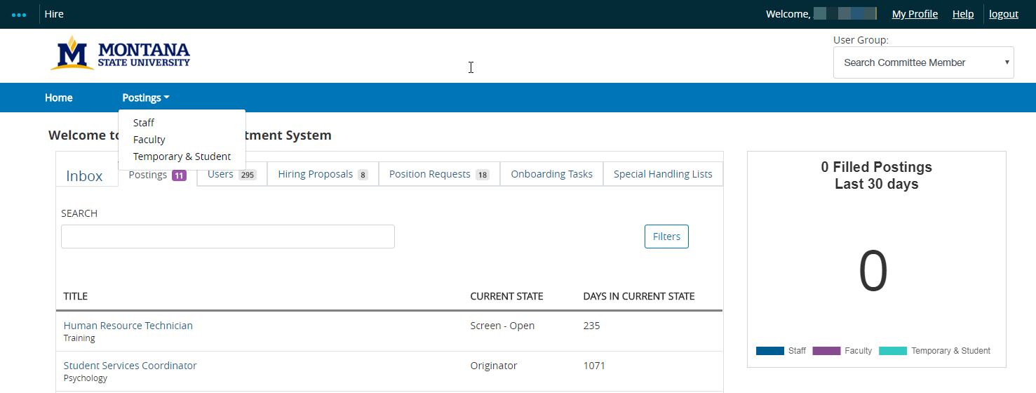

* Current role will be listed under **User Group** on the right-hand side.
* Any action that you are assigned to should show up in your Inbox under the correct action Tab
  + Example: are we looking for a **Posting, Position Requests, Hiring Proposals**?
  + The blue text will open the action referred to.
  + Selecting through the **Inbox** will automatically change to the role needed to complete the assigned action.
  + If you have multiple roles use **User Group** drop-down to manually select a role.
* To search for older searches or a missing search select **Postings** drop-down then select **Staff** or **Faculty**



* Enter positiontitle, vacancy number, or keyword in **Search** field (i.e. Program Coordinator or 16279 or 16279) *Do not use “- “(dashes) the system will generate an error.*
* Select the appropriate position
* Click on the **Actions** drop-down
* Select **Watch** to add to your watch list on your home page or **Stop Watching** to remove.
* Select **View Posting** or **View Applicants**
* ***OR*** the **Working Title** is a hyperlink and will bring up the vacancy announcement.

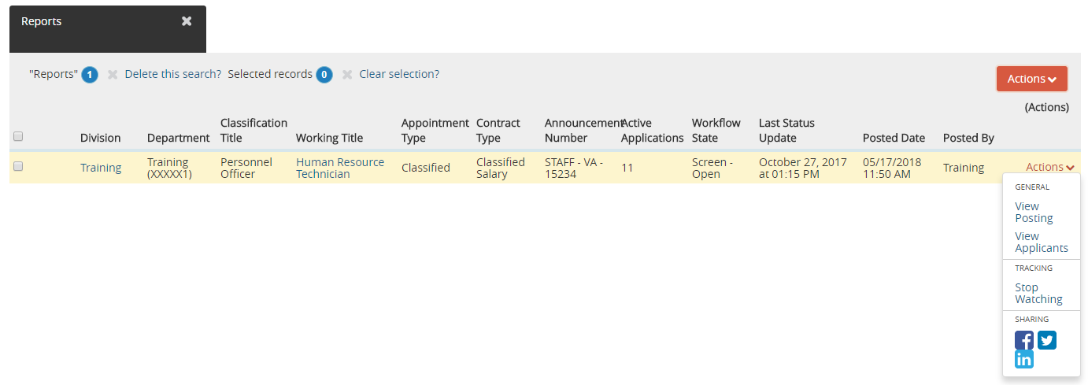

**VIEW SUMMARY AND APPLICATIONS**

* The **Summary** is your job posting view (or vacancy announcement) and can be referred to at any time in the process.
* To view the applications, click on the **Applicants** tab.
* **Anywhere that has a blue text is a hyperlink**
* Options: open summary on one of two screens, print out posting, or use hyperlink to go back and forth to assist with ranking applicants.

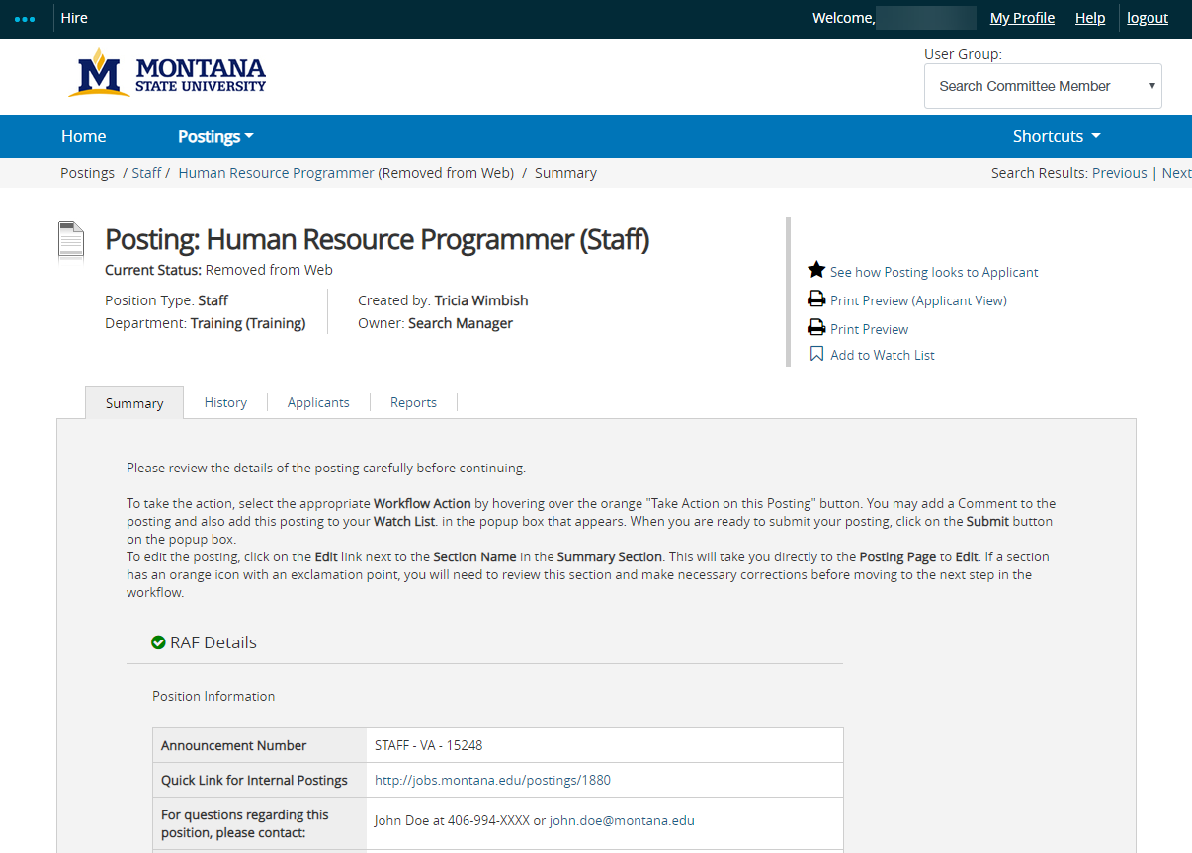

**NOTE for the following instructions when viewing more than 30 applicants:**

**Applicants are listed on the Applicant page. If more than 30 there will be several pages. The instructions below will need to be followed for EACH page. For example, once done downloading applications or evaluating the first 30 applicants, the same process will need to be followed for each page of applicants.**

**REVIEW APPLICATIONS/DOCUMENTS ONLINE**

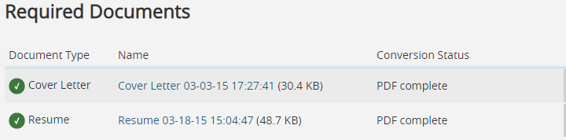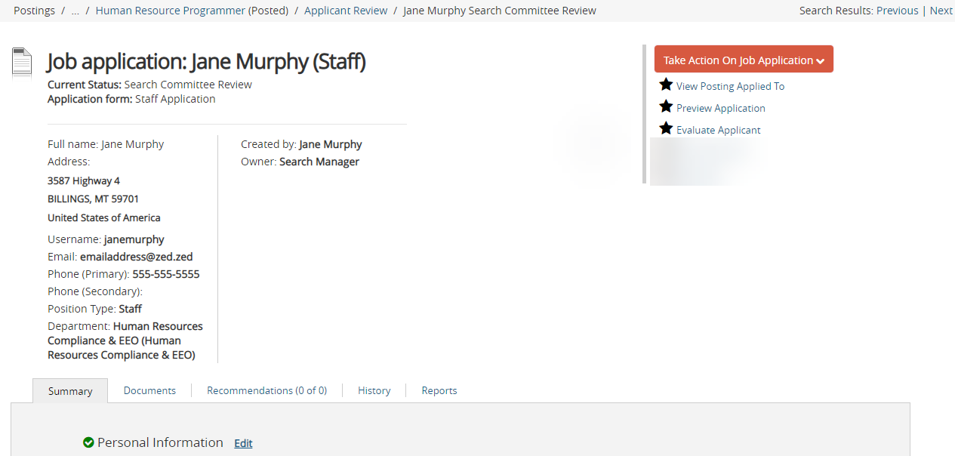

Documents can be viewed online on the documents tab at the top or at the bottom

* Summary tab is the complete application as submitted in the system
* Documents tab is any required or optional documents assigned in the posting can be viewed for this application that can be viewed in the online PDF viewer also linked at the bottom of the application

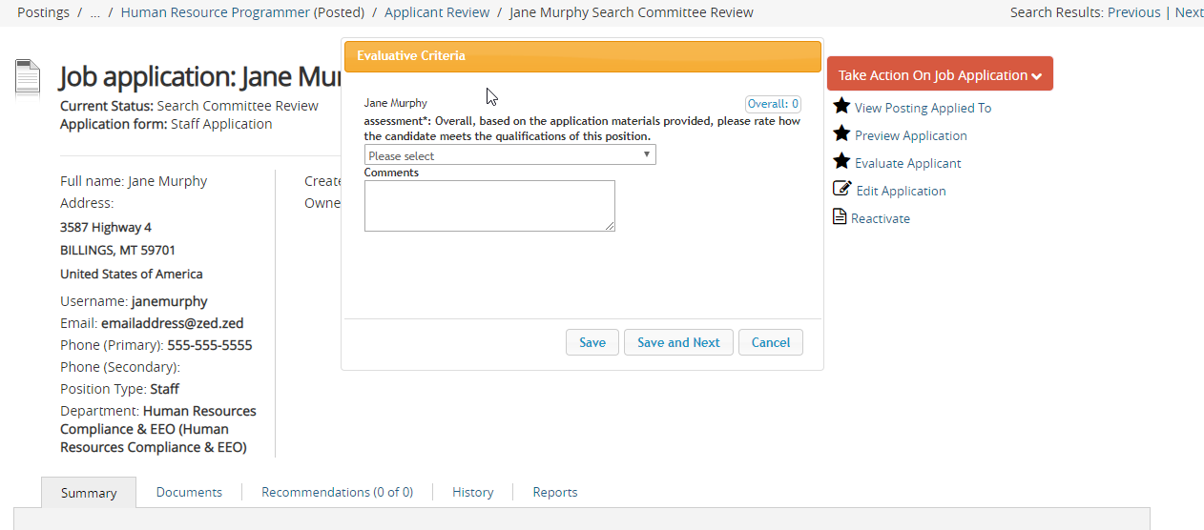

* When ready to evaluate click Evaluate Applicant that will open a floating window
* The floating window will scroll up and down the applicant page while you are viewing
* Not available on the Document page, will need to go back to **Summary** to open
* Hit Cancel if you need to switch screens, once you return just click again to open
* **Save and Next** to proceed to next candidate in the list or just **Save** to end

**PRINT OR DOWNLOAD APPLICATIONS-Optional**

From **Applicants tab,** click the **Actions** button to view options

* Under Bulk:
  + All Applications (including uploaded materials) can be downloaded in a single PDF file **OR**
  + An individual PDF document of each applicant can be created and viewed
  + The PDF’s can then be printed, ***if necessary***
  + ***NOTE: if the applications are printed, they MUST be shredded when the search is completed. Also, PDF’s must be deleted from desktop and from Recycle Bin at the end of the search.***

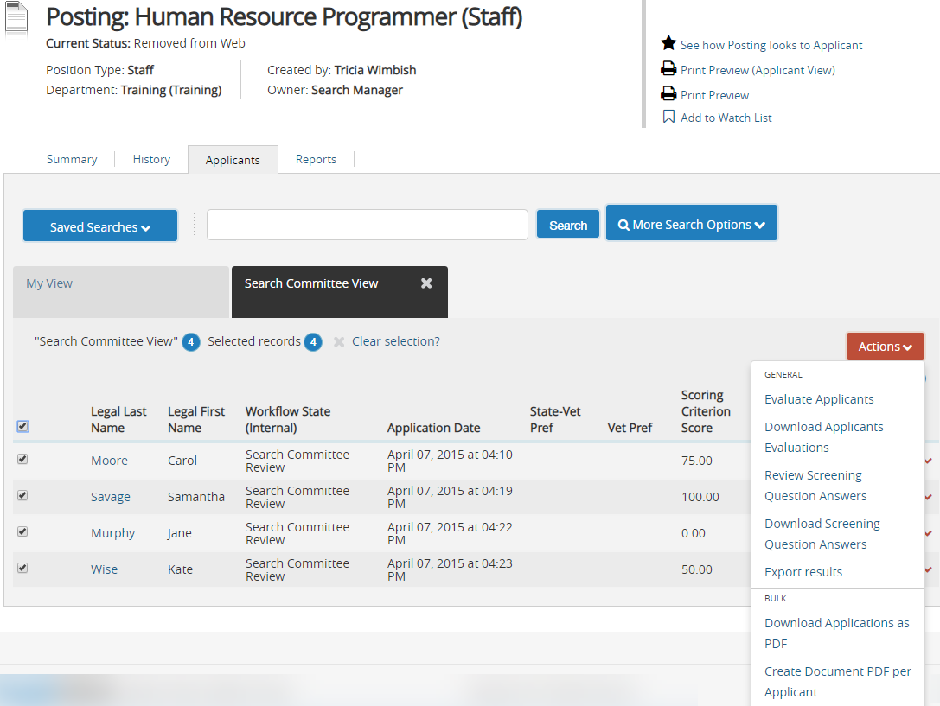

**Printing all applications (and uploaded materials) into one document**

* Click on **Applicant** tab
* Click on box beside “**Legal Last Name**” to select all applications
  + NOTE: If one application is needed, or just a few, click only on those box(es) needed.
* Click on **Action** button to the right of the screen
* Click on **Download Applications as PDF** under the **Bulk** section

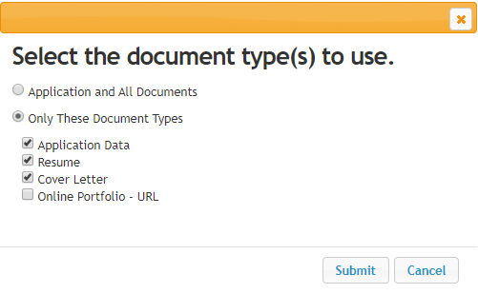

* The complete application (and uploaded documents) or parts of the application, can be downloaded
* Click **Submit** (for large pools this may take a while to generate the document).

**Download one application to a single PDF:**

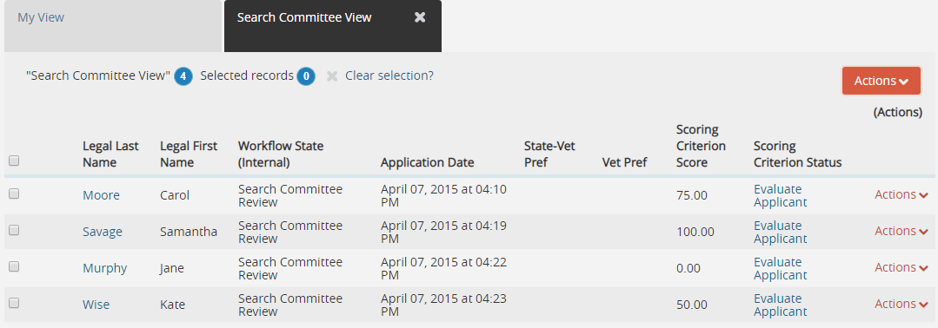

* Select the **name** of the candidate you wish to download.

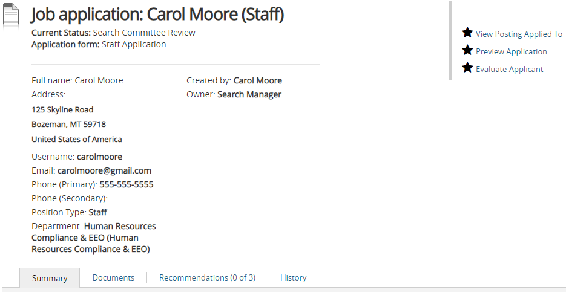

This will bring up the system view of the application

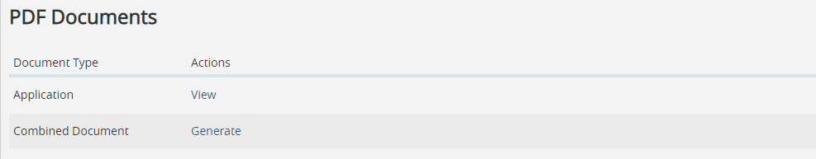

At the bottom of the screen you have the option to **View** the application as PDF or Combine Documents and **generate** a single PDF of their application/resume/cover letter/letters of recommendation (if requested).

***OR***

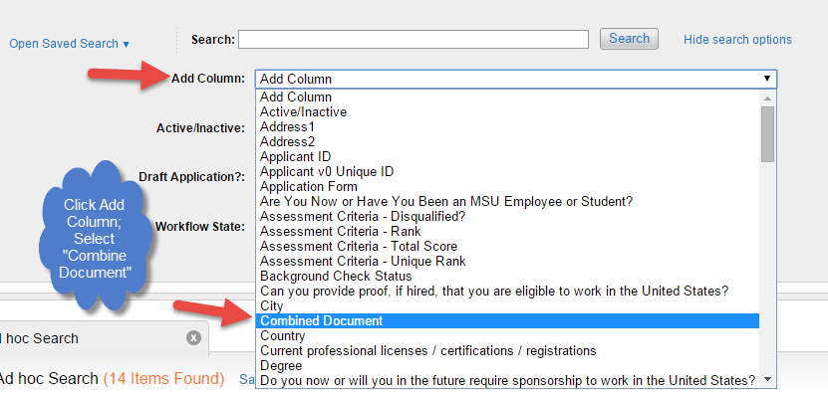

* Select **More Search Options**, then **Add Column** and select **Combined Document.**

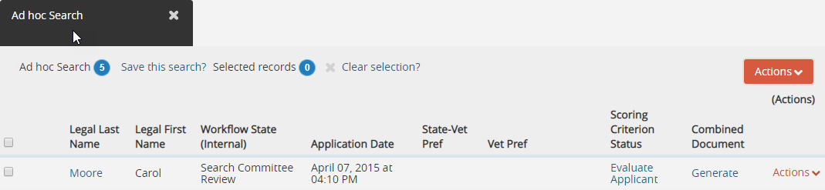

* Click on **Generate (FOR JUST ONE)**

***OR***

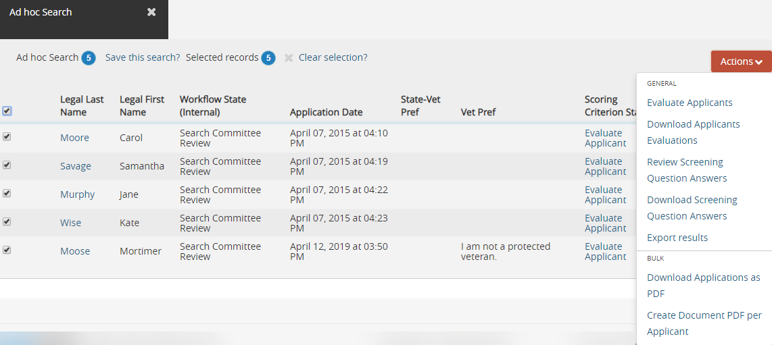

* Select check box for **Legal Last Name** to select all
* Click on **Create Document PDF Per Applicant** this combine



* Once conversion is done click on **View**
* Then can be printed off as individual PDF’s

***NOTE: if the applications are printed, they MUST be shredded when the search is completed. Also, PDF’s must be deleted from desktop and from Recycle Bin at the end of the search.***

**EVALUATE APPLICANTS**

**Ranking while reviewing online:**



* When ready to evaluate click Evaluate Applicant that will open a floating window
* The floating window will scroll up and down the applicant page while you are viewing
* Not available on the Document page, will need to go back to **Summary** to open
* Hit Cancel if you need to switch screens, once you return just click again to open
* **Save and Next** to proceed to next candidate in the list or just **Save** to end

***OR***

**Ranking after/when reviewing PDF:**

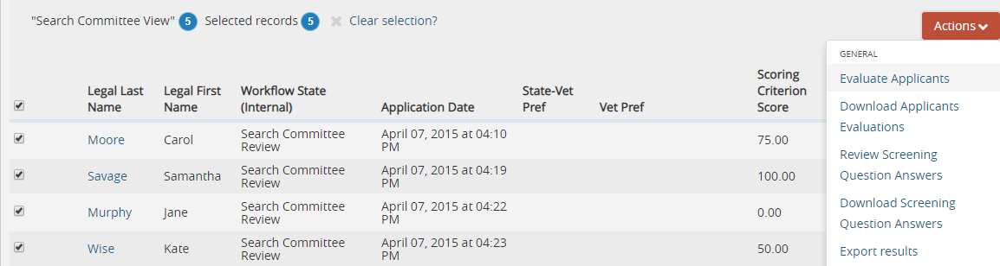

* Check mark selection box of applicant (or complete list by clicking box beside “Legal Last Name”)
* Click on **Actions**
* Select **Evaluate Applicants** from dropdown.

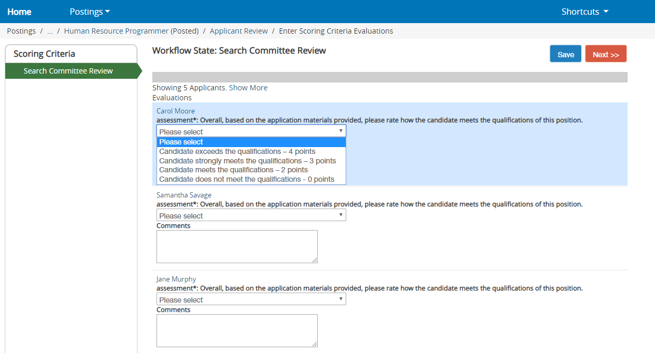

* This screen indicates applicants that are ready for evaluation.
* For each criterion, click the drop-down arrow and select the appropriate option for that applicant.
* **Repeat** for each applicant.
* To finish evaluating applicants at a *later time*, click **Save** and **log out**.
* Once ***all*** the applicants have been evaluated, click **Next**.

**SEARCH CHAIR INSTRUCTIONS**

The **Search Chair (may need to use Search Manager role)** can view the scores given the applicants.

* In the **Applicants Tab** click on **More Search Options** by using dropdown box
* **Add Column** box, click on **Ranking Criteria Score**
  + A column can be added for any information needed about the applicants with the option to export these results to a spreadsheet using the **Action** button.

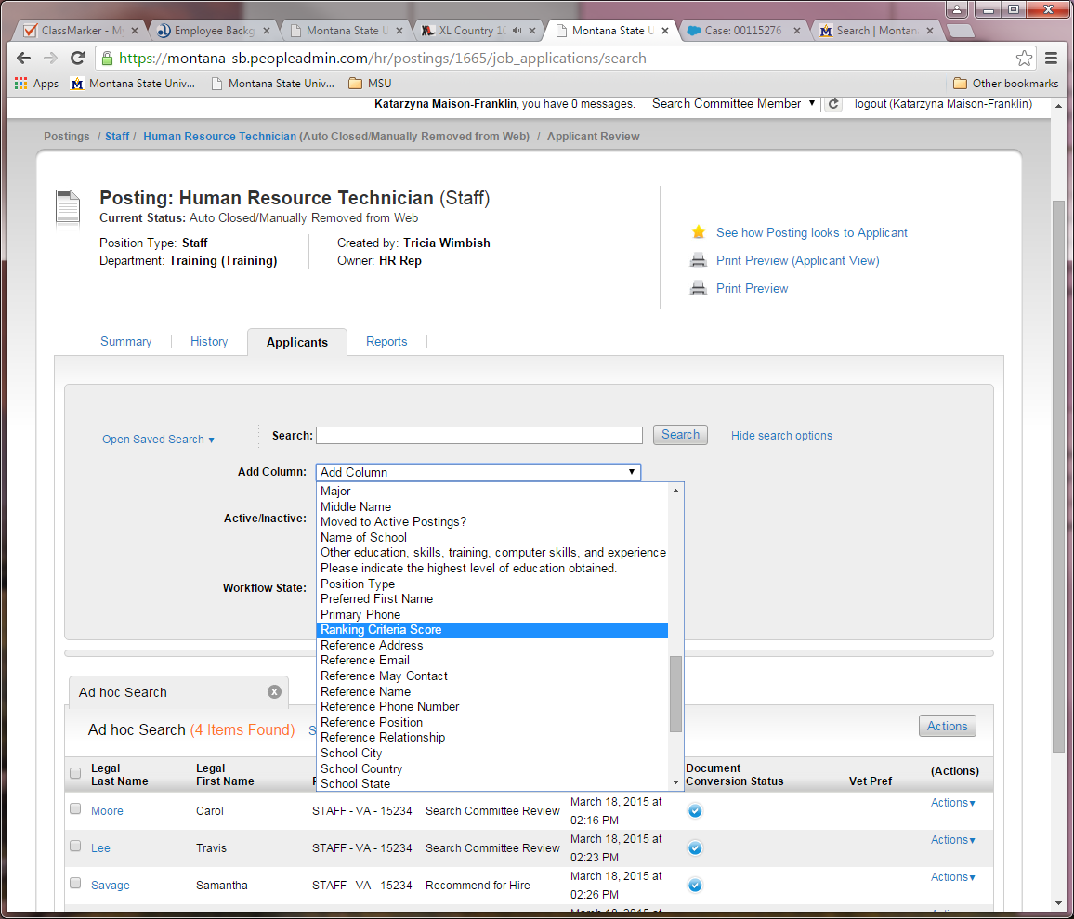

* Overall score will appear in the column

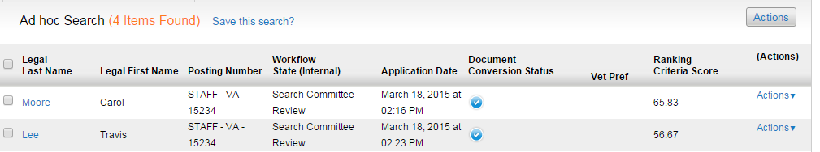

* To **export results** from this page to a spreadsheet, click on the **Actions** button and choose **Export Results**

To verify who has scored

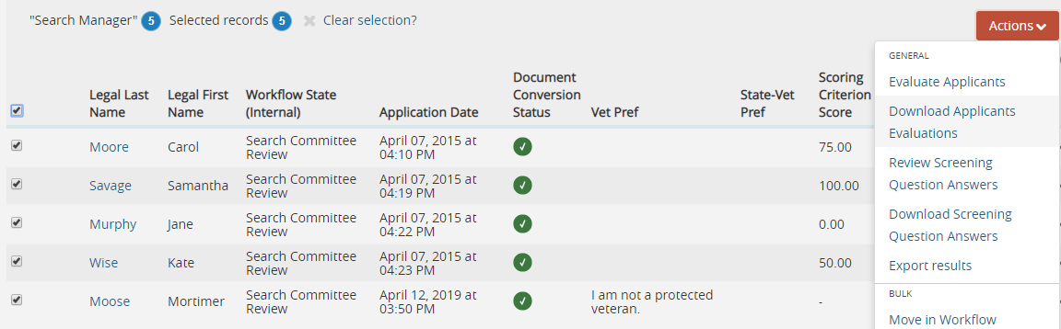

* Click box beside **Legal Last** Name to select all
* Select **Evaluate Applicants** on dropdown of **Action** button
* Select **View Detailed Entries**



* Select the **name** to see who has scored that individual

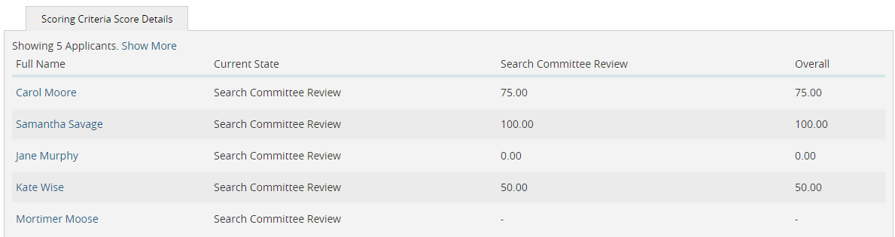

Never Ranked

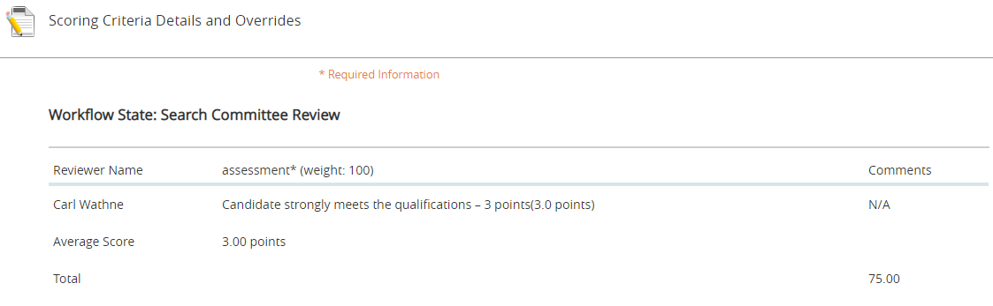

In this example only 1 committee member scored

**<no value entered>** means not scored by individual listed.

* Once the Search Committee members have completed the evaluation of the applicants and logged out
* Search Manager will move the applicants to the next stage of the search process. Once the Search Manager moves the applicants, Search Committee Members do not have access to the ranking screen.

Normal Workflow for applicants:

|  |  |
| --- | --- |
| Application: | Who Does Action: |
| Application Queue | Search Manager |
| Search Committee Review | Search Manager |
| Request Initial Interview | Human Resources |
| Initial Interview Approved | Search Manager |
| Request Final Interview | Human Resources |
| Final Interview Approved | Search Manager |
| Final Interview; Will be considered if candidate declines employment offer | Search Manager |
| Recommend for Hire | Search Manager |
| Hired | Human Resources |

**Download of Ranking - Optional – *NOT REQUIRED: HR can do for you, if requested!***

**To download the ranking** to see scores follow these steps.



* Click the **Actions** button
* Select **Download Applicants Evaluations**

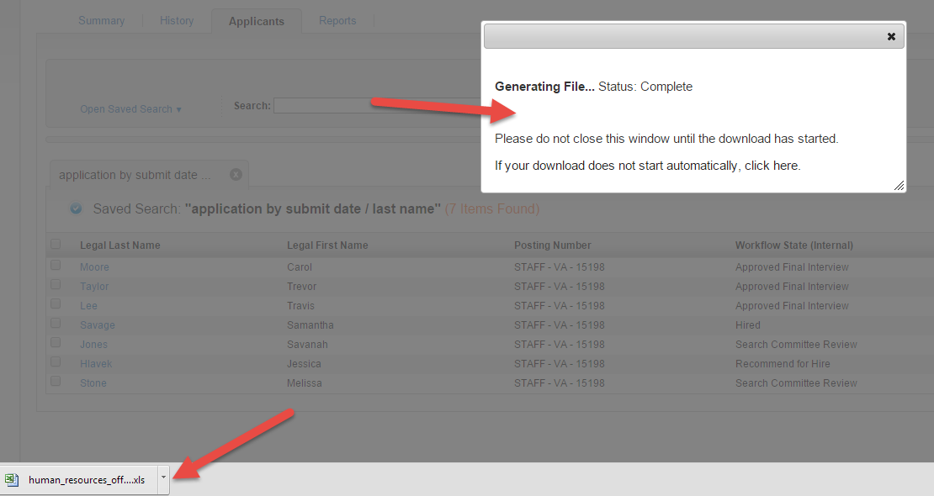

* The Generating File message box will appear.
* When the file is ready, it will appear in the lower left corner.
* Click the file to open (file will open in Excel).

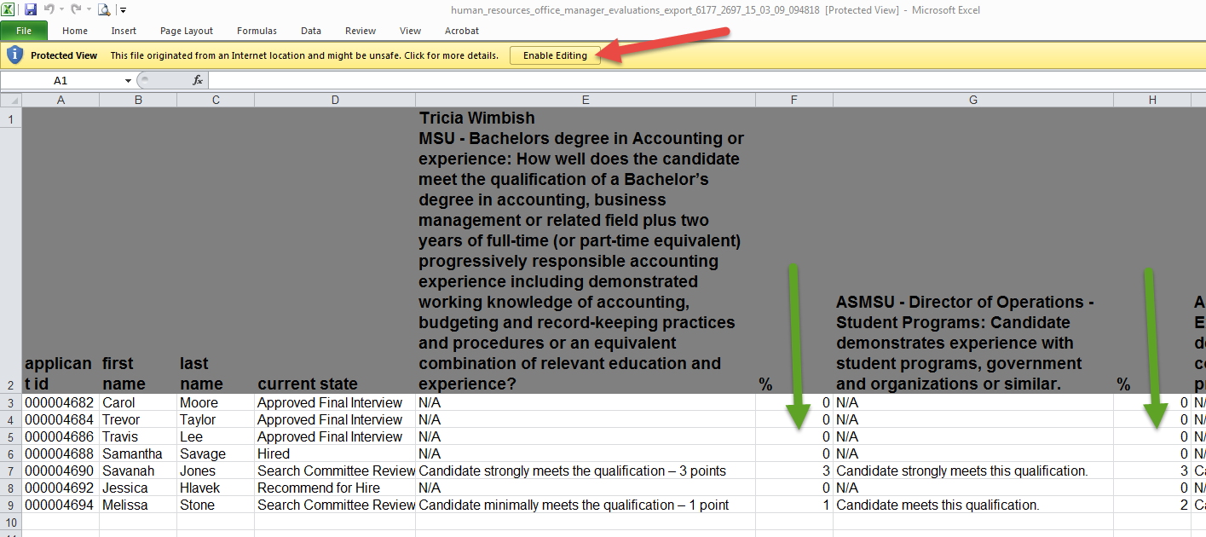

* Click the Enable Editing button at the top.
* Reduce Column width to 30 and scroll across to see if each committee member has 4 ranked
* Columns marked with a % sign indicate the ranking you have given the applicant