EPAF Errors & Solutions Page
Review all dates for the correct format MM/DD/YYYY Amounts should not contain ‘$’ or ‘,’
Remember to save after each section this will help you trouble-shoot if there is an error
Select the Submit button if available and more detailed error messages will appear.
Below are some common error messages and solutions: select a link to go to the solution or scroll to browse.
Warning-User does not have access to view current values
Error : Begin Date must equal the first Jobs Detail Effective Date
Error: Cannot submit. Person with Apply privilege must be the highest level
Error: New Effective Date cannot be after Employee’s Termination Date
Error: First Name, SSN, Birth Date, Sex Code or Ethnic Code Incomplete
Error: ID is not defined as an employee. Establish Employee record
Error: Effective Date must be greater than Last Paid Date of…
Error: First Labor Dist Effective Date must Equal the Jobs Begin Date
Error: New Effective Date must be greater than last date of…..

Warning - User does not have access to view current values.
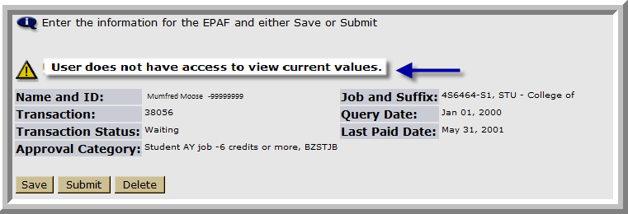

This is a Warning only and doesn’t prevent the user from submitting the EPAF
Solution – this warning refers to the originator’s org security, you may not be able to see the existing values. It does not prevent the originator from submitting the EPAF
- Is the 4 digit position number used in the EPAF correct for your department?

  - No

  - Yes

- Delete existing EPAF
- Create new EPAF with correct position number

- The budgeted org attached to the position does not match your org security

This does not prevent you from submitting the EPAF, you may not be able to see existing records.

NOTE: If you are unsure of your position number, they can be found, by using the following methods:
- First, Seach for the position by clicking the eye glass next to the Position text field on the New EPAF Job Selection page.

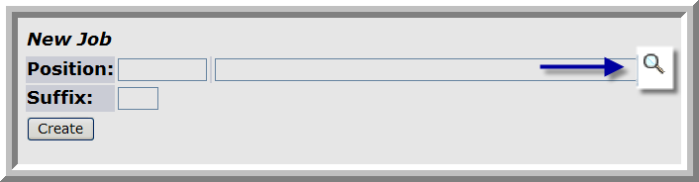
Next, select the 1H Employee Class, 1 COA (Chart of Accounts), and your department’s
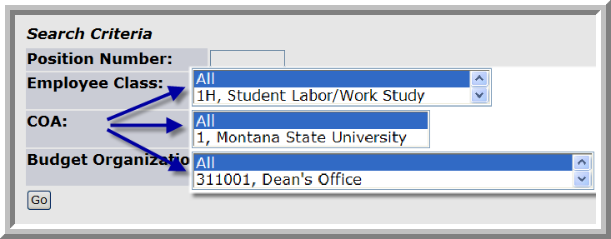
Budget Organization
Then select Go

- Go to the following web link to access the HR Customer Service Team file which lists each department’s Pooled Position.
http://www.montana.edu/pps/ImportantAnnouncements&Misc/HR-PPCustomerServiceTeams.xls

Error Message: Begin Date must equal the first Jobs Detail Effective Date
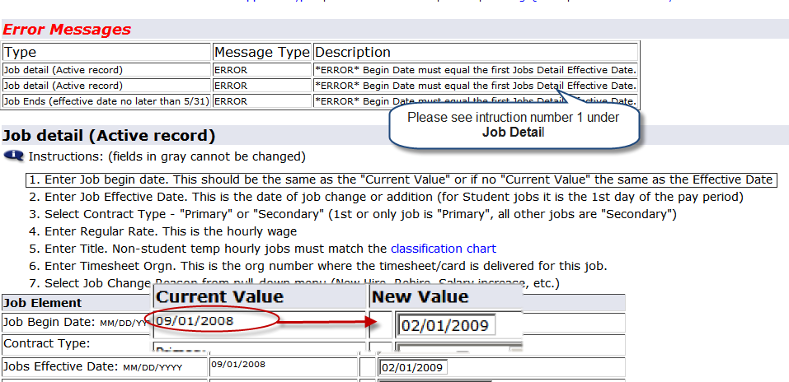

Error Message – Cannot submit. Person with Apply privilege must be the highest level
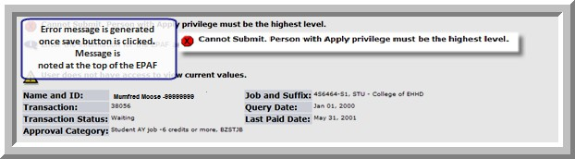
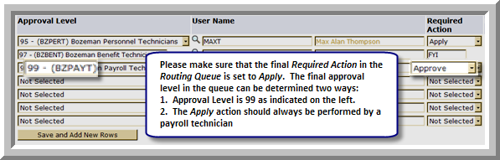

Solution – Please check the Approvers list at the bottom of the EPAF. Please note the Approval level and the required action. On the left hand side of the screen you will notice a numerical value next to the approval level. Please change the BZPAYT benefit required action to apply. If this does not work please contact your local payroll office for assistance.
NOTE: only one approver can be set up with Apply; If receiving this error be sure that all approver levels prior to BZPAYT are either FYI, or Approve.

Error Message - *ERROR* New Effective Date cannot be after Employee’s Termination Date
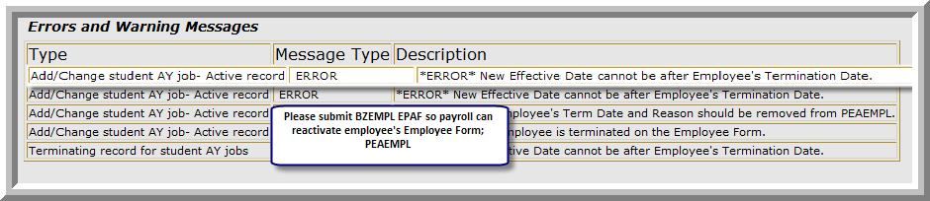
Solution – This message refers to an employee’s terminated employment status in the Employee Form PEAEMPL.
- Return to New EPAF Person Selection page.
- Please submit a BZEMPL EPAF to reactivate employee’s PEAEMPL record.
- When BZEMPL EPAF is applied (completed) re-submit the appropriate appointment EPAF

Error Message - *ERROR* First Name, SSN, Birth Date, Sex Code or Ethnic Code Incomplete
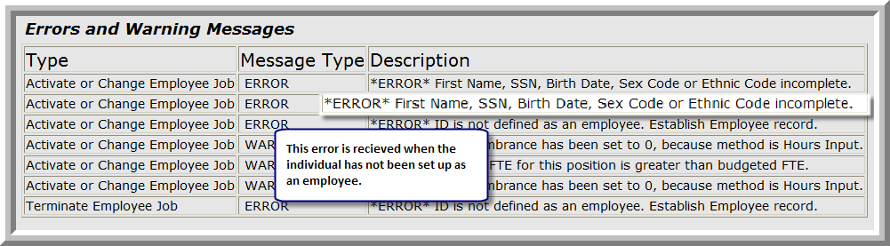

Solution – This message refers to an individual’s personal information in PEAEMPL which must be entered prior to them being defined as an employee in the Employee Form PEAEMPL. Anyone receiving

this message is a new employee. Please submit a New Hire Form in order to activate complete the individual’s PPAIDEN and PEAEMPL forms.
- Save and close the current EPAF
- Please submit New Hire Form to the following email address; newhires@montana.edu
  - To access the New Hire Form, please click the link below. http://www.montana.edu/hr/New-TerminatingEmployee/New%20hire%20form_departments.doc
- An HR representative will contact you, (usually within 24 hours) to request the SSN and birthdate of the employee. Once this call is complete the representative will activate the individual’s employment status.
- Following the call, submit the saved EPAF.

Error Message - *ERROR* ID is not defined as an employee. Establish Employee record.
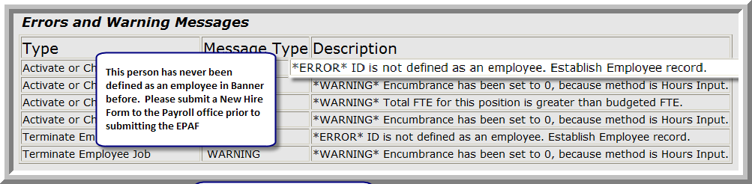
Solution – This message is notifying the user that the individual being appointed has never been defined as an employee in Banner. It refers to an employee’s employment status in the Employee Form PEAEMPL. Since they are a new employee to MSU a New Hire Form must be submitted in order to activate the PEAEMPL form
- Save and close the current EPAF
- Please submit New Hire Form to the following email address; newhires@montana.edu
  - To access the New Hire Form, please click the link below. http://www.montana.edu/hr/New-TerminatingEmployee/New%20hire%20form_departments.doc
- An HR representative will contact you, (usually within 24 hours) to request the SSN and birthdate of the employee. Once this call is complete the representative will activate the individual’s employment status.
- Following the call, submit the saved EPAF.

Error Message - *ERROR* Effective Date must be greater than Last Paid Date of…
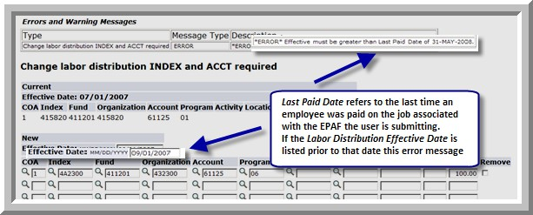
Solution – This message refers to the effective date of an employee’s proposed labor distribution in the Add/Change Job and Labor Distribution Change EPAFs.
- Change the labor distribution Effective Date to the first day of the next pay period. In the example above this date should be changed to 06/01/2008.
- Re-verify all other information on the EPAF
- Click Save
- Click Submit

Error Message: *ERROR* First Labor Dist Effective Date must Equal the Jobs Begin Date
Solution: Change the Labor Distribution Effective date to match the Job Begin date and the Job Effective Date
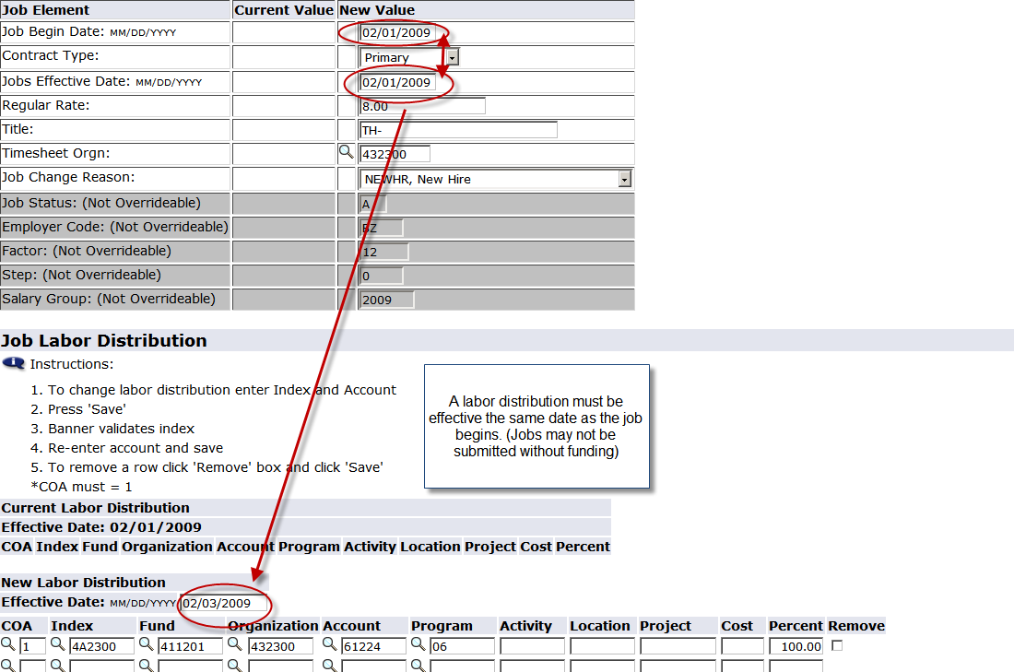

Error Message: *ERROR* New Effective Date must be greater than last date of…..
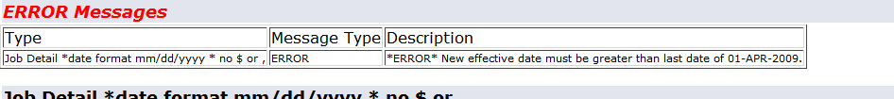
A future dated record must be deleted. Contact the payroll technician for your department.

