Report Tips

Please note that when you see the earn codes EPD on your payroll reports it does not indicate payment through payroll. It is used to impute income ( increase tax base) on same day meal reimbursements reported to payroll by University Business Services. FICA, work comp, unemployment will be charged to the department based on the gross reported. For example : You may see EPD- 10.00 This means the index will be charged about .80 cents for employer expense
Earn codes NCT, MOX and WFT are also used to impute income do not indicate payments made through payroll.

My employee does not have a dollar amount in the “Amount” column, is this okay?
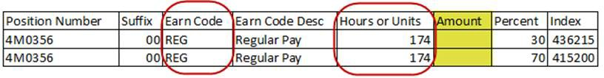
- Yes – If column “Hours or Units” has a number in it and the “Earn Code” column reads anything other than LWP.
- Why? – the record needs to be re-processed (Payroll Calculation process),.
§ Once the employee runs through this process there will be a dollar amount in the “Amount” column.
- Does Human Resources need to be contacted about this?
§ No – this is not an error, the record needs to be re-processed (Payroll Calculation process), there is nothing incorrect about the employee’s record.

The departmental payroll reports give each department specific employee data such as wages and hours worked to be verified by you, the department payroll liaison.

HR cannot verify that specific employee data such as wages or hours worked are correct we must rely on you as the department payroll liaison to let us know if there is an error. In working together we can strive to eliminate payroll errors and endeavor to pay all our employees correctly.

Ø As requested, there is now in the HR Dept Payrolls report folder a report that will include are all leave balances for employees by organization. The report is called: “Leave Balances”.

