Human Resources’ Guide to Completing
the Revised Employment Eligibility Verification (I-9 Form)

Federal law requires that every new employee complete an Employment Eligibility Verification Form (i.e. I-9). The purpose of the I-9 is to verify employees’ identities and employment authorization.

Recently, U.S. Citizenship and Immigration Services revised the I-9. Starting January 21, 2017 we can only accept the revised I-9. We have provided the link to the new form on our website, www.montana.edu/hr. The complete, executed I-9 needs to be sent to Human Resources.

The I-9 consists of three sections:

- Section One is completed by the employee.
- Section Two is completed by employers (i.e. you); and
- Section Three is only completed by employers for employees who are rehired or whose employment authorization requires reverification.

Things of importance to note is:

- An employee cannot be paid until the I-9 is processed by Human Resources. This is especially important to note if an employee is starting close to the end of a pay period.

- New employees can complete the I-9 prior to starting work at MSU, but cannot complete it until after they have officially been offered, and have accepted, the position.

- New employees are required to complete Section 1 of the I-9 on their first day of work and you will need to review and certify the new employee’s documents and complete Sections 2 and 3 within 3 days of the employee’s first day of work.

- The address that is on the I-9 is the address we put in our system for the employee and where their paychecks will be sent unless they are signed up for direct deposit or complete a Change of Address form.

- The following link is a good resource if you need further directions and/or information: https://www.uscis.gov/i-9-central

- Lisa Hespen is currently the Human Resource Personnel Associate who is processing I-9’s and you can call her with any questions at 994-3651.

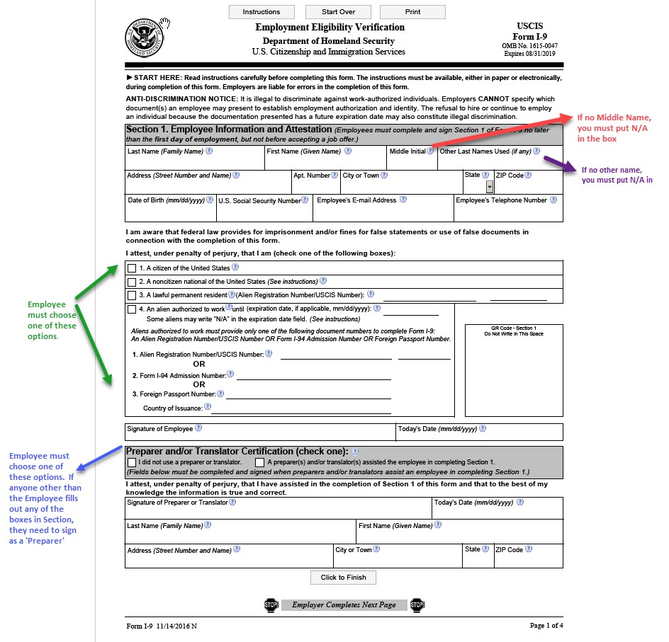

SECTION 1:

This section needs to be completed entirely by the employee. If anyone other than the employee completes any of the boxes contained in Section 1, then that person will need to fill out the Preparer/Translator Certification directly below the employee’s signature. The employee needs to provide their last name, first name (legal, not nickname), and middle initial. If they do not have a middle initial they must enter N/A. If they have used any other last names, they need to provide it, if not they must enter N/A.

The employee must include their full address and date of birth. We cannot require that an employee provide their Social Security Number, so this may remain blank. The employee is also not required to provide an email address or telephone number. If they choose not to provide this information, they need to enter N/A in the respective boxes.

Next the employee must check one of the four options regarding their citizenship. If they mark either 3 or 4, they must provide the information requested within those sections.
The employee must then sign the form and date (the day they completed the form). Please make sure they put the correct date, many times employees put their date of birth instead of the date they are completing the form and we have to return it to them for correction.

New to this form, the employee must now advise whether or not they used a preparer. If they did not, they only need to check the first box. If anyone helped them fill out the form or translate the form, they need to check the 2nd box, and then provide the requested information.

Back Page

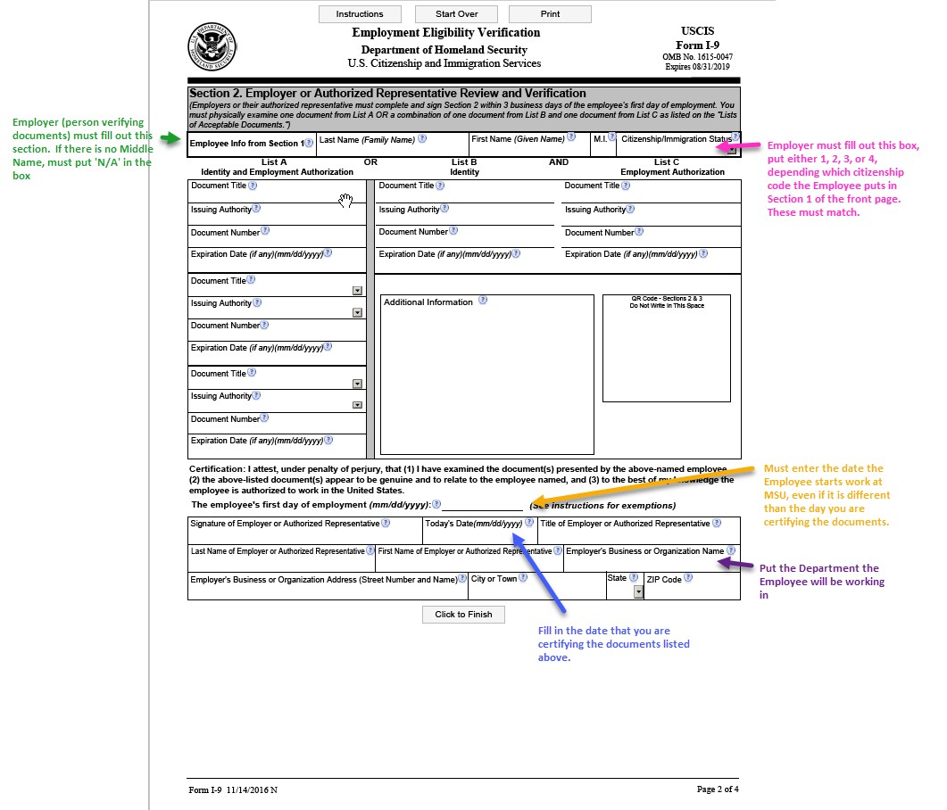

SECTION 2:

This section is to be completed by the employer (i.e. the hiring department). In the first part you need to fill in the employee’s last name, first name, and middle initial, as it appears on their documents. If they do not have a middle initial, you must put N/A. You are now also required to include their citizenship/immigration status. You must put the number they checked on the front of the form (i.e. 1, 2, 3, or 4).

In the second part you are required to look at the documentation they provide and fill out the boxes. They must provide documentation from List A only, or one from List B AND List C.

You will then be required to fill out the Certification. You must include all the information, including the employee’s start date located on top of the boxes. When entering the Employer’s Business or Organization Name, please fill in MSU- NAME OF HIRING DEPARTMENT.

SECTION 3:

You do not need to fill out this section unless you are doing a rehire or reverification. Please call Human Resources for more instructions if you need assistance with Section 3.

