Medical Resources
Legal Resources

406-995-6995 | Big Sky Medical Center- Big Sky
406-414-5000 | Bozeman Health Deaconess Hospital- Bozeman
406-898-1201 | Billings Clinic– Bozeman
406-587-0681 | BridgerCare Bozeman - reproductive health care services
406-924-5754 | Community Health Partners* Belgrade
406-585-1360 | Community Health Partners* Bozeman
406-222-1111 | Community Health Partners* Livingston
406-646-9441 | Community Health Partners* W. Yellowstone
406-585-8701 | Community Health Partners Dental Practice
406-582-3100 | Gallatin City-County Health Department
888-706-1535 | Gallatin County Office of Public Assistance - call for eligibility  criteria
888-706-1535 | Healthy Montana Kids (MT CHIP) Eligibility Hotline
406-222-3541 | Livingston Healthcare
800-362-8312 | Medicaid Help Line
800-633-4227 | Medicare Information Line
406-222-4145 | Park County Health Department
406-582-5300 | VA Clinic - for Veterans
* All CHP clinics have low cost/sliding fee behavioral health services, primary & preventive health care services available to everyone regardless of ability to pay.
406-582-9200 | Bozeman Job Services
406-444-2545 | Unemployment Insurance
406-582-3010 | Gallatin County Office of Public Assistance (for families only)
406-454-5709 | Rural Dynamics
800-772-1213 | Social Security Administration
406-646-7311 | West Yellowstone Job and Social Services Center
406-587-4486 | HRDC Energy Programs

866-820-5437 Child and Elder Abuse Help Line
406-585-9984 | Child and Family Services, Gallatin County
406-222-7402 | Child and Family Services, Park County
800-245-4743 | Disability Rights Montana - disabilityrightsmt.org
406-582-2075 | Gallatin County Victim Assistance Program
406-543-8343 | Gallatin Legal Assistance Clinic
406-582-2038 | HAVEN
800-666-6899 | Montana Legal Services Helpline

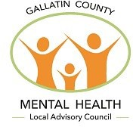
Mental Health & Social Services
Financial Assistance

Resource Guide
2022

When you don’t know what to do or where to get help...resources and assistance are available.

406-587-2434 HRDC Galavan
Transportation
Housing Assistance
406-587-2434 HRDC Streamline Bus Service 406-587-3008 Love INC
406-222-4668 Park County Angel Line 406-388-9999 TAXI
406-582-7388 | Family Promise
406-388-8225 | Habitat for Humanity
406-586-4111 | HAVEN
406-587-4486 | HRDC Housing Program
406-587-3008 | Love INC
406-586-5813 | Salvation Army
406-624-6277 | Volunteers of America - Housing assistance for Veterans
406-556-1123 | Bozeman Warming Center
406-333-2537 | Livingston Warming Center - Seasonal, Emergency Night Shelter *

406-640-0244 West Yellowstone Galavan Reservations (reserve early) 406-922-5683 Windrider, Livingston
406-646-7311 Call Job & Social Services for a voucher to ride – Check for eligibility

* Open late fall to early spring

Food Assistance
406-586-2421 Bozeman Senior Center - Meals on Wheels Program
888-706-1535 Gallatin County Public Assistance - Supplemental Nutrition
Assistance Program (SNAP)
406-285-3559 | Headwaters Area Food Bank | 406-209-5088 | Kiwanis Clothes Closet - free clothing
406-587-4225 | HRDC Fork & Spoon Homestyle Kitchen | 406-222-7641 | L’Esprit - Youth and Adult Services + School and Community Treatment
406-586-7600 | HRDC Gallatin Valley Food Bank - Operating in Bozeman, Three | 406-823-6604 | LiveWell 49 - Improving Health & Wellness in Park County

406-222-8154 Aspen, 24-Hour Domestic Violence Hotline and Emergency
Child & Family Related Resources
Shelter in Livingston 406-587-7786 Child Care Connections - child care referral
406-585-1360 Community Health Partners - primary & preventive health care services
406-587-2477 Family Outreach - assessments
406-587-2194 Greater Gallatin United Way kidsLINK Afterschool Programs 406-586-4111 Haven 24-Hour Domestic Violence Hotline and Emergency
Shelter in Bozeman 406-585-8544 Hearts & Homes Family Resource Center

Thanks to the following agencies who contributed to the costs of this publication:

Forks & Big Sky
406-222-5335 Livingston Food Resource Center, Livingston 406-587-3008 Love INC
406-222-8000 Park County Public Assistance - Supplemental Nutrition
Assistance Program (SNAP)
406-586-5813 | Salvation Army | 406-587-3840 | Thrive
406-646-7311 | West Yellowstone Job & Social Services Center | 406-585-9402 | Youth Dynamics - Children’s Mental Health & Behavioral Health Care
 |  | 406-586-9444 | Zoecare Pregnancy and Planning Clinic

406-522-7300 Montana Independent Living Project
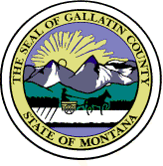
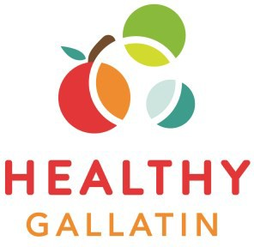
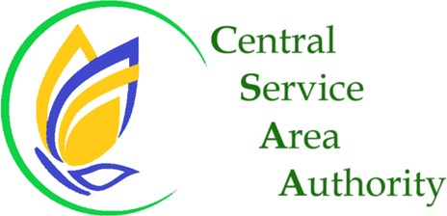
406-994-4113 MSU Human Development Clinic - Low-Cost Services Adults, Children,
Couples & Families
406-570-0738 Roots Family Collaborative - pregnancy & post-partum support
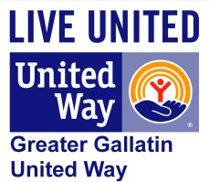
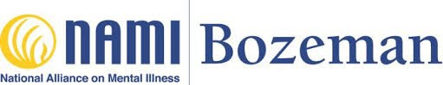
406-582-8566 SEPTA - Special Education Parent Teacher Association, Bozeman School District

For information on copies please contact: 406-582-3000
Visit: gallatincomt.virtualtownhall.net/mental-health-local-advisory-council to print off a PDF

Assistance for those in crisis
or urgent need of help
Dial 9-8-8 to reach Montana’s Suicide Prevention and Mental Health Crisis Lifeline
and / or
Dial 406-586-3333 to reach The Help Center
Text “MT” to 741-741 for Crisis Text Line

Dial 9-1-1 If immediately life threatening.

IF YOU ARE CONCERNED ABOUT SOMEONE, ARE THEY...

...Suicidal or Depressed?
Ask Them:

- “Have you had thoughts of killing yourself?”
- “Are you suicidal?”
- “How would you harm yourself?
- “Do you have access/ability to implement this plan?”
- “Do you know when you would do it?”
- Is this person in a safe place? Can you/ someone else stay with them? 9-8-8 Help Center

...Intoxicated with Drugs or Alcohol?
- What Substance and how much did they take?
- What behaviors is the person exhibiting?
- Is the person vomiting or seizing?
- Is the person unresponsive?

9-1-1 for Law Enforcement/ Emergency Medical Services, ask for a CIT officer.
406-585-1000 | Bozeman Health Hospital Emergency Room.
406-222-3541 | Livingston Health Care
406-995-6995 | Big Sky Medical Center
406-586-5493 | Alcohol & Drug Services of Gallatin County
406-404-7900 | Community Medical Services (Belgrade)
406-222-2812 | SW Chemical Dependency (Park County)

Behavioral/Mental Health Resources

406-586-5493 Alcohol and Drug Services of Gallatin County
Community Health Partners - Low-cost / sliding scale counseling & behavioral / mental health services offered to all regardless of ability to pay:
406-924-5754 Belgrade Bozeman 406-585-1360
406-222-1111 Livingston West Yellowstone 406-646-9441 406-404-7900 Community Medical Services - Medication assisted treatment for opioid use 406-586-3333 Help Center - 24 Hour Crisis Line and Suicide Outreach TEXT “MT” to
741-744 for crisis support
2-1-1 Help Center - 24 Hour Resource Referral
406-586-3333 Help Center - Local Number
406-585-1130 Hope House - Voluntary before crisis stabilization
406-587-4486 HRDC - Wrap-Around Services such as Housing, Food, Transportation & more
406-222-7641 L’esprit - Youth & Adult Services in Livingston

877-927-6642 Mental Health America of Montana montanamentalhealth.org 406-551-1058 Montana Peer Network
9-8-8 Montana Suicide Prevention and Mental Health Crisis line
877-688-3377 Montana Warm Line - Non-crisis support line - virtual drop-in center
Call or visit montanamentalhealth.org
406-994-4113 MSU Human Development Clinic - Low-cost counseling services for
community members
406-994-4531 MSU Counseling & Psychological Services - Counseling Services
for MSU students

If you call 911, ask for a Crisis Intervention Team (CIT) Officer.
CIT officers are trained to help with mental health crises.

Persons of any age can go to the Emergency Department at the nearest hospital:
406-585-1000 Bozeman Health Deaconess Hospital Emergency
406-222-3541 Livingston HealthCare
406-995-6995 Big Sky Medical Center

...Displaying Unusual or Unsettling Behavior?
- Is the person hearing, seeing, or anything unusual that could cause harm to self or others?
- Does the person appear to be talking to themselves in a way that is causing distress to themselves or is unsafe for others?
- Does the person appear frightened, angry, agitated or depressed? 2-1-1 Help Center

...Aggressive or Violent Behavior?
- Has the person behaved in a manner that would inflict harm?
- Has the person made any threats? What is the nature of the threats?
- Has the person consumed any alcohol or drugs?

2-1-1 for the Help Center or 9-1-1 for Law Enforcement/ Emergency Services 406-222-8154 ASPEN - Abuse Support Prevention Education Network (Livingston) 406-586-4111 HAVEN Domestic - Violence Shelter (Bozeman)

406-443-7871 National Alliance on Mental Illness (NAMI) 406-585-8959 NAMI Bozeman - namimt.org
406-579-4984 Providence Mental Health Center - Mental Health Outpatient
Counseling Services

406-539-1383 | Recovery In Common - Certified peer support for recovery
406-586-3333 | Sexual Assault Counseling Center
406-586-5813 | Salvation Army
888-866-0328 | State Addictive & Mental Disorders Information Line
888-444-9669 | State Mental Health Ombudsman
877-726-4727 | Substance Abuse & Mental Health Services Administration
406-222-2812 | SW Chemical Dependency (Park County)
406-582-5300 | VA Clinic - for Veterans
406-994-7069 | VOICE Center - Confidential support for MSU students impacted by sexual
assault or relationship violence
406-556-6500 Western Montana Mental Health - Gallatin - Out Patient Services
and Pharmacy
406-570-3907 Wellness in Action - Big Sky Community Counseling
406-585-9402 Youth Dynamics, Inc. - Children’s Behavioral Health Services

