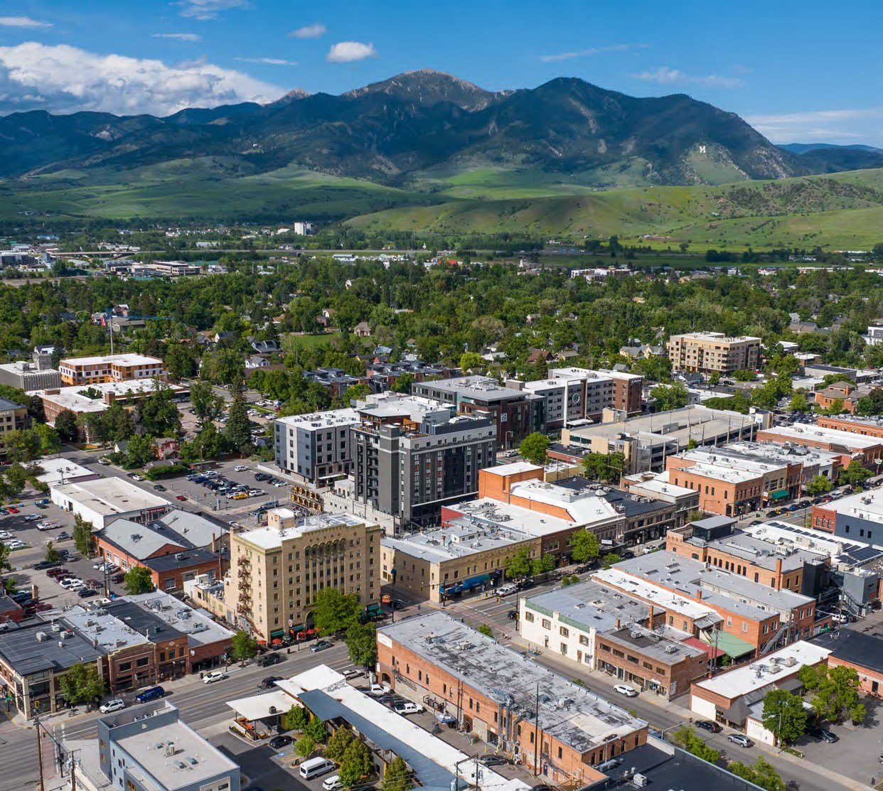
Y O U R G U I D E T O

M O V I N G T O
BOZEMAN, MONTANA

W W W . B O Z E M A N R E A L E S T A T E . G R O U P

Intro

WHY BOZEMAN?
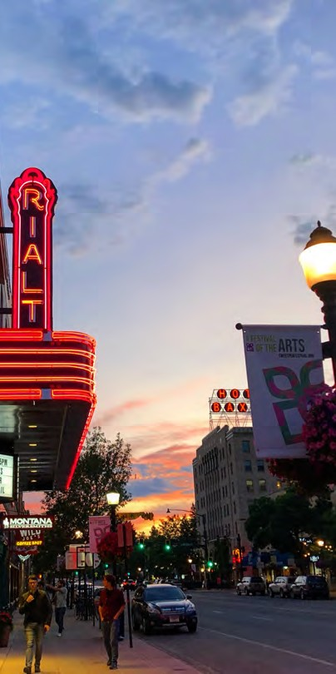
Bozeman, Montana is a place of opportunity. It is a place where business meetings are held on drift boats, where families come together on the trail, and where the mountains are endless.

When you move to Montana, evening walks will take place of rush-hour traffic and the time you used to spend waiting in lines will turn into time spent enjoying the outdoors with your family and friends.

Instead of city skylines, you’ll find ridgelines. Instead of long lines, you’ll find free time.

Your world will expand to the boundless mountain ranges that surround the Gallatin Valley. When it’s time to come inside, you’ll find a diverse selection of restaurants to please any foodie, nightlife, music, sporting events, theater, and more.

Welcome to Bozeman, Montana –your adventure is waiting to begin.

W W W . B O Z E M A N R E A L E S T A T E . G R O U P

BOZEMAN’S COST OF LIVING

According to www.payscale.com, the cost of living in Bozeman is 22% higher than the national average. Not so shocking compared to places like Manhattan, NY where the cost of living is more than twice the national average or Seattle, Washington where the cost of living is 50% higher than average. But if you are coming from a less expensive area, the cost of living in Bozeman can cause some sticker shock.

62%
H O U S I N G
14%
U T I L I T I E S
7%
G R O C E R I E S

There’s an old joke in Bozeman that residents pay
$10,000 in mountain taxes each year

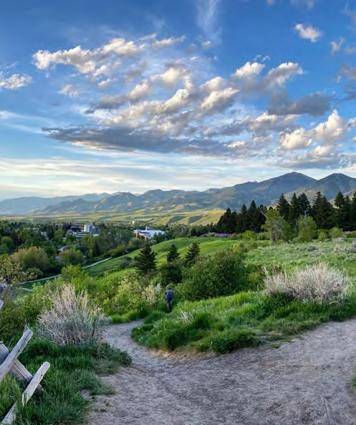
While the cost of living in Bozeman is 22% higher than the national, average, the average wage in Montana is 12% lower, making it difficult for many to manage the cost of living in Bozeman. The good news is that Montana wages are quickly catching up. Montana currently ranks 8th in the nation for wage growth in the last 10 years.

Many people have chosen to live in the areas that surround Bozeman where they can find significantly lower housing costs. Belgrade, Livingston, and Three Forks all offer a lower cost of living and are within a 30-minute drive of Bozeman.

W W W . B O Z E M A N R E A L E S T A T E . G R O U P

HOUSING PRICES

A Bozeman continues to receive national attention for its quality of life, housing costs have been driven to record highs. Bozeman’s population has increased by 50% since 2010, and that growth was fueled even more by the pandemic. High demand for homes and low inventory has driven housing costs in Bozeman higher than most places across the nation.

In the past 6 years, home prices in the Bozeman area have nearly doubled

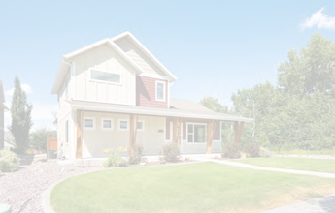
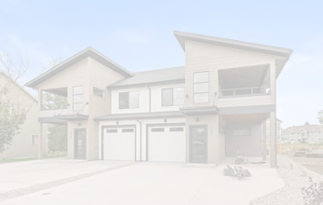
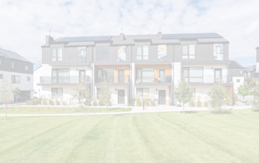
S I N G L E F A M I L Y
M E D I A N S A L E P R I C E
$905,000
T O W N H O M E
M E D I A N S A L E P R I C E
$560,000
C O N D O
M E D I A N S A L E P R I C E
$538,750

AFFORDABLE ALTERNATIVES TO BOZEMAN

As Bozeman’s home and rental prices rise, many people are searching for an affordable alternative. Fortunately, there are several cities just outside of Bozeman where home and rent prices are lower. Just 8 miles away in Belgrade, homes are 32% less expensive on average and residents enjoy great schools, mountain views, parks, and recreation areas. Livingston also offers lower home prices, but as its popularity grows, that may not last for long! Three Forks and Manhattan are also great alternatives for home buyers looking for a lower cost of living.

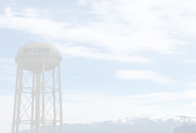
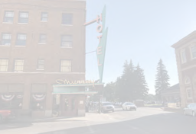
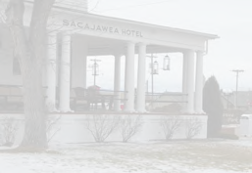
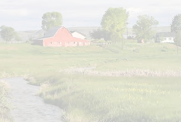
LEARN MORE
B E L G R A D E , M T
M E D I A N S A L E P R I C E
$538,000
L I V I N G S T O N , M T
M E D I A N S A L E P R I C E
$450,000
T H R E E F O R K S , M T
M E D I A N S A L E P R I C E
$279,900
M A N H A T T A N , M T
M E D I A N S A L E P R I C E
$722,600

These prices were updated in September 2023.
SEE THE MOST RECENT PRICES

W W W . B O Z E M A N R E A L E S T A T E . G R O U P

WHAT DO PEOPLE DO FOR WORK?

Bozeman is different than many of its metropolitan counterparts. With competition high and a limited number of skilled jobs available, it can be tough for professionals to find work in their field. However, Bozeman is becoming known for its quickly growing tech sector which is continuing to provide more job opportunities for professionals. Bozeman is also a great place for those with an entrepreneurial mindset. With increasing tourism spending, community support, and many resources designed to advance local businesses, Bozeman is a perfect place for a start-up business.
According to Business Insider, Montana has the highest rate of new entrepreneurs, second best startup activity score and the third best business survival score.
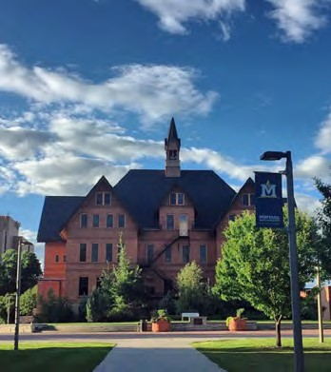
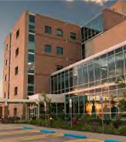
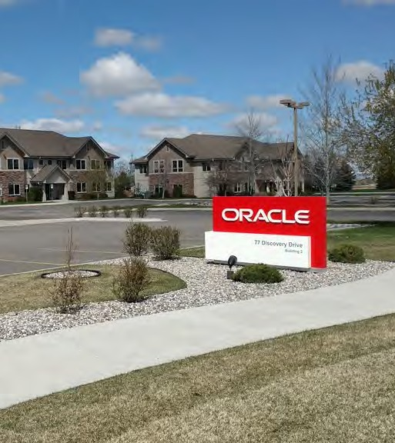
MONTANA STATE UNIVERSITY
BOZEMAN HEALTH
ORACLE

Montana State is the largest employer in Bozeman with nearly 5,000 faculty as well as over 680 graduate teaching and research assistants.
Bozeman Health is an integrated healthcare system that serves 8 counties in Montana. It is the 2nd largest employer with over 2,400 employees.
Oracle Corp is one of the largest tech firms in the world and provides high-paying jobs to locals as it continues to expand its operations.

SIMMS FISHING

A globally known manufacturer of fishing equipment known for making the “best waders in the world”.
MYSTERY RANCH

A well known high- performance backpack manufacturer that is based in Bozeman.
ONX

The developer of the most accurate GPS mapping app for outdoor enthusiasts is based in Bozeman.
SCHEDULICITY

A globally recognized online scheduling software company based in Bozeman.

Bozeman’s thriving economy and growing tourism industry means there are also a large number of service industry workers in the area. There are almost always jobs available in landscaping, construction, food service and retail. And if you’re willing to work outside of Bozeman, an estimated several hundred workers make the drive to Big Sky each day to work in various fields at Big Sky Resort, The Yellowstone Club, Spanish Peaks and Moonlight Basin.

HOW’S THE HEALTHCARE?

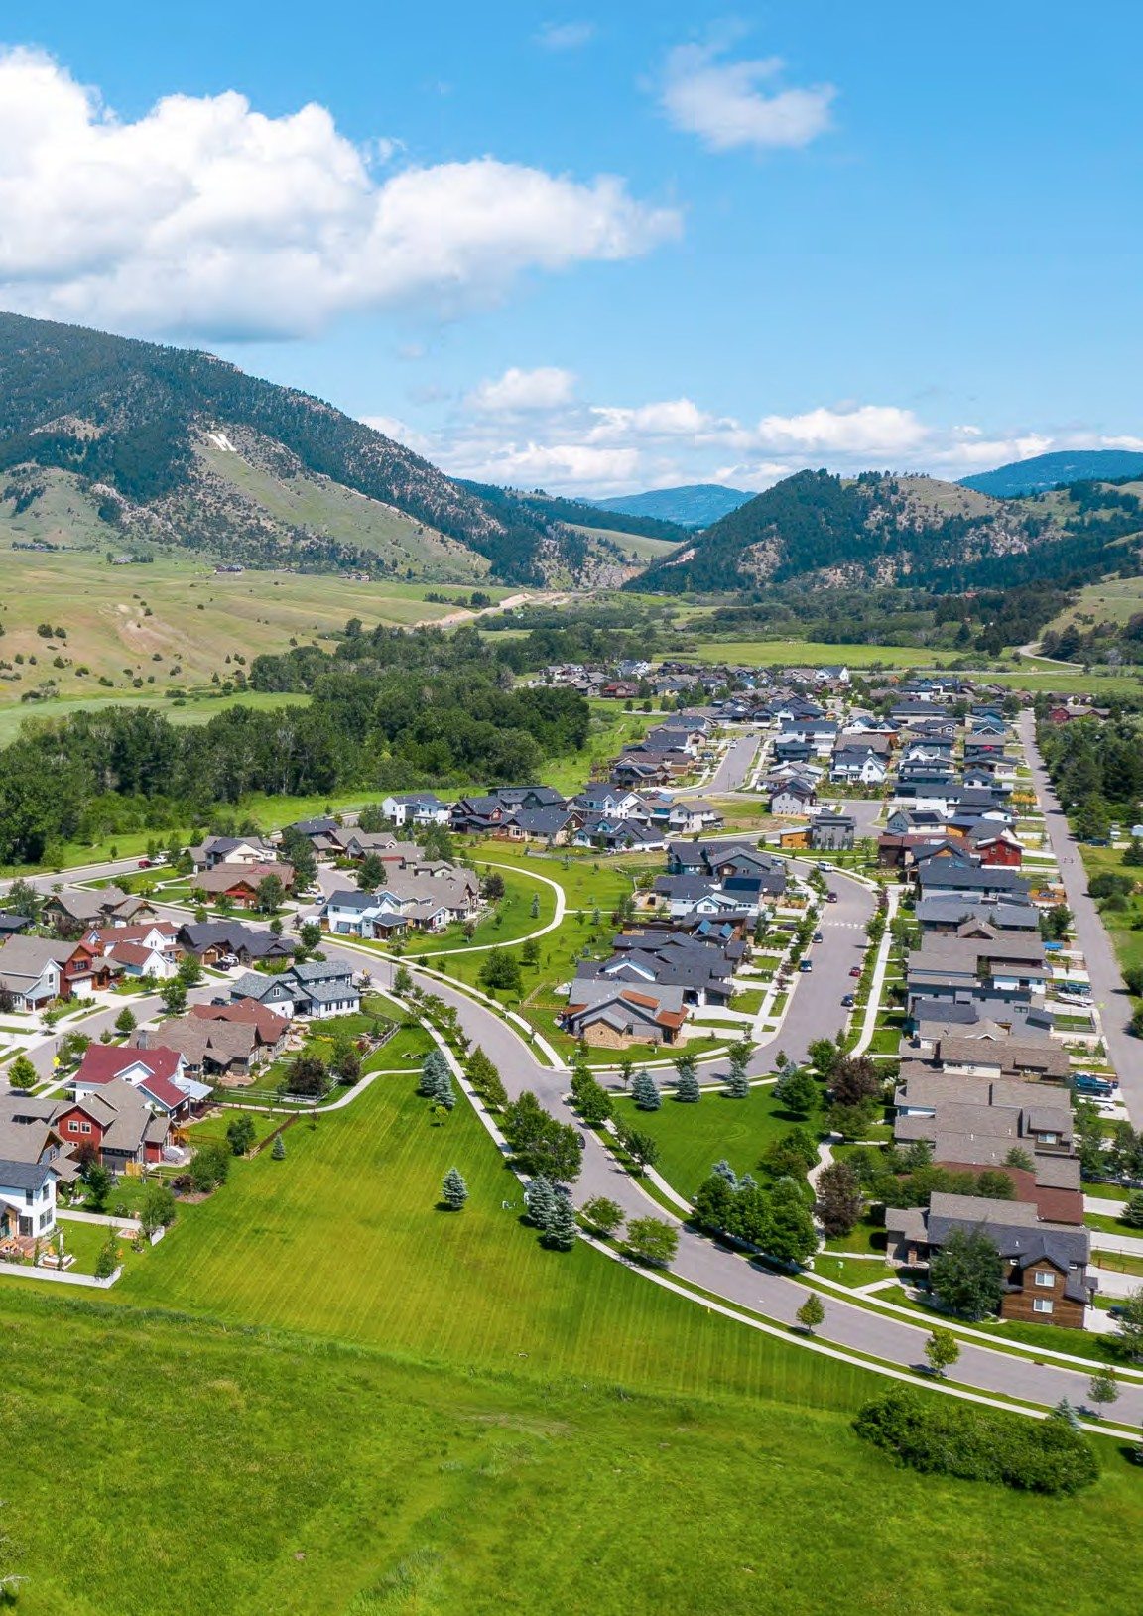
Maybe it’s all the fresh mountain air, or all the skiing, hiking and biking, but Gallatin County is considered the healthiest county in Montana. As Bozeman continues to grow, the healthcare community is doing the same.

Bozeman Health, the largest healthcare provider in the area offers two hospitals, specialty treatment centers, outpatient treatment facilities, Urgent Care and retirement and assisted living facilities.

Bozeman Health Deaconess Hospital is an 86-bed facility with 200 physicians and health professionals with more than 35 specialties.

In addition to the Bozeman Health Network, there are other Urgent Care locations along with many private practices and specialty doctors throughout the valley.

When it comes to choosing dentists, orthodontists or optometrists you’ll find plenty of options. And since many Bozemanites play hard, sometimes a little too hard, there is no shortage of physical therapists or orthopedic surgeons.

Billings Clinic recently opened the first phase of their Bozeman location, a 58-acre campus that has over 50 physicians, nurse practitioners and physician assistants with over 20 specialties.
.

WHAT ABOUT EDUCATION?

With eight elementary schools, two middle schools, and two high schools, the Bozeman Public School District is top-notch. The districts are set up with boundaries so most children go to a neighborhood school, making it easy to walk or bike when the weather is nice. Any day actually, they are Montana kids after all!

For the younger kids, there are a number of fantastic pre-school and daycare options throughout the community. Aside from the public school system, there are top-notch private schools in Bozeman as well.

When it comes to extracurricular activities, Bozeman is overflowing with options for kids of all ages. From hockey to gymnastics, to theater, there are so many activities to introduce your children to.
Many activities are offered through school intramural programs or after-school clubs. Bozeman also has a great YMCA and numerous private organizations to get your child into any extracurricular activity you can think of.

For older students, Montana State University, the fastest-growing university in Montana is in Bozeman. There is also the Gallatin Community College which offers a number of workforce programs and associate degrees. There are adult education classes offered through the Bozeman School District.

Beyond that, maybe you’ve wanted to give rock climbing a try or take a guitar lesson, don’t worry we’ve got those covered as well. Learning new things is just a way of life in Bozeman - at any age.

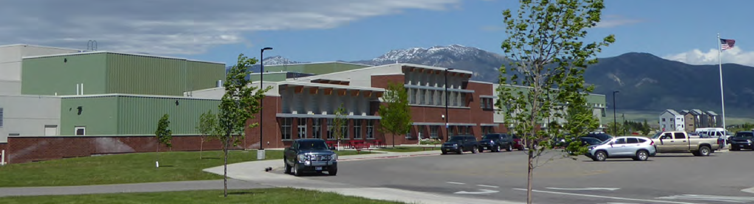

Learning goes beyond the classroom in Bozeman. Field trips mean exploring Lewis and Clark Caverns or a trip to the Willson Auditorium for a ballet performance.

SCHOOL DISTRICTS

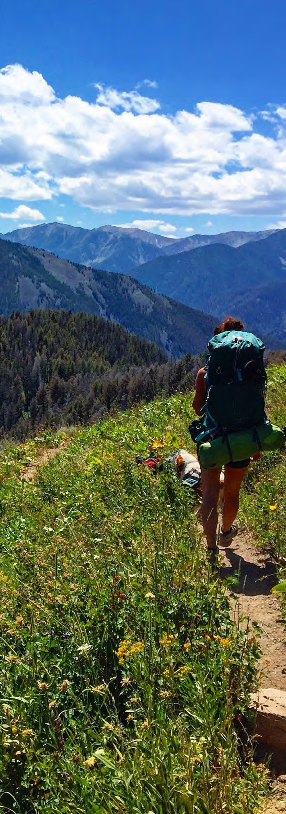

GETTING OUTSIDE

We will be honest with you. If you don’t like the outdoors, you’ve probably got the wrong place.

With some of the biggest skiing in America just an hour away, some of the best fly fishing
rivers, creeks, and lakes in the world, hundreds of thousands of acres of public land within a short drive, and one of the best ice climbing destinations in America in our backyard – it’s easy to see why Bozeman is an outdoor enthusiast's dream.

There are countless organizations that support our connection with the mountains and the land in Bozeman. The Gallatin Valley Land Trust maintains our trails, conserves the land, and has created a fantastic trail system, “Main Street to the Mountains” which winds throughout the city connecting downtown, neighborhoods, and parks eventually leading us to the mountains.

GET OUR BEST TIPS FOR OUTDOOR RECREATION

W W W . B O Z E M A N R E A L E S T A T E . G R O U P

For those living in or visiting Bozeman, the toughest decision isn’t finding something to do, its picking one.
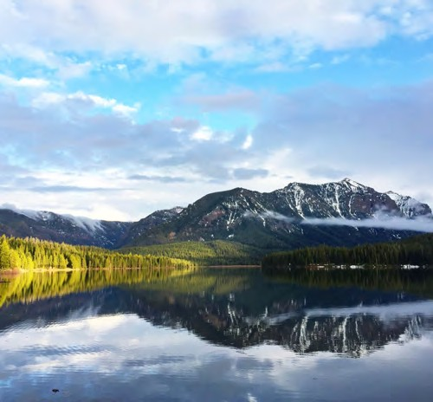
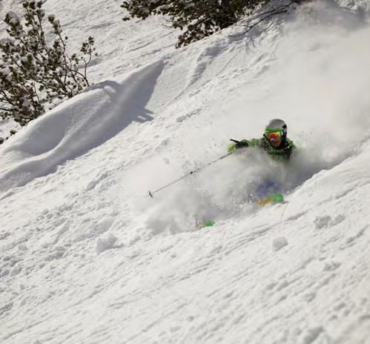
Hyalite Canyon
Skiing

Fondly known as “Bozeman’s backyard”, Hyalite Canyon is an adventurer's paradise with a beautiful reservoir for paddling, swimming, and fishing, peaks to climb, waterfalls to enjoy, trails to ski, hike, and bike, and some of the best ice climbing routes in America.
In the winter, the adventure continues with the biggest skiing in America at Big Sky Resort and the local favorite, Bridger Bowl which is just 20 minutes from town. Crosscut Mountain Sports Center has miles of scenic, groomed trails for cross-country skiing.

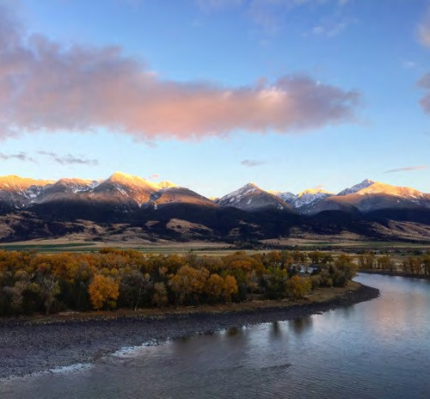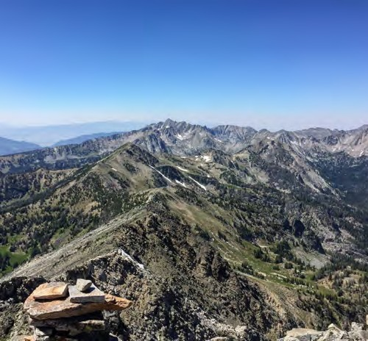
Yellowstone River
The Mountains

The longest undammed river in the lower 48, winds through Paradise Valley just 30 minutes away. With a strong population of cutthroat, brown and rainbow trout and more than 20 public access points along the way, this river is a fisherman's dream.
Six mountain ranges surround the Gallatin Valley - the Absaroka, Bridger, Crazy, Gallatin, Madison, Spanish Peaks, and Tobacco Root mountain ranges. These mountain ranges offer endless destinations for hiking, backpacking, camping, fishing, and peak bagging all within less than a two-hour drive.

WHERE TO EAT AND PLAY
Downtown Bozeman has always been the go-to place for a meal out, and the selection is impressive. You’ll find a bit of everything from old-school breakfast joints like the Western Cafe to sushi at Hooked and high- end steak houses like J.W. Heist. Many of the restaurants have a farm-to-table approach and focus on supporting other local businesses. And, we have to mention Bozeman’s food truck scene as well. You can find them at farmers markets and events, at the Food Truck Pod in Midtown, and at almost all of the breweries. It’s never difficult to find a delicious meal in Bozeman.

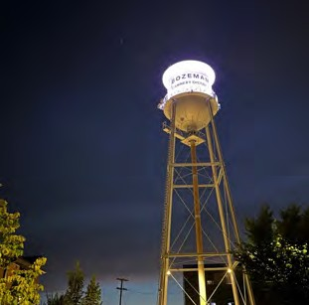
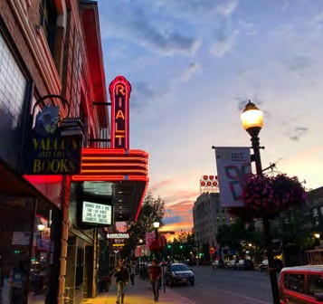
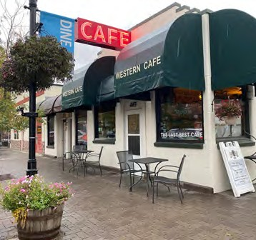
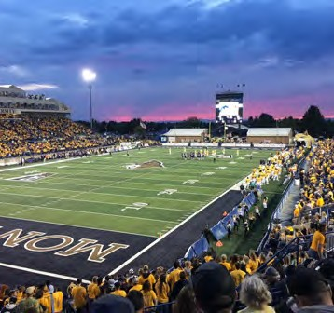
NIGHT LIFE

From dive bars to Sky Bars, Bozeman has a lively nightlife scene. If you are looking for an authentic experience we recommend the Hideaway or The Crystal. If you are looking for views, check out the Sky Shed. If you want a great cocktail we recommend Plonk, Copper, or Single Barrel. For dancing check out the Eagles Bar or Bourbon in Midtown.
LIVE MUSIC

We can get some big-name performers at the largest music venue in Bozeman the Brick Breeden Fieldhouse. There are also great performances by well-known bands at the Elm, Rialto, and the Armory Music Hall. For a more intimate show, we love Live From the Divide. On the other side of the spectrum, the Bozeman Symphony and the Intermountain Opera have performances throughout the year.
THE ARTS

The Verge is a small theater that brings some big performances to Bozeman. The historic Ellen Theatre offers a variety of live theater mixed with music, comedy shows, dance performances, and free family movies. Art galleries are big in
Bozeman and always fun to stroll through, especially during the summer Art Walks. Bozeman is also home to the Museum of the Rockies, one of the world’s finest history museums, and a fantastic children’s science center.
SPORTING EVENTS

The Bozeman community shows up to support the Montana State Bobcats whether it's football, basketball, or rodeo season. The community also loves to cheer on our high school teams, the Hawks and Raptors!

Stay up to date on all of the newest restaurants, businesses and more in Bozeman on our blog
OUR BLOG

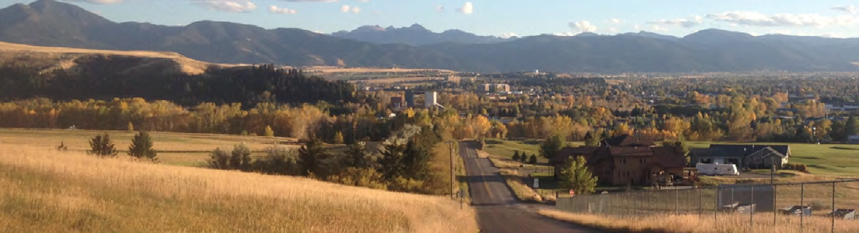
DISTANCES FROM BOZEMAN
BELGRADE
20 minutes
BRIDGER BOWL
30 minutes
LIVINGSTON
30 minutes
BIG SKY
60 minutes

HOW DO YOU GET AROUND?

People often say that Montana is the kind of place that requires your own vehicle, especially if you want to make the most of the outdoor recreation.

But, if you find yourself without wheels, Bozeman’s public transportation is through the Streamline Bus System which offers a fare-free service throughout Bozeman along with service to and from Bozeman, Belgrade, Four Corners, Livingston, Big Sky, and straight to the ski hill at Bridger Bowl in the winter. While the public transportation in Bozeman is improving, if you are coming from a metropolitan area you won’t have the same connectivity that you are used to.

Click here for the Streamline Bus routes and schedules.

Uber, Lyft, and Turo are all available in Bozeman, although they can be expensive. In the summer Bozeman does have Bird, a scooter service that allows for short rides in town.

According to Data USA, the average commute time in Bozeman is just 18 minutes.

W W W . B O Z E M A N R E A L E S T A T E . G R O U P

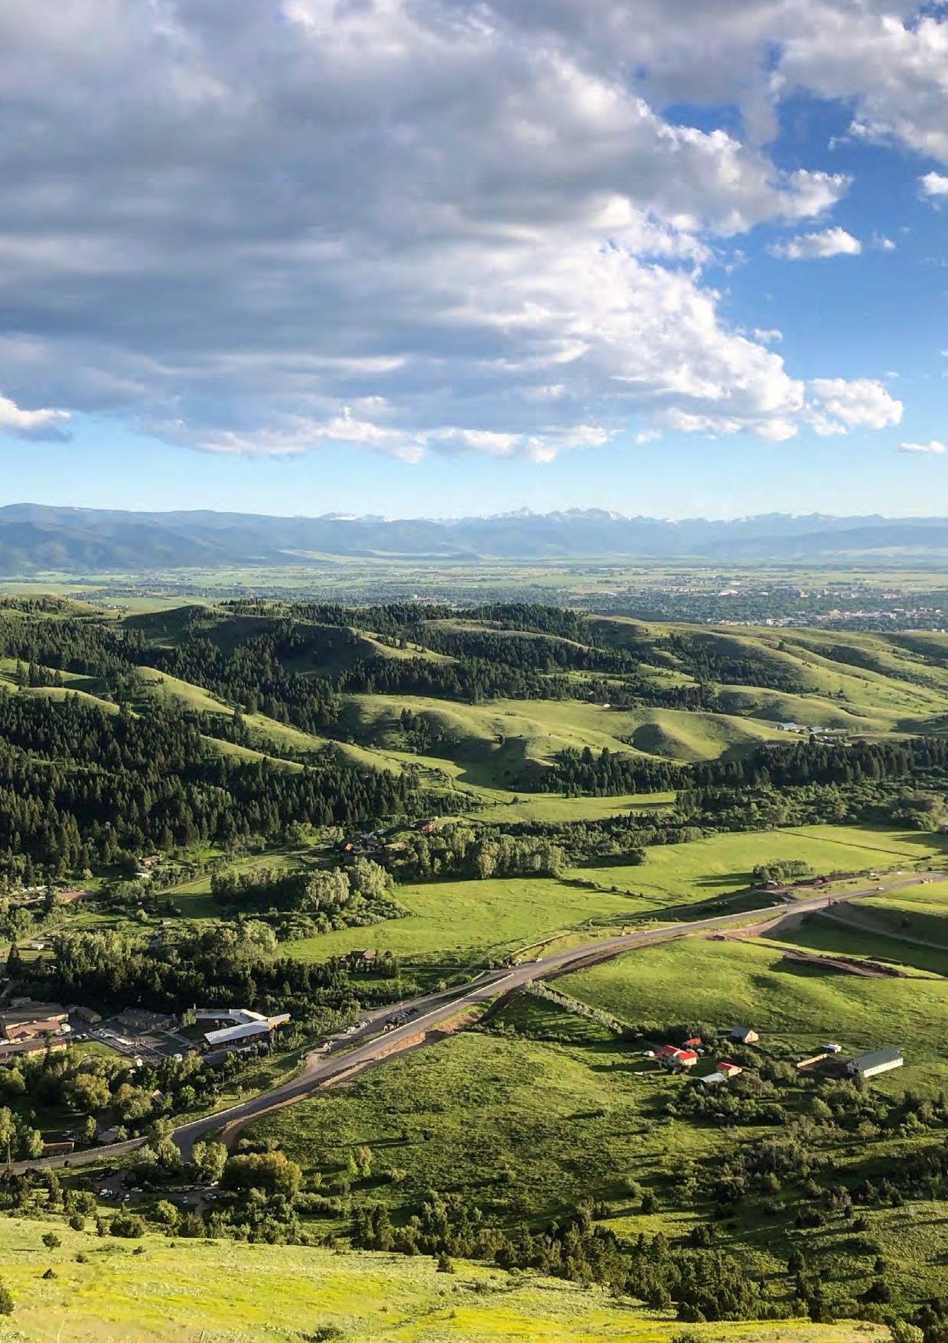

406.587.1717

info@bozemanrealestate.group

www.bozemanrealestate.group

