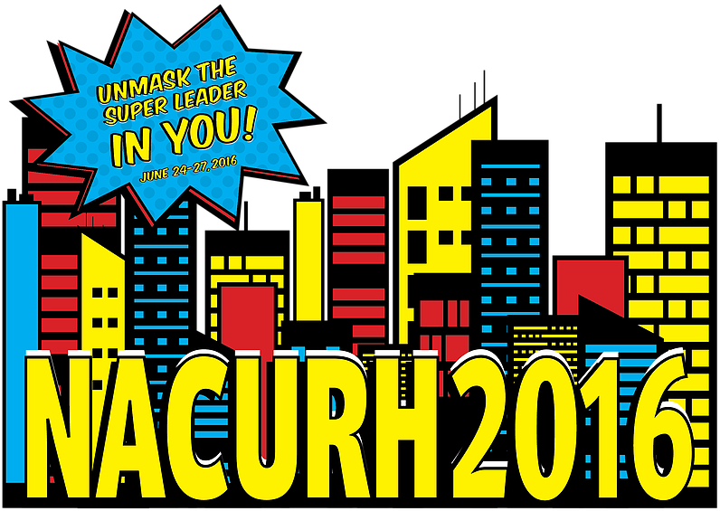

NACURH stands for the National Association of College and University Residence Halls. Every year, a conference is hosted for all of the regions to exchange ideas. At the NACURH conference, people come from all over to trade ideas about programs, fund raising, personal development, and so much more to improve your RHA! This conference provides the opportunity to make many new friends, learn about other RHAs, team build, and develop your leadership skills. NACURH conferences provide an exciting and unforgettable experience!!!

Applications due:
Friday, March 25, 2016

to the North Hedges Front Desk by 5pm
NOTE: Attendees must be planning on living in the residence halls for the Fall 2016 semester to attend NACURH!
If you have questions or concerns pertaining to the conference, application process or anything else please contact:

Tannur Oakes

tannur.oakes@gmail.com

NACURH Conference 2016

Delegate Application

The 2016 National Association of College and University Residence Halls conference is June 24 – June 27, 2016 at The University of Delaware. The purpose of NACURH is to inform student leaders on areas such as discipline, leadership, and overall personal achievement.

Name: Phone:
Address: Year in School:
Major: _____________

Have you attended any conferences in the past? Y N Please List below:

1) RHA office held currently or in the past (Please give dates, names of positions and halls served in):

2) List any organizations, clubs or extra-curricular activities that you have been involved with (High School and College):

3) In what ways will you apply the learned information to your floor, hall, and Interhall RHA?

4) What are three qualities that best describe you and tell us why you chose them?

5) How do you feel the qualities you listed above will benefit you as an NACURH delegate?

5) Why are you interested in attending NACURH 2016?

REMINDER: If chosen as a delegate, you are attend programs, possibly present programs, attend all delegation meetings, and will be financially obligated to repay all non-refundable costs incurred if you withdraw from the delegation/conference or do not bring programs back to campus.

NACURH Conference 2016
Recommendation for MSU-Bozeman Delegate
(Please fill this out for students interested in attending NACURH)

The 2016 National Association of College and University Residence Halls conference is June 24 – June 27, 2016 at The University of Delaware. The purpose of NACURH is to inform student leaders on areas such as discipline, leadership, and overall personal achievement.

Applicant: __________________________________________
Reference Name: Phone: ______________
Address: ___________________________________________
Relationship to applicant: __________________

Please check one: □ Confidential □ Non Confidential

How has this person contributed to RHA?

Please list leadership qualities you feel this person possesses that makes them a strong candidate for NACURH:

Do you feel this person will continue to contribute to RHA? (Please explain how/what):

Does this person work well with others? (Please explain):

Why is this person interested in attending NACURH 2014?

Please take this space to add any additional comments you feel necessary.
(Feel free to use additional space/pages)

Signature Date ___________________

Thank you for taking time to fill out this recommendation for the applicant. It is greatly appreciated and will help our selection process. Please return this form to the Roskie Front Desk by 5pm on Friday, March 7, 2014.

