MONTANA TIM STEERING COMMITTEE MEMBER

MT Highway Patrol
Sgt. Alex Betz, TIM Training Program Coordinator/Chief Instructor
Detachment 322 Commander
Helena MT, 59601
(406)475-0712
abetz@mt.gov

Marcee Allen, Chairperson
FHWA Montana Division
585 Shepard Way, Suite 2
Helena, MT 59601
(406) 441-3909
Marcee.allen@dot.gov

Terry Morrison, President
Montana Tow Truck Association
411 Bond Street Bozeman, MT 59715

Walt Kerttula, DES Coordinator
Montana Department of Transportation
2701 Prospect Avenue
Helena, MT 59620
(406) 444-6153
wkerttula@mt.gov

Jamie Bennett, Business Continuity Coordinator
Montana Department of Transportation
2701 Prospect Avenue
Helena, MT 59620
(406) 444-5450
jbennett@mt.gov
Shari Graham
Montana Department of Emergency Services
HHS Cogswell
(406) 444-6098
sgraham@mt.gov

(406) 587-3831
mrtsterry@gmail.com

Dave Mason
406 Fire Training
2606 Thunder Drive
Helena, MT 59601
(406) 459-7717
406firetraining@gmail.com
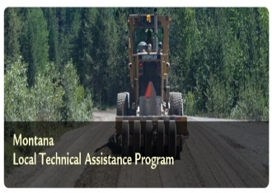
Matthew Ulberg, Director
Montana LTAP Center
Montana State University
PO Box 173910
Bozeman, MT 59717-3910
(406) 541-6671
Matthew.ulberg@montana.edu

Montana Traffic Incident Management Partners
Traffic Incident Management is a planned and coordinated program process to detect, respond to, and remove traffic incidents and restore traffic capacity as safely and quickly as possible. This coordinated process involves many public and private sector partners, including but not limited to:

MONTANA ASSOCIATION OF CHIEFS OF POLICE
P.O. Box 275
Great Falls, MT 59403
(406) 454-9091
info@macop.com

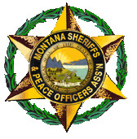
Montana Sheriffs and Peace Officers Association
34 West 6th Avenue, Ste 2E
Helena, MT 59601
Phone: 406-443-5669

Montana State Fire Chiefs’ Association
1627 West Main Street, #210
Bozeman, MT 59715
(888) 340-4141

Montana State Volunteer Firefighters Association
E-mail: info@montanavolunteerfirefighters.com
1627 W Main St #210
Bozeman, MT 59715
Telephone: +1 800 347 3546
FAX: + 1 503 299 4760

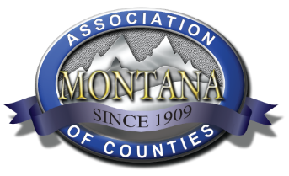

MACO Administration
2715 Skyway Drive
Helena MT 59602
(Ph) 406-449-4360
(F) 406-442-5238

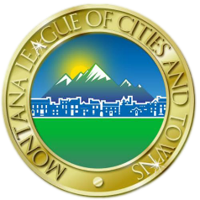
MONTANA LEAGUE OF CITIES AND TOWNS
PHONE: 406-442-8768
FAX: 406-442-9231
700 W. Custer Avenue
Helena, Montana 59602
PO Box 7388, Helena, Montana 59604-7388

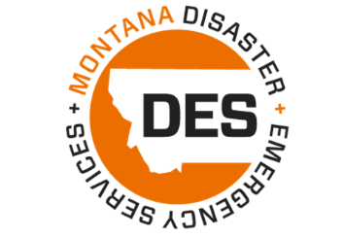
Montana Disaster and Emergency Services
1900 Williams St, Helena MT
406-324-4777
MTDES@mt.gov

Office of the Montana State Auditor, Commissioner of Securities and Insurance
Hours of Operation: Monday – Friday, 8:00 am – 5:00 pm
840 Helena Ave. Helena, Montana 59601
Phone: (800) 332-6148 or (406) 444-2040
TDD: (406) 444-3246
Fax: (406) 444-3497 or (406) 444-3413

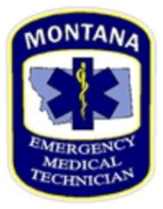
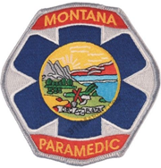
BOARD OF MEDICAL EXAMINERS
301 South Park , 4th Floor (map)
P.O. Box 200513
Helena, MT 59620-0513
Fax: (406) 841-2305

