Montana Traffic Incident Management Training

Classroom Training: Contact Sgt. Betz to schedule the 4-hour classroom training.

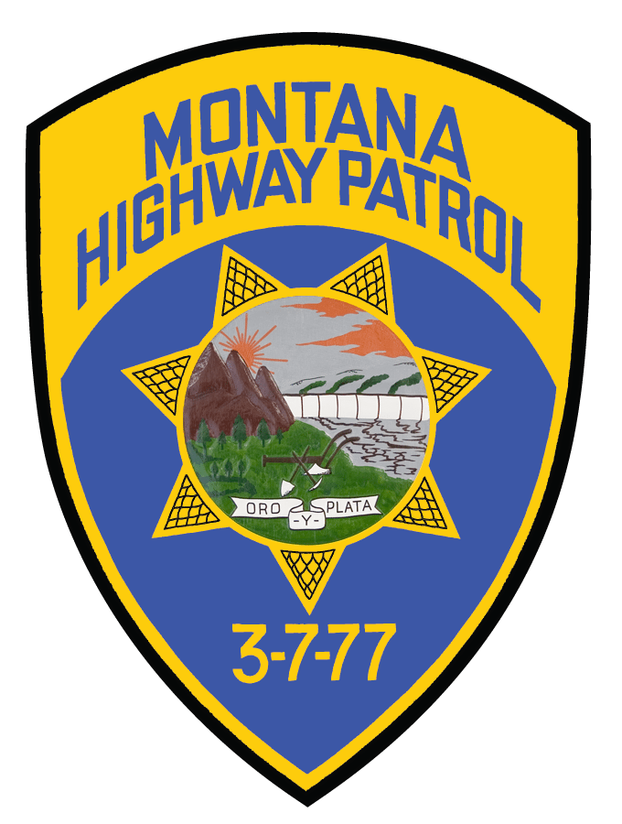

Sgt. Alex Betz, TIM Training Program Coordinator/Chief Instructor
Detachment 322 Commander
MT Highway Patrol
Helena MT, 59601
(406)475-0712
abetz@mt.gov

BASIC TRAINING

This 4-hour class is available to all disciplines of emergency responders and covers building teams who can work together in a coordinated manner, from the moment the first emergency call is made. You will learn the correct deployment of response vehicles and equipment, how to create a safe work area using traffic control devices, and techniques to speed up accident clearance with an emphasis on reducing the number of struck-by and deaths of roadway workers and responders, reducing secondary crashes, reducing on-scene times of responders of roadway.

**POST credit for law enforcement** **Continuing Education available**

TRAIN-THE-TRAINER
This 16-hour intensive course includes interactive training with case studies, tabletop role-playing scenarios, and field practicum. Train-the-Trainer builds a team of trainers within agencies, regions and throughout the state. They, in turn, train their colleagues using this innovative curriculum for correct deployment of response vehicles and equipment, how to create a safe work area using traffic control devices, and techniques to speed up accident clearance with an emphasis on reducing the number of struck-by and deaths of roadway workers and responders, reducing secondary crashes, reducing on-scene times of responders of roadway incidents.

**POST credit for law enforcement** **Continuing Education available**

Web-based Training:
- Emergency Responder Safety Institute-Free On-Line Training
(Free online responder safety training (24 individual modules)
- National Highway Institute Web-based TIM Responder Training (Free - Course #133126)

