Biofilm Annular Reactor Motor and Motor Controller Redesign
Stephen Pedersen and Bryan Warwood, BioSurface Technologies Corporation, Bozeman, MT

Project Goal: This capstone design project is to redesign an already existing product to meet the design criteria. At the completion of this project, BioSurface Technologies Corporation expects a working prototype of the new device, as well as all necessary documentation to sufficiently recreate the prototype without additional instruction (i.e. technical drawings, measurements, materials, suppliers, programming, etc.).

Project Description: The Biofilm Annular Reactor (BAR) by BioSurface Technologies Corporation (BST) has been a key product sold by BST for many years. It was the first reactor designed and built by the company, and little has changed in the design since it was first sold. This reactor is sold and distributed all over the world to both industry and academia and is used to grow biofilms resembling those found on the inside of large-diameter piping systems (sewage, drinking water, oil, etc).
The reactor consists of a polycarbonate interior cylinder which contains sample surfaces on which to grow biofilms (known as slide coupons). This inner cylinder rotates inside an outer, glass cylinder which contains the growth media or fluid (usually water). The rotational movement of the sample surface inside the layer of water produces similar fluid hydrodynamic shear and flow rates to the pipelines it is designed to mimic.
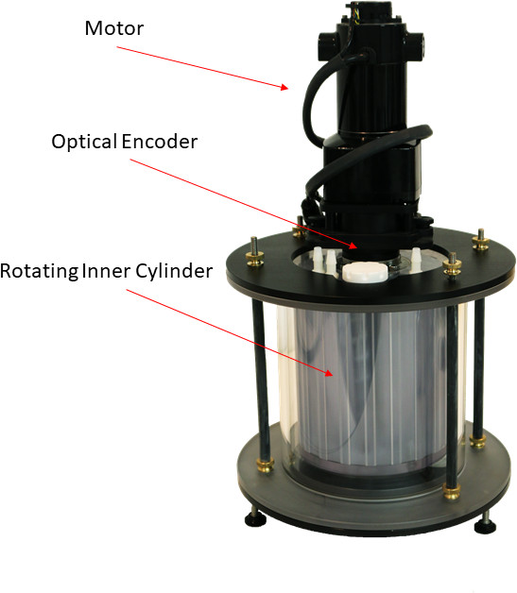

Figure 1: Annular Reactor with attached motor.
The inner cylinder is rotated using a 1/29HP, DC, gear motor. This motor is controlled by an external motor control box. An optical encoder is used to measure rotational speed of the motor and displays this number in real time using a digital display. A dial POT is used to adjust RPMs accordingly.

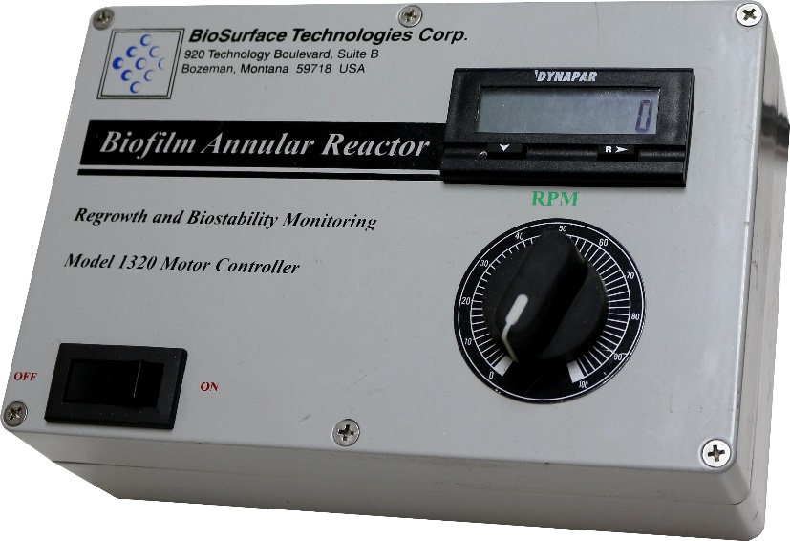

Figure 2: Motor control box for the Annular Reactor.

In recent years, the motor and motor control box have become increasingly expensive to build due to rising part cost as older parts become unavailable. The original design, though it still works well for this application, is becoming outdated. The result of this project will be to have a new motor and motor controller which uses parts that are easily available or manufactured, and which match or exceed all important specifications of the current model.

Prototype Budget: A budget for the construction of the prototype design will be provided by BST if all primary specifications have been met during the design phase and will not exceed USD$2,500.00 unless circumstances require additional expenses and it is deemed a worthwhile endeavor by BST. An expense report is expected upon delivery of the prototype to ensure appropriate spending.

Design Specifications: For this project to be considered a success, all primary design specifications must be met, and all secondary specifications must be considered and addressed.
Primary Specifications
- Motor must have sufficient torque to start up and continuously operate under normal operating conditions of the current reactor design
- Motor must accurately reach a rotational speed of 500 RPM, and be controllable at 1 RPM increments to within 2.5% of current speed
- Motor must be rated for long-term, continuous operation of at least 6 months
- System must be entirely enclosed in a single unit, which can be easily replaced
- Design must accommodate the use of both 110v and 220v power
- Total part cost must be at or below USD$1,000.00, and total assembly time must be below 6 work-hours
- System must include a display for RPM readout
Secondary Specifications
- Calculation of required torque and power must be included with the final design
- Motor must be quiet and unobtrusive in a normal scientific laboratory
- Total part cost must be at or below USD$500.00, and total assembly time must be below 3 work-hours
- System must not exceed 5kg in weight
- System must meet CE certification criteria
- System must prominently display company name, logo, and contact information

Non-disclosure Agreement Requirement: All students, faculty, and staff involved with the design and construction of a prototype device for BioSurface Technologies Corporation will be required to fill out and submit a non-disclosure agreement.

We look forward to working with a diverse team of engineering students to create a high quality, long-lasting product design, and are willing to provide any necessary support to help accomplish this goal.

Contact Information:
Stephen Pedersen, Design and Fabrication Engineer III
Email stephenp@biofilms.biz | Tel 406.585.2812 | Web www.biofilms.biz
BioSurface Technologies Corp. | 421 W Griffin Dr #2, Bozeman, MT, USA

