UAV Drone Competition

Design and develop a remote-controlled drone equipped to locate and pick up randomly located spherical objects, and return the object to a known location. The drone will then repeat the process.

Specifications
Design: The drone may include off-the-shelf components – including motors, rotors, and electronic controls, but the primary structure must consist of student-designed components. Additionally the pickup and release system must be an original student design. The pickup system must accommodate grasping a spherical target object of diameter 1.680 inches (42.67 mm). The weight of the sphere will not exceed 1.620 ounces (45.93 g).
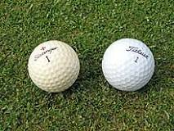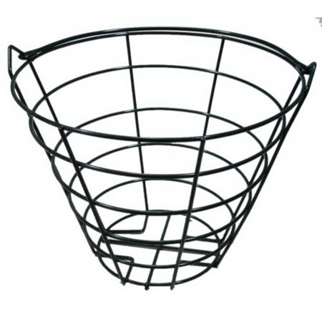
Figure 1. Drone Competition Target Objects Figure 2. Designated Receptacle

Competition
- The Competition will be scheduled during the last week of classes, weather permitting. Competition goal is to identify and retrieve target objects (golf balls) to the receptacle (i.e. bucket.) The drone team retrieving the largest number of target objects while conforming to rules and regulations will be declared the winner.
- The event will begin with each drone at rest in the designated flying area. At the starting signal the participants will launch their drones, seek out and pick up target objects, and return them to their team’s designated receptacle.
- The competition will consist of three ‘rounds’ of 10 minutes each, separated by 5-minute breaks. Target objects will be randomly distributed by volunteers prior to the event, over an area approximately 100 yards square, consisting of a moderately flat gravel or asphalt surface.
- At the end of each round a signal will be sounded. At the signal, drones are to be flown in a vertically descending trajectory and landed as quickly as possible. (No target drops after signal sounds.) Once all drones are landed, the 5-minute intermission begins: During intermission, teams may approach drones to change batteries, perform service or repair, etc.
- If a drone is unable to return to duty at the end of the 5-minute intermission it must be brought back to the pilot area/safety zone for any further work while the competition resumes. No target objects may be manually returned with a drone in such a case. The repaired drone may be returned to the ongoing competition when ready, and does not need to wait until the subsequent round.
- If a drone crashes or becomes non-flightworthy during a round, no efforts to retrieve may proceed until the designated intermission time.
- In the event of a tie at the end of the 3rd round, the competitors will enter a ‘sudden death’ round where the first who retrieves a target object will be declared the winner.
Other rules:
Total cost not to exceed $500/team, not including re-purposed components.
Each member of each 3-person team must pilot their teams drone during one round of competition
No radio jamming or intentional electronic interference permitted.
No weapons or intentional physical drone-on-drone contact permitted.

Proposed Competition Location
Pending approval by MSU authorities, the competition will occur on MSU property located
off of Kelly Canyon Road, as defined on the images below.
