Dual Filament Mixing Nozzle for Tailored Material Properties – Improvements
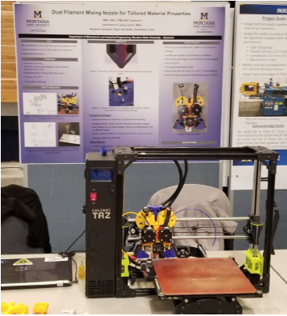
3-D printing is an additive manufacturing process that is being widely applied in a variety of engineering disciplines and applications including automotive, aerospace, biotechnology/medicine, and rapid prototyping. A common 3-D printing technique is fused deposition modeling (FDM), also often called fused filament fabrication (FFF). This fabrication method involves heating a filament of plastic that softens upon heating (thermoplastic) and depositing this molten material layer by layer in a computer-defined pattern. Our group works with composite filaments comprised of bio-derived and biodegradable thermoplastics mixed with chopped short natural fibers. We would like to be able to mix two filaments: (1) neat thermoplastic with (2) composite, to dynamically tailor the material properties during a print. We would also like to be able to (3) use dissolvable filament to print more complicated geometries.
Project Goal: To re-engineer the heat dissipation system used in last year’s print head, taking elements of the current head that were developed last year. To add the functionality to print a separate water-soluble filament to the 3D print head. Realize the ability to mix two filaments with the percentage (feed rate) of each filament controlled by software.
Requirements:
- Interface with LulzBot Taz6 3D printer
- Interface with Cura software (or another means of reliably interfacing with printer)
  - There will be coding with G-Code
  - The coding is part of the way there, however there are still challenges – having a good coder on the project will be helpful
- Head must be able to mix two 2.85mm filaments with flexibility to accommodate 1.75 mm
- Head should have the ability to also print dissolvable filament separately from the composite filament
- Temperature control for heating up to 300°C
- Print with a specified ratio of each filament. Desirable: calibration between feed rate and the percent of each filament represented in the final mixed volume of material.
Budget: $500, You will have access to last year’s team design files.

