The Flapperatus: A High-Frequency Rotation Stage to Replicate Insect Flapping Kinematics

Overview: Insects are extremely dexterous fliers due to the unsteady aerodynamic mechanisms made possible by flapping wings. Consequently, flapping wing insects are often considered design paradigms for centimeter-scale micro air vehicles. However, the structural and aero mechanics of flapping, flexible wings are not well understood. This is in part because biological organisms are challenging to work with; flapping kinematics are not repeatable, physiological conditions affect flight performance and natural variation amongst insects makes trends difficult to understand. Therefore, the scope of this project is to conceptualize, design and fabricate a high-frequency three-axis rotation stage capable of emulating the flapping kinematics are wingbeat frequency of a large moth. This device will facilitate state-of-the-art research in flapping wing aero and structural mechanics.

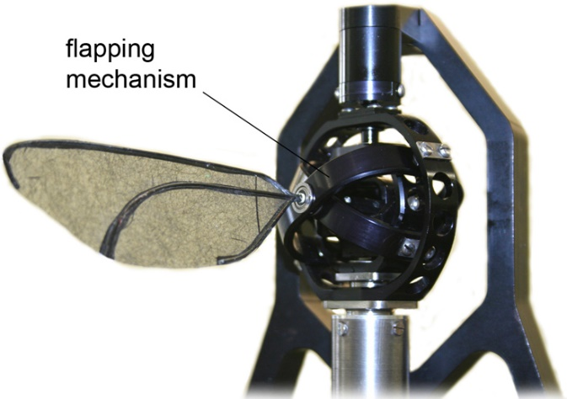
Figure 1. Benchtop robotic flapping mechanism. Photo credit: Royal Veterinary College of London

Project: A benchtop robotic mechanism capable of emulating insect flapping kinematics will be designed and constructed through this project. The flapping mechanism must have three rotational degrees of freedom (pitch/roll/yaw) and must be able to flap a small wing (5 cm wingspan, 1 g) as fast as 25 Hz for rotation amplitudes of 1 radian. This is extremely fast for a mechanical device. Each degree of freedom must be controlled independently via closed-loop servomotors. The team must deliver not only the device, but also a graphical user interface where the user specifies flapping speed as well as rotation phases and amplitudes.

