CHAPTER ONE

TITLE IN ALL CAPS

First Level Heading

Second Level Headings: If Heading is too Long,
Wrap to the Next Line, Single Spaced
The Styles in the Home tab are set for headings; long quotes; and figure/table captions (above and below). Watch the formatting tutorial videos for information on how using these styles will shortcut your formatting work and improve accessibility. There is also a Formatting FAQ to help with various formatting tasks.

Third Level Heading.
If you have any questions, please reach out to the Formatting Advisor at gradformatting@montana.edu.

Style Formats

Tables and Figures
With The Graduate School’s template, you can use the format styles for the chapter titles; first, second, and third level headings; long quotes; and figure/table captions (above and below).
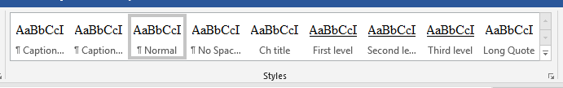
Figure 1. A screenshot of the format styles. Highlight your text and apply a style. There is a “caption above” or “caption below” format style for figure/table captions.
You text would continue with a triple space between the caption and the body text. Captions can be above or below – just be consistent. Figures and tables fit inside the page margin requirements.
To use the third level style heading, put heading on separate line, apply Third level, move your cursor to the end of the heading and click “Ctrl+Alt+Enter”

More Figure/Table Examples
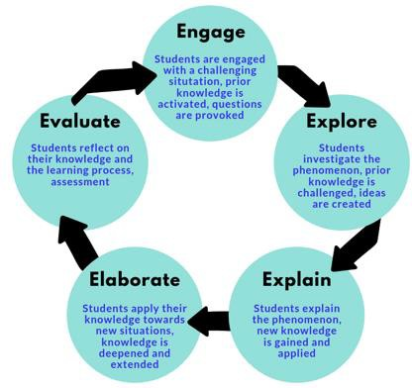
Figure 2. Overview of the 5E learning cycle model (Adapted from Knowledge Quest).
There should be a triple space between figure/title captions. Be sure to add Alt Text to tables and figures.

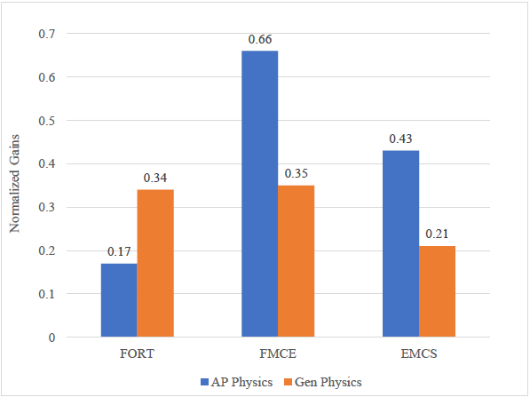
Figure 3. Normalized gains for concept mastery and scientific reasoning, (N=10). Note. FORT: Montana State University formal reasoning test. FMCE: Force and motion conceptual evaluation. EMCS: Energy and momentum conceptual survey.
Table 1. Data Triangulation Matrix.
Watershed | Data Source #1 | Data Source #2 | Data Source #3
How does the incorporation of an anchoring phenomenon to drive  instruction via the 5E Learning Cycle affect student growth | Pre- and Post- Tests | Lab Quiz Results | Formative Assessments via CATs
What affect does the incorporation of an anchoring phenomenon to drive  instruction via the 5E Learning Cycle have on student engagement? | Engagement Tally Sheet | Student Surveys and Interviews
How does the incorporation of an anchoring phenomenon to drive instruction via the 5E Learning Cycle affect students’ attitudes toward  science? | TOSRA Survey | Student Surveys and Interviews

REFERENCES CITED

Start references on the first line of the page. If you do not need a divider page, your REFERENCES CITED title would sit on the top line of the page.

All references should be single spaced with a double space between references.

Use hanging indentation as modeled below. A YouTube search for hanging indentations for your specific version of Word will get you the directions.

References should precede appendices unless appendix material is included in the references section.

Bobrowsky, B. (2018). How can I make science fun and have students learn more by using phenomenon-based learning? Science and Children, 56(2), 70-73.

German, S. (2018). Teaching with everyday phenomena. Science Scope, 41(6), 32-34.
Dictionary by Merriam-Webster: America's most-trusted online dictionary. (n.d.). https://www.merriam-webster.com/

NGSS Lead States. (2013). Next Generation Science Standards: For states, by states. The National Academies Press.

NGSS Lead States. (2013). Next Generation Science Standards: For states, by states (insert specific section title(s) being used if not referring to entirety of the NGSS). http://www.nextgenscience.org/

The Wonder of Science. (n.d.). https://thewonderofscience.com/

APPENDICES

APPENDIX A

APPENDIX TITLE IN ALL CAPS (TRIPLE SPACE BELOW APPENDIX A)

APPENDIX B

APPENDIX TITLE IN ALL CAPS (TRIPLE SPACE BELOW APPENDIX B)

