**Overview of the Six-Week Course**

**Grant Writing Boot Camp Syllabus**

**Description:** This training is designed to facilitate faculty in the production of a solid, review-ready grant proposal. Participants will benefit from interdisciplinary collegiality, learn grant approaches to different agencies, and have the opportunity to submit proposals for review and comment by grant-successful senior investigators. A team of proposal support personnel will be aligned to the submitters’ individual needs.



**Session Format:** In each two-hour session, participants can expect to interact with grant-successful faculty and staff to learn the skills and insights required to develop competitive grant proposals. The first hour of the session will be devoted to lecture or discussion, and the remaining hour will consist of hands-on participatory writing and workshop activities.

*All sessions will be held in [example] Room XX from 10:00 am–12:00 noon. Bring your laptop or tablet as this classroom offers internet-capable services. Coffee and sustaining snacks will be provided.*

**Group Work:** Participants will be assigned to a small group or partnership and will share their writing progress each week by posting drafts to a shared drive.

**Expected Outcomes:** At the end of the Boot Camp, grant submitters will have gained knowledge of developing narratives and budgets, funding agency and university requirements, and the grant review process. The most significant product of these sessions will be a review-ready grant proposal.

Required Pre-Workshop Activities and Registrations:

1. Register for the SPIN funding database by signing up at <http://spin.infoedglobal.com>
2. Join the Boot Camp shared drive, enter your folder, and complete the Bioform with a brief description of yourself, your research interests/current proposal idea(s), and your goals for Grant Writing Boot Camp. Throughout Boot Camp you will access the folder for weekly course resources and to post drafts for review and edit with your workshop colleagues. See information on each session (below) for dates documents need to be posted.
3. Register for your respective agency application portal (i.e. FastLane for NSF, eRA commons).

Assignments and Expectations:

1. We request that you commit to writing and reading for at least 30 minutes per day in order to make satisfactory progress on your proposal.
2. Expect to complete the fundamental pieces of a federal grant proposal including the project summary, biosketch, project narrative (overview, research strategy, broader impacts, management plan and timeline), and budget. Both NSF and NIH requirements will be addressed as well as other agency and foundation requirements if applicable to the group.
3. Participants should expect to have a review-ready draft proposal by [week after Boot Camp’s last session].

**Session One: FINDING FUNDING**

Welcome, introductions, and an overview of Boot Camp’s session format and the grant writing process. Participants will present a short elevator speech on their project and any interdisciplinary interests. Presenters will give an overview of the grant submission process (see next page), discuss to how to fit grant writing into your workload, fitting your research to a funding source, and guide them through a hands-on experience in researching external funding searches.

**Presenters:** Director, Center for Faculty Excellence; Director, Office of Sponsored Programs (OSP)

In-Class Work:

* Access SPIN and start a funding search

Out-of-Class Work:

* Run a funding search in the SPIN system and locate three promising opportunities.
* Save the Request for Proposals or Opportunity Description and post these documents to the group’s shared drive; also bring a printout of your primary choice to the next class.
* Review R. Porter (2015) *Six Critical Questions to Launch a Successful Grant Proposal.* NCURA Magazine May/June.
* Review Zerzan, J. T., Hess, R., Schur, E., Phillips, R. S., & Rigotti, N. (2009). *Making the most of mentors: A guide for mentees*. Academic Medicine, 84(1), 140-144.

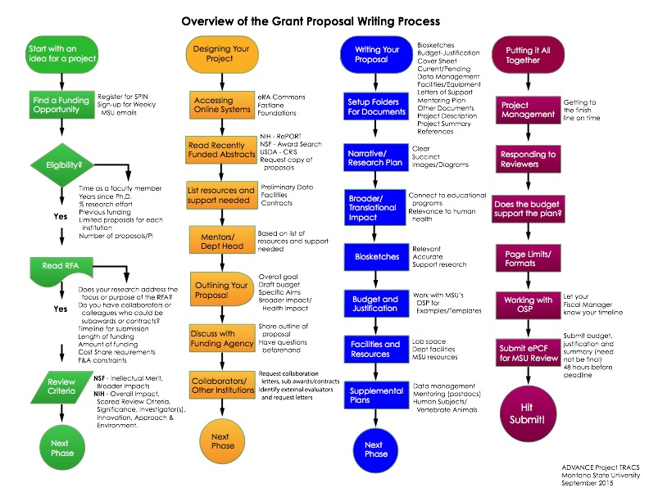

**Session Two: STARTING THE GRANT WRITING PROCESS**

This session goes through the process of reading a funding announcement, introduces you to the MSU Office of Sponsored Programs, and talks about the importance of mentors to the grant writing process.

**Presenters:** Director and a senior fiscal officer, OSP; senior grant-successful faculty.

Assignment(s) Due:

* Save the Request for Proposals or Opportunity Description and post these documents to the group’s shared drive; also bring a printout of your primary choice to the next class.

In-Class Work:

* Based on your RFA (or equivalent) make a list of the resources, support, and assistance you need from your mentor or department.
* Discuss any barriers you anticipate in getting these needs met, and how you will deal with those barriers.

Out-of-Class Work:

* Write a one-page letter to your department head or prospective mentor that describes your project and the specific support you will require. Send it and be prepared to share your experience.
* Update your CV if needed to include any new grant, publication, teaching, service, or other significant activity and convert to a BioSketch (either NIH or NSF format).
* Register for the funding agency you have targeted (FastLane, eRA commons, etc) and register access with OSP before the next session.

**Session Three: DESIGNING YOUR PROJECT**

This session introduces participants to the scope of documents required for a grant submission in addition to the project description, giving examples of projects summaries and specific aims. Experienced faculty members will talk about what goes into a successful proposal and the potential for pre-submission interaction with program officers, an often-overlooked yet critical part of a successful grant submission.

**Presenters:** Senior faculty with experience with looking at grants from the reviewer’s point-of-view, Program Officer from NSF/NIH

Assignment(s) Due:

* Be prepared to share your experience reaching out to your department head or mentor
* Bring Biosketch for feedback.

Out-of-Class Work:

* Complete a 1–2 page draft of your project summary and specific aims with notes related to your next steps and post to shared drive; work on these steps if possible.
* Reach out to your Funding Agency contact to setup a time to discuss your proposal
* Develop questions for your Funding Agency contact
* Review R. Porter (2007) *Why Academics Have a Hard Time Writing Good Grant Proposals.* The Journal of Research Administration. Volume XXXVIII, Number 2, 37.
* Review Chronicle of Higher Education Article: *“What to Say- and Not to Say- to Program Officers”*

**Session Four: ASSEMBLING YOUR PROPOSAL TEAM**

In this session, participants will meet representatives from MSU groups that can help with advice and template for writing a successful grant, including tackling the illusive “Broader Impact” section.

**Presenters:** Representatives from University resources such as the library and research centers that can help faculty with their proposals.

Assignment(s) Due:

* Complete a 1–2 page draft of your project summary and specific aims

In-class Work:

* Discuss project summary and specific aims

Out-of-Class Work:

* Revise project summary and specific aims and post to Dropbox
* Review materials on Merit Review Process
* Discuss your ideas with your funding agency contact
* Review *“8 Concepts Every Grant Writer Must Master For A Successful Proposal!”*

**Session Five: YOUR PROPOSAL NARRATIVE**

Proposals typically involve a number of pieces that ultimately “communicate” with the main proposal narrative. As the blueprint for the research project, it is critical that this central piece clearly and concisely describes the project overview, its aims and objectives, and the methods and plan of work. Part of that narrative is incorporating collaborators, co-PIs and other institutions. By mastering the proposal narrative, proposers can move on to the remaining pieces with relative ease.

**Presenters:** Grant-successful faculty with experience in crafting narratives for STEM/SBS grant proposals and working with co-PIs and other institutions.

Assignment(s) Due:

* Bring your revised project summary and specific aims
* Be prepared to discuss your conversation with your Funding Agency contact

Out-of-Class Work:

* Review NSF YouTube channel for ideas about innovation and the “wow” factor
* Draft your main narrative (5 pages minimum) and post in your shared drive folder for next session.

**Session Six: THE SUBMISSION PROCESS AND NEXT STEPS**

Plan for official submission of your proposal and strategize the remaining pieces – including budget and budget narrative.

**Presenters:** Grant-successful faculty to talk about project management and the final submission process.

Assignment(s) Due:

* Bring your draft project narrative to discuss in groups

In-class Work:

* Discuss draft project narrative
* Draft budget and budget narrative

Out-of-Class Work:

* Revise full project narrative and upload to your shared drive in 2 weeks for review
* Make appointments with grant writing staff to help in the final submission of your grant.