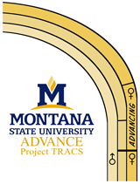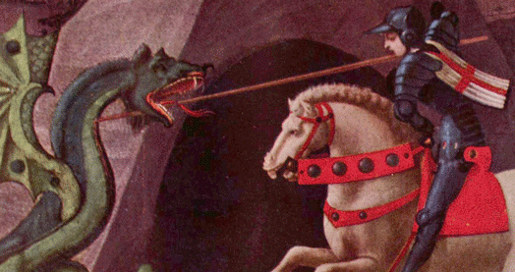

Strong coffee and healthy snacks (thanks, CFE!) will be served each week in a supportive, technology-facilitated space for our work.   
**For more information on our events see the ADVANCE Project TRACS website:** [www.montana.edu/nsfadvance](http://www.montana.edu/nsfadvance)

**(10/10) Session Four:   
ASSEMBLING YOUR PROPOSAL TEAM**

Explore the potential for pre-submission interaction with mentors and program officers, an often-overlooked yet critical part of a successful grant submission, as well as the ins and outs of working with other institutions and co-PIs, and the additional administrative requirements that compound these challenges, at least initially.

**(10/17) Session Five:   
THE PROPOSAL NARRATIVE**

As the blueprint for a research project, the proposal narrative   
must clearly and concisely describe the project overview, its aims and objectives, and the methods and plan of work. The workshop format of this session will prepare participants to clearly identify what works in proposals, and what does not, by analyzing a number of proposal narratives.

**(10/24) Session Six: THE NEXT STEPS**

Plan for official submission of your proposal and strategize   
the remaining pieces with the assistance of personnel relevant   
to your team. Course follow up includes staff   
and campus resource assistance with your   
next steps and support from grant-writing   
colleagues. Yes, you can slay that dragon!

**(9/19) Session One:   
FINDING FUNDING**

Welcome, introductions, and an overview of Boot Camp’s session format. Participants will present a short elevator speech on their project and any interdisciplinary interests. Presenters will introduce participants to funding resources at MSU, and guide them through a hands-on experience in researching external funding searches.

**(9/26) Session Two:   
THE GRANT WRITING PROCESS**

Need-to-know information on the grant submission process, how major agencies operate, how other funding sources operate, how grants are reviewed, how grants are received and administrated, how to time-manage grant writing into your workload, and what   
to expect overall.

**(10/3) Session Three:   
THE SUBMISSION PROCESS**

Grasp the scope of documents required for a grant submission, learn how to access guide information from agencies to organize and prepare all required documents, and campus resources available to support you in completing documentation.

## ADVANCE Project TRACS’ Grant Writing Boot Camp is designed to help grant-interested faculty produce a quality, review-ready proposal in just six weeks, with valuable information and support from grant-successful facilitators.

six Fridays! from 10:00 am to 12:00 noon • September 19 – October 24

## All meetings in Animal BioScience 145 • Limited Enrollment • Great Experience!

## Reserve your space by September 10 – Go to: www.montana.edu/nsfadvance

Slay the dragon!

**Grant Writing   
Boot Camp**

**Fall, 2014**

ADVANCE Project TRACS, Center for Faculty Excellence, Office of Sponsored Programs, Vice President for Research & INBRE Present:

Or just the grant proposal. Yes, let’s start with that...