

Enter PI's Name’s

Laboratory Biosafety Manual

Building and Lab Room Number(s): Bldg Name and Rm #(s)

Biosafety Containment Level: Choose an item.

IBC Protocol Number(s): Enter Number(s)

IACUC Protocol Number(s) (if applicable): Enter Number(s) or NA

Date: Click or tap to enter a date.

This manual must be reviewed annually or sooner when laboratory scope of work has changed.

Manual Template Reviewed by IBC: February 14, 2024

# Introduction

This manual is provided to assist Principal Investigators (PIs) in the development of a *laboratory-specific* biosafety manual with instructions to safely handle and manipulate biological agents in the laboratory.

The PI is responsible for:

* Completing this Manual
  + Title Page
  + Page 4 contact information table
  + Page 5 emergency equipment locations
  + Page 6 additional PPE requirements
  + Page 13 description of decontamination procedures
  + Page 16 list all biological agents present in the laboratory
  + Page 17 complete exposure risk section
* Including background information for each agent (see [MSU Pathogen Safety Data Sheets](https://www.montana.edu/orc/biosafety/psds/index.html) (PSDS)).
* Making protocols (IBC, IACUC, etc.) and experimental SOPs available to lab staff.
* Writing an exposure risk assessment.
* Detailing surface decontamination and disinfection procedures.
* Writing standard operating procedures (SOPs) for experiments and specific laboratory procedures.

Appendix A: Laboratory staff must be trained and understand the risks associated with the general laboratory. Training dates for the following must be captured on a signature sheet in Appendix A. Signatures may be physical or digital (e.g., DocuSign).

Training items:

* This document.
* All relevant MSU IBC Protocols including:
  + How to access protocols.
  + Biological materials and their hazards (see MSU Pathogen Safety Data Sheet).

Appendix B: MSU Policy requires that the Principal Investigator assures that individuals performing procedures with biohazardous material are adequately trained/experienced to perform those procedures. Activities requiring training include, but are not limited to:

* Understanding the characteristics of biological agents and the risks associated with their work (See MSU Pathogen Safety Data Sheets)
* Aerosol control
* Laboratory practices (e.g., pipetting, vortexing, centrifuging, etc.)
* Personal Protective Equipment (PPE)
* Proper use of biological safety cabinets
* Decontamination procedures
* Waste procedures
* Lab specific Standard Operating Procedures

Appendix C: Any laboratory that directly works with or can be reasonably anticipated to come into contact with human derived materials is required to be trained on the OSHA Bloodborne Standard. Direct work with human derived materials requires an approved IBC protocol, and annual training is captured in the protocol. There are many instances across the MSU campus where researchers may be reasonably anticipated to come into contact with human derived materials. Training must be documented in Appendix C for any other scenario that researchers may encounter during their work. These include but are not limited to:

* Shared equipment (e.g., flow cytometers, cell sorters, microscopes, plate readers, etc.)
* Shared flexible lab space (e.g., bench space, computers, etc.)

If any laboratory determines the need to deviate from standard work practices outlined herein, then such deviations must be submitted to the BSO in written form with an explanation for approval.

In addition to this manual, PIs and research staff must follow requirements outlined in the [MSU IBC Manual](https://www.montana.edu/orc/biosafety/forms-manuals-regulations/ibc-manual.html), [MSU Biosafety Manual](https://www.montana.edu/orc/biosafety/forms-manuals-regulations/msu-biosafety-manual.html), [Biosafety in Microbiological and Biomedical Laboratories (BMBL) 6th Edition](https://www.cdc.gov/labs/BMBL.html), and the [NIH Guidelines for Research Involving Recombinant or Synthetic Nucleic Acid Molecules (NIH Guidelines)](https://osp.od.nih.gov/wp-content/uploads/NIH_Guidelines.pdf).

Prior to working in the lab, personnel must read this entire manual and all relevant IBC Protocols. Staff must sign the signature sheet indicating they have read and understand all items and have had the opportunity to ask questions. The signature page is found at the end of this manual in Appendix A.

Contents

Introduction 2

Responsibilities 5

Principal Investigator (PI) 5

Laboratory Staff/Students 5

Emergency Information 5

Emergency Contacts 5

Fire Alarms/Extinguishers 6

Eyewash and Emergency Showers 6

Standard Operating Procedures (SOPs) 6

Standard Microbiological Practices and Guidelines 6

Hygiene and Housekeeping 6

Laboratory Specific SOPs 7

Personal Protective Equipment (PPE) 7

Injuries 7

Needle Stick/Animal Bite/Cut Procedures 8

Biological Spills 8

Biological Spill Kit 8

Biological Waste Disposal 11

Liquid Biohazardous Waste: 11

Solid Biohazardous Waste: 11

Sharps Biohazardous Waste: 11

Decontamination 14

Training 15

Agent-Specific Training 15

Training Requirements: 15

Training Options 16

Biohazard Warning Signs and Postings 16

Biological Safety Cabinet (BSC) 16

Biological Agents and Exposure Risks 17

List of Biological Agents 17

Exposure Risks 18

Agent(s)-Specific Pathogen Safety Data Sheets 18

Appendix A: Laboratory Specific Biosafety Manual Staff Signature Page 19

Appendix B: Laboratory Training Documentation – Individual Qualification 20

Appendix C: OSHA Bloodborne Pathogens 22

# Responsibilities

## Principal Investigator (PI)

The PI has the primary responsibility for ensuring that the laboratory is safe and is responsible for the safe use of biological materials in the lab.

In addition, the PI is responsible for the following:

* Limit personnel, student, and visitor exposure to hazards to the lowest practical level.
* Be familiar with the required medical surveillance for each type of biological agent used in the laboratory.
* Develop written lab-specific safety procedures and train personnel on them.
* Maintain documentation of training in this Laboratory Specific Biosafety Manual.
* Provide the appropriate Personal Protective Equipment (PPE) and instructions on proper use.
* Ensure all forms of waste are properly disposed of.
* Report spills, exposures, or incidents to the Biosafety Officer.

## Laboratory Staff/Students

* Complete all required training before conducting any lab activity.
* Knowledge of the biological agents and procedures used in the laboratory.
* Follow approved lab procedures and safety guidelines.
* Know emergency procedures.
* Report any unsafe conditions to the PI and/or the Biosafety Officer.
* Utilize appropriate lab equipment and containment facilities.

# Emergency Information

## Emergency Contacts

|  |  |
| --- | --- |
| **Principal Investigator:** | **First, Last** |
| Lab Location: | Lab Location |
| Office Phone: | Office Phone |
| Cell Phone: | Enter number |
| **Secondary Contact** | **First, Last** |
| Office Phone: | Office Phone |
| Cell Phone: | Enter number |
| **Biosafety Officer** | **Amy Robison** |
| Office Phone: | 406-994-6733 |
| Cell Phone: | 406-451-3511 |
| **Chemical Safety Officer** | **Ryan Brickman** |
| Office Phone: | 406-994-7760 |
| **MSU Work Control** | **Building Emergencies** |
|  | 406-994-2107 |

In the event of a medical emergency, call 911.

If there is a fire or explosion immediately pull the fire alarm and evacuate the building. Then call 911 from a safe location.

For building emergencies (e.g., water leak) call MSU Work Control.

If any emergency or spill/exposure occurs in the laboratory, immediately notify the Biosafety Officer and your lab supervisor/PI. Any spills involving Recombinant/Synthetic Nucleic Acid Molecules (r/sNA) must be reported to the Biosafety Officer.

## Fire Alarms/Extinguishers

Locations of fire pull stations: Enter locations

Locations of fire extinguishers: Enter locations

Know the location of each of these and identify the location of the extinguisher closest to your lab bench. If the fire alarm sounds, leave the building immediately and move away to a safe distance and call 911.

## Eyewash and Emergency Showers

Locations of eyewash stations: Enter locations Person responsible for weekly flush: Enter Name

Locations of emergency shower: Enter locations Person responsible for monthly flush: Enter Name

**Flush and document that eyewash stations are functioning, and water temperature is tepid on a weekly basis.**

In case of biological exposure, proceed to nearest eyewash station. Hold eyelids open with thumb and forefinger and rinse for at least 15 minutes. Wash from outside edges towards the inside to prevent washing back into the eye.

Rinse should be aimed at the inner corner of the eye (near the nose) not directly at the eyeball. “Roll” eyes around and up and down to ensure full rinsing.

Contact lenses (if worn) should be removed as soon as possible. Have another member of the lab call for emergency response immediately. The area around the eye wash station must always remain clear.

# Standard Operating Procedures (SOPs)

## Standard Microbiological Practices and Guidelines

These refer to the safe laboratory work practices when experimenting with biological agents. For additional information refer to:

* Montana State University Biosafety Manual
* BMBL, 6th ed.
* NIH Guidelines

## Hygiene and Housekeeping

Keep work areas clean and uncluttered to reduce the chance of cross-contamination and inadvertent exposure to biohazards. To avoid ingestion of contaminated material, use a mechanical pipetting device. Food and drink are not permitted in the laboratory. Refrigerators, freezers, microwaves, ice machines, and other equipment must be labeled with biohazard symbols and a notice that no food or drink is permitted. Eat, drink, or apply cosmetics only in designated areas outside the laboratory.

The following must be adhered to by lab staff:

* Wash hands with soap and water after removing gloves, and before leaving the lab.
* Clean work surfaces and decontaminate with the appropriate disinfectant(s) after work and at the end of each day.
* Remove gloves and wash hands before leaving the lab, touching the face, keyboards, cell phones, or control panels.
* Remove lab coats prior to leaving the laboratory. PPE is not to be worn in common areas (including hallways).

## Laboratory Specific SOPs

The purpose of this section is to develop lab specific SOPs. Detailed, step-by step protocols describing entire experiments with materials and methods are not necessary. Staff must be trained on lab specific SOPs prior to performing the work. Appendix B is a training documentation template that can be found at the end of this manual for tracking of SOP training proficiency. Examples of SOPs where safety is emphasized are bulleted below:

* Propagation of viruses/bacteria
* Experiments that require PPE in addition to a lab coat, safety glasses and gloves
* Experiments that require manipulation of a BSL2 agent outside a biosafety cabinet
* How to properly vortex or sonicate a viable agent
* Safety concerning the handling of human or non-human primate cell lines or tissues
* Safety when injecting a research animal with a biological agent
* How to safely centrifuge a sample

**Place copies of SOPs and signature sheets at the end of this manual.**

# Personal Protective Equipment (PPE)

The following PPE must be worn when working with biological agents in the laboratory:

* Lab coat
* Disposable gloves (nitrile or latex)
* Safety glasses

NOTE: Personal prescription glasses are not considered safety glasses. Staff must wear ANSI Z87.1 standard safety glasses over top of personal glasses or obtain prescription safety glasses.

Please check appropriate boxes for additional PPE that is required:

**Safety glasses N95 Respirator PAPR Shoe covers**

**Face shield Surgical mask Medical scrubs**

**Hair net No Additional PPE**

#### PPE Considerations

* Remove rings or other jewelry that could puncture gloves.
* Wear the appropriate glove for the hazard. Latex or nitrile glove is recommended for working with biological material.
* Do not reuse gloves.

Wear protective eyewear appropriate for the hazard:

* Standard lab safety glasses, goggles, or face shield when performing operations that pose a splash hazard.
* Always wear safety glasses, a lab coat, and thermal gloves when opening a hot autoclave to prevent steam burns.

# Injuries

Injury to an individual in the laboratory (i.e., needle stick, cut, biological agent exposure incident, etc.):

1. Immediately stop work and move to a safe area. If relevant stop all work in the lab e.g. Spill or aerosol release.
2. If the injury is a Medical Emergency call 911.
3. Flush affected area with soap and water for 15 minutes.
4. Secure all infectious materials.
5. Notify the PI and Biosafety Officer at x6733 or University Police by dialing 911 after working hours.
6. Use the nearest First Aid Kit located in the laboratory.
7. Seek medical treatment. Montana State University offers occupational health via the preferred locations below. Or you may seek initial treatment at a medical professional of your choice.
   1. **During business hours (8AM-6PM Monday through Friday; 9AM-5PM Saturday and Sunday):**
      1. Bridger Orthopedic West - Occupational Health & Urgent Care 3400 Laramie Dr., Bozeman, MT; 406-587-0340
   2. **After business hours (between 6 PM and 8 AM, and on weekends):**
      1. Bozeman Deaconess Hospital Emergency Room 915 Highland Blvd, Bozeman, MT
8. Complete the [First Report of Injury Form](https://firstreportinjury.mus.edu/) documenting the route of exposure and the circumstances under which the incident occurred.

## Needle Stick/Animal Bite/Cut Procedures

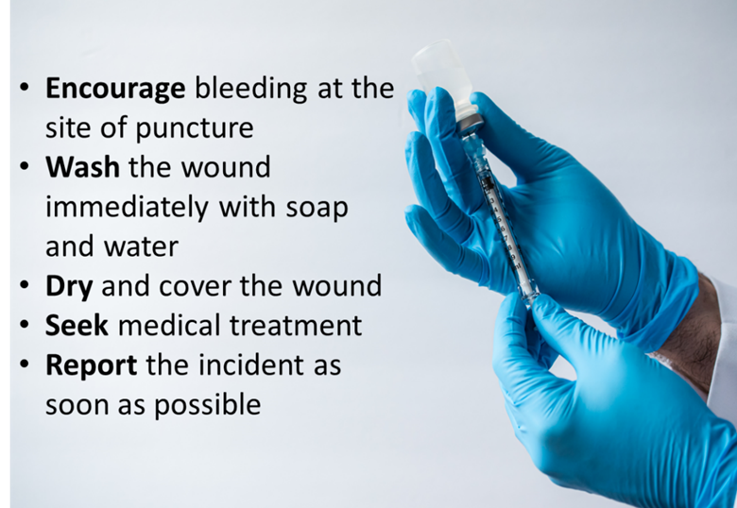

**To report any injury or exposure**: <https://firstreportinjury.mus.edu/>

Montana State University Occupational Health: Safety and Risk Management: 406-994-2711

# Biological Spills

Call the Biosafety Officer when a significant spill occurs.

A significant spill is defined as:

* Spills containing recombinant/synthetic nucleic acids or genetically modified materials
* Spills greater than 5 ml outside primary containment.
* Spills that result in an exposure.
* Spills that present an inhalation hazard.
* Spills that cannot be easily cleaned.
* Spills that endanger people or the environment.

## Biological Spill Kit

The Principal Investigator must ensure the lab has a stocked biological spill kit. All staff must know the location of the spill kit. Label the spill kit storage location.

Note that 1:10 bleach or any other disinfectant must be made fresh at time of spill clean-up. Spill clean-up procedures are outlined below. Print and hang the sign on the next page throughout your laboratory.

#### Spill Kit Contents

Every biosafety laboratory that works with biological agents must have a biohazard spill kit on hand, that is readily accessible and easy to find in the laboratory. It must have appropriate equipment and supplies for managing spills and accidents involving biohazardous materials.

The supplies available in a biohazard spill kit should include, but are not limited to:

* Container to keep all contents in.
* A copy of the Spill Cleanup Procedures.
* PPE - Nitrile disposable gloves, eye protection, lab coat (nearby if not in kit).
* Absorbent material, such as paper towels.
* All-purpose disinfectant, such as normal household bleach (freshly diluted 1:10).
* Tongs/forceps, and/or dustpan and hand broom for cleaning up broken glass or contaminated sharps.
* Sharps waste container (in lab, nearby).
* Autoclavable biohazard waste bags.
* Biohazardous spill warning signs.

All non-disposable items should be autoclavable or compatible with the disinfectant to be used. Most of the listed items, as well as other biohazard spill control items, often are contained within various commercially available biohazardous spill control kits, or you can make your own.



##### **Biological Spill Clean-Up Procedures**

1. Alert others in the laboratory and leave the immediate spill area.
2. Mark the area to prevent others from walking into the spill area.
3. Remove contaminated PPE and dispose of it in biohazard bag—place any reusable PPE into a separate biohazard bag (e.g., lab coat). Autoclave when available.
4. Wash your hands.
5. Don a new lab coat, gloves, and safety glasses.
6. Cover spill with absorbent material (e.g., Pig Pad, paper towels, beach towels).
7. Prepare fresh disinfectant (e.g., 1:10 bleach:water)
8. Carefully pour disinfectant on the spill, working from the outside to the middle.
9. Allow disinfectant to contact spill for no less than 20 minutes.
10. If broken glass, or other sharps (e.g., needle, razor) are part of the spill, use tongs or plastic scoops to pick up absorbent material and sharp material. Dispose of it in a sharps container, or broken glass container.
11. If no sharps are present, dispose of absorbent material in biohazard waste.
12. Remove PPE and wash your hands.
13. Report all spills to your supervisor. All spills involving recombinant/synthetic nucleic acid molecules must be reported to the Biosafety Officer.
14. If a spill is inside BSC- Keep BSC running for at least 15 minutes after the cleanup. Clean spill tray below work area and trough below air intake grill while BSC is running.

##### **Wound/Cut Procedures**

CALL 911 FOR ALL LIFE EMERGENCIES

1. Expose the wound—remove gloves.
2. Express blood from the wound and wash affected area for 5 minutes.
3. Cover the wound with clean gauze or bandage.
4. Seek medical treatment.
5. Complete First Report of Injury form.

To report any injury or exposure: https://firstreportinjury.mus.edu/

|  |  |  |
| --- | --- | --- |
| Bridger Orthopedic West - Occupational Health & Urgent Care | 3400 Laramie Dr., Bozeman, MT | 406-587-0340 |
| Montana State University Occupational Health | Safety and Risk Management | 406-994-2711 |

##### Compliance/Ethics Anonymous Reporting

Call: 855-753-0486 Visit: www.mus.ethicspoint.com

# Biological Waste Disposal

## Liquid Biohazardous Waste:

All liquid biological waste from the lab must be treated prior to disposal. Examples of biological waste include cell lines, recombinant DNA, recombinant proteins, biological agents, and any associated media or buffer.

The procedures below are an example of the steps to treat liquid biohazardous waste generated in the lab:

1. Always wear appropriate PPE such as disposable gloves, lab coat and eye protection (safety glasses or goggles) when working with biohazardous waste.
2. When liquid biohazardous waste is anticipated to be generated, add 100 ml of undiluted bleach into a 1-liter beaker. Label the beaker appropriately.
3. As experiments are performed and completed, pour the biological waste into the beaker with the bleach.
4. When experiments are completed (and if the beaker contents are less than 1-liter) add water to bring the volume to 1-liter. This provides for a 1:10 bleach:waste (0.5% sodium hypochlorite) solution.
5. Let bleach and biological waste solution stand for at least 30 minutes.
6. Dispose of the solution down the lab sink, flushing with excess water or dispose of the solution according to lab SOP.
7. Rinse the beaker thoroughly with water.

## Solid Biohazardous Waste:

The procedures below outline the steps to take to treat solid biohazardous waste generated in the lab:

1. All solid lab waste that has come in contact with biological waste must be treated prior to disposal. Examples include used PPE, paper towels, pipette tips, Petri dishes, pipettes, culture flasks.
2. Always wear appropriate PPE such as disposable gloves, lab coat, and eye protection (safety glasses or goggles) when working with biohazardous waste.
3. Place all potentially contaminated items in biohazardous waste bag.
4. Once the bag is ¾ full close bag and place autoclave tape on the bag.
5. Take the biohazard bag to the autoclave room per MSU transportation guidelines as follows and place in the autoclave.
6. Complete autoclave logbook entry and autoclave biohazardous waste for at least 60 minutes at 121°C.
7. Once the autoclave cycle is complete, ensure cycle has completed properly by checking the autoclave print out/chart recorder for exposure time and temperature. Additionally confirm waste sterilization by observing if the autoclave tape has turned color. Allow sterilized bag to cool in a bin.
8. Place the biohazardous bag into a black garbage bag and dispose of in the dumpster.
9. If the autoclave tape did not turn color and/or the autoclave display indicates errors occurred during operation or an incomplete cycle the load has not been sterilized. Notify the Biosafety Officer or your contracted autoclave technician to have the autoclave serviced.

## Sharps Biohazardous Waste:

The procedures below outline the steps to dispose of sharps:

1. All used sharps must be immediately discarded into a sharps container.
   1. Sharps containers must be kept upright and never filled past the “fill-line” marked on the container.
   2. Put sharps containers in the immediate work area for easy use.
2. When sharps waste has reached the pre-marked “fill-line” of the container close and lock the lid.
3. Contact Safety and Risk Management to have sharps containers picked up and replaced.

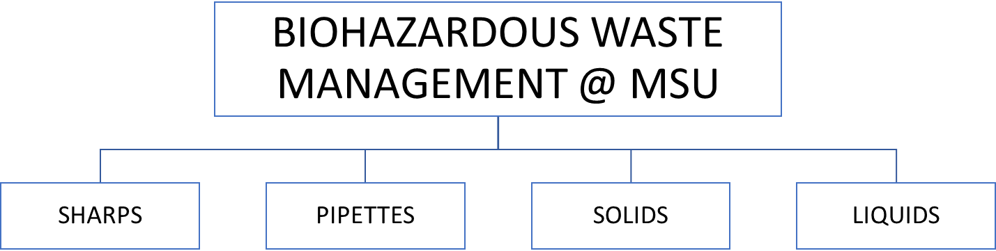

Razor blades, scalpels, lancets, syringes with needles, broken contaminated glass, etc.

Collect in red plastic sharps containers. Do not fill past the fill line. Close tightly when filled.

Dispose of per local regulations. MSU utilizes a [waste pickup form](https://www.montana.edu/srm/forms/waste/pickup-request-biohazard-sharps.html) through Safety and Risk Management.

Serological pipettes and pipette tips

Gather pipettes in an autoclave bag*. Place that bag in a puncture resistant container lined with a biohazard bag.

Label bag with autoclave tape and close loosely. Transport to autoclave in a leak proof container. Place in autoclavable tray.

All laboratory gloves and potentially contaminated solid waste: disposable plasticware, shoe covers, agar plate cultures, paper towels, etc.

Place in a puncture resistant floor bin lined with an autoclave bag*. Do not fill more than 3/4 full.

Autoclave

Human blood, animal blood, tissue culture, body fluids, cultures of genetically modified or biological agents

Place into autoclave safe container, cap loosely, then autoclave

Disinfect with appropriate chemical disinfectant & contact time

Dispose of down laboratory drain and flush with water

*Place autoclaved waste in black plastic bags and take to dumpster.*

* Use only clear or orange autoclave bags. No RED bags.

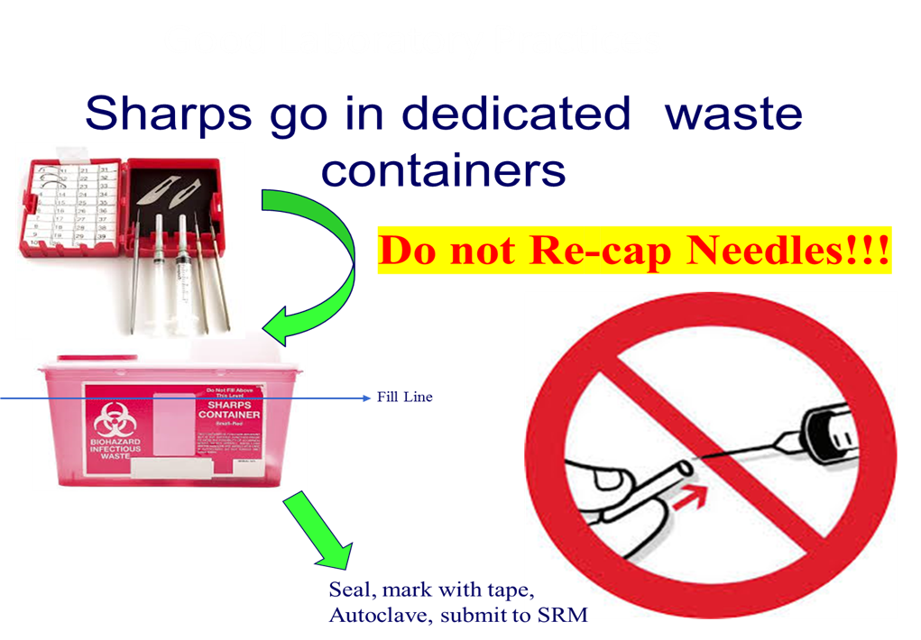

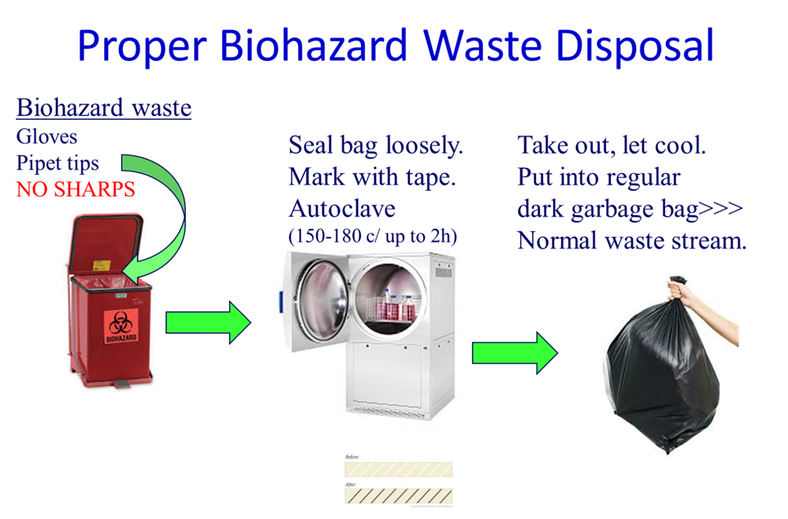

Hazardous Chemical Waste Management

Please contact Safety and Risk Management (SRM) to dispose of hazardous chemical waste materials.

Disposal Guidelines: <https://www.montana.edu/srm/programs/waste.html>

* Hazardous waste must never go down any MSU drain at any time or in any amount.
* Hazardous waste is collected by Safety and Risk Management using the waste pickup request: <https://www.montana.edu/srm/forms/waste/>

Hazardous Materials Contacts:

[Safety & Risk Management](https://www.montana.edu/srm/)

Ryan Brickman, Chemical Safety Officer, x7760

Patrick Ryan, Hazardous Materials Manager, x7803

# Decontamination

Select the reagents (disinfectants) and/or processes used to inactivate biological agent(s) and the method to decontaminate surfaces.

1:10 Bleach:water

70% Ethanol

Accelerated hydrogen peroxide (e.g., Rescue)

5% MicroChem

1% SDS

Iodophor

Virkon

CaviCide

Other

Describe Other

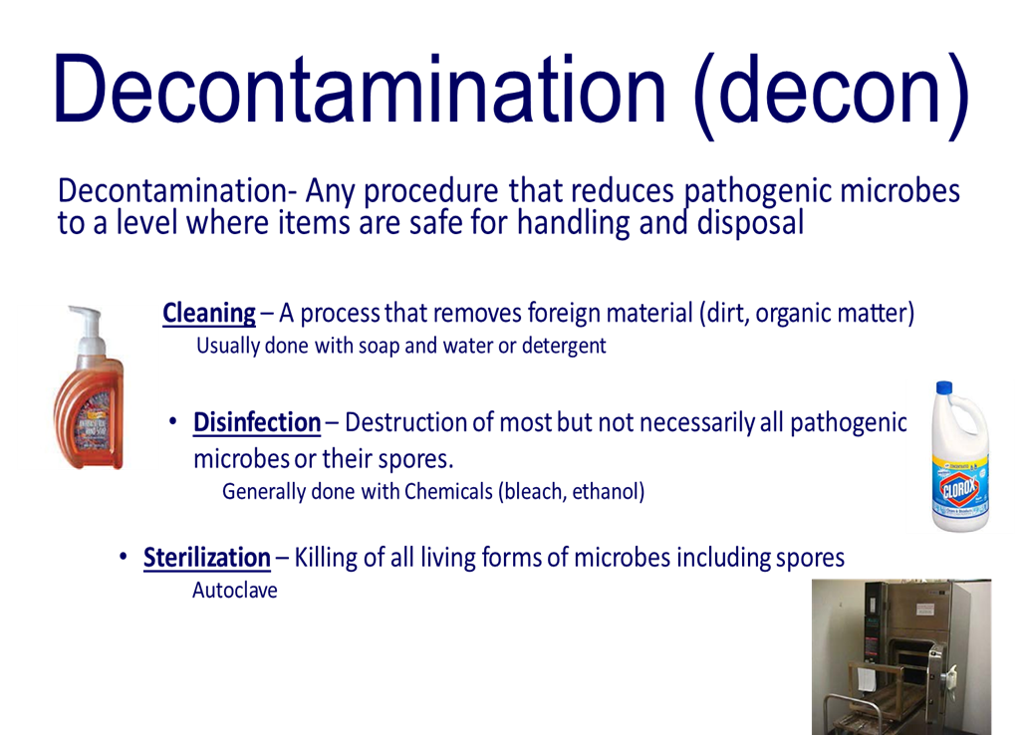

# Training

All laboratory research personnel must take institutional provided training. Training must be documented. Personnel should not initiate research until training is completed. Training can be confirmed via CITI and/or TOPAZ – certificates do not need to be printed and stored with this manual.

Agent-Specific Training

Laboratory personnel are not allowed to work with biological agents until trained by the PI who supervises their work or a designated technical expert. The worker should demonstrate good microbiological skills and an understanding of SOPs prior to being permitted to work with agents.

## Training Requirements:

#### Biosafety Training:

**MSU Biosafety for the Laboratory Worker** – Required for all researchers; *3-year certification*. This course combines general Biosafety for BSL1 and BSL2 Laboratories and the NIH Guidelines for Research Involving Recombinant or Synthetic Nucleic Acids.

**OSHA Bloodborne Pathogens** – Required for any work with human-sourced material; *1-year certification*.

**Plant Research Biosafety** – Required for all plant researchers; *3-year certification.*

**Shipping and Transport of Regulated Materials** – Required for anyone shipping biological or biohazardous material, or anything on dry ice; *2-year certification.*

**Biosafety for the Principal Investigator** – Required for all PIs; *required once.*

#### Chemical Safety Training:

**Hazard Communication** - Required for all employees that work with/around Hazardous Chemicals (cleaning and industrial chemicals, laboratory chemicals, solvents or acids, mechanical fluids, etc.)

## Training Options

In House Training

Biosafety & Hazard Communication Training. This is a 2-hour course that covers MSU Biosafety for the Laboratory Worker, OSHA BBP, and Hazard Communication.

* Details: <https://www.montana.edu/orc/training/biosafety/biosafety-hazard-com-training.html>

#### Online Options

Biosafety: [Collaborative Institutional Training Initiative (CITI Program)](https://www.montana.edu/orc/training/citi/index.html)

Chemical Safety: [SRM Online Training Options](https://www.montana.edu/srm/training/index.html)

# Biohazard Warning Signs and Postings

Each laboratory must clearly display a sign at the entrance door that provides safety information to visitors and service personnel. SRM will provide the signs.

* All areas and laboratories which contain biohazardous agents must be posted with a biohazard sign.
* The sign must have information regarding biosafety level, materials used, entry requirements, exit requirements, emergency contact name and phone number.

Please confirm that your laboratory entry signs are accurate and up to date. If they need correction, please contact Amy Robison (BSO x6733) or Ryan Brickman (CSO x7760).

# Biological Safety Cabinet (BSC)

BSC’s should be positioned in the laboratory away from normal traffic patterns to minimize airflow disruption.

Some work may be done on the open bench by people wearing appropriate protective clothing or gear. Any work that may produce aerosols of infectious materials must be done inside a biological safety cabinet (BSC).

Clean materials should be kept to one side of the work surface, dirty items on the other. Management of workflow within the BSC is crucial to preventing spills and cross-contamination.

Rapid air movement outside the cabinet (caused by co-workers walking past, air supply vents directed across the face of the BSC, fans, doors opening, etc.) will interrupt the air curtain.

The chair should be adjusted so that the lower portion of the sash is even with the worker’s armpits.

Any paper or plastic materials introduced into the BSC should not be allowed to interfere with air flow through the front or rear grilles.

The downward airflow from the supply filter “splits” about one third of the way into the cabinet; in the front third, air moves to the front grille, with the remainder of the air flowing to the rear. This means that aerosol-generating activities should be performed towards the rear of the cabinet to provide further worker protection.

# Biological Agents and Exposure Risks

## List of Biological Agents

List all biological agents used in your laboratory:

* Enter biological agents

## Exposure Risks

Describe how laboratory personnel could be exposed to the agent(s). Include practices that pose potential for exposure, such as those that could create aerosols.

Enter Details.

## Agent(s)-Specific Pathogen Safety Data Sheets

Pathogen Safety Data Sheets can be found at the [MSU Biosafety website](https://www.montana.edu/orc/biosafety/psds/index.html). If needed, [Public Health Agency of Canada (PHAC)](https://www.canada.ca/en/public-health/services/laboratory-biosafety-biosecurity/pathogen-safety-data-sheets-risk-assessment.html) has additional resources. Print applicable PSDS’s and include them in this manual.

# Appendix A: Laboratory Specific Biosafety Manual Staff Signature Page

***I have read, understand, and agree to adhere to the biosafety procedures contained within this document and IBC Protocols. I have been given the opportunity to ask questions of the trainer and have been given the contact information of the Biosafety Officer regarding any additional questions I may have.***

Principal Investigator:

|  |  |  |  |
| --- | --- | --- | --- |
| Typed Name (First Last) | Title | Signature | Date |
|  | Principal Investigator |  |  |

Laboratory Staff:

|  |  |  |  |
| --- | --- | --- | --- |
| Typed Name (First Last) | Title | Signature | Date |
|  |  |  |  |
|  |  |  |  |
|  |  |  |  |
|  |  |  |  |
|  |  |  |  |
|  |  |  |  |
|  |  |  |  |
|  |  |  |  |
|  |  |  |  |
|  |  |  |  |
|  |  |  |  |
|  |  |  |  |
|  |  |  |  |
|  |  |  |  |
|  |  |  |  |
|  |  |  |  |
|  |  |  |  |
|  |  |  |  |
|  |  |  |  |
|  |  |  |  |
|  |  |  |  |
|  |  |  |  |

Appendix B: Laboratory Training Documentation – Individual Qualification

|  |  |
| --- | --- |
| Staff Name: | Principal Investigator/Supervisor: |
| MSU Email: |  |

**BIOSAFETY PROCEDURES AND DOCUMENTATION OF TRAINING/EXPERIENCE**

MSU Policy requires that the Principal Investigator assures that individuals performing procedures with biohazardous material are adequately trained/experienced to perform those procedures. Activities requiring training include, but are not limited to:

* Understanding the characteristics of biological agents and the risks associated with their work (See MSU Pathogen Safety Data Sheets)
* Aerosol control
* Laboratory practices (e.g., pipetting, vortexing, centrifuging, etc.)
* Personal Protective Equipment (PPE)
* Proper use of biological safety cabinets
* Decontamination procedures
* Waste procedures
* Lab specific Standard Operating Procedures

Appropriate training can be obtained by a number of means, including:

* Principle Investigator
* Qualified senior researchers in your lab or other labs
* External training provided by vendors for specialized equipment

List all procedures/topics you have been trained on, the training dates, the trainer, and when proficiency was achieved. Create additional lines/pages as necessary.

| **Procedures/Topic** | **Training Date** | **Trainer Initials** | **Training Date** | **Trainer Initials** | **Training Date** | **Trainer Initials** | **Date Proficiency Achieved** | **Trainer Initials** |
| --- | --- | --- | --- | --- | --- | --- | --- | --- |
|  |  |  |  |  |  |  |  |  |
|  |  |  |  |  |  |  |  |  |
|  |  |  |  |  |  |  |  |  |
|  |  |  |  |  |  |  |  |  |
|  |  |  |  |  |  |  |  |  |
|  |  |  |  |  |  |  |  |  |
|  |  |  |  |  |  |  |  |  |
|  |  |  |  |  |  |  |  |  |
|  |  |  |  |  |  |  |  |  |
|  |  |  |  |  |  |  |  |  |
|  |  |  |  |  |  |  |  |  |
|  |  |  |  |  |  |  |  |  |
|  |  |  |  |  |  |  |  |  |
|  |  |  |  |  |  |  |  |  |
|  |  |  |  |  |  |  |  |  |
|  |  |  |  |  |  |  |  |  |
|  |  |  |  |  |  |  |  |  |
|  |  |  |  |  |  |  |  |  |
|  |  |  |  |  |  |  |  |  |
|  |  |  |  |  |  |  |  |  |
|  |  |  |  |  |  |  |  |  |
|  |  |  |  |  |  |  |  |  |
|  |  |  |  |  |  |  |  |  |
|  |  |  |  |  |  |  |  |  |
|  |  |  |  |  |  |  |  |  |
|  |  |  |  |  |  |  |  |  |
|  |  |  |  |  |  |  |  |  |
|  |  |  |  |  |  |  |  |  |
|  |  |  |  |  |  |  |  |  |

Appendix C: OSHA Bloodborne Pathogens – Required Annually

The standard is a regulation that prescribes safeguards to protect workers against health hazards related to bloodborne pathogens, originally published in 1991. It imposes requirements on employers of workers who may be exposed to blood or other potentially infectious materials (OPIM) such as certain tissues and body fluids.

The Standard requires employers to:

* Establish and implement an [Exposure Control Plan](https://www.montana.edu/orc/biosafety/forms-manuals-regulations/bbp-exposure-control-plan.html) (ECP)
* Update the ECP annually
* Implement the use of universal precautions
* Identify and use engineering controls
* Identify and ensure the use of work practice controls
* Provide personal protective equipment (PPE)
* Make available hepatitis B vaccination to all workers with occupational exposure
* Make available post-exposure evaluation and follow-up to any occupationally exposed worker who experiences an exposure incident
* Use labels and signs to communicate hazards
* Provide information and training to workers
* Maintain worker medical and training records

The definition of a bloodborne pathogen is: “Pathogenic microorganisms that are present in human blood and can cause disease in humans”. The pathogens of primary concern are:

* Human immunodeficiency virus (HIV/AIDS)
* Hepatitis B virus (HBV)
* Hepatitis C virus (HCV)
* Others: Trypanosomes, Plasmodium spp. (Malaria), West Nile Virus, B. burgdorferi (Lyme Disease); other parasites, arboviruses, prions, viruses, and bacteria

Epidemiology, symptoms, and transmission of BBP:

* + HBV: The most common form of hepatitis; a liver disease that initially causes inflammation of the liver and frequently leads to more serious conditions, including cirrhosis and liver cancer. HBV is usually transmitted through mucous membranes or breaks in the skin. After exposure, it can take two to six months for HBV to develop. The initial symptoms of HBV infection are like those of a mild case of the flu: fatigue, stomach pain, loss of appetite and nausea. As the disease progresses, jaundice (yellowing of the skin) and darkened urine will occur. Although there is no cure, vaccination directly after contact (well before symptoms appear) can prevent infection.
  + HCV: An inflammation of the liver; can cause both acute and chronic hepatitis, ranging in severity from mild illness to a serious, lifelong illness including liver cirrhosis and cancer. HCV is a bloodborne virus, and most infections occur through exposure to blood from unsafe injection practices, unsafe health care, unscreened blood transfusions, injection drug use and sexual practices that lead to exposure to blood. Antiviral medicines can cure more than 95% of persons with HCV infection, but access to diagnosis and treatment is low. There is currently no effective vaccine against hepatitis C. The incubation period for HCV ranges from 2 weeks to 6 months. Those who are acutely symptomatic may exhibit fever, fatigue, decreased appetite, nausea, vomiting, abdominal pain, dark urine, pale feces, joint pain and jaundice.
  + HIV: A bloodborne pathogen that attacks the immune system. Symptoms of HIV can include weakness, fever, sore throat, nausea, headaches, diarrhea, and some forms of cancer. Many people can go years before showing symptoms. HIV eventually may lead to Acquired Immune Deficiency Syndrome (AIDS) and the breakdown of the immune system. Currently, there is no vaccination against HIV and no proven cure. However, there have been some major breakthroughs in recent years in controlling HIV and significantly delaying the onset of AIDS.

Universal Precautions:

Universal precautions is an approach to infection control. According to the concept of Universal Precautions, all human blood and certain human body fluids are treated as if known to be infectious for HIV, HBV, and other bloodborne pathogens. This includes, but not limited to:

* Human blood, human blood components, and products made from human blood
* Human body fluids: semen, vaginal secretions, cerebrospinal fluid, synovial fluid, pleural fluid, pericardial fluid, amniotic fluid, saliva (during dental procedures)
* Any unfixed tissue or organ (other than intact skin) from a human (living or dead)
* Human and continuous cell lines not deemed to be negative for BBP
* HIV-containing cell or tissue cultures, organ cultures, and HIV- or HBV-containing culture medium or other solutions; and blood, organs, or other tissues from experimental animals infected with HIV or HBV

Hepatitis B Vaccination:

* Employers must offer hepatitis B vaccination to all workers with occupational exposure to BBP at no cost to the employee.
* Vaccination is offered after initial employee training and within 10 days of initial assignment to all employees identified in the exposure determination section of the ECP.
* Employees may decline vaccination, and they may change their mind anytime and receive the vaccination at no cost to the employee.
* Documentation of vaccination or declination, antibody testing, and medical evaluation is kept by the employees' occupational health department.
* Non-MSU employees may seek vaccination at their institution's occupational health program or preferred medical provider.

Employee Responsibilities:

The employer is responsible for protecting the worker, but the worker is responsible for practicing Universal Precautions, wearing appropriate PPE, washing your hands, understanding engineering controls and proper sharps handling. Additionally, employees must:

* Comply with MSU’s ECP
* Share responsibility for acting in a safe manner
* Consult with you supervisor regarding the safe handling and proper disposal of human blood or OPIM
* Wear all necessary PPE
* Know what to do in the case of an occupational exposure incident
* Report job related exposures to your supervisor

Review of Appendix C **is required annually** (within 365 days of the prior review) if you may be reasonably anticipated to come in to contact with human derived materials. Sign and date the following page after each annual review.

Appendix C Signature Page

|  |  |  |
| --- | --- | --- |
| **Print Name** | **Signature** | **Date** |
|  |  |  |
|  |  |  |
|  |  |  |
|  |  |  |
|  |  |  |
|  |  |  |
|  |  |  |
|  |  |  |
|  |  |  |
|  |  |  |
|  |  |  |
|  |  |  |
|  |  |  |
|  |  |  |
|  |  |  |
|  |  |  |
|  |  |  |
|  |  |  |
|  |  |  |
|  |  |  |
|  |  |  |
|  |  |  |