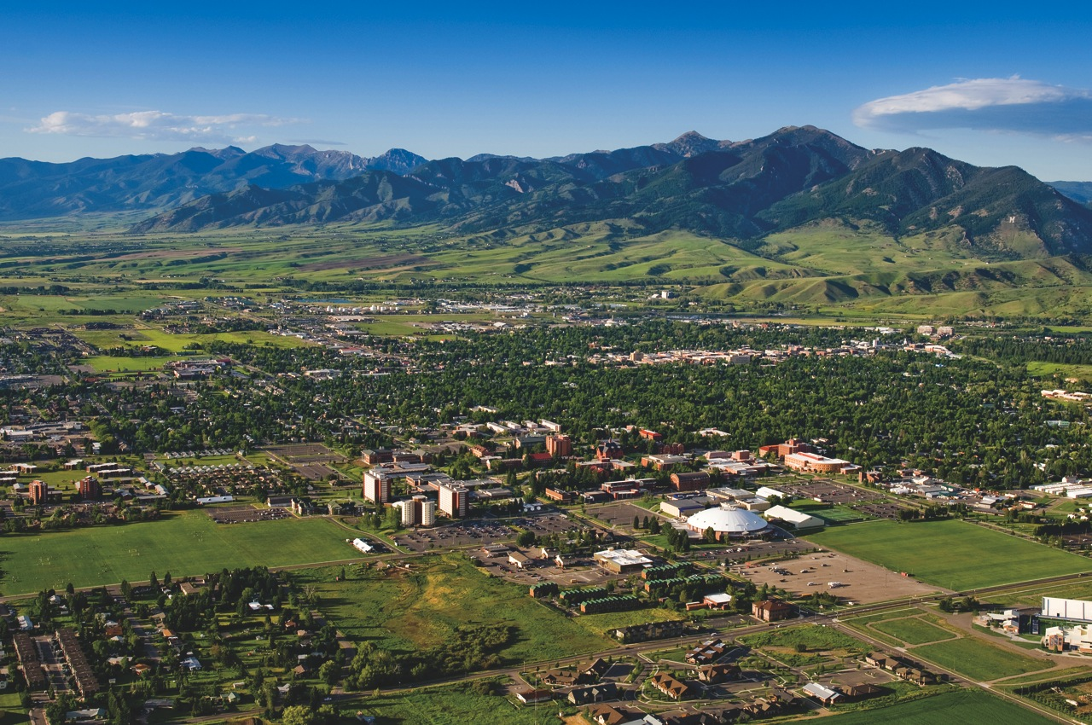
Basic Police Mountain Bike Class A Course
Montana State University Police-Bozeman PD
Bozeman, MT July 11-14, 2016

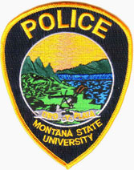
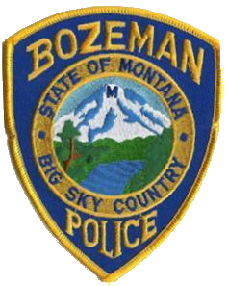
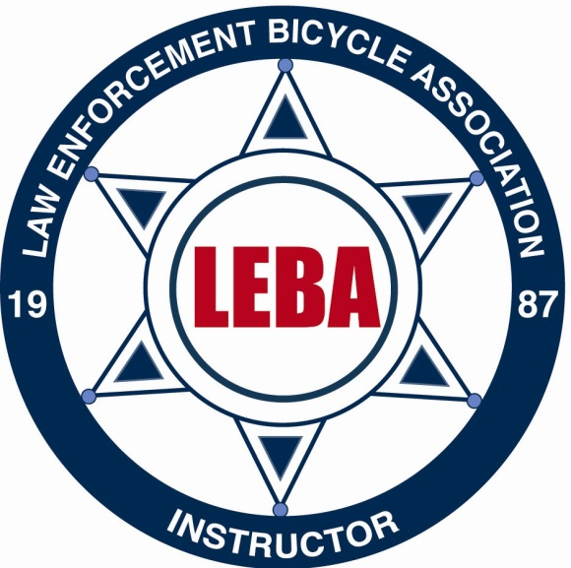

Prerequisites to attend this course:
1. Be a member of a City, County, State, Federal or Military Law Enforcement agency.
2. Be in excellent physical condition with no medical conditions that would prevent you from participating in strenuous physical activity.
3. Have Department/Agency approval to attend.
4. Be covered by appropriate “on the job” industrial insurance.
5. Have a CPSC, SNELL, ANSI or ASTM, CAN-CSA approved bicycle helmet.
7. Have eye protection, cycling gloves and comfortable cycling clothing with proper shoes for cycling.
8. Have toe clips & straps or power grips on your pedals.
9. Have a bicycle that is mechanically sound and functioning properly.
10. Have a great attitude and the desire to work as a team member with officers from different jurisdictions.
11. Have access to a duty belt. A simunition scenario will be part of the course. If your holster accommodates a Glock frame pistol it will work. If not a holster will be provided for the scenario.

Tuition:
Tuition is $125.00. It must be paid in full, on or before the first day of the school.
Lodging:
Lodging on campus is available for $30 per night. Contact course instructors for further details.

The Montana State University Police Department in partnership with Bozeman PD is pleased to announce the offering of LEBA’s nationally recognized Basic Police Mountain Bike Course.
This four(4) day course is scheduled for July 11-14, 2016 in scenic Bozeman, Montana. This course will challenge the student both physically and mentally.
This class will stress teamwork and overcoming obstacles. Training rides will be conducted daily and you must be able to complete rides from 20 to 35 miles maintaining a 12-14 mph pace. Cone drill techniques must be completed to the satisfaction of the Instructors and a written examination must be passed with an 80% or higher score.

Instructor Contact Info
Sgt. Matt Wemple-MSUPD
Office Line: 406-994-1215
Email: mwemple@montana.edu

Officer James Lusby-Bozeman PD
Office Line: 406-582-2693
Email: jlusby@bozeman.net

