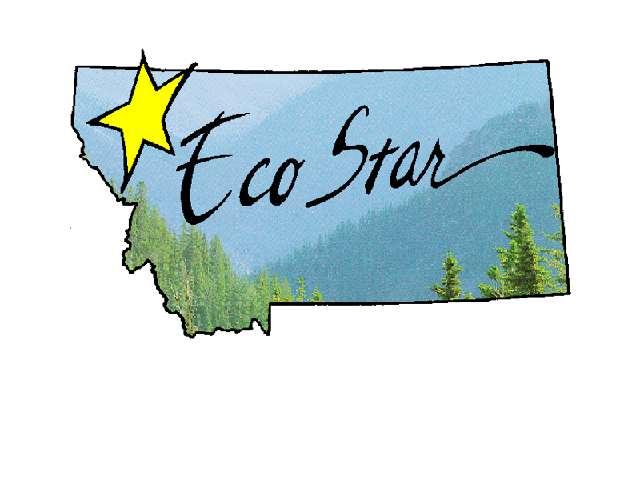

2017 Montana EcoStar Pollution Prevention Award – Application
The Ecostar Award for Pollution Prevention (P2) is awarded annually to Montana businesses, non-profit organizations, schools, hospitals, cities/counties or community groups who have made a significant improvement in protecting Montana’s environment by preventing pollution, whether thru the reduction or elimination of wastes and pollutants, product design, energy use, manufacturing, distribution, sale, use, material recovery or thru education of the importance of such steps.
Applications must be submitted electronically by March 1, 2018.

Part I: CONTACT INFORMATION

Contact information of business/non-profit/institution etc.:
Name <Type in grey box, fields will expand>
Address
City Zip # of employees
Telephone Website
Name as you would like it to appear on the award (if awarded)

Contact information for person submitting application:
Name Title
Telephone Fax *E-mail

Award categories
Organization type: (check one) P2 Activity type: (check all that apply)
Business Hospital/Health Care Source reduction Water conservation
Non-profit Agricultural Toxicity reduction Energy conservation
County/City School Waste reduction Recycling
Industry/Manufacturing Composting Reuse
Other Education Use of local products
Other Other

How did you hear about the Ecostar Pollution Prevention (P2) Award?
E-mail previous winner newspaper other
Website listserv MT Extension agent

Part II: POLLUTION PREVENTION (P2) BY THE NUMBERS
Use the table below to summarize the 2017 P2 results of your business/organization etc. *Be as specific as possible and use the EPA P2 data calculators available at the link below when feasible:
http://www.p2.org/category/general-resources/p2-data-calculators/
POLLUTION PREVENTION (P2) Measures  (include as many rows as needed under each measure/category) | Specifics  (i.e. type of material/waste) | Amount reduced | $ saved
HAZARDOUS WASTE REDUCED (*definition of hazardous waste below chart)  Example 1:  Example 2: | Lead  Batteries | lbs.  xxx lbs  xxx lbs | $  $xxx  $xxx
NON-HAZARDOUS WASTE REDUCED  Example: | Cardboard | lbs.  xxx lbs | $  $xxx
MATERIALS REUSED  Example: | cooking grease reused | lbs.  xxx lbs | $  $xxx
MATERIALS RECYCLED $ |  | lbs. | $
GREENHOUSE GAS EMISSIONS REDUCED/AVOIDED  Example: | Diesel fuel: reduction in driving due to sourcing closer pasture | MT CO2e  xxx mtco2e | $  $xxx
WATER USE REDUCED Example: $ | Installed new low flow toilet in public bathroom saving 100 gal/day | gallons  xxx gallons | $  $xxx
ENERGY SAVED  Example: | LED lighting retrofit in office | kWh  xxx kwWH | $  $xxx
Other $ |  |  | $
*Hazardous Waste = A solid waste, or combination of solid waste, which because of its quantity, concentration, or physical, chemical, or infectious characteristics may (a) cause, or significantly contribute to, an increase in mortality or an increase in serious irreversible, or incapacitating reversible, illness; or (b) pose a substantial present or potential hazard to human health or the environment when improperly treated, stored, transported, or disposed of, or otherwise managed.[RCRA §1004(5)] http://www.epa.gov/osw/hazard/wastetypes/listed.htm

- ADDITIONAL DETAILS REGARDING P2 EFFORTS DESCRIBED ABOVE:
<Type in grey box, fields will expand>

Part III: WRITTEN DESCRIPTION of P2 EFFORTS
Applications are judged on the following criteria: environmental benefit (energy & water savings etc.), economic benefit, leadership, innovation, and ability to be modeled by others.

1. Benefits to the environment: Summarize the current P2 efforts of your business/organization.

- Describe your P2 efforts and the environmental, ecological, employee or customer health benefits experienced or expected from these P2 efforts, including those associated with life-cycles of products or materials.
<Type paragraph here, field will expand>

- Explain how the success of your P2 efforts has eliminated or reduced waste, toxicity or pollution as compared to past years or as compared to standards, averages or common practice?

2. Economic benefits: Discuss the costs and economic benefits of your P2 focus.

- Include project or program costs, savings and/or increased revenues and decreased disposal and/or raw material costs as a result of your P2 efforts.

- Include the expected payback period needed to recover costs of your P2 efforts.

- Describe any marketing advantage you may have received as a result of your P2 efforts.

3. Commitment and leadership P2
Describe how your organization demonstrates commitment and leadership in P2 both internally as well as with suppliers, customers, and the community.

4. Innovation
Describe how your business/non-profit/community/school etc. is innovative or unique. Explain how you go beyond what is commonplace in your industry, community, organization, or market niche.

5. A model for others
Explain how your business/non-profit/community/school etc. lends itself to replication by others to enhance P2 efforts community wide/industry wide etc.

6. Additional Benefits
Describe other benefits that do not fit in the above categories.

7. Looking Forward: Goals for 2018
- Set a specific, measurable pollution prevention goal for 2018 (i.e. switch to alternative fuel vehicles for company use; provide incentives for employees to actively engage in P2 practices; replace all cleaners with biodegradable alternatives; etc.).

b. List at least one step – with a time frame – that you will take in 2018 to achieve this goal.

Part IV: RENEWAL of ECOSTAR STATUS (required for past recipients only)
Did your business or organization achieve its Waste Reduction Goal as stated in your past EcoStar application? Yes No
If yes, how? If no, state the barriers and new plans for meeting the goal.

What new achievements has your business or organization accomplished in 2017 towards sustainable pollution prevention (i.e. moving beyond reuse and recycling to a source reduction program; utilizing an environmentally responsible procurement plan, etc.)?

►Applications due March 1, 2018
I AM AWARE THAT A MT DEQ STATE REGULATORY COMPLIANCE CHECK WILL BE CONDUCTED.  BY SUBMITTING THIS APPLICATION, I CERTIFY THAT, TO THE BEST OF MY KNOWLEDGE, I AM CURRENTLY IN COMPLIANCE WITH APPLICABLE ENVIRONMENTAL REGUALTIONS AND THAT THE INFORMATION CONTAINED WITHIN THIS APPLICATION IS TRUE AND CORRECT.  _____________________________________________________  Contact Name Title  _____________________________________________________  Signature Date |  | Submit application electronically to: Jenny Grossenbacher, MSU Extension jenniferg@montana.edu  406.994.4292 *toll-free 888-MSU-MTP2
SPONSORED BY

