MTP2 Pollution Prevention Intern Application

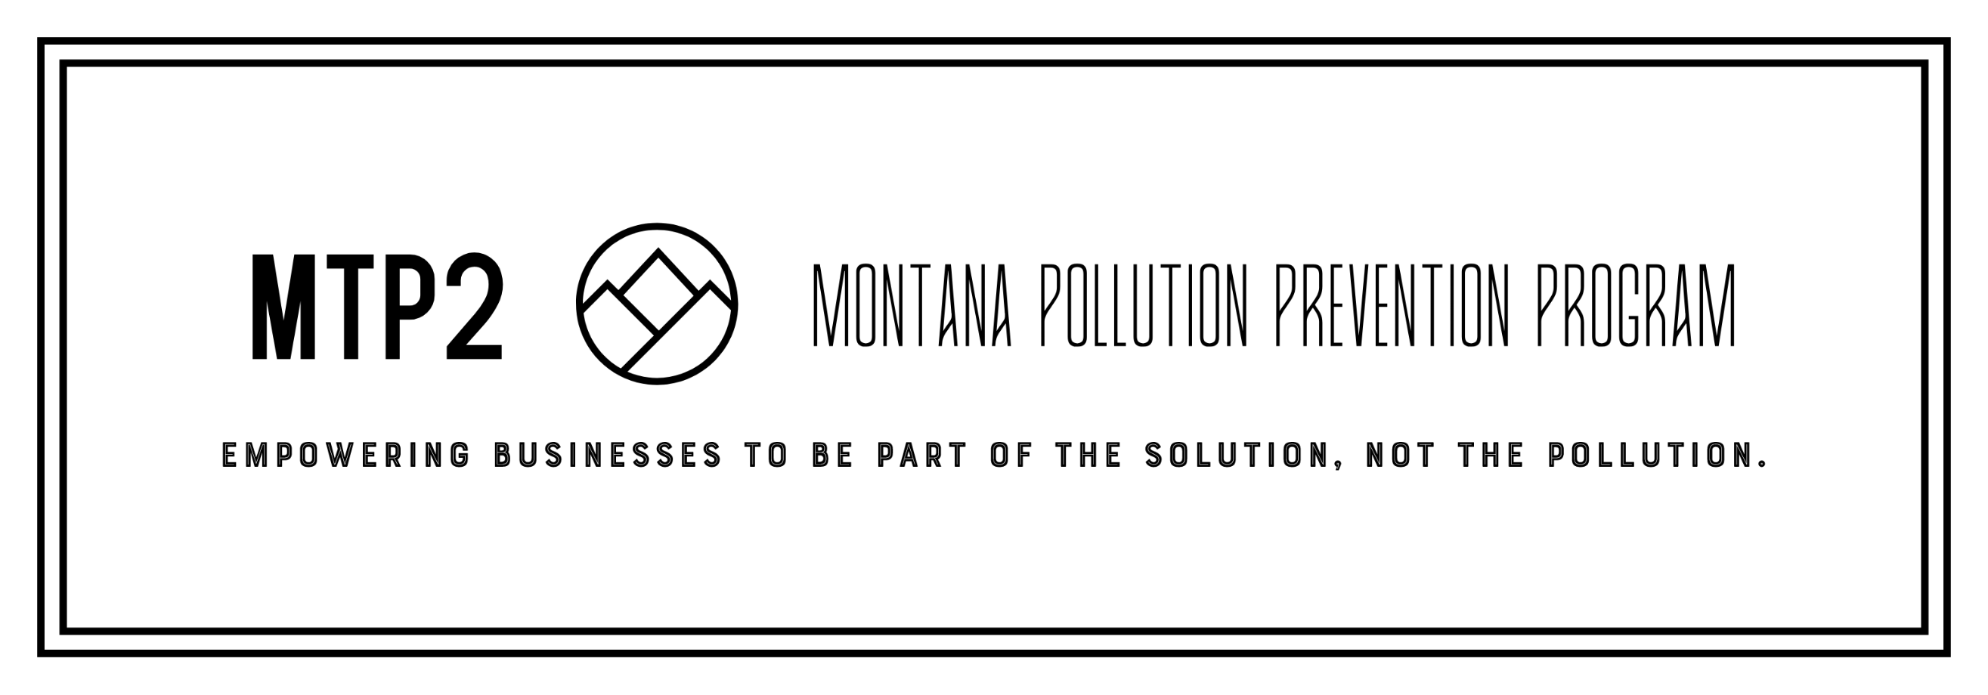

Application Instructions
Please submit the following electronically to jenniferg@montana.edu:

- Application
- Résumé
- Cover letter including discussion of the following questions:
  - What type of pollution prevention projects pique your interest?
  - What skills or attributes make you a good fit for this program?
  - How will this internship help advance you toward your career path?

*Note: The intern selection process will begin mid-February and continue thru the semester until assignments are finalized.

Name Major Focus area of study Academic Advisor GPA
School Anticipated Graduation Date
(mm/yyyy)

Please specify class status you will be in for the summer of 2024:
Junior Senior Master or PhD candidate

Residential Address (While attending School)
City | State | Zip
Cell Phone | School Email

Emergency Contact:
Name | Relationship
Address
City | ______________________________ State | Zip
Phone | Email

Where did you hear about the P2 Internship?
Program participants will be required to travel within the community or region where they are assigned.
Do you have access to an automobile? | Yes | No
It is necessary for many students to relocate for the summer.
Are you willing to temporarily relocate anywhere in Montana? | Yes | No
If not, what are your geographic limitations?
Please place an “x” next to any of the following tasks for which you may need special accommodation:
Standing for more than 6 hours per day | Climbing a ladder
Bending, stooping, or kneeling frequently throughout the day | Lifting heavy items occasionally
Walking 2 or more miles per day | Sitting for extended periods
Working on scaffolding or in high or tight spaces | Other: | ___________________

Students with the P2 Intern Program work approx. 35 hours per week for 11 weeks. Please list any dates during this schedule (beginning early June 2024 thru mid August) that you would not be available to report to your worksite:

I currently have specific experience or knowledge in projects related to the following areas:

Water Conservation | Water Treatment | Energy | Compressors
Chemical Processing | Solid Waste | HVAC | Heat Recovery
Manufacturing Processes | Auditing | Lighting | Alternative Energy
Source of experience or knowledge of above (coursework, projects, hands-on experience):
Additional programs and/or equipment with which you have experience:

References:
Name | Phone
Relationship | Email
Name | Phone
Relationship | Email

I acknowledge the dates of the internship for which I am applying and confirm that I have no scheduling conflicts that would interfere with the stated timeline, except as noted above. I also understand that if I am selected for the Pollution Prevention Intern Program, I may be asked to take a pre-employment drug, background and/or security screening dependent upon the policy of the company to which I am assigned. Your signature will constitute your acknowledgement and willingness to comply.

Applicant Signature |  | Date

