Topics for today:
- Quiz on reading and lecture material.
- Anatomy and physiology of the ear (refer to text information).
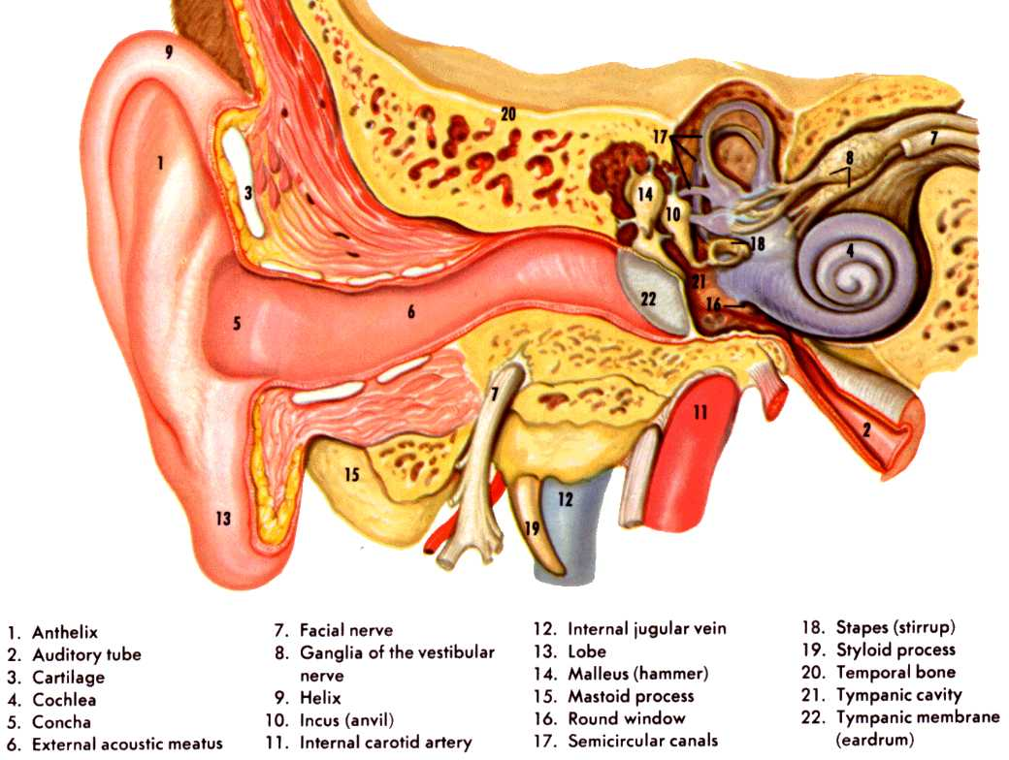

Topics for the next lecture:
- Anatomy and physiology (cont.)
- Read Chapters 15 and 17.

