Division Meeting

August 8, 2014

Minutes

Announcements

* Welcome and Looking Forward- Chris Kearns, Vice President for Students Success
* Transfer Working Group
  + Looking at improving.
  + 1 month to report back to OneMSU group.
  + Record student experience.
* New Content Management
  + Web page management
  + Push content and organize in a more efficient manner.
* Division meeting focus – professional development
* Division Wide Kick-Off – twice a year (town hall style)

Business Items

* Framing our work

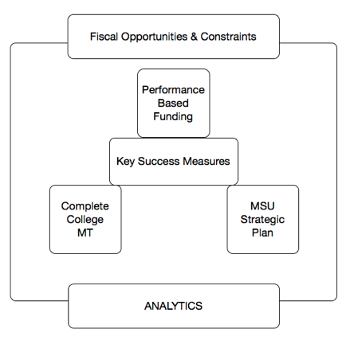

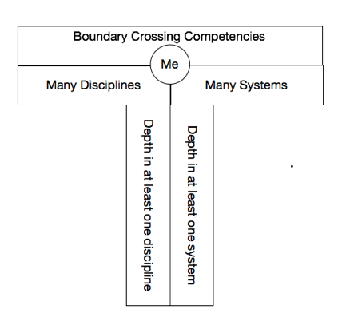

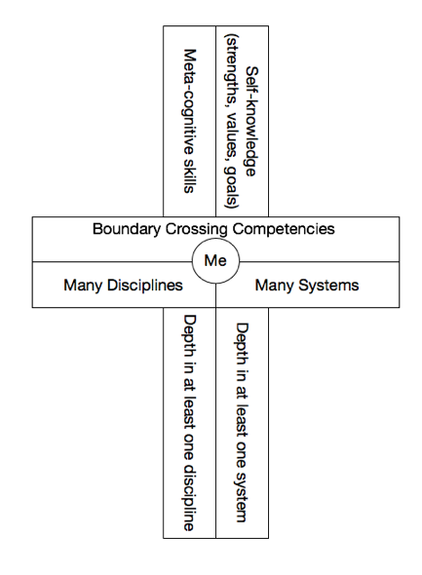

* + Providing boundary crossing skills.
    - Be good at training students
    - Value is lacking
      * Value what they do/learn.
  + T-Model
    - Make what they do cross outside of their current space.
  + Plus Model
    - Need to know:
      * Strength
      * Learning Style
      * Understand Themselves
      * How they can take advantage.
  + Division has a central role.
    - Clarify how it fits together.
    - Flesh out where we fit in.
* Draft Key Success Measures

We must show our success with metrics – demonstrate in a measurable way why we do

* + Access & Affordability
    - % of students receiving (paid non-federal aid
    - %of student receiving (paid) aid – all types
    - Stream-lined process for re-admission, advising and degree completion
  + Annual community service hours for students
  + Career development participation
  + Developing and inspiring students to learn how to learn
  + Diversity
  + Engagement
    - Club sports participations and number of teams
    - Overall RSO participation rates
    - Student participation in extracurricular activities
    - ChampChange
  + Financial Literacy
  + Health and Safety
  + Information fluency
  + Internship Participation
  + Leveraging social media
  + Montana Resident Students – quality/quantity
  + Removing barriers
  + Recidivism rates in student conduct.
  + Recruitment growth in MSU’s veteran population
  + Retention and Completion Rates
    - First Year/First Time
    - Four, Five, Six Year Graduation Rates
    - Persistence
    - Relationship between retention to tutoring and or coaching efforts
    - Reducing UWDs
    - Increasing number of students who return to learn.
  + Using best practices in student success
  + Utilizing the latest in technology
* Presentation on Key Success Measures  
  Carina Beck, Allen Yarnell Center for Student Success  
  Bonnie Ashley, Registrar
  + How will these fit into our plans/things we are doing currently and how do we use those things to contribute to the items in the plus model?

Updates

* Legend of the Bobcat – Carina Beck (5 min)