Division of Student Success Steering Committee

July 24, 2014 @ 1:30PM (SUB 232)

MINUTES

Attendee

Chris Kearns, Cheryl Blank, Jim Mitchell, Brenda York, Kathy Tanner, Erin McCormick, Tammie Brown, Brandi Payne, Eric Wold, Matt Caires, Jordan Garceaux, Jen Joyce

Announcements and Updates

* Res Life Update
  + Miller will be open in time for Fall semester.
  + RA training starts August 10.
  + Switch over - August 15, 24 hour desk coverage.
  + Harrison Street Work
* Service Excellence
  + Based on 4 values.
    - Safety, Courtesy, Reliability, Competency  
      <http://www.montana.edu/service/>
  + Wear your nametags every day! Print reminder cards for division desks.
    - Front line staff training for all areas on campus. (LMSU style training.)
  + Run around, present the process as people helping out rather than places to go.
* DSS Retreat
  + Possible October Timeline
  + Content that is bought by all.
    - Outcomes  
      1. List of accountability metrics.  
      2. Knowing each other better.
  + Attendees: Steering Committee
  + Chris' vision:
    - Substantive, bring the group together and be accountable. Administrative goal is to stress a systemic force in moving the campus forward.
    - Graduation, retention, student mental health. Triangulate - focus on teamwork but include the accountability metrics. Identify a set of specifics that we are collectively going to held accountability. Develop analytics aimed at our goals.

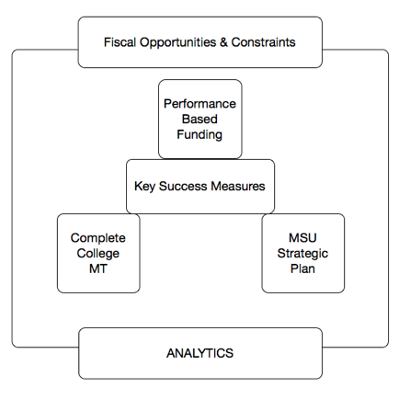

* + Looking lenses:

Complete College Montana Effort (<http://mus.edu/CCM/default.asp>)

MUS

Performance based funding (<http://mus.edu/CCM/performancefunding/>)

* + T-Model from Michigan State (Phil Gardner) - go one step further

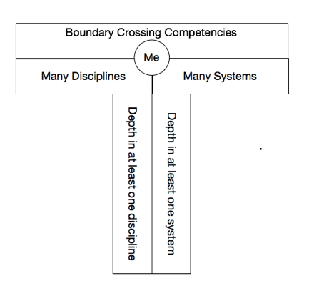

* + Two kinds of knowledge you need to focus on.
    - Really depth oriented knowledge.
      1. Major or Concentration
      2. Learn some system
    - Boundary crossing model
      1. Gained in lots of different ways.
      2. Horizontal piece.
      3. Student Success is part of this.
  + Change this model as it's incomplete. Add a third self-knowledge... learning style, self-value and worth. Share what we do that doesn't feel like poaching to faculty and show what 'Planned learning for undergraduate success.' looks like. Create a common language across advising to all areas of campus. Work from your talents and strengths. Build life on character, strength and what you can give.

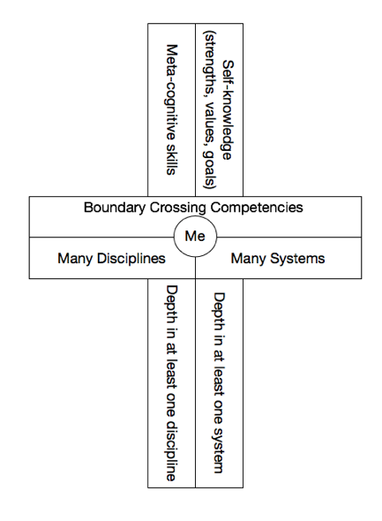

* + 'You can't add without a plus!'
  + Bring someone in to help us get to know each other... strengths mapping.
  + **Assignments:**
  + What kind of a 'get to know ourselves' does the group think would be beneficial?
  + Think about the list of things Student Success will be held accountable.

Business Items

* Phone Update
  + ITC Information: They did all the testing they thought they needed to do but there were some problems occured that were unanticipated. They have troubleshot the problem and they think they have isolated the problem. The fix for the security issue created the additional problems and they have pulled that fix out and are going to investigate a new fix for the security issue. The campus is going to move forward and will work on fixes as we go. Menu systems will not be brought back online until they resolve the issue completely. Menu system messages must be recorded at ITC and they are working to make that process more user friendly. The old system is no longer supported so the plan is to keep moving forward with the new system and resolve the issues.
* Follow up on the vision strategy and expectations
  + No surprises - clarification.
    - Chris would like our practices be such that we have a real seamless way of working with each other. High trust - high transparency. Everyone, knows the items that need to be shared.
    - This should not slow down critical work we are doing. Deal with the safety issues or mission critical problems but keep Chris in the loop as soon as you are able.
    - If you are talking to people in the President's cabinet, please let him know.
      1. They must know that all the plans are strategic.
    - Info he needs to know.
      1. Safety and Welfare
      2. Division impact - even if you aren't sure.
      3. Anytime you get something you don't know what to do with but think he may need to know.
      4. ANYTHING that 'smacks' of the media.

Misc:

There is increased pressure to have an active intervention process.  If you are working on something that will impact our colleagues inside and outside the division, keep all parties in the loop as much as possible.