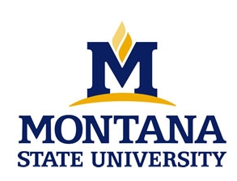
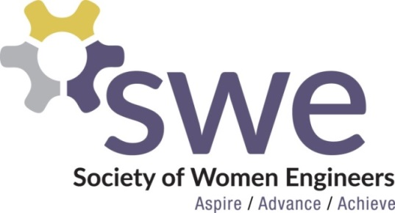

EVENTS CALENDAR FALL 2016

Join MSU’s local chapter of SWE this Fall at the following events!

Thurs. 9/8 SWE Social - 7:00 PM - Get to know other engineers (guys and girls) at Hannon Green while enjoying some frisbee, volleyball and music.

Wed. 9/14 Cookies with SWE -6:30 PM Join us before the Women in Engineering (WIE) Welcome to eat cookies with the SWE officers and learn more about the national organization, our local chapter, and how to become more involved!

Thurs. 9/15 First Open Officer Meeting - 6:30 PM Get actively involved with our local chapter of SWE by sitting in on an open meeting with the SWE officers.

Wed. 9/28 What they don’t tell you about internships! - 7:00 PM - Come hear about some of the SWE officers’ experiences as interns and get the inside scoop on what it’s actually like to have an internship.

Sat. 10/8 Hike with SWE- 9:00 AM- Come enjoy scenic Bozeman- meet at the M
trailhead. Anyone in engineering department is welcome!

10/27-10/29 SWE Annual National Conference in Philadelphia, PA with Career Fair

Thurs. 11/17 National Conference Report - 7:00 PM - Listen to SWE members talk about their experiences at the 2016 SWE National Conference and learn about how you can attend the conference next year.

Wed. 11/30 FroYo Night - 7:00 PM - Come de-stress from exams and studying with frozen yogurt at Toppers with SWE!

All events will be in ROBH 218 unless otherwise noted.

*Dates/Times/Locations/Events subject to change. Check http://www.montana.edu/swe/ for up to date schedule. Or check out facebook.com/montanastateswe

