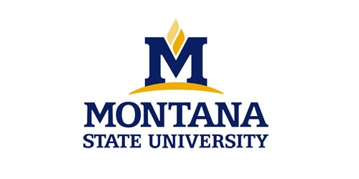
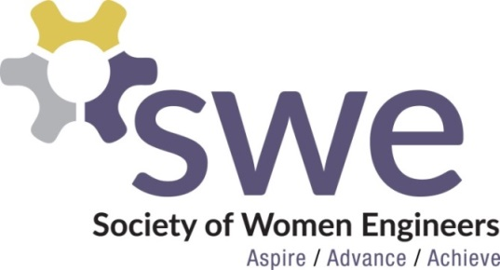 @

Join MSU’s local chapter of SWE this Fall at the following events!

8/20-8/21 Catapalooza - Visit SWE’s booth to learn more about how you can get
involved!

9/2 SWE Social - 7:00 PM - Get to know other women engineers at Hannon Green while enjoying some frisbee, volleyball and music.

9/9 First Open Officer Meeting - 6:30 PM - Get actively involved with our local chapter of SWE by sitting in on an open meeting with the SWE officers.

- Cookies with SWE- Join us before the Women in Engineering (WIE) Welcome to eat cookies with the SWE officers and learn more about the national organization, our local chapter, and how to become more involved!

9/24 What they don’t tell you about internships! - 7:00 PM - Come hear about some of the SWE officers’ experiences as interns and get the inside scoop on what it’s actually like to have an internship.

10/14 Research Forum - 7:00 PM - Come hear about research and learn how you can get more involved with research on campus.

10/22-10/24 SWE Annual National Conference in Nashville, TN with Career Fair

10/29 Halloween Movie Night - 7:00 PM - Take a break from school work to watch movies and eat Halloween candy with SWE!

11/18 National Conference Report - 7:00 PM - Listen to SWE members talk about their experiences at the 2015 SWE National Conference and learn about how you can attend the conference next year.

12/3 Study Party - 7:00 PM - Eat pizza and study for finals with SWE during Deadweek!

*Dates/Times/Locations/Events subject to change. Check http://www.montana.edu/swe/ for up to date schedule. Or check out facebook.com/montanastateswe

