Purpose
The purpose of the lab is to demonstrate the signal analysis capabilities of Matlab. The oscilloscope will be used as an A/D converter to capture several signals we have examined in previous labs. These signals will then be examined and analyzed in Matlab. Effects of A/D quantization noise will be seen.

Reference Sources

Proakis chapter 7.4.1, equations 7.4.1 to 7.4.3 as attached

Prelab

- YOU WILL NEED thumb drive
- What is the quantization noise power P_{q} (eq 7.4.2) for an 8-bit A/D with an input range of +1V to -1V? (n=8 and x_{max}=1V)
- Does this noise power depend on the sample frequency? Explain
- The power spectral density, PSD, of the noise is $S_{q}=\frac{P_{q}}{{F_{s}}/2}$ Watts/Hz. This is the quantization noise floor of the A/D. What is the noise floor PSD when F_{s} is 10Ks/sec?
- What would the Signal to quantization noise ratio SQNR be if the input signal is a 2Vp-p sine wave, x_{max}=1V, and n=8 bits? (SQNR=P_{signal}/P_{q})

Capture the following signals on a floppy disk as csv files for analysis in Matlab. You may do the data analysis at your leisure before the next lab.

1. Set the oscilloscope for a sample rate of 100 Ks/sec, 10,000 points, and 1mV/div. Disconnect the probe from the scope. This is the minimum resolution of the scope.
- Record the mean, Pk-Pk, and RMS voltages using the scope measurements
- Capture the trace to a .csv type data file
- Write a Matlab file to read the data file and:
  - Plot the data in time
  - Find the mean, Pk-Pk and RMS noise voltages. Compare the results to what you recorded on the oscilloscope.
  - Plot the power spectral density (PSD) in Watts/Hz. Be sure to correct for the resolution bandwidth of the FFT. You may assume R=1
  - Estimate the Δ (voltage resolution of the A/D) by finding the minimum non-zero voltage change between points.
  - The full scale range of the A/D is Δ x 512 (9-bit). How does this compare to the full scale range of 8 mV as seen on the scope screen? Explain

2. Set the oscilloscope for a sample rate of 100 Ks/sec, 10,000 points, and 200mV/div. Disconnect the probe from the scope.
- Capture the trace to a data file
- Repeat part 1 using this data.

3. Set the oscilloscope for a sample rate of 100 Ks/sec, 10,000 points, and 200mV/div. Now connect a signal generator and apply a 1 KHz sine wave of 1 Vp-p.
- Capture the trace to a data file.
- Repeat part 1 using this data.
- Estimate the full scale range of the scope, +/1 X_{max}, under these settings. How does this compare to the displayed +/- 800 mV signal on the scope display.
- Estimate the dynamic range of the scope in dB, SNQR=20*log(X_{max}/V_{noise}). V_{noise} is the no input rms noise voltage from 2.
- Compare the level of the noise you expect to see for the sine wave with what you see in the FFT plot. Explain. (Hint: Resolution Bandwidth)

4. Set the oscilloscope for a sample rate of 100 Ks/sec, 10,000 points, and 200mV/div. Now connect a signal generator and apply a 1 KHz sine wave of 2 Vp-p.
- Capture the trace to a data file.
- Repeat part 1 using this data.
- Is the sine wave distorted in the Matlab plots? Explain

5. Change the input waveform to a 100 KHz triangle waveform 2.5 Vp-p
- Capture the trace to a data file.
- Repeat part 1 using this data.
- Is the triangle wave distorted in the Matlab plots? Use this to find the pk-pk range of the A/D.

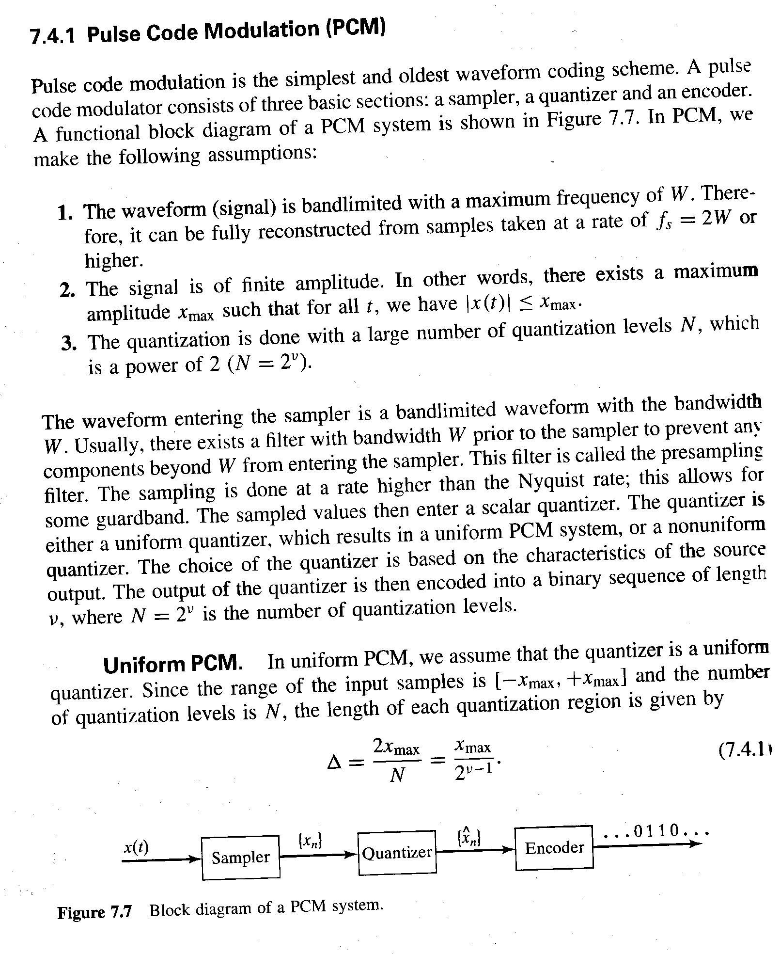
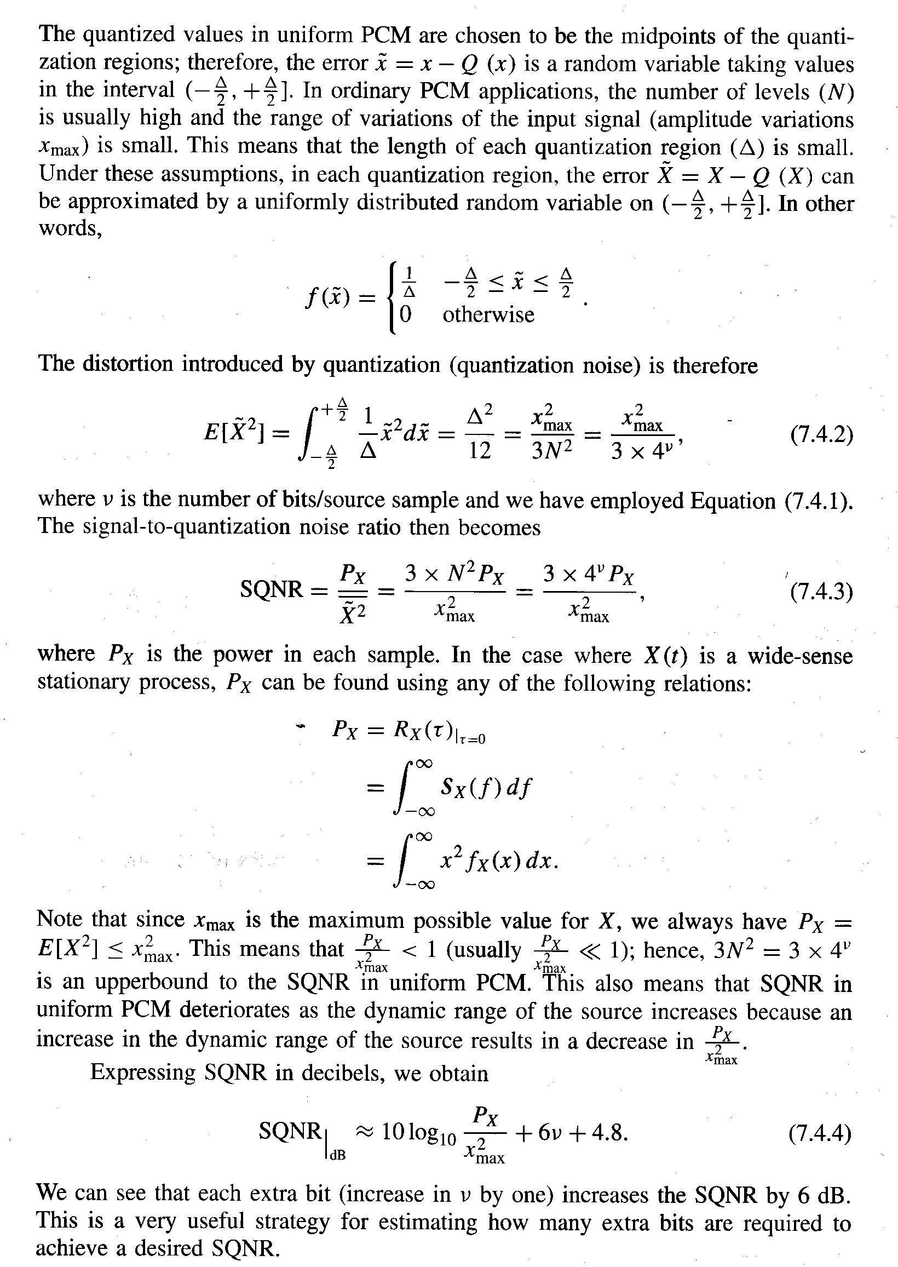
P_{q}=

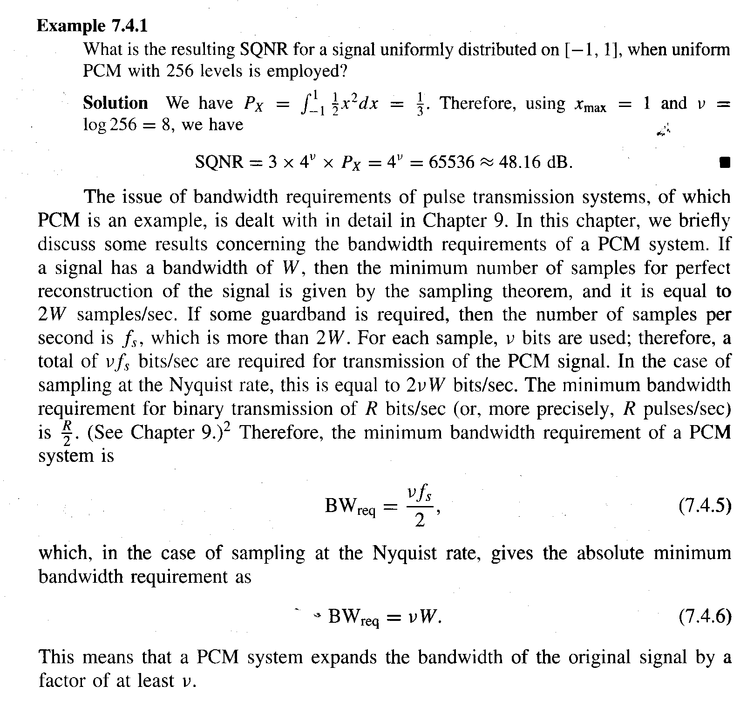
Sample data analysis from Matlab program:
Screen shots from EELE44512lab5.m Matlab file. You should see something similar.

Zoom was used on the above graph to see the individual quantization steps. 4mV in this case.

