Purpose
We consider the bandwidth of a Frequency Modulated (FM) carrier when it is modulated by a 1 KHz sinewave. The modulation index for FM is defined to be:

β =ΔF_{pk} /(F_{m)}

Where ΔF_{pk} is the peak frequency deviation of the carrier frequency, and F_{m} is the frequency of the modulating sinewave.

The amplitude of the spectral components of the modulated signal are determined by Bessel functions.
J₀(β) is the carrier amplitude
J₁(β) is the amplitude of the modulating frequency sidebands, F_{c} +/-F_{m}
J₂(β) is the amplitude of the sidebands at F_{c} +/- 2F_{m}

$s(t)=\sum_{n=−∞}^{∞}{A_{c}J_{n}}(β)\text{cos}\left[\left(ω_{c}+{nω}_{m}\right)t\right]$

The occupied bandwidth for 98% of the transmitted power is determined from Carson’s Rule:

$$\text{BW}=2\left(β+1\right)f_{m}$$

Reference Sources
Couch Chapter 5-6, Table 5-2,3, figure 5-11, eq 5-61and Bessel handout for lab 10

Prelab:

- Define narrow band FM.
- Determine the magnitude of the spectral components you will see on a spectrum analyzer for a modulating frequency of f_{m}= 1 KHz with a peak frequency deviation of Δf=600 Hz and for a peak deviation of Δf=2.4 KHz. (You may use the FM sideband calculator on the website or modify Couch E5_60m Matlab file.) The carrier frequency is 12 MHz.
- Understand how to apply Carson’s rule to predict the occupied bandwidth of the signal. (Bessel function order for Carson n_{max}= β+1)

Method:

Narrowband FM:

- Set the generator for a 12 MHz, 2volt p-p into 50 ohms sinewave output with no modulation. Connect the generator to the spectrum analyzer (SA) through the 3dB attenuator. Verify that the generator output is about 10dBm. Remember that the generator output is: SApower dBm+ attenuator loss of 3dB.
- Record the actual power for use in the following steps for use as the total s(t) power. Be sure to record the unmodulated carrier power level in dBm as accurately as possible to minimize your measurement error.

- Turn on the FM sinewave modulation with a frequency of 1KHZ and a deviation of 100 Hz.
- Record the levels in dBm of the carrier, first and second sidebands.
- What is the measured occupied bandwidth of the measured signal? (approx. 98% of total signal power)
- How does this compare to AM modulation?
- What does Carson’s rule predict?

- Using the setup from part 1, increase the frequency deviation of the modulation to 600 Hz.
- Record the levels in dBm of the carrier, first and second sideband pairs.
- Use Bessel functions to calculate the theoretical power of the spectrum and compare your measured amplitudes with the predicted amplitudes.
- Does this still qualify as narrowband FM?

J₀ Carrier Null for β=2.4 and J₁ Null for β=3.83:

- Using the setup from part 1, continue to increase the frequency deviation of the 1 KHz modulating signal in 100 Hz steps and watch the amplitude of the carrier.
- At what deviation does the carrier amplitude disappear?
- What is the measured modulation index, how does it compare to the theoretical J₀(2.4) zero crossing?

- Set the frequency deviation to 2.4 KHz.
- Record the levels of the sidebands and compare them to the levels predicted by the Bessel functions.
- Calculate the percent of total power measured in the spectrum in Carson’s rule.
- How does this compare to the bandwidth predicted by Carson’s rule?
- How does the bandwidth compare to AM?

- Continue to increase the deviation of the modulating signal in 100 Hz steps until the 1KHz sidebands decrease to a minimum power.
- Sketch the spectrum and record the deviation where the J₁ term has zero amplitude.
- Identify the approximate occupied bandwidth on your plots and compare this value calculated by Carson’s rule.

- Continue to increase the deviation of the modulating signal until the J₂ terms minimize.
- Sketch the spectrum and record the deviation.
- Does this β correspond to the Bessel chart J₂ null? Give a reason for the error, if the null does not appear at the correct β.

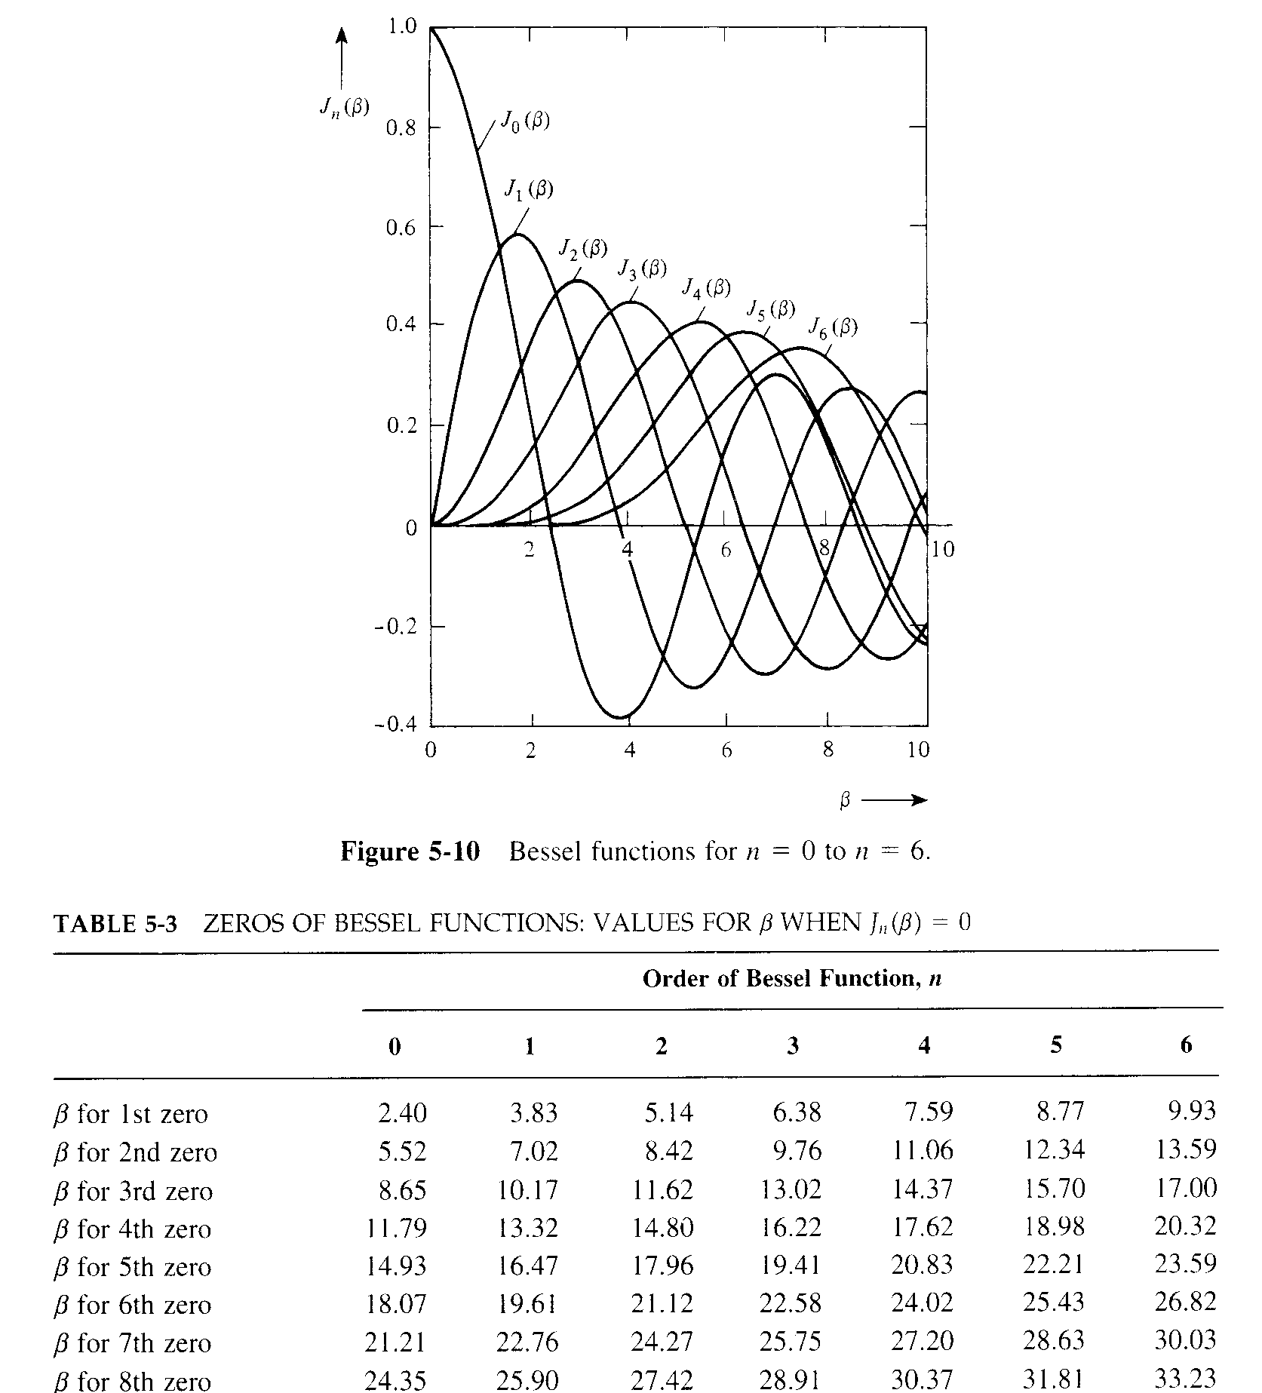

Note: underlined values in table 5-2 correspond to Carson’s Bandwidth Rule

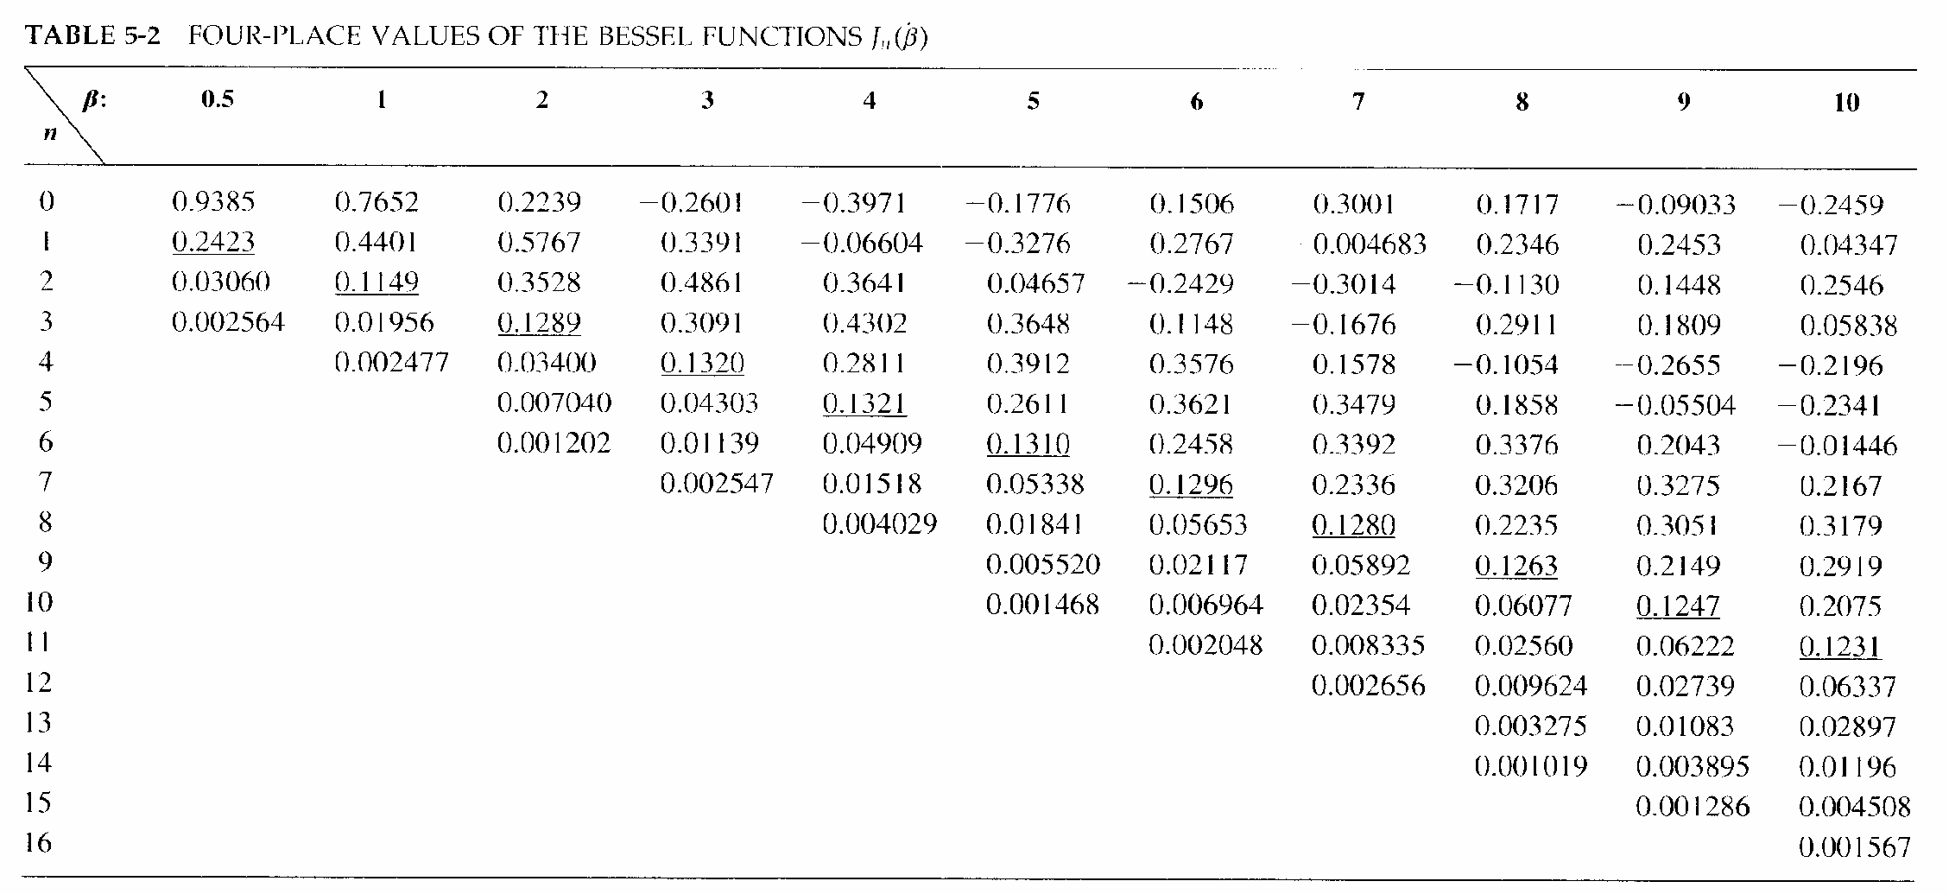

Narrowband FM:

- Remember that the generator output is: SApower dBm+ attenuator loss of 3dB.
- Record the actual power for use in the following steps for use as the total s(t) power. Be sure to record the unmodulated carrier power level in dBm as accurately as possible to minimize your measurement error.

- f_{m}=1KHZ and a deviation of Δf=100 Hz.
- Record the levels in dBm of the carrier, first and second sideband pairs.
- What is the measured occupied bandwidth of the measured signal? (approx. 98% of total signal power)
- How does this bandwidth compare to AM modulation?
- What does Carson’s rule predict for the bandwidth?

- f_{m}=1KHZ and a deviation of Δf=600 Hz.
- Record the levels in dBm of the carrier, first and second sideband pairs.
- Use Bessel functions to calculate the theoretical power of the spectrum and compare your measured amplitudes with the predicted amplitudes.
- Does this still qualify as narrowband FM?

J₀ Carrier Null for β=2.4 and J₁ first sideband Null for β=3.83:

- Using the setup from part 1, continue to increase the frequency deviation of the 1 KHz modulating signal in 100 Hz steps and watch the amplitude of the carrier.
- At what deviation is the carrier amplitude a minimum?
- What is the measured modulation index? Compare this to the theoretical carrier null that occurs at J₀(2.4)=0

- Set the frequency deviation to Δf=2.4 KHz.
- Record the levels of the sidebands and compare them to the levels predicted by the Bessel functions.
- Calculate the percent of total power measured in the spectrum in Carson’s rule.
- How does this compare to the theoretical power predicted by Carson’s rule?
- How does the bandwidth compare to AM?

- Continue to increase the deviation in 100 Hz steps until the J₁ terms minimize.
- Sketch the spectrum and record the deviation where the J₁ terms are minimize.
- Identify the approximate occupied bandwidth on your plots and compare this value calculated by Carson’s rule.

- Continue to increase the deviation of the modulating signal until the J₂ terms minimize.
- Sketch the spectrum and record the deviation.
- Does this β correspond to the Bessel chart J₂ null? Give a reason for the error, if the null does not appear at the correct β.

