The Initiative on the Ethical and Social Implications of Science and Technology

and the Women’s, Gender, and Sexuality Speaker Series

PRESENT

Creating Perfect Babies?

Reprogenetic Technologies and Ethics

Monday, September 10th at 4:10pm

Procrastinator Theater (SUB)

Dr. Inmaculada de Melo-Martín

Weill Cornell Medicine - Cornell University

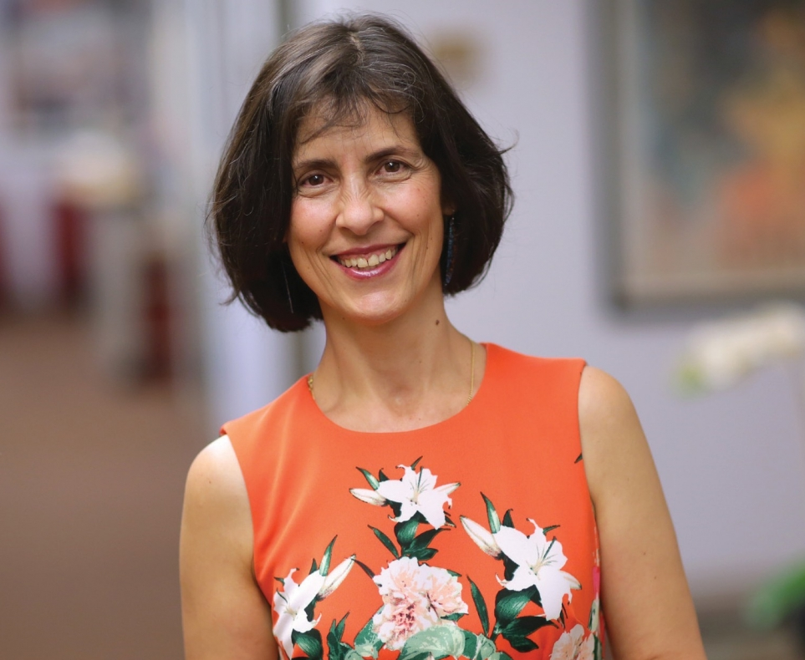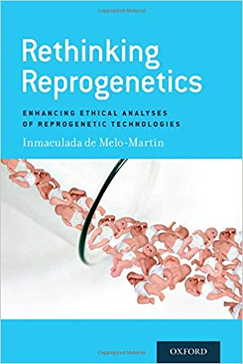

Reprogenetic technologies, which combine the power of reproductive technologies with the tools of genetic science and technology, give prospective parents a remarkable degree of control not simply over whether and when to have a child, but also over a variety of a future child’s characteristics. While many have enthusiastically embraced these technologies, this presentation will challenge the assumptions underlying such assessments.

Dr. Inmaculada de Melo-Martín, PhD, MS, is Professor of Medical Ethics at Weill Cornell Medicine—Cornell University. She holds a PhD in Philosophy and an MS in Molecular Biology. Her research interests include Bioethics and Philosophy of Science, particularly ethical and epistemological issues related to reproductive technologies and molecular genetics. Most of her work has been directed to critically analyze the importance of placing evaluations of biomedical science and technology in context. Dr. de Melo-Martín is the author most recently of Rethinking Reprogenetics (OUP, 2017).

