MSU Budget New Fiscal Year Budgeting

Logging in to MSU Budget
- Navigate to www.montana.edu/budget/msu_budget_axiom.html
- Please see instructions for Mozilla Firefox and Google Chrome. Before using the system for the first time, you must download a clickonce app
  - Download a clickonce app for the appropriate browser
  - If using Internet Explorer, no additional app is necessary
- Once your clickonce has been installed, follow the link to the software: https://montanasu.axiom.cloud
- Log in using your NetID and Password
Accessing the System
- Once you have logged on, you will see the screen below.
- Click on the rocket on the right-hand side and select Windows Client and install the software if it is your first-time logging in
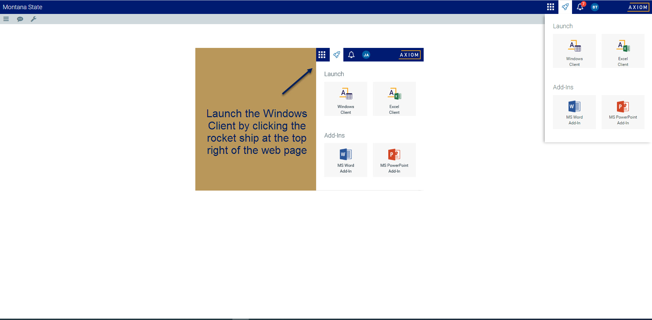
- The system will look like this when you log on
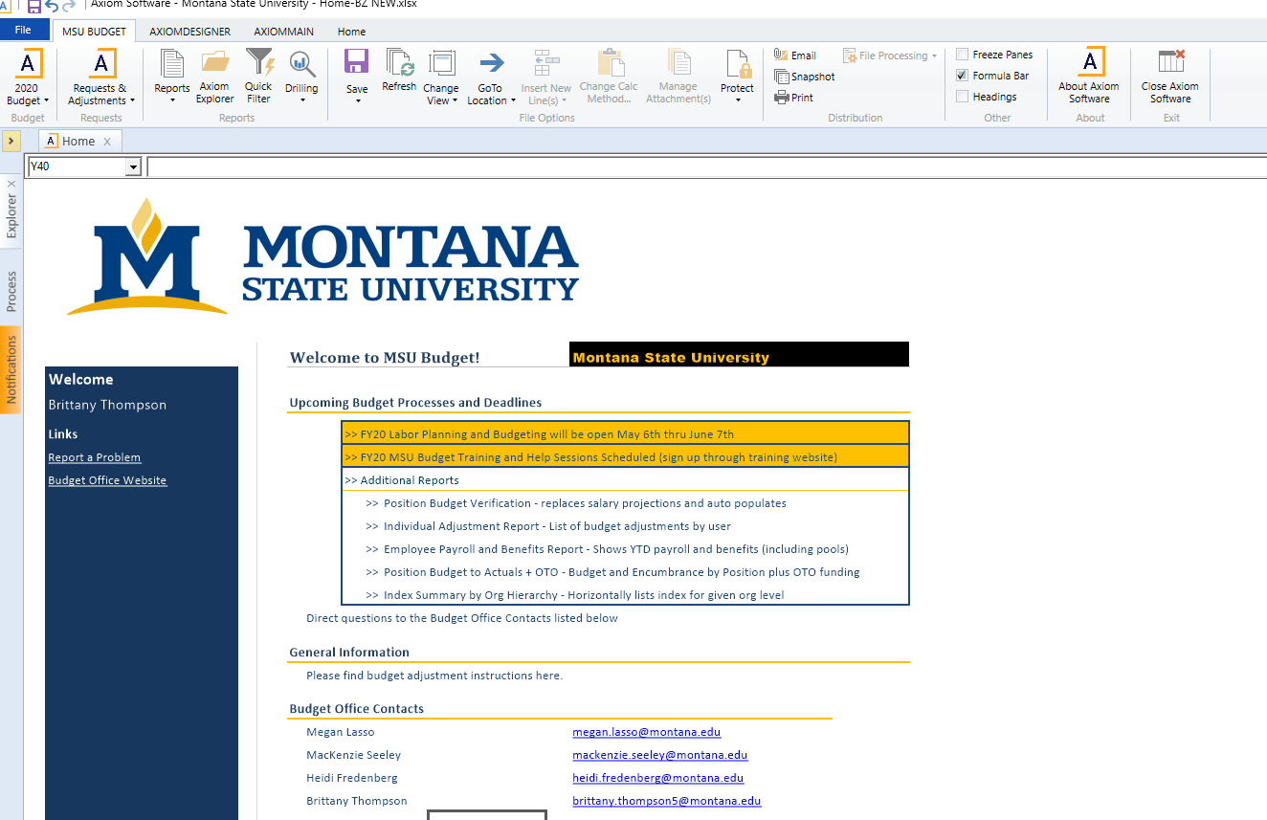
Running Initial report
- Expand your Axiom Assistant by click the arrow on the top left corner
- Navigate to Reports Library/Budget Reports/Budget Preliminary Summary
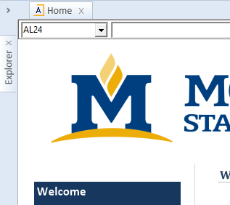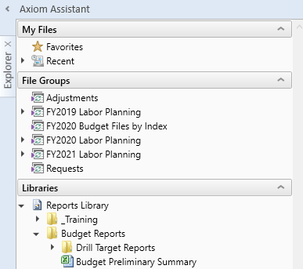
- Double-click the report and enter your full org or a wildcard version of your org (i.e. 4121, 435, 44 etc.)
  - Select current fiscal year
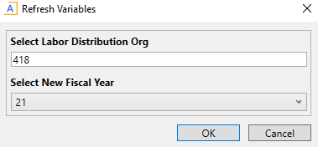

- The report will reflect your current proposed budget for FY21 by index, account and position. This is the starting point from which you can make changes.
  - If positions are budgeted, you will see position level information
  - For indexes that have revenue, you will see both a revenue and an expense section with a net total at the bottom
  - For indexes that don’t have revenue (current unrestricted), you will only see expense information.
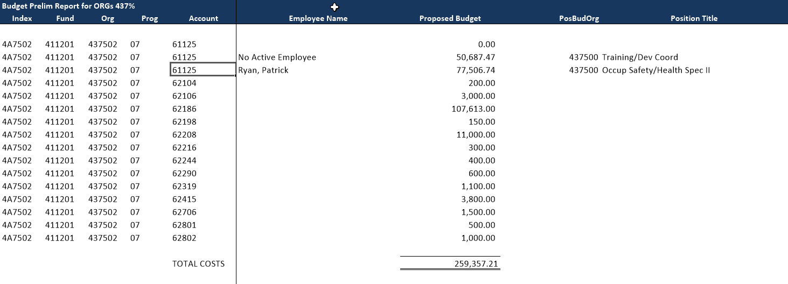

Updating Budgets in Labor Planning after Review
- The MSU Budget Tab at the top of your ribbon is how you will access your Plan Files
- To open your positions click on ‘2021 Budget’ then ‘Labor Plan’ then ‘Open Plan Files’
- This will bring up a list of the orgs for which you have access
  - Double-click on the org for it to open
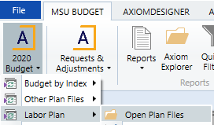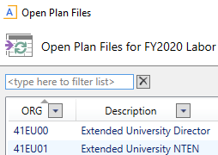
- There are 4 sections (separated by color) included in your labor planning data
  - Section 1: Information about the employee, index, account
  - Section 2: Payroll information for each employee as of the snapshot date
  - Section 3: Current budget information for each position/employee
  - Section 4: FY21 Proposed budget information which is where you can make updates
Screen s
C
*For single, filled, non-tenure-track faculty positions the payroll information is populating the budget information. The purpose is to more accurately budget across all fund types. All other positions are based off the Current Budget Snapshot.

- Single, filled position are at the top, then vacant positions, and then pooled positions
  - You can navigate to the sections above or to individuals using the ‘GoTo Location’ menu at the top
- Cells that are blue may be updated
  - To change the FTE select the blue cell under the “FTE column”
    - Changing the FTE will update the Proposed FY21 Budget amount for most filled, non-tenure-track faculty position. You can manually change these amounts after you update the FTE.
  - To change position budget, select the blue cell under “Proposed FY21 Budget”
    - This will update the dist % and populate a value in the “FY21 Increase or (Decrease)” column
  - To change the index double click on “Add New Index/Acct Combo (dbl click)
    - This will pull up an options box. Here you will type in the new index and account then select okay.
    - The new index will appear under the indexes already listed for that position
    - Changing the individual indexes in blue will not update the amount in grey because it is tied to actual pay rates
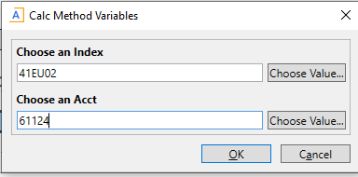
  - If adding a stipend to a position that doesn’t currently have one, you will need to reach out to the budget office to add this for you (budgetoffice@montana.edu).
    - A new account code, 61123D, was created this year to identify stipends for budgeting purposes (i.e. not payroll purposes). All stipend related splits need to be updated to this account code.
  - When adjusting positions be sure to use the blue boxes under the comments field with helpful descriptions in case you need to research an adjustment in the future.
  - Do not budget grant indexes; this is completed in a different process.

- EXAMPLE 1 (multiple splits with some grant funding)
- EXAMPLE 2 (single split with MSU Budget making a change to current budget)
- EXAMPLE 3 (faculty with a stipend and increases of market, merit, or equity that were effective on 02/01/2019)
- EXAMPLE 4 (employee with additional longevity in FY20)

Updating Revenue and Operating Budgets after Review
- To access the budget files, go to ‘2021 Budget’ then ‘Budget by Index’ then ‘Open Plan Files’
- Select the index you would like to work on and double click
  - Please note these are indexes and not orgs
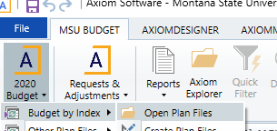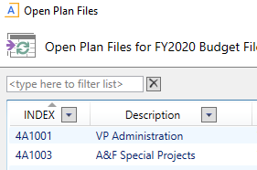
- The information from labor planning will pull over and is not updateable in these plan files. If you need to complete Labor Plan edits, close the Budget by Index file and re-open after you have saved the changes in the Labor Plan file.
- Current Budget Amount is used as the starting point for FY21 for non-position account codes.
- Cells that are data enterable are blue
- To update budgets, select the blue cells under “FY21 Proposed Budget” and enter the total FY21 proposed budget for each account code if different than what is showing. Be sure to update the blue boxes under the comment field with helpful descriptions in case you need to research an adjustment in the future
Tips and Reminders
- There are several reports available for your use in this process under Budget Reports:
  - Budget Preliminary Summary: shows total budgeted for FY21 in each index compared to revenue or allocation
  - List of People to Launch Labor File: If you are unsure where to find an employee, you can use this report to determine which POSBUDORG (i.e. Org for Labor Plan file) they are in
  - Prior Year vs Current Year Position Budgets: This report shows the difference in position budgets from FY20 end point to what is currently input for FY21

- Budget all indexes for which you are in charge and ensure you have enough revenue budgeted for non current-unrestricted-fund (CUF) indexes.

- Annualization of the FY20 pay plan for positions is calculated in the Labor Plan files. For CUF indexes, the FY21 pay plan will be centrally budgeted and distributed when needed. For non CUF indexes budget the total FY21 projected pay plan, based off a 1% increase on January 1st, 2021, in Account 61199. For large units please only budget the pay plan for all subunits in one index.

- If you are changing FTE in a CUF index, use 61199 (Admin/Prof) or 61299 (Classified) as a placeholder for the contribution to/return from the institutional benefits pool. Once budgets are finalized, the Budget Office will conduct a review of FTE/benefits to ensure appropriate funding and move money, as needed.

- For stipends, please update in “Stipend” section, similar to years past. If a new stipend is being added to a position, please contact the Budget Office to activate that part of the form. A new account code (61123D) was recently created for stipends to assist with reporting. Similar to the 61123R used for NSF/HERD reporting, it will be for budget purposes only.

- Admin Fee in 62889A will automatically be calculated for the indexes that are necessary

- Do not budget more than $5,000 in Account 62899

- Always log in to the Windows Client

- The preliminary timeline is to have units work on budgets for non CUF indexes between May 7th and May 29th. On May 29th, the University Budget Office (UBO) will provide CUF allocations to units. From May 29th to June 15th at 8 a.m., units will enter CUF index budgets. UBO WILL BE SHUTTING OFF EDIT ACCESS TO BOTH LABOR PLAN AND BUDGET BY INDEX PLAN FILES AT 8 AM ON JUNE 15TH.

