Annual Budgetin Process – MSU Budget (Axiom) Quick Reference Guide
Launch Windows Client in MSU Budget (Axiom) - https://montanasu.axiom.cloud
- Start by running the “Budget Preliminary Summary Report” – this provides an overview of the current proposed budget for all account codes and positions under the org for the new fiscal year compared to revenue or allocation
  - On the MSU Budget ribbon select Reports Budget Reports Budget Preliminary Summary
  - Enter the org or wildcard version of the org (i.e. 4121, 435, 44, etc.) and select new fiscal year

- After reviewing the “Budget Preliminary Summary Report”, update position budgets in Labor Planning
Annualization of the FY20 pay plan for positions is calculated in the Labor Plan files. For CUF indexes, the FY21 pay plan will be centrally budgeted and distributed when needed. For non CUF indexes budget the total FY21 projected pay plan, based off a 1% increase on January 1st, 2021, in Account 61199. For large units, budget the pay plan for all subunits in single index.
  - To open click on ‘2021 Budget’ then ‘Labor Plan’ then ‘Open Plan Files’
    - This will bring up a list of the orgs for which you have access
  - Single, filled position are at the top, then vacant positions, and then pooled positions
  - Cells that are blue may be updated
    - To change the FTE, select the blue cell under the “FTE column”
      - Changing the FTE will update the Proposed FY21 Budget amount for most filled, non-tenure-track faculty position. You can manually change these amounts after you update the FTE.
    - To change position budget, select the blue cell under “Proposed FY21 Budget”
      - This will update the dist % and populate a value in the “FY21 Increase or (Decrease)” column
    - To update the index double click on “Add New Index/Acct Combo (dbl click)”
      - Type in the new index and account in option box then select OK. The new index will appear under the indexes already listed for that position.
  - If adding a stipend to a position that does not currently have one, you will need to reach out to the budget office to add this for you at (budgetoffice@montana.edu)
    - A new account code, 61123D, was created this year to identify stipends for budgeting purposes (i.e. not payroll purposes). All stipend related splits need to be updated to this account code.
  - When adjusting positions be sure to use the blue boxes under the comments field with helpful descriptions in case you need to research an adjustment in the future
  - Do not budget grant indexes, this is completed in a different process
Example of Labor Planning Position Budgeting:
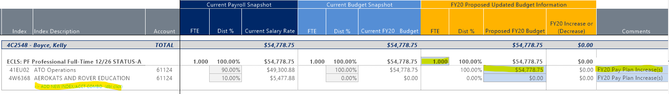
- Then update Revenue & Operating budgets
FY20 Current Base Budget amounts are used as a starting point for the FY21 non-position account codes.
  - To access the budget files, go to “2021 Budget” then “Budget by Index” then “Open Plan Files”
  - Select the index you would like to work on and double click - note these are indexes and not orgs
  - The information from labor planning will pull over and is not updateable in these plan files. If you need to complete Labor Plan edits, close the Budget by Index file and re-open after you have saved the changes in the Labor Plan file.
  - To update budgets, select the blue cells under “FY21 Proposed Budget” and enter the total FY21 proposed budget for each account code if different than what is showing. Be sure to update the blue boxes under the comment field with helpful descriptions in case you need to research an adjustment in the future
Example of Budget by Index Budgeting:
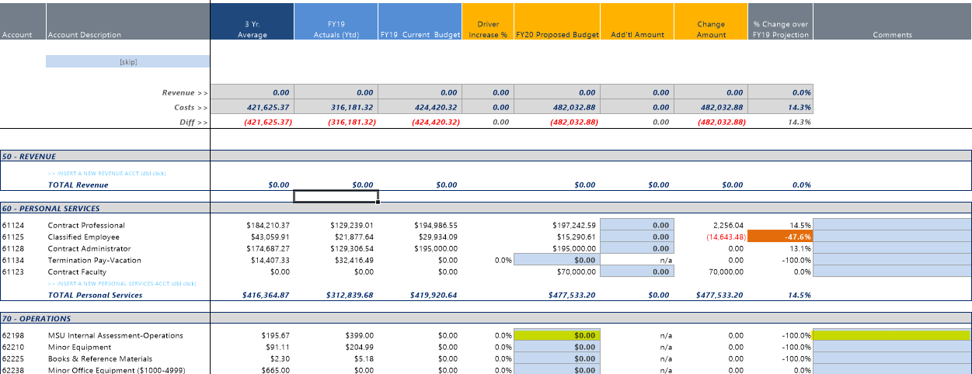

- Once you have updated your budgets, rerun the “Budget Preliminary Summary Report” to verify that the “New Year Budget” ties out to your allocations for CUF indexes (40,41,4A,4R,4S,4F,4EU), revenue matches expenses in restricted (gift) and agency funds (42 & 48) and ensure you have enough revenue budgeted in designated and auxiliary indexes (43, 44).

Additional Information
- Preliminary Timeline
  - May 7th to May 29th – Budget all non CUF indexes
  - May 29th – Receive CUF allocations from UBO
  - May 29th to June 15th at 8 a.m. – Budget CUF indexes
  - June 15th at 8 a.m. – UBO shuts off edit access to files
- Admin Fee in 62889A will automatically be calculated for designated indexes
- Do not budget more than $5,000 in Account 62899

