Preparing to Login to Montana State U Budget
- If using Mozilla Firefox or Google Chrome, you must first download an add-on. Use the following links:
  - ClickOnce Helper for Google Chrome and click on the ClickOnce for Google Chrome
  - ClickOnce Helper for Firefox and click on the FxClickOnce
- If using Internet Explorer, no additional download is necessary
Logging in to Montana State U Budget
- Navigate to https://montanasu.axiom.cloud
- Login using your NetID and Password
- Click on the Windows Client
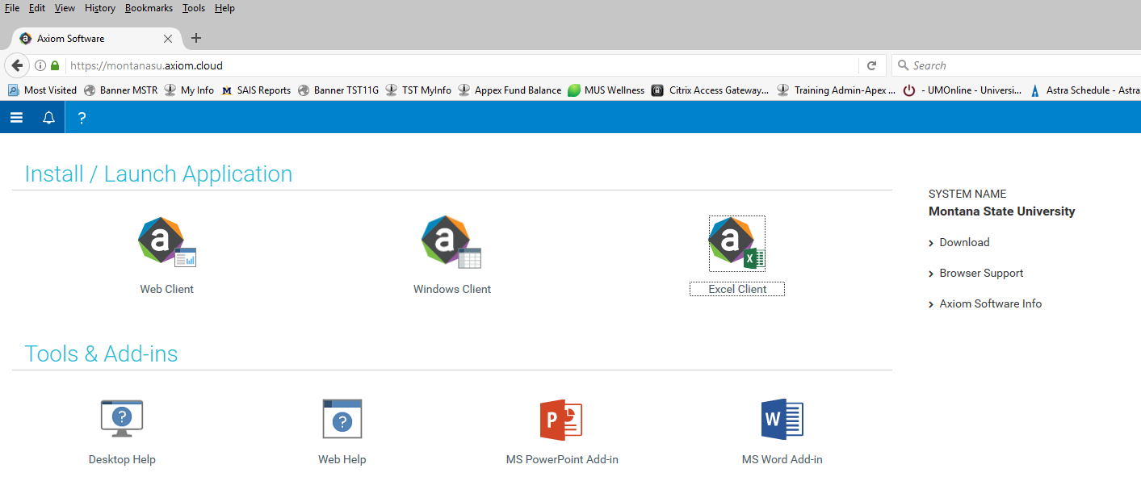
- If using Mozilla Firefox or Google Chrome, you will get the following popup. Click on the ‘ClickOnce Install’ which will launch the application and take you to the home page
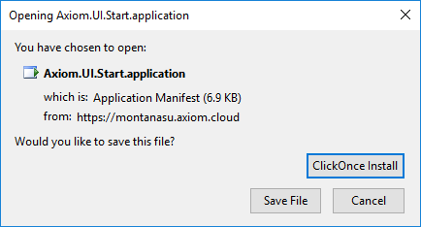

- The system looks a lot like Microsoft Excel or Microsoft Word. You have two options for navigation, one at the top and one on the left. To see more of your screen, you can hide the menu on the left by clicking the arrow by the words ‘Axiom Assistant’
2% Reallocation Files – Everything in on Request File
- Click on the drop-down menu under “Requests & Adjustments”

- Select ‘Open Existing Request’
- A list of requests that have your user ID will pop up. At this point, except for shared services, you will only see one file that is for entering the 2% reallocation. Everything should be entered in this one file.
- Select the request that has the name of your unit followed by the words “2% Reallocation”
  - It will open and you will see two tabs at the bottom, click on the Financials tab
  - Here you will find a place to enter approvers, target numbers, and section for details
- Enter approver names
  - If you have a Dean/Director that needs to see this request before it is submitted, please select their fiscal manager as the 1st approver. Otherwise, do not select.
  - For the 2nd approver, please enter the following, depending on your area:
    - Academic Affairs Megan Lasso
    - Student Success MacKenzie Seeley
    - Research & Ec Dev MacKenzie Seeley
    - UIT Megan Lasso
    - Athletics MacKenzie Seeley
    - Communications MacKenzie Seeley
    - KUSM MacKenzie Seeley
    - Other President MacKenzie Seeley
- To begin entering your index/account information, double click on the “Add new acct/index combo”
7) In the variable box, select and index/account code
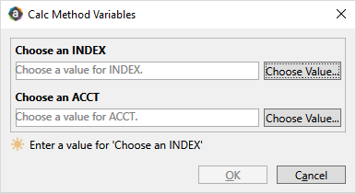

- Select Base or OTO in the drop down, depending on which you are reducing in the related index/account code

- Enter the dollar amount in the blue box under “Req. Amt”. Please enter as negative numbers.
- Continue following the steps above to add index/account combinations
- If putting amounts forward for shared services, please include the following:
  - In the comments use format “Position Number – Shared Service Type” (Example: 4M0000 – HR Shared Service)
  - Add FTE and associated position budget as needed.
  - Ensure “Base” is selected as the type
- When you are ready, click “Save” and Process Management will prompt you to move to next step
  - If you are still going to work on this file, select ‘Leave in current step’
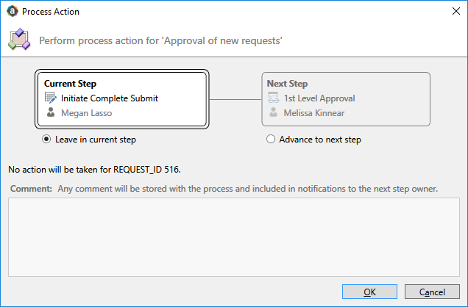

  - If you are finished with the file and ready to submit for approval, select ‘Advance to next step’. If you would like to include a comment, you can type it in the comment box.
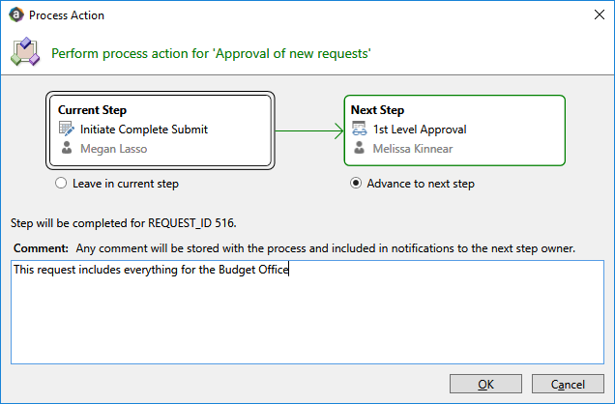
- Close the file when completed.

Strategic Investment Requests – Could Have Multiple Files (1 for each initiative)
- Once logged into MSU Budget, click on the MSU Budget tab in the top ribbon
- Click the drop down arrow and select ‘Reallocation & Investment Request’
- Enter the Title of the Request which should be associated with the strategic initiative
  - For Academic Units, please include all anticipated sections requests in one file
- Click Create
- This will take you to the “Info” tab which will need to be completed for each request. It includes a space to enter the following:
  - Narrative – describe the initiative and its impact
  - Primary Index – select an index by double-clicking on the 3 blue dots to bring up a list of indexes
  - Strategic Plan Metrics – Select at least one and up to 3 prioritized metrics
  - Assessment Plan – Describe how you will know if this initiative is successful or not
- When completed, go to the “Financial Details” tab
- Use the same logic as above for selecting a 1st approver and a 2nd approver
- For each individual request, a priority number must be assigned. If a single unit has 5 requests, they should be prioritized 1 through 5 using the box to the right of the request number
- You will enter index/account combinations as above by double-clicking on the Add index/acct combo
- Include a comment that describes that particular line, select base or OTO, add request amount as a positive
  - Please be sure to include FTE for positions associated with personnel
- When finished click “Save”
- Continue creating and prioritizing requests as needed for individual initiatives
Report for Summary
- To view a report with all of the information, navigate to the reports library.
- Under the Budget Reports file there is a report called “Reallocation & Request Summary”

