Spreadsheet Budgeting Steps in Banner for
Montana State University-Bozeman

Preliminary Banner Steps

Note: on NTRFINI, the "FEED BUDGET TO FINANCE BUDGET DEVELOPMENT" check box should be checked ONLY when processing position budgets from NBAPBUD to Budget Development -- this box must be Unchecked for ALL other processes. (Does not affect operations ledger upload into Budget Development -- appears to only affect position budgets.)

- Verify that new year has already been created in FTMFSYR (query first, then if necessary, create next Fiscal Year in Finance FTMFSYR for budget development)
  - In FTMFSYR, <ENTER QUERY> (F7)
  - Type in needed fields: COA: 1 FS Yr: 06
  - <EXECUTE QUERY> (F8)

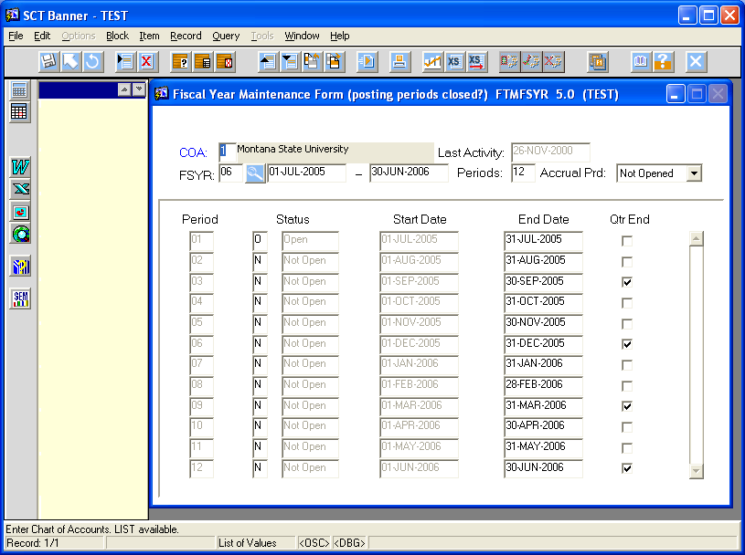

If new year (FY06) does not exist, then create it:
  - Repeat Steps a through c above, querying for current year 05
  - <INSERT RECORD> (F6)
  - <DUPLICATE RECORD> (F4)
  - Change the FSYR to new year 06
  - Type in the date: 01-JUL-2005 and the end date will default in
  - <NEXT BLOCK>
  - The first day of the month will appear for the first month of the new year (July 1) and the rest of the year SHOULD appear automatically
  - The "quarter end" box should be checked for only Sept, Dec, Mar, and Jun
  - SAVE and EXIT

- Verify in NBAFISC that the next year is there and the current fiscal year is the "active" year. If new year is not there, create it:
  - In NBAFISC <NEXT RECORD> to empty line or <INSERT RECORD>
  - Type in the new year: 2006
  - COA: 1
  - TAB across to automatically bring in dates
  - SAVE record and EXIT

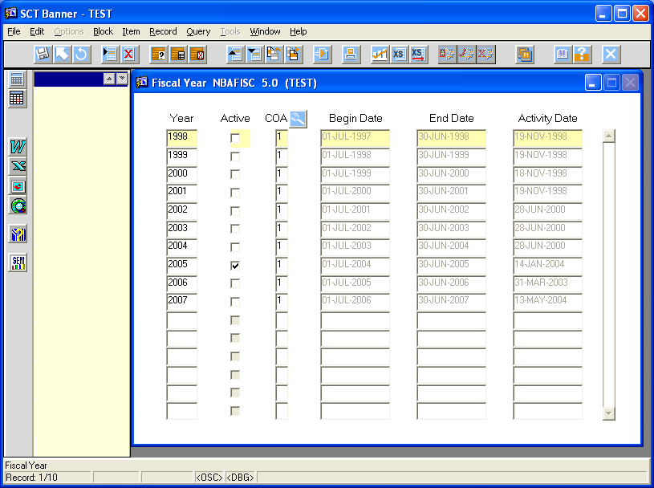

- Verify in NTRFINI that the next fiscal year already exists (do NOT use Fiscal Year drop box to select new year, use ↑ and ↓ ARROW KEYS) and check the "Feed Budget to Finance Budget Development?" box, then SAVE (will be unchecked later, after running specified processes).
If new year does not exist, create it for budget development as follows:
  - Click on COPY PRIOR YEAR option at left, and message will appear "Enter the values of the old year and chart when prompted for Query, then Execute Query" Click on OK
  - Fiscal YR: 2005 (current year to be copied to new year)
  - COA: 1
  - <EXECUTE QUERY> and message will appear "Copying record forward to new year"
  - Click on OK.
  - Check the "Feed Budget to Finance Budget Development?" box (VERY IMPORTANT!), compare parameters to sample shown below, SAVE, then EXIT.

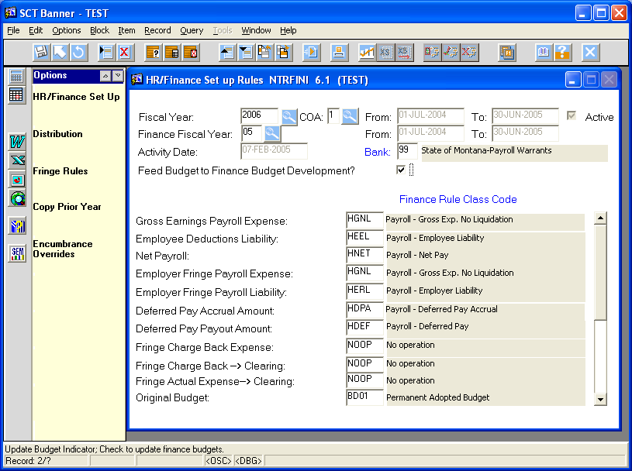
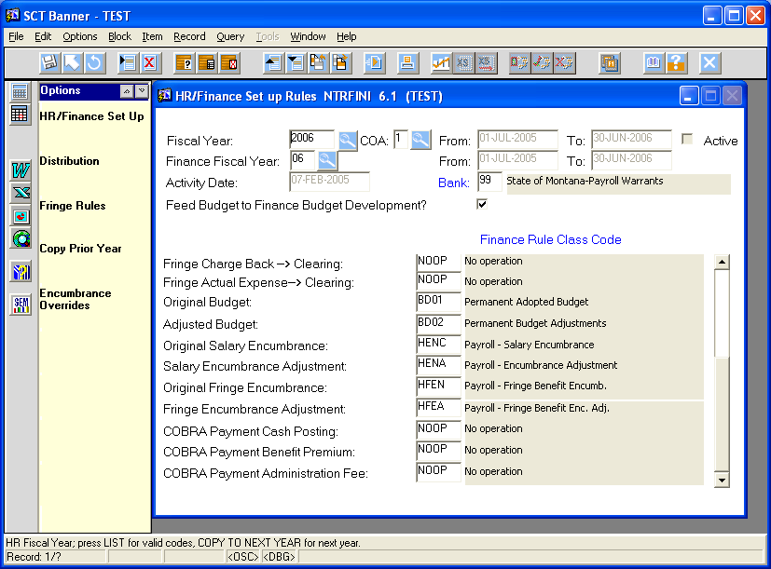

The "Feed Budget to Finance Budget Development?" box can be unchecked after NBPBROL has completed. Uncheck this box to process payroll -- if checked, it will populate GURFEED with position budget data with each payroll. But it must be checked to roll budget into Budget Development.
Keep in mind that Position Control will ONLY feed WORKING budgets to budget development.

- Create budget ID's and phases in FTMOBUD.
After FTMOBUD opens, initiate a query (F7), then click on Budget ID flashlight. Select new year (FY06), then OK, then execute query (F8) to bring up new year. If new year is not there, click on current year and print out a copy of the screen showing how it is listed. Cancel out and go back to the regular screen, starting over. When FTMOBUD opens, enter new year data (follow example of previous year you just queried and printed out), then click on SAVE (see specific steps below). When you query it, it should be there.
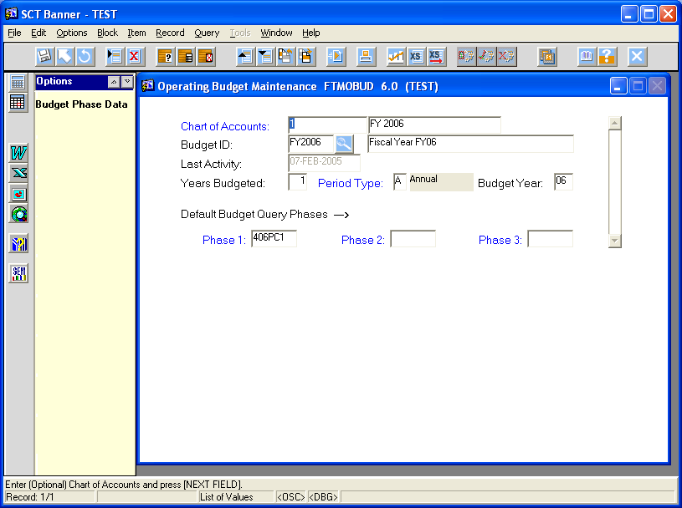
Any number of phases are allowed and can be created now or any time later (form allows for three "default" phases, which can be a pain if you use subsequent phases more frequently -- may wish to leave "default" phases blank). Can also delete phases in FTMOBUD, once the phase has been cleared of any budget data (use RECORD REMOVE key after second phase sheet has been called up). Phase names are allowed only six spaces, and (at this time) will be set up as follows or following the following "pattern." You will need at least one phase for the Position Control download. The current-year budgeted positions must be rolled to the new year, and into a phase, before you can download them. Operations data can be downloaded directly from the current or any past year and won't need a phase until you want to validate or upload them. So create at least one "new year" Position Control phase at this point.
Fund Entity Budget Year Type Phase # Phase Name
0 ES FY06 Position Control 1 006PC1
1 FSTS FY06 Position Control 2 106PC2
3 Great Falls FY06 Operations Ledger 3 306OL3
4 Bozeman FY06 Combine PC & OL Final 406CF
6 Billings
7 Havre
9 AES
A All units FY06 Combine PC & OL Final A06CF

If phases have already been set up for new year, to see them INITIATE QUERY (F7), click on Budget ID flashlight, click on new year, then EXECUTE QUERY (F8). Then click on "Budget Phase Data" on the left to get to those phases. Use UP ARROW and DOWN ARROW to view phases. To add phases to existing phases, use F6 and F4 to create and copy to a new record, then edit that new record for new phase. SAVE and exit.
To enter new year and set up phases:
- Do an F7, click on Budget ID flashlight, highlight new year, OK, then F8 to bring up new year. Then click on "Budget Phase Data" at the top left to get to any existing phases. Use arrow up and down keys to scroll through phases.
- If new year is not listed, note the existing Budget IDs and Budget Titles, click on CANCEL, and enter it on the main menu. Budget ID is FY2006, and name is Fiscal Year FY06. Chart of Accounts is 1 and Short Title is FY 2006. Enter a "1" for Years Budgeted, an "A" for Period Type, and an "06" for the new Budget Year.
- Can also INITIATE QUERY (F7), enter Budget ID for new year, and then EXECUTE QUERY (F8).
- SAVE record.
- Click on Budget Phase Data to the left to bring up Budget Phase Information window. This will bring up all previously-created phases, window by window (use directional arrow keys), or a new window to enter your first phase. You can use F6 and F4 to copy/save for additional new phases. May work better to SAVE after creating each new phase, arrow down to new form, COPY PREVIOUS (F4), edit it, then SAVE again.
- Enter new Budget Phase name: 406PC1 and title: Bozeman FY06 PosnCtrl #1
- Sequence number will be automatically generated.
- Tab and enter Short Title: Bozeman FY06 PC #1
- Open Status: CHECK for open (uncheck for closed only for the approved final phase of the budget AFTER it has been rolled completely into the operating ledger. This is how you can freeze a specific budget phase.)
- Activation Date: Normally left blank. Enter for the FINAL APPROVED BUDGET PHASE only, usually the first day of the next fiscal year, 01-JUL-2005.
- Chart of Accounts: 1
- Budget Rule Class: BD10 (Budget Development Request)
- Finance Rule Class: Normally left blank. Enter BD01 only for final approved phase which is to be rolled into the operating ledger.
- Base Budget ID: Leave blank.
- Base Budget Phase: Leave blank.
- Measurement Type: Enter "D" for dollars (Can use "H" for hours for labor-type accounts)
- Phase Period Type: Enter "A" for annual
- Click on the following boxes:
  - Allow Summary Codes
  - Display Comparative Data
  - Accumulate Budget
- On the main FTMOBUD form, you can (if you wish) identify the default budget query phases, or just EXIT. To enter default phases, click in empty fields and enter phase names or double-click to choose one. SAVE and EXIT.

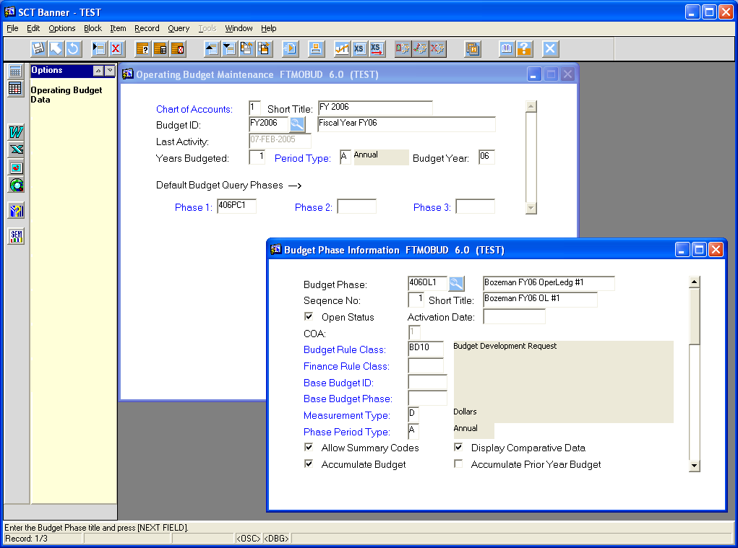

- Check a position in NBAPBUD, under "Position Budget Information," to verify that "Budget Roll Rules" have been set to appropriate choice -- we want CURRENT BUDGET setting so that current budgeted amounts and FTEs will be rolled to the new year. A special script will need to be run to change this setting (MSU-Connie Hupka). Position salaries will have been updated and corrected by departments and through the salary projection process, so starting with current data will be easier for departments to update than starting with all positions at zero (which was the "Zero" setting will do).
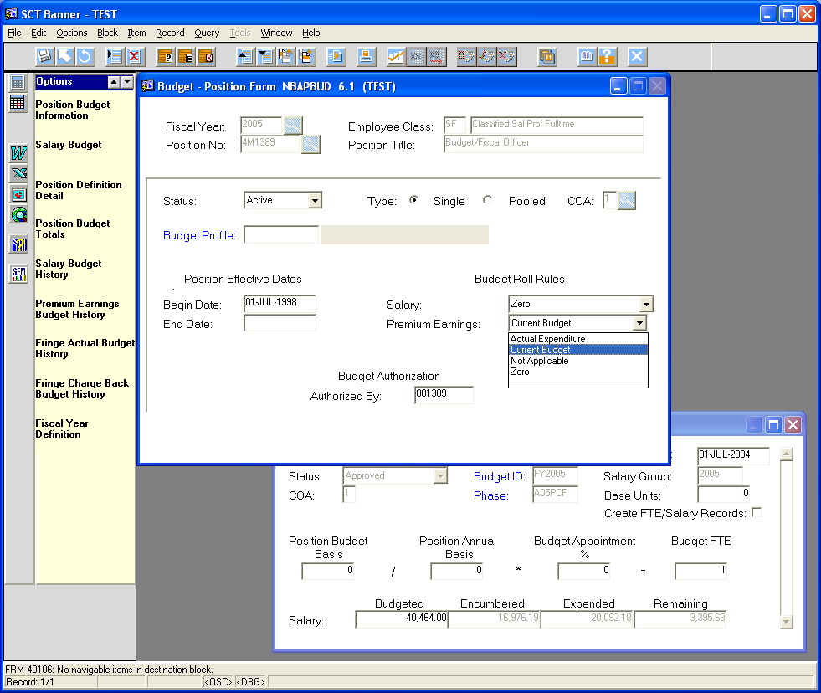
All positions need to be moved to
CURRENT BUDGET

- Check NTRSGRP to make sure new salary year has been built. (MSU Personnel & Payroll Services-Gretchen if it is not there for each salary group). To add new salary years, for each type highlight the most recent year, do F6 then an F4. Edit the year in the new duplicated line, then SAVE (activity date will automatically correct itself) or SAVE after doing all of them.
- Make sure the Setup Mass Salary Roll Table NTRSTRL has been processed. (MSU Payroll Services)
NTRSTRL -
- At top "Roll From Salary Group:" click on flashlight and choose current year, then SELECT; then for "To:" choose new year, then SELECT. Click on NEXT BLOCK to enter next section.
- For "Salary Table:" click on flashlight and select first current year table (that would be 2005 Administrator/Professional - Salary Table AP), then SELECT.
- Enter "Percent Increase" using a zero if unknown or variable by grade (optional if an amount is to be entered).
- Enter Amount of Increase, using a zero if not applicable (optional if percent is entered). Both percent and amount can be entered. The percent is applied before the amount is added.
- For Rounding use “None” for all except Crafts (CR) and enter nothing in the Round Amount By: cell ("null"). For Crafts, use “Nearest” and Round Amount By “.01”
- Check box for "Change All Grades?" or manually enter Applicable Grades.
- Hit F10 to populate grades and save record.
- Use down arrow key ↓ to get to next record for further entry.
- Repeat for each Salary Table to be updated. (It appears all must be updated even though SCT documentation says not.)

- Make sure the Mass Roll Process NBPMASS has been run, which will update the salary tables. (MSU Payroll Services)
NBPMASS – to create new NTRSALA records for the new fiscal year
Note: Run first in Report Mode (R) for an opportunity to preview the results before updating the tables. When Report has been reviewed and approved, run NBPMASS again, changing parameter 01, Report Mode to (P)rocess/Update tables to process the actual updates. Use NEXT BLOCK to move from one section to another, clicking on SAVE at the end, which will cause program to process.

Printer: either enter printer code or "database" if you don't want a printed report

Parameters:
- 01 Report Mode: (R)eport or (P)rocess/Update Tables
- 02 Process : (U)pdate table/grade/steps
- 03 Job Change Reason Code: Blank (not updating Jobs now)
- 04 Salary Group (From): old year (for example, 2005)
- 05 Salary Group (To): new year (for example, 2006)
- 06 Rule Set: Blank (not needed now)
- 07 Personnel Change Date: Blank (not updating Jobs now)
- 08 Use Population Selection: (N) for No
- 09 – 11 all Blank

Submission: click on "Save Parameters" to save current parameters, then click on SAVE to save and execute process. To review output, click on Review Output > "Number" > and then the appropriate log or list file.

Processing Notes:
- All salaries/rates on form NTRSALA are updated for the new fiscal year based on the parameters entered on NTRSTRL when NBPMASS is run in the (U)pdate process. Manual entries to NTRSALA should only be needed if changes in the structure of the salary group are required. (EX: Foremen in Crafts usually receive a dollar amount increase above the Journerymen). After NBPMASS, (U)pdate process is completed, view the records on NTRSALA by entering the new year.
- If a particular table is not rolling, verify the table was set up correctly on NTRSTRL.
- The old year records on NTRSALA are not deleted by the process.
- No changes will occur at this time on any NBAJOBS records.
- NTRPCLS and NBAPOSN will not reflect the new salary groups until the NBPBROL process is run to roll budgets from “working” to “approved” status. Budget Office process NBPBROL.

- NBPBROL - Roll initial Working Budget from current year to new year. (Can run multiple times to multiple phases.) This process will roll all ACTIVE positions to working status for the new fiscal year, including any adjustments made on NTRBROL. Use "NEXT BLOCK" to move from one section to the next. Use "DATABASE" for "printer." Parameters to be used are:
01 Fiscal Year - new year (2006)
02 Budget Id - new year (FY2006)
03 Budget Phase - new year phase (406PC1) or whatever phase you want it rolled to
04 Current Fiscal Year - current year (2005)
05 Chart of Accounts Code - 1
06 Salary Group Code - new year (2006)
07 Report Choice - "R" to roll the budget from current year to new year
- Verify new working budget for new year in NBAPBUD
- OPTIONAL: A Really good option. Roll initial position control phase to budget development.
  - Run – NHPFIN1, NHPFIN2, and FBRFEED. Make sure NTRFINI has new year chosen as Fiscal Year and Finance Fiscal Year and that "Feed Budget to Finance Budget Development?" box is CHECKED. (Need to use GJIREVO to verify processes in NHPFIN1 and NHPFIN2 after getting out of them)

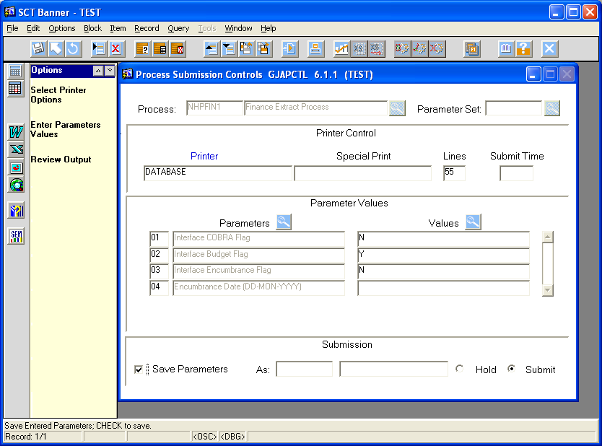
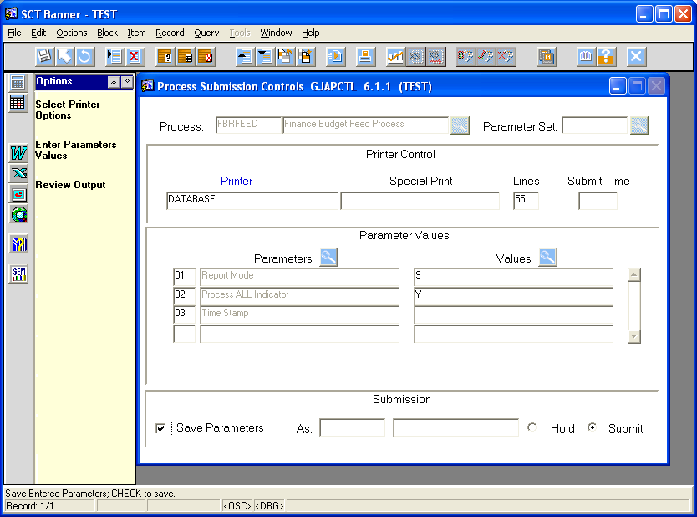
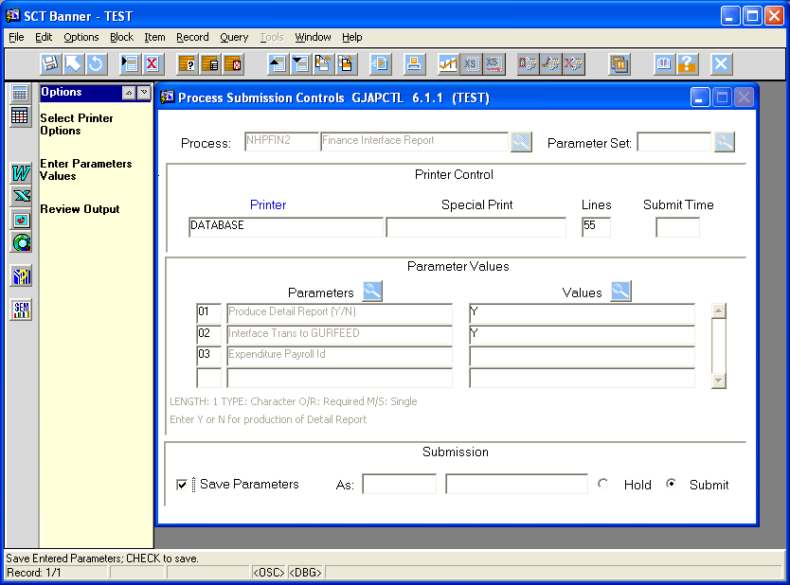

  - Verify on FBIBUDG that the phase is now in Budget Development (must tab through all the fields), Next Block to get data, then Next Block again to get totals.

Spreadsheet Budgeting Steps

Download Position Control
- Open a new Excel spreadsheet or workbook.
- Launch Excel Banner menu should be in the menu bar ("Banner"), to the right of "Help" at the top. If not, see "Appendix A - Instructions for Excel Icon" and "Appendix B - Instructions for Client Install of Spreadsheet Budgeting." Our biggest problems were in individual employees getting adequate "security" clearances to access everything.
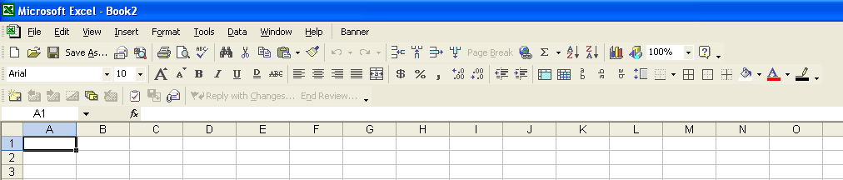
- Click on "Banner" > "Connect to Database."
- Enter user name, password, and database to which you wish to connect, then click on "Connect." Everything should "disappear." When you reclick on "Banner" up above, you should now have the options of disconnecting from the database, or going into Spreadsheet Budgeting.
- Choose Spreadsheet Budgeting > Download Wizard.
- Select "Position Control" > "Next."
- Choose the top option, "Position Control and Employee Job Assignments," when asked which Spreadsheet files you'd like to create. Then click on "Next."
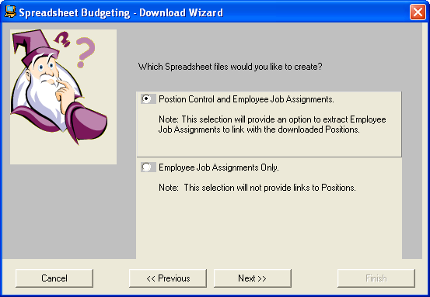
- Choose the parameters you want from the menus offered.
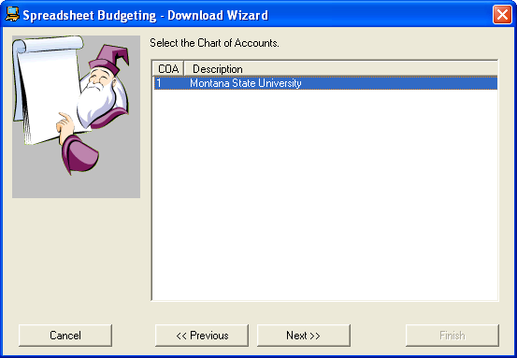
- The next menu will ask you what year you wish to download from. You should have already rolled positions from your current year to the NEW fiscal year, and that would be the year offered in the menu.
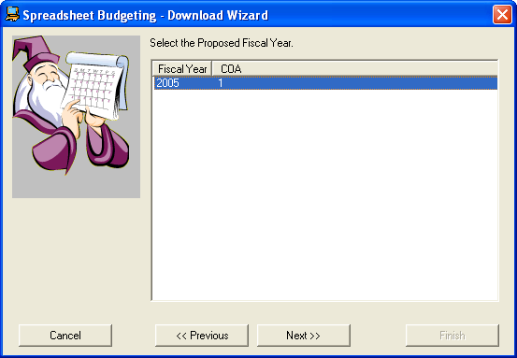
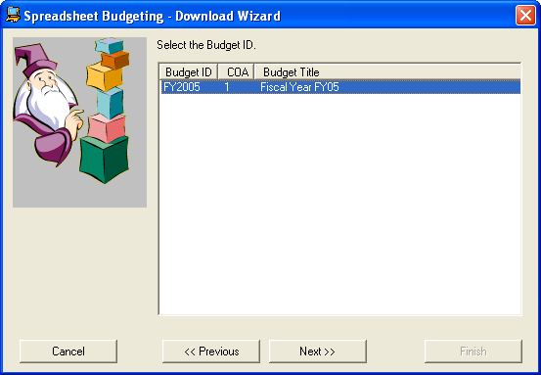
- The next menu will ask you to select the Budget Phase for the requested Budget ID, listing all the phases currently available. Select the appropriate phase you wish to download FROM (would normally be the phase you rolled current year positions INTO for the new year).
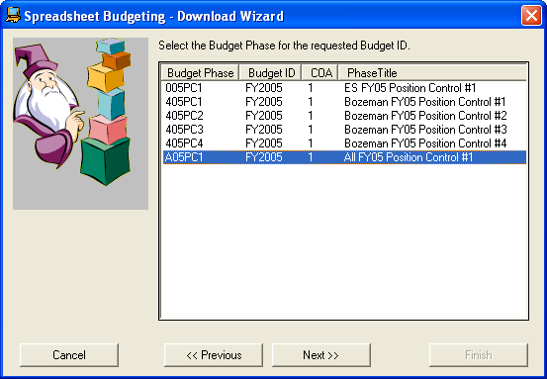
The next menu will ask whether or not you wish to download employee job assignments that match positions -- to be safe, click on YES.
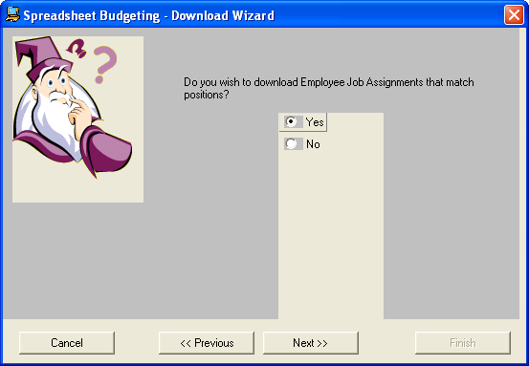
- The next menus will ask for a selection date and data grouping. We used April 15, which is BEFORE most 9- and 10-month staff terminate for the summer. If you use June 30, it will not pick up any academic year staff terminating before that date.
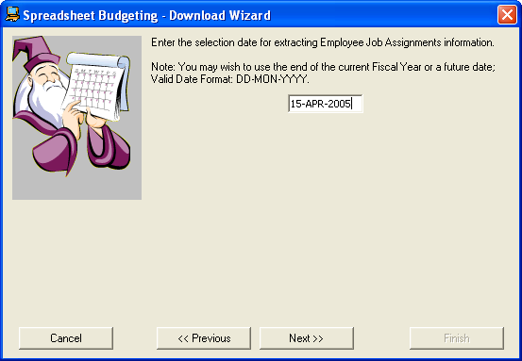

MSU's preference for data grouping is the "Job, Salary, and Salary Table Information," but it can be customized by choosing the second grouping "Customize your data elements . . . "
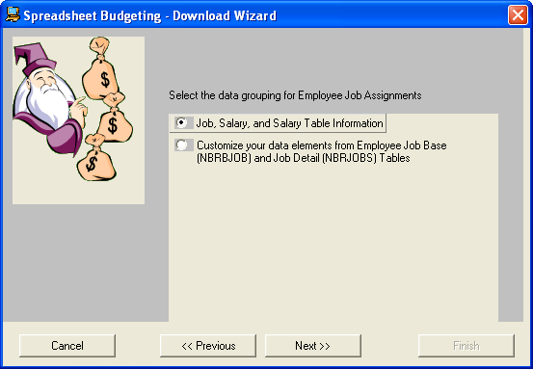
- The next menu will ask you to choose employee classes you want, in order to limit the download. By not choosing any, you will get ALL employees in ALL those classes. So choose one or more only if you want to exclude all the rest.
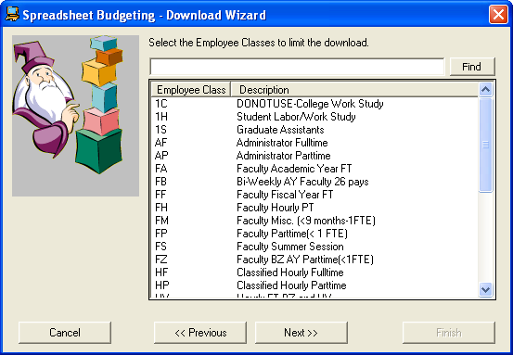
- The next menu will allow you to limit the ORG choices to specific orgs. You'll get all of them unless you choose specific ones -- after leaving it alone (not choosing any) or choosing the specific ORGS you want, click on FINISH to proceed. The download wizard will then download all the requested data into your open spreadsheet. Keep in mind that trying to download EVERYTHING for a large institution may be too much for Excel's capacity.
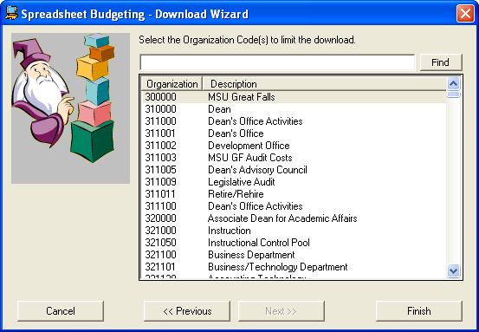
- When complete, the Download Wizard will have downloaded five new spreadsheets: EMPLOYEE JOBS, FRINGE BUDGET, PREMIUM BUDGET, LABOR DIST., and SALARY BUDGET. After downloading, delete the original sheets "Sheet1," "Sheet2," and "Sheet3." (When you download the operations ledger later, you should do it into this existing spreadsheet, creating a new labeled spreadsheet, so you will not need Sheet 1, Sheet 2, or Sheet 3.)
- Each of the individual five position control worksheets must retain specific columns and/or column headings in them. The first three, Employee Jobs, Fringe Budget, and Premium Budget do not need to have any DATA in them, however, but you must keep column headings marked with a * below. You will actually not need to retain the Employee Jobs worksheet, but will need it to provide employee names and other information as you build your "working" spreadsheet. The validation and upload process will not ask for anything from the Employee Jobs spreadsheet.
- You will have a plethora of columns of data in each spreadsheet. Delete what you won't need (use the table below as a guide). You're going to build a master spreadsheet, which will then be used to update and manipulate data, so some of these columns will be necessary to that process, but will not be necessary for the final upload.

Download Operating Ledger
- Launch Excel Banner menu, which should be in the menu bar
- Use download wizard

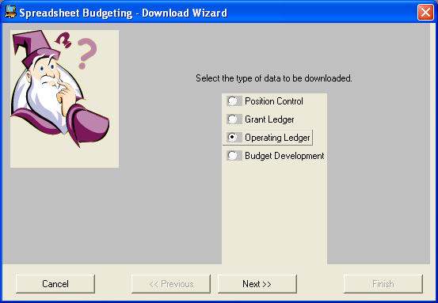
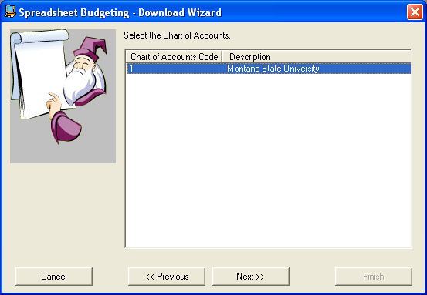

- From the next menu, select the year you wish to download FROM (which is NOT the new fiscal year as in the Position Control download). This is usually the previous or current year, to capture current or previous budgets and/or expenditures.
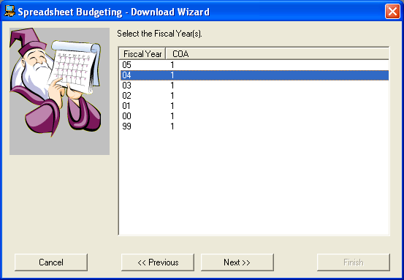

- From the next menu, select the desired Fiscal Period -- usually "14," as this will include all YTD data (selecting Fiscal Period 01 will give you only July's data).
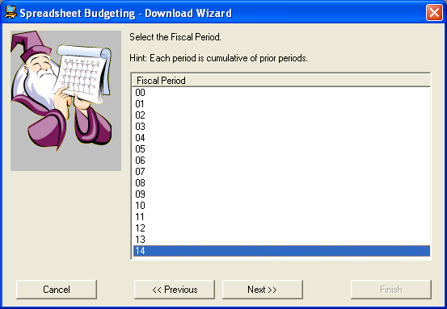

- The next menu allows you to stipulate the type of data to be downloaded. Click on any that you wish to download. For BUDGET data, choose the following three: Adopted Budget (all BD01's), Budget Adjustment (BD02's and BD04's added together), and Temporary Budget (BD04's). For ACTUAL EXPENDITURES, choose Year To Date Activity (although that will only give you YTD expenditures or activity through the current date). Even if you select budget data only, you're still going to get YTD activity with zeros, whether you want it or not! These should eventually be deleted from the spreadsheet.
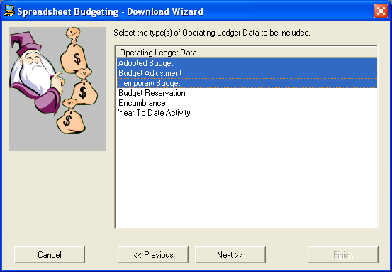
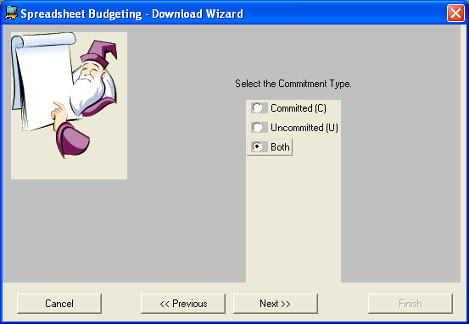

- The next menu is simply telling you that you can still narrow the download process down by clicking on NEXT. If you want everything from every agency and campus for the year selected, just click on FINISH. But if you wish to narrow it down by fund and org, click on NEXT.
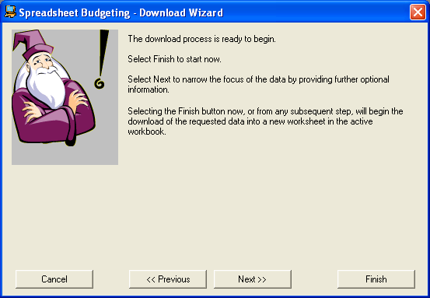
To select ALL options, either leave it alone with no selections and click directly to "Next" or "Finish," or select individually, select as a group, or enter a code in the "find" box (can use % as wild card). Selecting absolutely EVERYTHING may be too much for your Excel program and may be very unwieldy -- we found it best to download "sections" of data, either by fund or org.
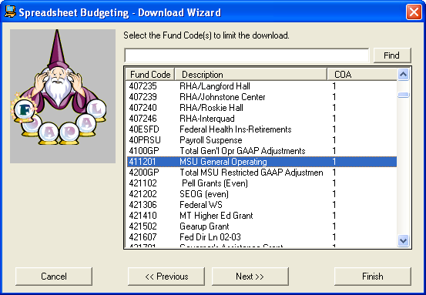
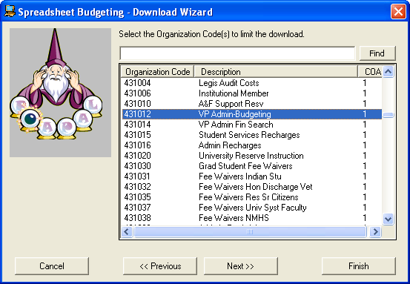

- On the next four menus, you can limit the ACCOUNT, PROGRAM, ACTIVITY and/or LOCATION codes by highlighting them, or just leave them alone and let them all download by clicking on NEXT in each menu. After the choices of LOCATION codes, click on FINISH.
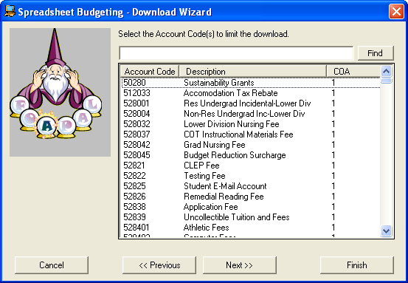
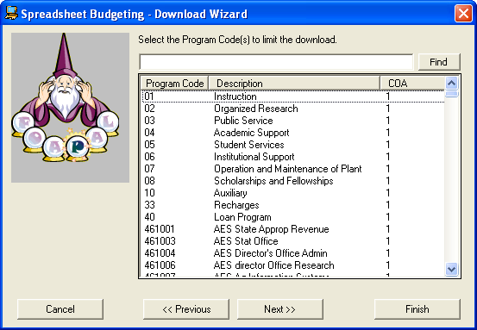
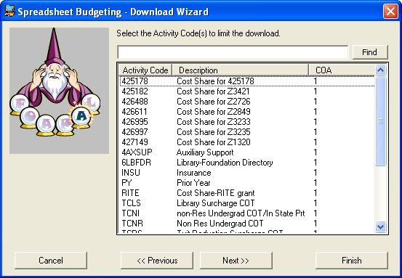
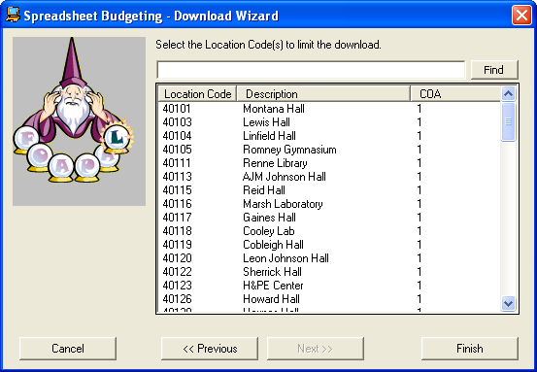

- You'll get a new "Operations Ledger" spreadsheet. Move this new spreadsheet to the end, following the five Position Control spreadsheets. It will include all account codes which had ANY activity in them (not just budget), but with zeros for totals. Insert new column to the right, insert formula to ADD "adopted budgets" (all BD01s) PLUS "budget adjustments" (all BD02s and BD04s) MINUS "temporary budget adjustments" (just BD04s). Copy down. Once calculated, copy the column cells and paste as values; relabel this new column (now containing only BD01s and BD02s, or just BASE adjustments) as "Current Year (FY2005) Adjusted Base Budgets," then delete original three columns. You can also insert another new column to the right for the NEW YEAR budgets, using the existing one (just created) as a guide. Be sure you select the correct column for uploading, so label clearly. Sort for amounts in those columns and delete all "zero" total lines. Resort as desired (by FOAP, position, etc.).

REQUIRED SPREADSHEETS and REQUIRED COLUMNS/HEADINGS
Employee Jobs | Fringe Budget | Premium Budget | Labor Distribution | Salary Budget | Operations Ledger
Position Number | * Benefit Code | *Position Number | *Fund | *Org | *Fund
Employee Name | * Position Number | *Earn Code | *Org | *Position Number | *Org
 | * Fringe Budget | *Earnings Budget | *Pgm | *Budget FTE | *Pgm
 |  |  |  | Position Status | *Acct
 |  |  | *Acct | *Salary Budget Amt | Acct Description
 |  |  | *Position Number | *Posn Budget Basis | *Operations Budget Amt
 |  |  | *Distribution Budget Amt | *Posn Annual Basis | *Activity Code
 |  |  | *Activity Code | *Budget Appt % | *Location Code
 |  |  | *Location Code | *Base Units
 |  |  |  | *Create FTE/Salary Record

FORMAT AND MANIPULATE DATA:
- All columns in all spreadsheets should be formatted as follows (don't worry about Employee Jobs worksheet as it won't be uploaded):
a. Format all budget dollar amounts, percentages, and FTE are NUMBERS, along with columns labeled "Position Budget Basis," "Position Annual Basis," Budget Appointment %," and "Base Units" as NUMBERS (shown in GREEN ITALICS in above table)
b. All other data is TEXT (shown in RED in above table)
- Because the Position Control download is based on ORGANIZATIONS rather than specific Funds, all the data will need to be "pulled together" before Index numbers can be assigned (an Access Report, for instance, will pull the Fund and Org codes from the "Labor Distribution" sheet and the Salary Budget Org from the "Salary Budget" sheet. The Index assigned will be based on the Labor Distribution Fund and Org, as the Salary Budget Org may differ -- and in this case, the Salary Budget Org should be changed to match the Labor Distribution Org.
- Employee Jobs worksheet: While this spreadsheet will not be "called for" in the validation or upload processes, it is the only worksheet that matches Position Numbers with Employee Names. You can delete all columns except POSITION and EMPLOYEE NAME. Sort by Position Number, then review carefully for all duplicate position numbers. Delete all duplicate non-pooled positions so that each position appears only ONCE. For pooled positions (usually begins with 4?6xxx, as in 4S6123), delete all but one and replace the employee name with something like ADJUNCT POOL, STUDENT POOL, TEMP LABOR POOL.
- The Fringe Budget worksheet can have all columns deleted EXCEPT for "Benefit Code," Position Number," and "FY05 Base Budget." All data can be deleted as it is not required for the Upload process, leaving just those three column headings.
- The Premium Budget worksheet may have no data in it. All columns can be deleted EXCEPT for "Position Number," Earn Code," and "Earnings Budget," leaving just those three column headings.
- Labor Distribution worksheet: contains all the FOAPAL elements (and will be used for reporting purposes to add Index Numbers and Index Descriptions). The columns which must be kept are: "Fund," "Org," "Pgm," "Acct," "Activity Code," "Position Number," "Salary Budget," "Distribution Budget," "Distribution Percent," and "Location Code," and there must be data in those required columns. Relabel the "Org" column as "Labor Distribution Org."
- Salary Budget worksheet: Can delete all but the following columns: "Org" (relabel this "Salary Budget Org"), "Position Number," "Budget FTE," "Position Status," "FY05 Base Budget," "Posn Budget Basis," "Posn Annual Basis," "Budget Appt %," "Base Units," and "Create FTE/Salary Record," and must have data in all of those columns. Use a zero if there is no data.
- Sort by Position Status and delete all FROZEN positions.
- Operating Ledger: can delete all columns except Fund, Org (relabel "Operations Ledger Org"), Pgm, Acct, Activity Code, Location Code, and the three "budget" columns: "Adopted Budget Amount for Period 14," "Budget Adjustment Amount for Period 14," and "Temporary Budget Amount for Period 14."
a. These last three columns represent BD01s, BD02s+BD04s, and BD04s respectively. Insert a new column to the right, and insert a formula that adds the first two column cells and subtracts the third (BD01 + BD02/BD04 - BD04) so the new column will contain only the Adjusted Base Budget for the current year -- label the column FY05 Adjusted Base Budget. Copy down all the cells in the new column and "paste special" as values, then delete the previous three columns.
b. Insert a new column to the right and label it FY05 Operations Budget. This will be the column that will be populated with the new year's budget amounts and ultimately uploaded into Banner -- the previous FY05 column becomes merely a guide and can be ultimately deleted. Can also budget in the FY05 column and keep just that one, but be sure to relabel it.
c. Sort by adjusted base budget amounts and delete all rows with zero budgets (the download pulls all financial transactions also, not just budgets).
d. Sort by account code and delete all rows with account codes tied to specific positions, leaving only the few non-position-related account codes and benefit codes.
e. Sort by Fund, Org, and Program.
f. Make sure that columns match the Labor Distribution worksheet, as you're going to copy the Operating Ledger worksheet data into the Labor Distribution worksheet. Or you can copy column by column.
- Because Banner will only issue paychecks for positions ultimately uploaded into Banner, we must be careful that ALL valid positions be retained and eventually uploaded. Sort by "Position Status," segregating into separate files all non-active status positions. Then segregate and save in a separate file all Grant Indexes 425xxx, 426xxx, 427xxx, 428xxx, and 429xxx. These will be uploaded later with zero budgets and FTEs so that they will allow paychecks to be generated, but the position will not be budgeted.

PREPARE THE SINGLE WORKSHEET for distribution and entering of budgets:
- If distributing budget worksheets to other agencies, campuses, or departments to complete, and you're budgeting both positions and operations, you'll want to combine data into one spreadsheet through an Access program or by copying and pasting from each individual worksheet.
- See Appendix C for suggested and required columns for single combined worksheet. Set up the new spreadsheet with the same columns, adding additional columns as needed. This will depend on how much current or prior year budget information you wish to include as a guide, how you wish to show split positions, etc. You must insert new columns for FY05 TOTAL BASE BUDGET, FY05 POSITION FTE, Distribution Percent (Splits), and FY05 Base Budget. You may also need an additional column against which departments budget, a "total allocation" or "budget authority."
- Sort by Position Number so that you can work with all positions at once (operations will be at the bottom and are not affected).
- The FY05 TOTAL BASE BUDGET and FY05 POSITION FTE columns will be filled in by the department, so leave them blank (format for whole dollars and three decimal places for FTE). The data in the Distribution Percent column is picked up from the Labor Distribution worksheet.
- Insert a formula into the cells under Budgeted FTE (Splits) which will multiply the Distribution Percent times the Position FTE. Copy down for all positions.
- The Total Budgeted FTE column will be used by the departments and the Budget Office to total FTE budgeted per index. Can't really put any formulas in there until the total index is completely budgeted.
- The FY05 Base Budget column must have a formula in it which multiplies the Distribution Percent times the FY05 Total Base Budget.
- Segregate all grant indexes (may have to be by fund or org 425/6xxx-429xxx).
- Distribute to departments, having them add and correct data. They must NOT delete any positions listed, but simply budget them at zero. They can, however, add new positions and budget appropriately.
- The single summary spreadsheet(s), after having been "budgeted," will need to be separated back out into six separate spreadsheets before Validation and Upload (five for Position Control and one for the Operating Ledger). Make sure all six worksheets conform to the requirements outlined above.
- The satellite campuses will attempt to divide their spreadsheets back into the six spreadsheets and formats required for Validation and do the Validation themselves, forwarding them to MSU-Bozeman after their Validation process. So Bozeman should expect to have to Validate only its own. But Bozeman must, at this time, do all the Uploads.

PREPARE THE MULTIPLE-SHEET WORKBOOK FOR VALIDATION AND UPLOAD:
- Either create a new workbook, with six worksheets in it, or utilize the original downloaded workbook or a copy of it. But you will need same six worksheets with the required columns and data in them (see earlier table).
- It's probably easiest to make a copy or multiple copies of the single worksheet so you can sort and delete as needed.
a. Label the required worksheets and the required columns appropriately.
b. Isolate only the data that needs to be copied into the new six worksheets, and then copy it into those worksheets.
- Double check new single Operating Ledger worksheet and make sure no position-related object codes are listed.

VALIDATION PROCESS
- The purpose of the Validation process is to verify that the data to be uploaded is complete and accurate. Once the Validation process has been completed with no errors, the Upload process can be run.
- Remember that data must be uploaded into NEW or "empty" phases -- cannot be uploaded into phases that contain any data. May have problems with a previously-used but "vacant" phase, so may have to delete that phase and then create a new one with the same name.
- Double-check parameters for spreadsheet before attempting Validation:
  - Position Salary Budget (only one line for each position, which reflects a total of all splits)
    - Position Number
    - Salary Budget
    - Position Orgn
    - Budget FTE
    - Position Budget Basis (requires numeric data, use 0.00)
    - Position Annual Basis (requires numeric data, use 0.00)
    - Budget Appt % (requires numeric data, use 0.00)
    - Base Units (requires numeric data, use 0.00)
    - Create FTE/Salary Rec (requires data, use text N)
  - Position Labor Distribution (this spreadsheet will list all individual "splits"). Would be a good idea to sort by position and make sure every position is budgeted 100%.
    - Position Number
    - Distribution Budget
    - FUND
    - ORG
    - ACCT
    - PROG
    - ACTV (Activity Code - can be null)
    - LOCN (Location Code - can be null)
  - Premium Earnings (all data can be null, just need column headings)
    - Position Number
    - Earnings Budget
    - Earnings Code
  - Fringe Actuals (all data can be null, just need column headings)
    - Position Number
    - Fringe Budget
    - Benefit Code
- Launch Excel Banner menu from the menu bar.
- Use Validation wizard and choose "Position Control" for the position budget worksheets and then NEXT
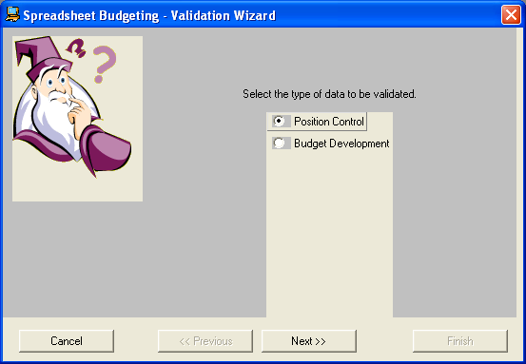

Select the appropriate institution or agency, then Next:
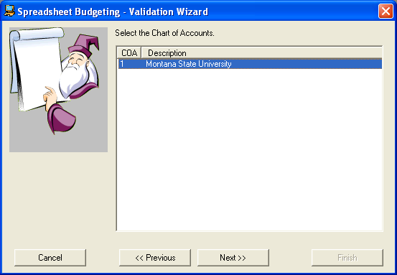

Select the NEW YEAR you wish to upload TO, then Next
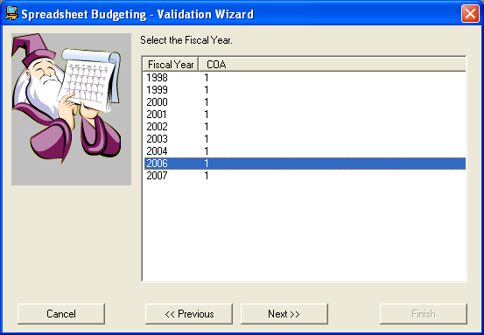

Select the type of data to be validated:
For POSITION CONTROL, select Position Control for the type of data to be validated, then Next:
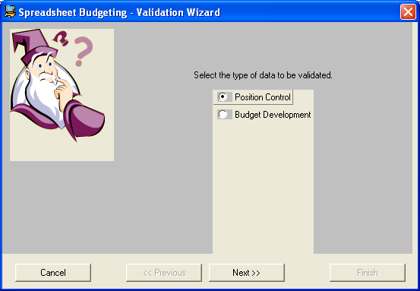

Select the appropriate Chart of Accounts (only one for MSU!):
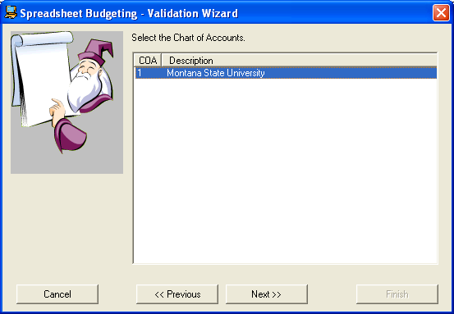

Select the NEW fiscal year:
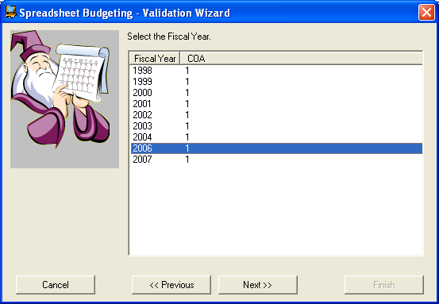

Select the Budget ID for the NEW fiscal year:
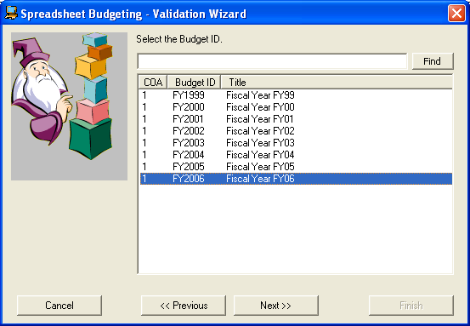

Select the NEW YEAR phase you wish to UPLOAD TO (you would have downloaded from a different phase in the new year, updated the downloaded data, and now need to UPLOAD to a new, clean phase in the new year):
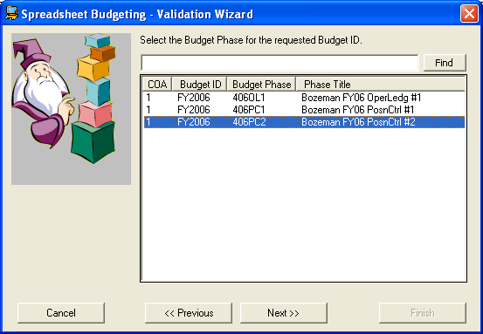

Select all NEW YEAR salary group codes. Do this either by highlighting individual lines or using the "Find" option (type in 2006% and then click on Find -- only the 2006 salary group codes will remain. Highlight all of them then click on Next:
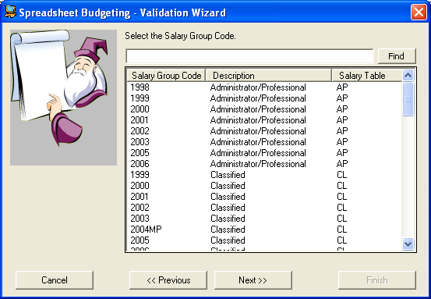
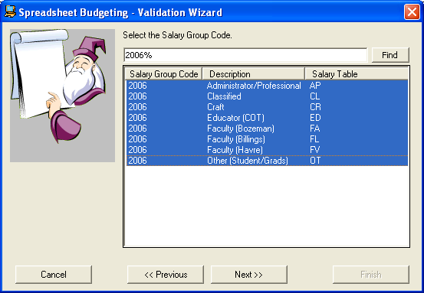

The next screen will remind you that all worksheets to be uploaded must be named and must have column headers. If this has been done, click on Next to proceed.
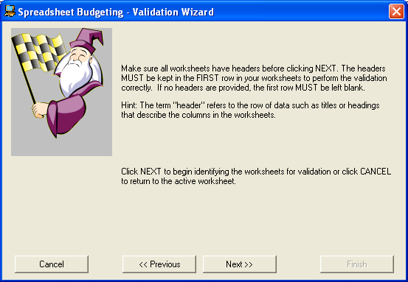

The next screen requires you to reference the SALARY BUDGET worksheet or POSITION SALARY BUDGET worksheet. Highlight that worksheet, then click on Next.
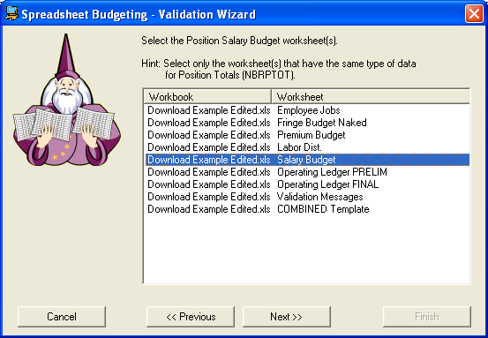

The next screen requires the selection of appropriate columns of data to be uploaded. Match each of the requirements on the left to the appropriate column from the worksheet by clicking on one of the selections in the dropdown box. Once all are selected, click on Next to proceed:
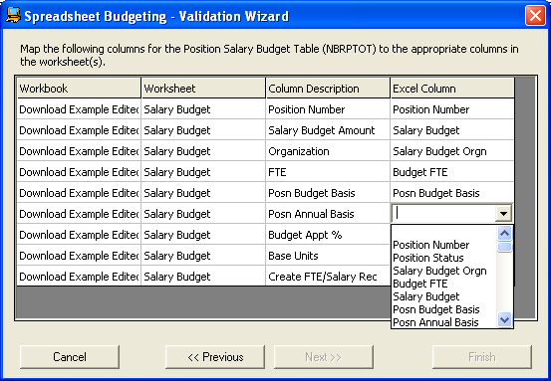

Continue selecting the required worksheet and matching columns to be uploaded for the Position Labor Distribution, Premium Earnings Budget, and Fringe Actual Budget worksheets. You will have selected four Position Control worksheets in all. If done properly, a message stating that the "validation process is ready to begin" appears, telling you that if errors were found, a new "validation message" worksheet will be created in your Excel spreadsheet. If there were no errors, you'll see a message confirming that the validation process was completed successfully. Click on Finish to continue.
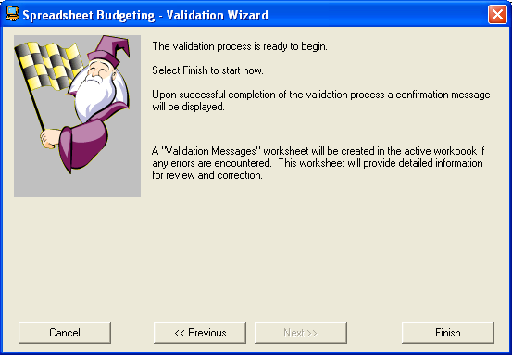

For validation of the OPERATING LEDGER data, click on Budget Development for the type of data to be validated, then Next:
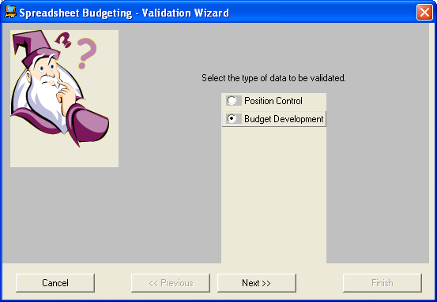

Select the operating ledger worksheet (should be labeled something like Operations Ledger or Operating Expenses) and then NEXT:
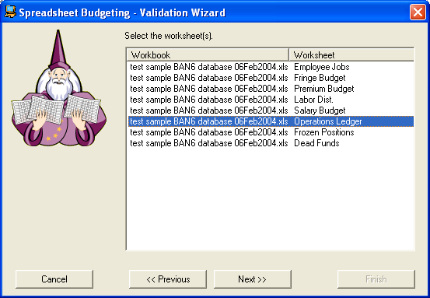

Then select the worksheet(s) that have headers (should just be the one offered, that was just selected on the previous screen), then NEXT.
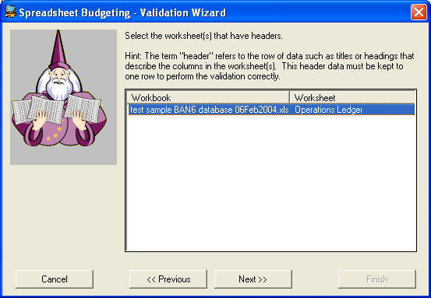

Select the appropriate chart of accounts, then Next:
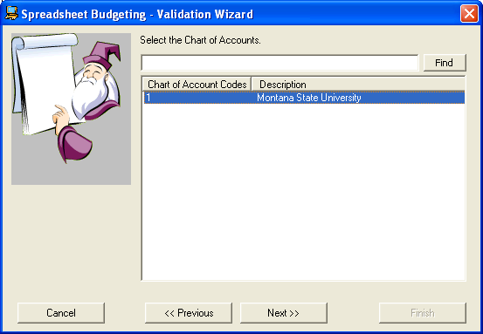

The next screen will warn you about needing specific data. Click on Next to proceed:
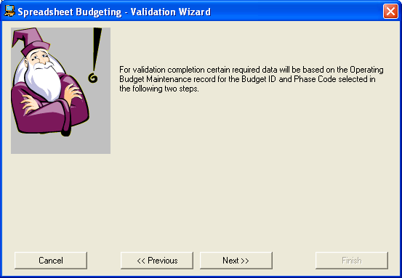

The next menu requests that you select a Budget ID for where you wish to UPLOAD TO -- choose the new year.
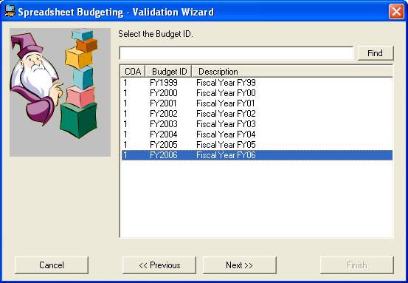

The next screen requests you choose the phase you will ultimately upload TO. Choose the appropriate phase and click on Next to proceed:
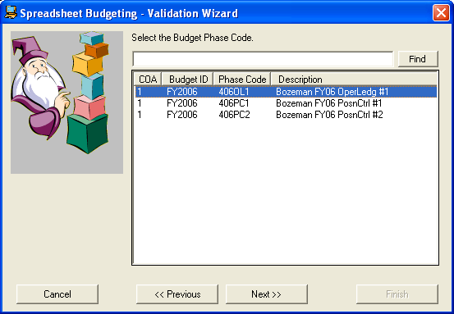

On the next screen, select "Permanent Budget Only" (MSU's preference), then Next to proceed:
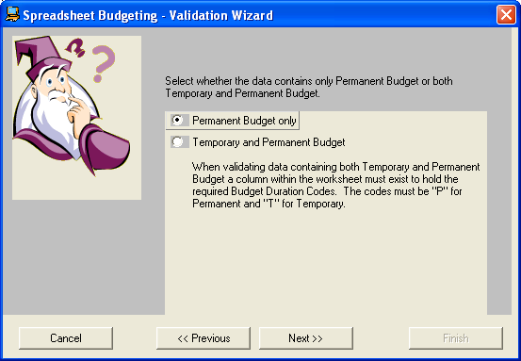

On the next screen, click in each cell under "Excel Column" and choose the column heading that matches the "Column Description" to the left. All your column headings in the sheet will pop up -- select the matching one. Click on either Next or Finish to proceed (choosing "Next" will bring up a message that if the validation is clean, you will be informed of that; but that if it has errors, a validation worksheet will be added to your Excel workbook. If you don't need this information, just click on "Finish."
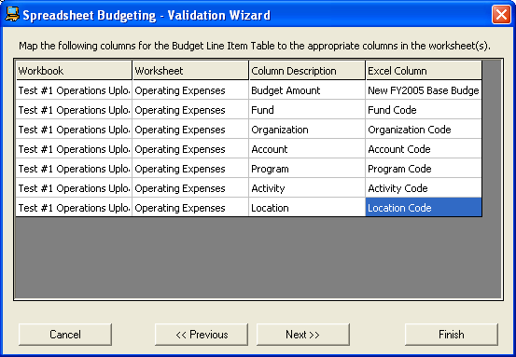
After clicking on "Finish," you will either get a popup message saying YOUR PROCESS HAS BEEN COMPLETED SUCCESSFULLY or you will get a new spreadsheet with validation errors on it. If it completed successfully, you are ready to upload the data into Banner. If you have errors, correct them then rerun Validation.
- VALIDATION ERRORS??? Correct any errors from the rows and re-run the process. (Normally will have to delete all but one portion of zero-budgeted splits) until you get a "clean" validation message. Some splits will not feed as the Wizard thinks they don't add up to 100%, which is a Banner error as Banner rounds to two decimal points, whereas some of the splits will carry out to three or more decimal points, adding up to 99.9999% or 100.0001%. With budgets of ZERO, delete all but one FOAP and make it a 100% distribution with zero budget. To get around this, and at least get the split position to enter, use dollar figures that will not divide into more than two decimal points ($1 + $1 + $2, or 25%, 25%, and 50%). After uploaded, go into NBAPBUD and correct the total budget amount and the individual splits. Note that the total percentage total is not equal to 100% -- it's usually the last split position, but add or subtract $1 from that position and see if it "flips" into the right amount. If it doesn't "flip" into the correct amount, try another FOAP. You'll have to play with this.

UPLOADING POSITION CONTROL - a two-step process: first through SSB Wizard into POSITION CONTROL, which loads into NBAPBUD, and then from NBAPBUD into Budget Development (NOT through the Wizard), as follows:
- Use FBIBUDG to view data before upload. Should be nothing in the phases into which the data is to be uploaded. If there is data in that phase, it must be deleted:
a. FBABPRC - Action = Delete; Delete by fund type (F) or account type (A) (find Fund Type in FTVFUND, Acct Codes in FTVACCT). Probably faster to delete by "A" Account Types, which are: 1P, 51, 53, 55, 57, 5B, 5D, 5F, 5H, 5J, 5M, 5P, 5S, 5U, 5V, 62, 64, 66, 68, 6C, 72, 74, 76, 78, 7A, 7C, 7E, 7G 7J, 7L, 7N, 7W, 82, and 86. Rerun that phase in FBIBUDG by acct codes for anything NOT deleted
b. FBRBDBB – Run process to delete data
2. Once the Validation process executes successfully, you are free to upload the data. The Upload process is executed exactly the same as the Validation process (see above instructions). Despite the Validation process completing successfully with no errors, we did have the Upload process result in error messages and an incomplete process. Once corrected, the Upload process completed successfully.
3. After running Upload process successfully, check a position in NBAPBUD to verify the upload (you should see an uploaded position in the second phase it was uploaded to). Remember that positions will have been uploaded TWICE now into NBAPBUD -- the first time was from the current year into a new phase from which they could be downloaded. The second time was edited data from the initial download, which was uploaded into a SECOND new year phase.
4. In FBIBUDG, check that data was loaded and that phase totals match.

5. Run the following processes:

NHPFIN1 to move labor budget information to create file for Budget Development. This may take some time because it will pick up all working budgets from NBAPBUD to be included in the file.
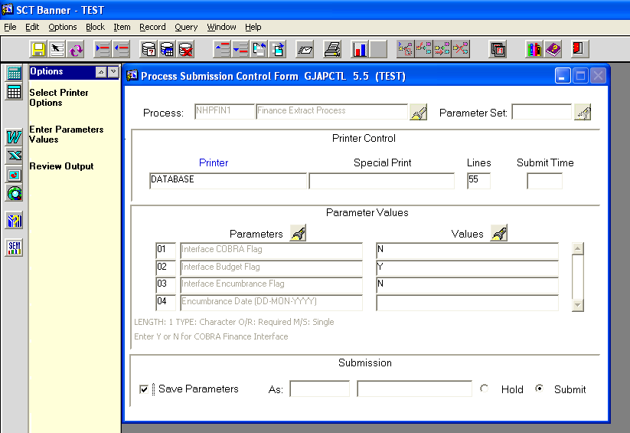

After NHPFIN1 has run successfully, run NHPFIN2 to populate the GURFEED table. This may also take some time to run.
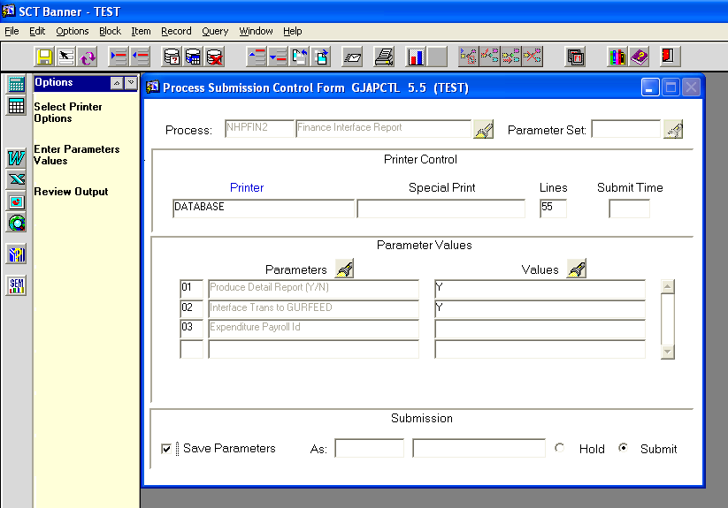
OPTIONAL: Run GURDETL to view GURFEED table.

Run FBRFEED to load the labor budget information to Budget Development.
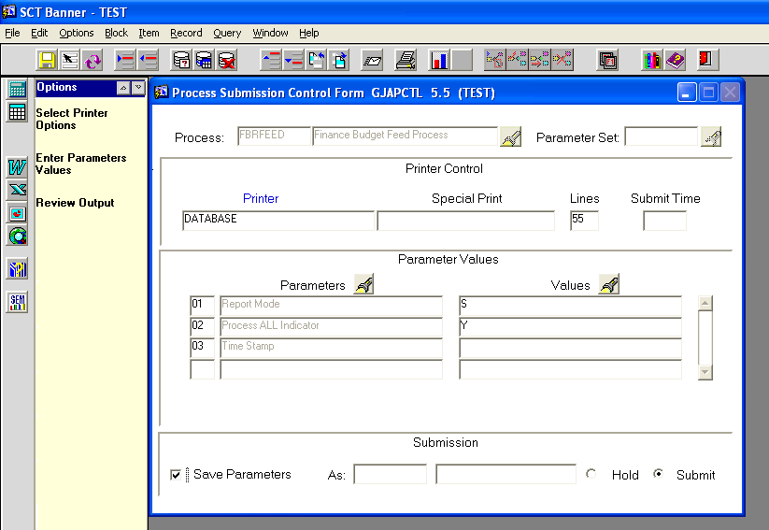
After running FBRFEED, data should show in FBIBUDG. Can click into cells to query and select appropriate parameters (at bottom choose FUND and then ORG), then NEXT BLOCK to execute and view detail.
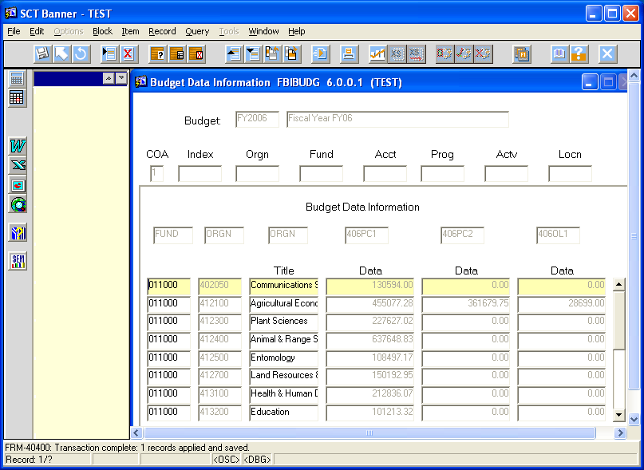
then NEXT BLOCK again to see totals for each phase:
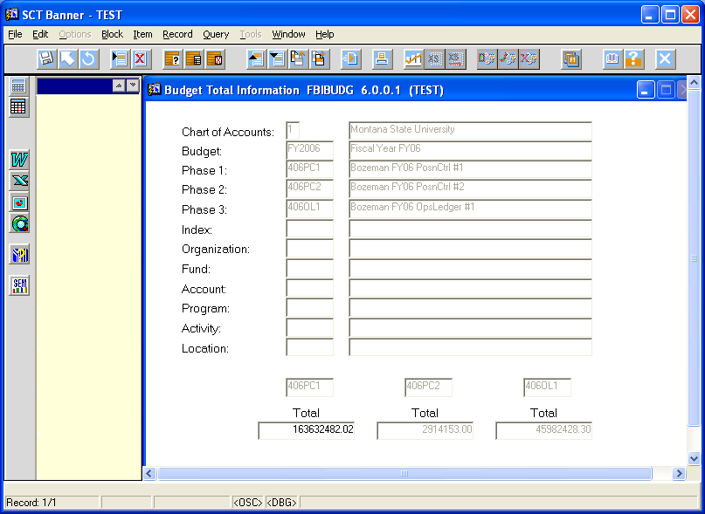

Combining Phases
- In FBIBUDG, query final phases for Position Control and Operations Ledger to make sure there are no duplicated account codes. Delete unwanted account types from either phase so they don’t overlap (can delete data in original spreadsheets, revalidate, and reupload into NEW final phases). May have to delete a phase and then recreate it.
- To combine phases, make sure a "final" or "destination" phase has been created, into which you will load data from other phases. If not, create it now (page 4, FTMOBUD).
  - In FBABPRC, enter new budget year into Budget ID cell, and the phase you wish to copy data INTO, then click on "Action" drop box -- choose BUDGET LINE. Then do a NEXT BLOCK to bring up the SOURCE DATA block. Fill in the SOURCE DATA cells and complete the other information as follows, then click on SAVE:

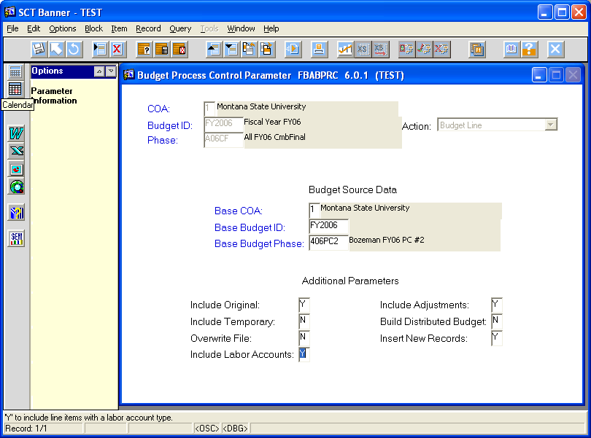

  - Run FBRBDBB. There will be no parameters to complete. Do NOT check the "save parameters" box at the bottom! Click on SAVE at top left to run process.
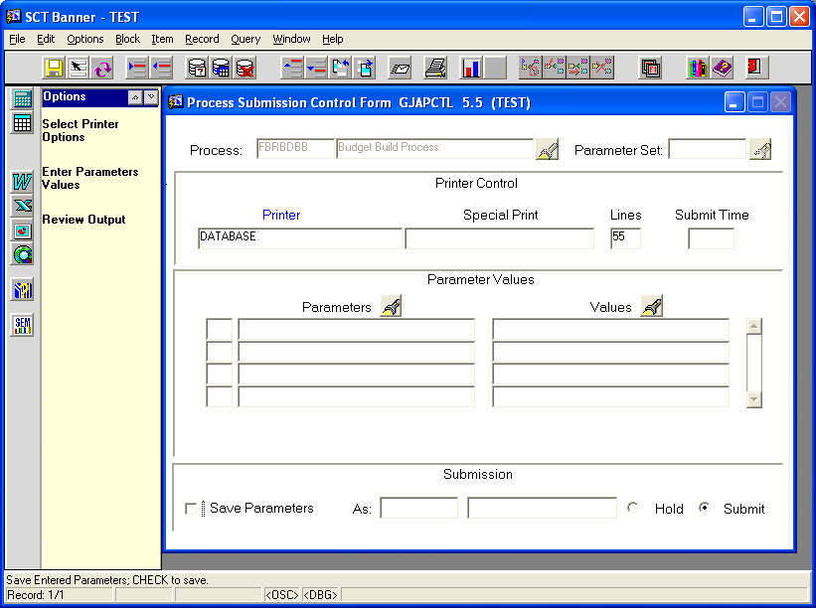
Do not check!
  - Repeat for the second phase to be combined into the designated phase, running FBABPRC and then FBRBDBB.
  - Call all phases up in FBIBUDG and make sure the final phase total is equal to any phase totals that were combined into it, that the totals tie. If the totals don't tie, then data was "dropped," possibly some invalid FOAPAL elements (a FUND or ORG that was inactivated after you ran the Validation and Upload processes).
- If desired, delete any unwanted phases.

Budget Roll to Approved Status

- After completing the Upload process for both Position Control and Operating Ledger (Budget Development), and combining all preliminary phases into one final phase, verify that final phase in NBAPBUD by viewing several positions.
- Verify that the “Feed to Budget Development” box in NTRFINI is checked
- Run NHPFIN1 with parameters N, Y, N, blank
- Run NHPFIN2 with parameters Y, Y, blank
- Run FBRFEED with parameters S, Y, blank
- NTRFINI – Uncheck “Feed to Budget Development box
- NBPBROL – Run in approved mode; parameters to be used are:
01 Fiscal Year - new year (2006)
02 Budget Id - new year (FY2006)
03 Budget Phase - new year phase (A06PCF) or whatever phase you want it rolled to
04 Current Fiscal Year - current year (2005)
05 Chart of Accounts Code - 1
06 Salary Group Code - new year (2006)
07 Report Choice - "A" to roll the budget from a “working” status to “Approved”

NBPBROL Processing Notes:
The approval of position budgets does not generate any transactions to Finance.

Before feeding any new fiscal year transactions to the Banner Finance system, your FIS department will need to approve the FIS budget and open the new fiscal year.

The NBPBROL process sets the “Active” indicator on NBAFISC for the new fiscal year.

When rolling NBAPBUD records to an APPROVED budget status in the new fiscal year, the prior year budget status will be automatically set to (C)losed and the status on the new fiscal year will change from (W)orking to (A)pproved.

The salary information fields on NTRPCLS and NBAPOSN will be updated with the new salary group information (table/grade/step) from NTRSALA.

- NBAPBUD - view positions to verify "approved" status
- NTRFINI - uncheck "Feed to Budget Development?" box
- Run NHPFIN1 with parameters N, Y, N, blank
- Run NHPFIN2 with parameters Y, N, blank

ROLL APPROVED BUDGETS FROM BUDGET DEVELOPMENT INTO BANNER FINANCE

Approving Budget and Feeding to the Operating Ledger

- Open 1st period of new year when ready to roll budget to OPAL.

- In FTMFSYR, verify that the period to which you want to roll the budget into is defined and OPEN. Open form, initiate a query (F7), choose new fiscal year and OK, then execute query (F8). If there's an "O" for Open Status for the first period, you can proceed. If it's not open, call Kevin Ward in the Finance Group.
- In FTMOBUD, initiate a query (F7), use flashlight to choose new year, then execute the query (F8). Then click on Options at left, "Budget Phase Data." Then use the "up" and "down" arrow keys to scroll through all the new year's budget phases. Uncheck the "Open Status" box on ALL phases except the final phase.
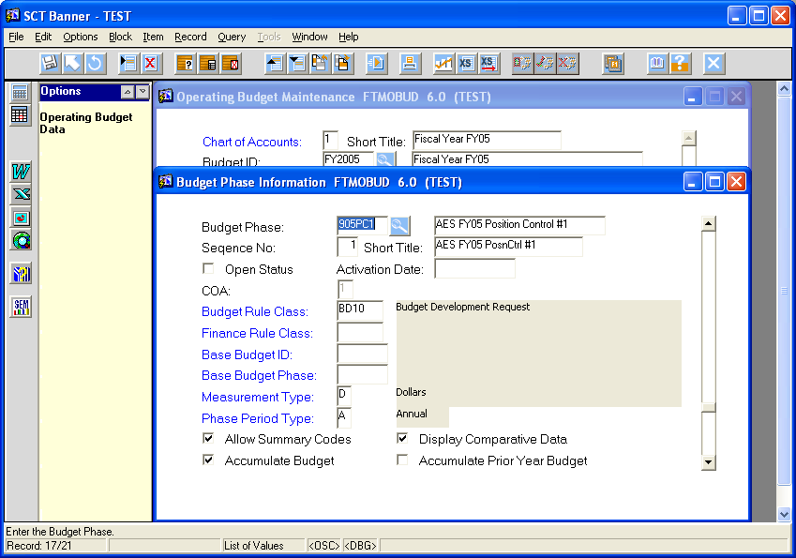
- After unchecking boxes, go back to the one final phase (where the "open Status" box checked), and enter activation date (usually first day of new fiscal year). Then enter BD01 in Finance Rule Class. Save.
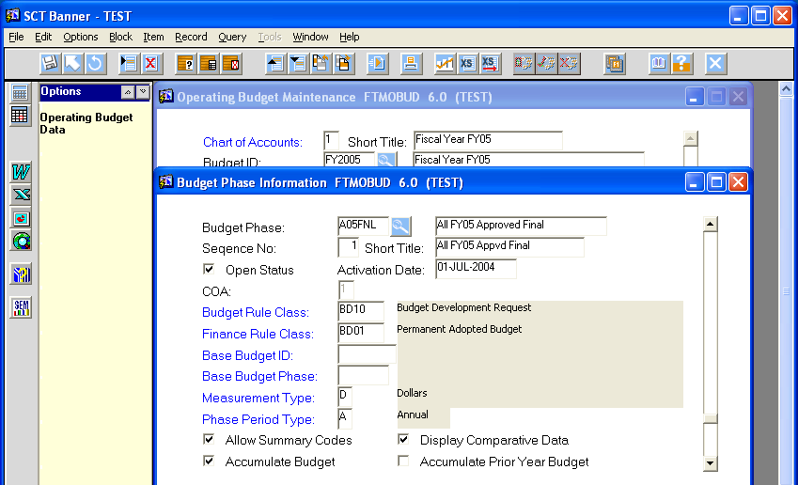
- (optional) FBRAPPR – Approved budget report. Compare to the spreadsheet and budget development.

- FBABDDS to choose distribution method. After checking "Distribute all the budgets within" box, choose (on left or dropdown box) the option "Distribute Budget by Period."

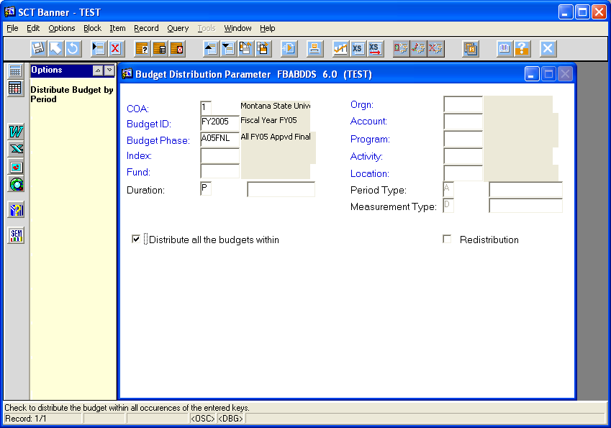
- Start Period: 1
- Number of Periods: 1
- Distribution %: 100. Then Save and Exit.

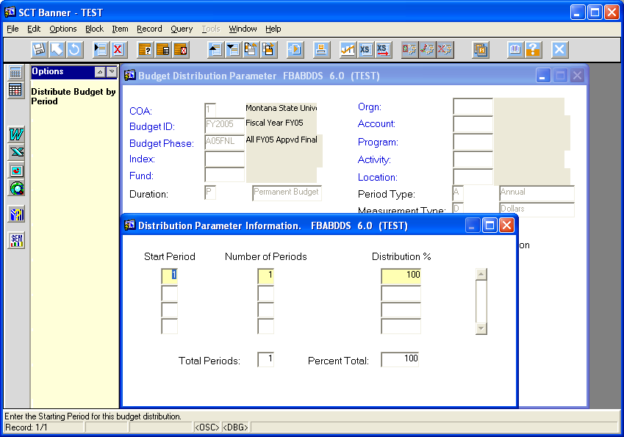
- To distribute budget to Finance, run FBRBDDS (no parameters, just keep clicking on NEXT BLOCK, then SAVE, and it will process.
- (optional) FBRAPPD – Run approved budget report
- To activate distributed budget, use FBABPRC – Enter budget ID and phase and choose “Activate” from the pull down menu, then NEXT BLOCK, fill in per sample, then SAVE. Exit.
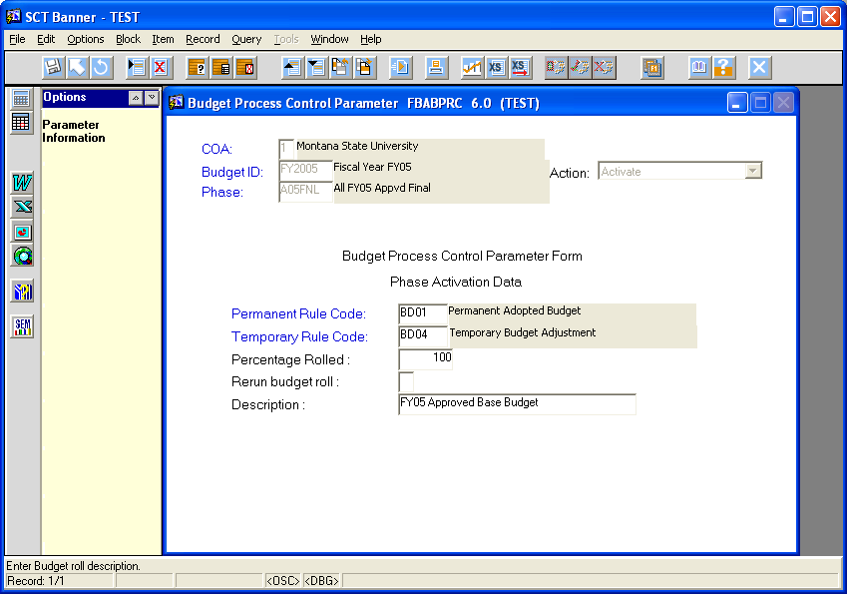

- FBRBDRL – Budget roll process (just NEXT BLOCK, database, and no parameters). This process will populate the FGBTRNI table. Save the output "list" report to a file, then copy the text into e-mail to someone in the Finance Group with request that they run the next three processes).
- The following three processes need to be run by someone in the Finance Group: FGRTRNI (validates postings), FGRTRNR (transaction error report), and FGRACTG (the posting process).

Note: on NTRFINI, the "FEED BUDGET TO FINANCE BUDGET DEVELOPMENT" check box should be checked ONLY when processing position budgets from NBAPBUD to Budget Development -- must be Unchecked for ALL other processes. (Does not affect operations ledger upload into Budget Development

APPROVE BUDGET IN POSITION CONTROL
Banner HR requires any outstanding encumbrances attached to position records in the old fiscal year to be posted to Finance before the new fiscal year position records can be approved. The NBPBROL process to roll positions to an “approved” status will abort if you have not posted all outstanding encumbrance amounts.

For the MSU system, encumbrance liquidation processes should be run about July 8^{th.}
- Have HR Lead Analyst submit a DBA Request form in order for the DBA’s to run the NWPYEEN script created by Frank Abney. It is located on unix at /sct/ban60/local/posnctl/misc/nwpyeen.sql. If Lead Analyst is not available, can send the DBA Request yourself. It’s located at www.b2k.montana.edu/Banner2000/teams/dba/dba_request.htm. This script will set amounts opposite of outstanding encumbrances, by position, in the enc_to_post fields in both the job record and jlbd table. Next, run NHPFIN1 and NHPFIN2. This NWPYEEN script replaces the NBPBUDM process at FYE. NHPFIN1 parameters are: N, N, Y, 01-JUN-200X (current year). NHPFIN2 parameters are Y, Y, blank if run prior to the FYE Finance roll and Y, N, blank if run after the FYE Finance roll.

- Run enc_to_post not zero script to identify positions that aren’t set to zero.

- If any rows are selected, have HR Lead Analyst run NBRJLBD_FYEND to zero identified positions. The encumbrance number should be PR0X0001, X being the current fiscal year. NHPFIN1 and NHPFIN2 will then need to be run again. The enc_to_post not zero script should be re-run again to see if any records are hanging out there.

- If the above processes are run prior to the FYE Finance roll, have the Finance Support Group run the posting processes to Finance.

Other Year End processes
Update fringe amounts in NTRFRNG (Fringe Budgeting Rule Form). This form defines rules for developing benefit and deduction budgets. Budget parameters can be defined as either amounts or percentages. Verify budget amounts have been created for each employee class to be encumbered. These records establish the parameters and rates used during encumbrance processing. Coordinate with Trudy Collins, MSU-Billings, to agree on percentages, by ECLS, for benefit account codes in NTRFRNG. Update any changes for the new fiscal year. Set Benefit Amount, 1ER, (account code 61403, group insurance) to zero before running the NBPBROL process. After NBPBROL has completed, reset account code 61403, group insurance to the new fiscal year amount. The benefit amount for 1ER, group insurance, for FY05 is $5,520. The Worker’s Comp benefit 0WC, budget percent for FY05 was changed to .51.

Notify HR to run NTRCROL, NBPMASS, and NTRFINI through step 3 of ‘Create encumbrance numbers for new fiscal year’ on next page.

Update Contract Start and End Dates (NBAJOBS)
The “Contract Start” and “Contract End” dates in the Encumbering Information section on the front page of NBAJOBS, narrow the time period over which the salary is to be encumbered. When these fields are null, Banner assumes the salary is encumbered over the entire fiscal year (12 months).

- Go to the Contract Dates Roll Parameter Rule Form (NTRCROL).

- Starting with the “From Contract Dates” columns, insert in the “Begin” and “End” fields the current dates found in the “Contract Start” and “Contract End” fields on your NBAJOBS records. In the “To Contract Dates” columns, enter the dates you want your NBAJOBS records to reflect for the new fiscal year. For every possible combination of dates, enter a new row.

- Run NBPMASS to create new Contract “Begin Dates” and “End Dates” on NBAJOBS records. Budget Office DOES NOT have sufficient privileges to run this.

Parameters:
01 Report Mode: (P)rocess/Update or (R)eport
02 Process: (D)ates rolled (contract dates)
03 Job Change Reason: Blank
04 Salary Group (From) Blank
05 Salary Group (To): Blank
06 Personnel Change Date: Blank
07 Use Population Selection: (N)o

NBPMASS needs to be run twice; first in (R)eport mode and then in (P)rocess mode.

Create encumbrance numbers for new fiscal year (NBAJOBS)
This process creates new job labor distribution records in NBAJOBS for all active job records. The labor distribution records have new encumbrance numbers assigned to them for the new fiscal year. NOTE: Problems occur if a position is terminated after this process has run and the termination applied to the prior fiscal year. Records with a July 01 or greater effective date for the new fiscal year need to be removed from the job labor distribution for these particular positions.

- Go to the HR/Finance Set Up Rule Form (NTRFINI). Budget Office DOES NOT have sufficient privileges to run this.

- Go to the “Fringe Chargeback Rules” section by clicking on the “Fringe Rules” button.

- Check the box for “Recalculate all Salary or Fringe Encumbrances”.

HR will notify Budget Office when they’ve completed the previous three processes (NTRCROL, NBPMASS, and NTRFINI).

- Verify that the “Feed to Budget Development” box in NTRFINI is UNCHECKED

- Run the NBPBUDM process. This will need to be run twice, once for monthly campuses immediately followed by the NHPFIN1 process and once for biweekly campuses immediately followed by the NHPFIN1 process.

NBPBUDM Parameters:
01 Process Mode (P)rocess/Update or (R)eport
02 Budget Processing (N)o
03 Encumbrance Processing (Y)es
04 Active or Working Budgets Active***
05 Chart of Accounts Blank
06 Fiscal Year Blank
07 Budget Id Blank
08 Budget Phase Blank
09 Encumbrance Date 01-JUL-200x for mo.; xx-JUL-200x for biweekly
10 Monthly or Biweekly (M)onthly, (B)iweekly

- *** Parameter 04 is required; however, the parameter is not actually used for this process.

- Run the NHPFIN1 process twice; parameters N, N, Y, Jul-01-200x (current year) for monthly; xx-JUL-200x (current year) for biweekly

- Run the NHPFIN2 process; parameters Y,Y,blank

Processing notes:

A new 01-JUL-200x job labor distribution record should exist. You can verify this on NBAJOBS. This labor distribution is created from the most current labor distribution record prior to July 1st existing on the NBAJOBS record at the time NBPBUDM is run. Banner does not grab the labor distribution from NBAPOSN like it does when an NBAJOBS record is first created for an employee.

A new year encumbrance number should be created for the job labor distributions. You can verify this on the Labor Distribution Change History Form (NBIJLHS). To query the new records, use 01-JUL-200x for the “As of Date” in the header block. If you use a date prior to the 01-JUL-200x, Banner does not display the NBPBUDM process. Note: The third and fourth digits of the encumbrance number represent the fiscal year.

If NHPFIN1 returns a NULL error, the HR Lead Analyst needs to run nbrjlbd-encd-num.sql to identify records with a null encd_num and encd_seq_num. Once the Payroll and Budget Office have provided input regarding these identified “nulls,” the HR Lead Analyst needs to run update-nbrjlbd-encd.sql to update the null records.
-- appears to only affect position budgets)
NOTES ON PHASES:
Budget ID: FY2006
Budget Title: Fiscal Year FY06

Fund: Types:
0 ES PC Position Control
1 FSTS OL Operations Ledger
3 Great Falls CF Combined Final
4 Bozeman
6 Billings
7 Havre
9 AES
A All

Proposed Phases:
406PC1 Bozeman FY06 Position Control #1 (use for initial PBUD roll from FY05 to new year FY06)
406PC2 Bozeman FY06 Position Control #2 (use for first UPLOAD of edited position data)
406PC3 Bozeman FY06 Position Control #3 (use for second UPLOAD of edited position data)
406PC4 Bozeman FY06 Position Control #4 (use for third UPLOAD of edited position data)
406PCF Bozeman FY06 Position Control Final (for combined phases of previous position phases)
406OL1 Bozeman FY06 Operations Ledger #1 (use for first UPLOAD of edited operations data)
406OL2 Bozeman FY06 Operations Ledger #2 (use for second UPLOAD of edited operations data)
406OL3 Bozeman FY06 Operations Ledger #3 (use for third UPLOAD of edited operations data)
406OL4 Bozeman FY06 Operations Ledger #4 (use for fourth UPLOAD of edited operations data)
406OLF Bozeman FY06 Operations Ledger Final (for combined phases of previous operations phases)
406CF Bozeman FY06 Combined Final (for combining ALL Bozeman phases, positions and operations)
same for other campuses and agencies . . .
A06CF All FY2006 Combined Final (for combining ALL agencies, all data)

Appendix A
Instructions for Client Install of
Spreadsheet Budgeting

The following is a set of step-by-step instructions for performing the client install of spreadsheet budgeting. It also covers updating the goddtop.dll file.

Needed before install:
- SSB Client Install disc or access to the http://sais.montana.edu/ website
- Cup of coffee – preferably hot with cream and sugar.

Technical Support:
For Tech support please start by contacting your local desktop support personnel. If they are unable to correct your problem then please contact Joseph Tess jtess@montana.edu at 994-7434.

Instructions for Obtaining the files:

From an install disc
- Insert the CD into the disc drive.
- Open up Windows Explorer.
- Double-click on your disc drive in Windows Explorer.
  - You should now be able to see the contents of the CD. The files are ‘goddtop-setup.exe’, ‘goddtop.dll’, and ‘ToolsUpdate.exe’.
- Copy these three files to a temporary directory location on your computer.
- Skip to ‘Installation instructions’.

From the SAIS site
- Navigate your browser to http://sais.montana.edu.
- Click on ‘Downloads’ in the top center of the screen.
- Now click on ‘User Docs – Reports and Procs’ under ‘Banner Human Resources’.
- Now click on ‘Spreadsheet Budgeting client install files and instructions’.
- Click ‘open’ on the dialog box and then ‘I agree’.
  - Winzip should now open up and have the install docs and files listed for SSB.
- Click ‘Extract’ and then point it to a temporary location on your machine.
- Click ‘Extract’ again.
- Skip to ‘Installation instructions’.

Installation instructions
- Now navigate in Windows Explorer on your computer to the location where you saved the installation files.
- Double-click on the file ‘goddtop-setup.exe’
  - Some processing will occur and you will eventually be confronted with a ‘Welcome’ dialog box.
- Click ‘Next’.
- Click ‘Yes’.
- Click ‘Next’.
  - The actual install will begin and after a while you will be confronted with another dialog box that asks you if you would like to update the DLL file.
- Click ‘Yes’.
- Click ‘Find new DLL’ and navigate to the location where you saved the installation files.
- Select the file ‘goddtop.dll’ and click ok.
- The next screen will inform you that your PC must be restarted. Click ‘finish’ and allow your PC to restart.
- Once your PC has restarted, open up Microsoft Excel and select Tools-Add ins.
- Click ‘Browse’.
- Navigate to the folder “c:\sct\banner\goddtop”, select “DesktopTools.xla”, and click ‘Ok’.
- Click ‘Ok’ again.
  - This will add the plug-in into Microsoft Excel. You should now see a menu item called ‘Banner’ at the top of your Excel window.

Testing Your Install
- Click the ‘Banner’ menu item in Excel and select ‘Connect to Database’.
- Enter your Banner login username/password and enter the database to which you wish to connect.
- Click ‘Ok’.
- If all goes well, there should now be some SSB menu options under the ‘Banner’ menu item. Which ones appear will depend upon the security that’s been granted to you.
  - If you receive no error messages but there are no SSB wizards in the Banner menu then please contact Karen Maika at 406-994-3585 kmaika@montana.edu. She can change your security if necessary.

Banner Excel Icon
At this point, you will now need to make sure that the Excel icon in Banner is set to work with SSB. To do this please refer to the file “Instructions for Excel Icon.doc” that should have been included in the files you downloaded.
Appendix C

Suggested Columns for Single Worksheet

Agency or Campus - for ease in sorting and distribution
Authority - for ease in sorting and distribution
Index - most departments use Index Codes rather than FOAPs
Index Name - ease in recognition
Fund - required for upload
Org - required for upload
Pgm - required for upload
Acct Code - required for upload
Acct Code Description - ease in budgeting process
Activity Code - required for upload
Location Code - required for upload
Position Number - required for upload
Employee Name - ease in budgeting process
Budget FTE - required for upload
Budget Amount - required for upload
Distribution Percent - to doublecheck split positions, make sure they're 100% budgeted
Posn Budget Basis - required for MSU upload, use 0.00
Posn Annual Basis - required for MSU upload, use 0.00
Budget Appt % - required for MSU upload, use 0.00
Base Units - required for MSU upload, use 0.00
Create FTE/Salary Rec - required for MSU upload, use "N" for NO
Budget Authority or Total Allocation - budget authority for each Index

