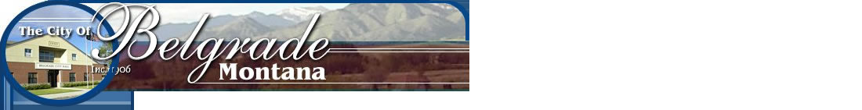
- Home
- Jobs
Toggle navigation

- 01-Oct-2020 to Until Filled (MST)
- Belgrade, MT, USA
- $20.90 - $29.23 DOE
- Hourly
- Full Time
This position is a fully benefited position including medical, dental, vision, and retirement.
Email Me Similar Jobs Email Me This Job

Due to the exciting growth in the city, the City of Belgrade has a brand new position for a Public Works Inspector. Please see the attached job description. Experience is preferred. Position will stay open until the right candidate is found and hired. Position will report to the Director of Public Works. This position is non-exempt and will be eligible for overtime if needed. The salary will depend on the knowledge, skills and experience of the candidate chosen in addition to what certifications that candidate already has. This is a fully benefited position.

Full Job Description

