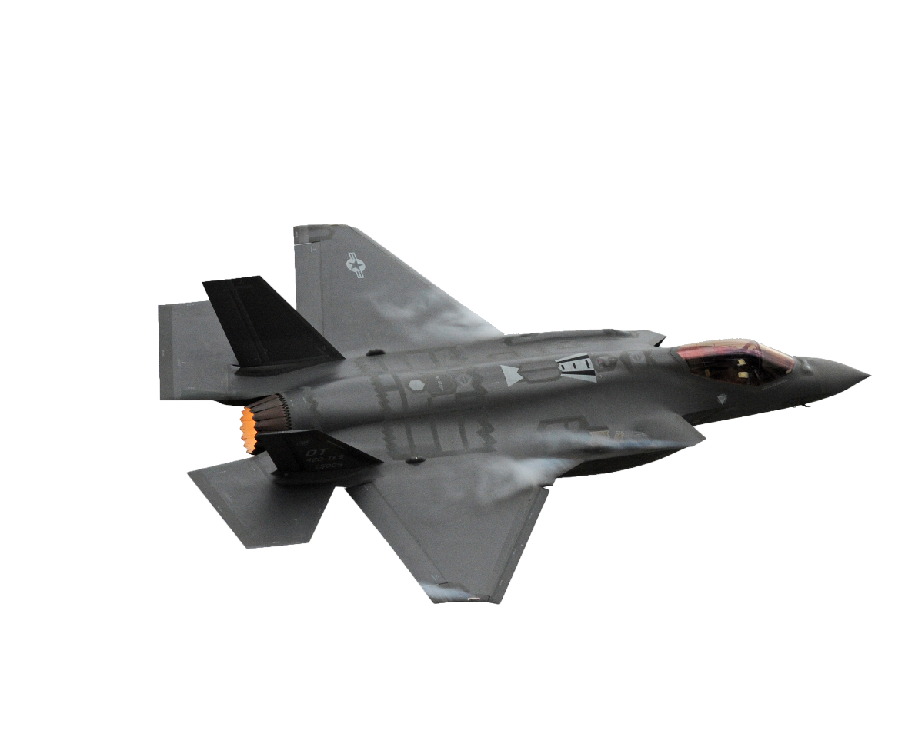

**CALLING COMPUTER SCIENTISTS AND ENGINEERS**

Department of Defense Civilian Workforce is HIRING!

Full time and Internships available

 Join us for a LIVE presentation:

“A Day in the Life of an Intern and New Hire”

**When:** 19 October 2021

**Time:** 1pm PT, 2pm MT, 3pm CT, 4pm ET

**Zoom Link:** <https://www.zoomgov.com/j/1605493647?pwd=eGRKUGkwMjhJV00ydlJpT1V4NWg3QT09>

**Meeting ID: 160 549 3647 Passcode: 1208**

**Upload Resumes:**

Internships: [309SWEG.MXDES.Internship@us.af.mil](mailto:309SWEG.Internship@us.af.mil) Full Time: <https://airforcestem.recsolu.com/external/form/jujXNL0hBlFWdQ3TKaSfDA?locale=en>

**Brought to you by: Software Engineering Group/Engineering Group at Hill AFB, UT; Robins AFB, GA; Tinker AFB, OK and Air Force Nuclear Weapon Center at Hill AFB, UT**