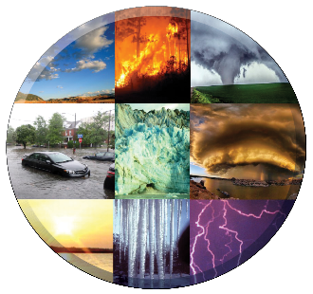

**4-H Weather and Climate   
Youth Learning Lab   
*Evaluation***

**Please return this evaluation to:**

**Questions for Leaders**

1. Tell us what worked well and what was well-received in the Learning Lab.
2. Describe any challenges you encountered either with the Leader’s Guide or the individual activities.
3. How might we improve the materials through future revisions?
4. What additional information or activities could we include?
5. Please provide any other information you wish to share with us.

**Questions for Youth Participants**

1. Which activities were the most interesting and why?
2. Tell us one to three things you learned that stand out.
3. How do these activities compare with others you have done?
4. Please provide any other information you wish to share with us.