PLEASE JOIN US FOR AN OPPORTUNITY TO ATTEND A PRESENTATION BY RENOWNED IMMIGRATION ATTORNEY KEN STERN
WHAT- “H-1B CAP and PATHS TO GREEN CARD”
WHERE- ANIMAL BIOSCIENCES BUILDING ROOM 138
WHEN- MONDAY, OCTOBER 12th FROM 1:30-3pm
For more information contact Sally O’Neill at the Office of International Programs, sallyo@montana.edu
406-994-7688

About Ken Stern:
Ken is a Senior Partner at the Immigration Law firm of Stern and Curray. He has been an attorney for over 35 years and his practice encompasses all areas of immigration law with a special emphasis on business immigration. Ken works closely with company professionals to help develop a strategic vision for leveraging immigration visas to attract and retain the best talent from around the world. Ken also works with companies to develop effective and efficient internal practices and policies in the area of immigration law.

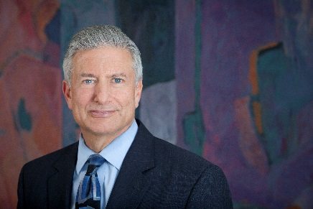
Ken received his bachelor’s degree from Tufts University in 1974. He received a law degree from the University of Denver in 1978. Ken has been named “Best of the Bar” in immigration law by the Denver Business Journal and Law Week Colorado and has been listed in Best Lawyers in America since the inception of that publication.
Ken is regularly listed in 5280 Magazine as one of Denver’s top lawyers in the field of immigration law. Ken has received a lifetime achievement award from the Colorado Chapter of the American Immigration Lawyers Association and received the prestigious Jack Wasserman award from the national organization.
Ken has been active in the community serving on the boards of many non-profit organizations. Ken and his wife Linda founded a free English Language Program which served the community for many years.at CLE events. His presentations stress the necessity for engaging in immigration-based strategic planning and the importance of companies developing their own specific immigration policies ir of the Committee for Balanced Legal Careers, a committee y his peers for every year that it has been in existence and was the only immigration lawyer named in the Top 50 Lawyers in Colorado by Colorado Super Lawyers Magazine. Ken is active in a number of community activities and was honored by the Chinook Fund at their 25th Anniversary

