Power to Fuel & Fuel to Power using Electrolysis and Fuel Cells

By Research Professor Mogens B. Mogensen

Department of Energy Conversion and Storage, Technical University of Denmark, DTU Risø Campus, DK-4000 Roskilde, Denmark
____________________________________________________________________________________________________________________________________________
The potentially most important renewable energy sources, wind and solar power, are fluctuating to a degree that makes huge energy conversion and storage absolutely necessary in a modern society based on 100 % renewable energy. Also the more stable hydropower will benefit from cheap chemical conversion and storage technology as hydro-resources may fluctuate over the year in many regions world-wide.
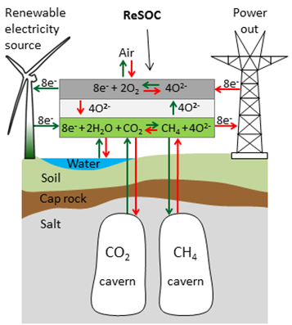
This presentation will be about visions of how we can convert renewable electrical energy into chemical energy, in form of hydrogen and CO using electrolysis. This is technically realized already, but there is still an economical issue to be solved before an energy market will appear for electrolysis. Potentially, it is also possible to convert water and CO₂ directly into methane using some types of pressurized electrolysers and then store the methane (CH₄) as envisioned on the picture, which illustrates how CH₄ and the necessary CO₂ may be stored underground under high pressure [1]. Methane is also called synthetic natural gas and can naturally be used for electricity production back into the net using the same electrochemical cells in fuel cell mode, and also for cars, trucks and ships. Another attractive synthetic fuel is dimethyl ether (CH₃OCH₃, DME), which can be used as diesel fuel without formation of any soot. Also fuels for airplanes may be produced from synfuel. Note that when the used CO₂ has been collected from air, these hydrocarbon fuels are totally CO₂ neutral.
Apart from the main arguments for the use of electrolysis and fuel cells, also status and issues of the very intense research and development of electrolysis and fuel cells will be given [2-5]. The increase of the performance of the classical alkaline electrolysis cell by a factor of 10 by increasing temperature and pressure will be shown as an example of R & D at DTU Energy. Development of new cell design and materials combinations were needed in order to increase temperature and pressure from about 100 °C to the necessary temperature at 200 °C.

References
[1] S.H. Jensen, C. Graves, M. Mogensen, C. Wendel, R. Braun, G. Hughes, Z. Gao, S.A. Barnett, Large-scale electricity storage utilizing reversible solid oxide cells combined with underground storage of CO₂ and CH₄, Energy Environ. Sci., 8, 2471 (2015).

[2] S.D. Ebbesen, S.H. Jensen, A. Hauch, M.B. Mogensen, High Temperature Electrolysis in Alkaline Cells, Solid Proton Conducting Cells, and Solid Oxide Cells, Chem. Rev., 114, 10697 (2014).

[3] C. Graves, S.D. Ebbesen, S.H. Jensen, S.B. Simonsen, M.B. Mogensen, Eliminating degradation in solid oxide electrochemical cells by reversible operation, Nature Materials, 22 December 2014, DOI: 10.1038/NMAT4165

[4] J.T.S. Irvine, D. Neagu, M.C. Verbraeken, C. Chatzichristodoulou, C.R. Graves, M.B. Mogensen, Evolution of the electrochemical interface in high-temperature fuel cells and electrolysers, Nature Energy. 1, 13 p. (2016)
[5] C. Chatzichristodoulou, F. Allebrod, M.B. Mogensen, High Temperature Alkaline Electrolysis Cells with Metal Foam Based Gas Diffusion Electrodes, J. Electrochem. Soc., 163, F3036 (2016).

Bio - Mogens Bjerg Mogensen

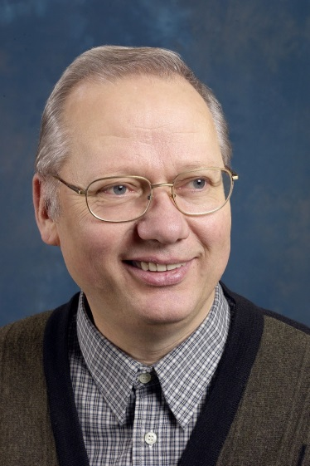
Mogens Bjerg Mogensen is Research Professor at Department of Energy Conversion and Storage, Technical University of Denmark (DTU). MSc Chemical Engineering, 1973, and PhD in Corrosion, 1976, from Department of Metallurgy, DTU. 43 years in electrochemistry (corrosion, anodic dissolution of iron, Li-batteries, fuel cells and electrolyzers). Employed for 36½ year (since 1st of April, 1980) in the same place that first was Risø National Laboratory, which later was merged into Technical University of Denmark (DTU) in 2007. R&D on high temperature solid oxide fuel cells (SOFCs, 600 - 1000 °C) for 27 years, solid oxide electrolyzer cells (SOECs) for 15 year, a novel type of high temperature, pressurized alkaline cells (HT-AEC, >200 °C, >20 atm., own invention) for 7 years, and PEMEC (60- 70 °C) for 2 years, and still active in research in all these types of electrolysis and fuel cells. Managerial experience: previously Head of Program (2 y), coordinator for 2 big EU projects on SOFC (6 y in total), leader of Strategic Electrochemical Research Center (6 y), and project manager in numerous Danish, EU and other international projects. His bibliometric records on Web of Science are: 276 papers cited 11500 times, average citations 41.6; h-index 55. 1 paper cited over 1100 times, 10 papers more than 200 times. 20 patents/patent applications. He received Christian Friedrich Schönbein Medal of Honour, at the 8th European Fuel Cell Forum, Lucerne, in 2008, and is Fellow of the Electrochemical Society. He is every year invited to give talks at international conferences and workshops. e-mail: momo@dtu.dk.

