Measuring Molecules Near Surfaces: Better than a Needle in a Haystack
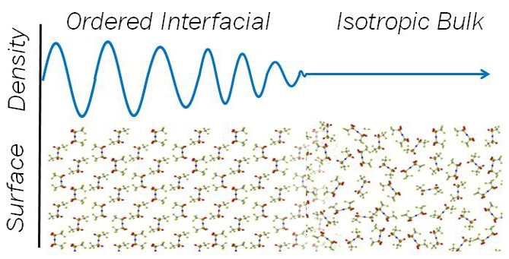

Chemical interfaces contain unique molecular architectures that contribute to important processes including surfactancy, self-assembly, and heterogeneous catalysis. However, specific relationships between intermolecular interactions and observed interfacial behaviors remain poorly defined. This is particularly true of soft, high vapor pressure, dynamic interfaces which are challenging or impossible to investigate with ultra-high vacuum techniques. Research in the Shaw group focuses on making analytical measurements at chemical interfaces that are relevant to energy and environmental fields. We are particularly interested in understanding the distal extent of chemical interfaces and the dynamics of molecular reorganizations within these microscopic volumes. This talk will introduce our approach to studying interfacial measurements, describe spectroscopic data showing unique, long-range ordering behaviors of ‘interfacial’ molecular and ionic liquids, and present results from thermal and electrochemical approaches to control and tune the observed interfacial behaviors.

