General Notes
To be in compliance with the Graduate School best practices for offering assistantships as a condition of admission, we need to ensure we are filling out the “Graduate Assistantship Letter” as part of the application review process in CollegeNet. This should reflect the minimum you are willing/able to cover to give the student a baseline of what to expect, if you choose to increase the stipend or cover more tuition/fees, as funding allows, you are able to do so. Try not to overstate your commitments if you are unsure.
*Applications missing the “Graduate Assistantship Letter” information will be returned to you.

Process
- Navigate to CollegeNet and login. https://www.montana.edu/gradschool/resources/cnethelpcenter.html
- Click on the “Admit” button.
- Click the next to “Ecology” to access the program options.
- Click the next to the program to access the folder options.
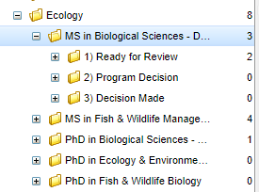
- Single click on “Ready for Review”, the student names (applications) should appear in the window on the right.
Click
Click to load applications

- Double click on the name of the applicant you are reviewing from the window on the right.
- Once the application opens, use the left/right arrows to scroll right until you see the “Graduate Assistantship Letter” tab.

- Fill in the blanks. This information will be automatically entered into the letter on the left when the application is processed (you won’t see it happen). Reminder: the hours per week are the total hours of work associated with the position, not including the work the student will be doing for their own project as stated in the letter.
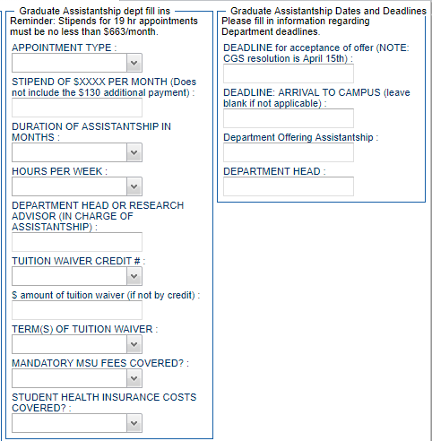
- Add any additional notes or clarification needed in the “Graduate Assistantship Extra Text” box at the very bottom of the page.

- Complete your review.

- Check the “Evaluation Complete” box and “Save”. You will not receive a message confirming you have completed your evaluation but if you click “Save”, it will trigger an automated process that forwards the application to the Department Head for approval.

