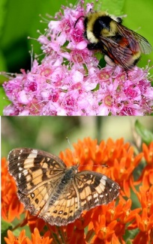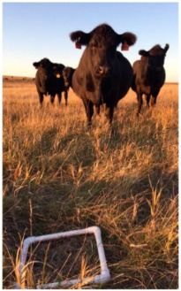****

Wildlife Research Specialist

**North Dakota State University | School of Natural Resource Sciences**

**|**

**Position Description**

**Salary:** Competitive and DOE + Full benefits

**Location:** Fargo, ND

**Start date:** 2022, flexible

**Direct questions to:**

Dr. Torre Hovick

701-219-3086

torre.hovick@ndsu.edu

*North Dakota State University is an equal opportunity employer and all qualified applicants will receive consideration for employment without regard to race, color, religion, sex, national origin, age, disability or veteran status.*

The Rangeland Wildlife Ecology Lab in the School of Natural Resource Sciences at North Dakota State University formally seeks applicants for a 12-month, full-time research specialist position. The successful candidate will assist Dr. Torre Hovick in running his lab and coordinating research projects on rangeland wildlife. Current lab projects include songbird nest survival in response to different grazing practices, ring-neck pheasant survival and habitat selection, butterfly community composition in pastures grazed by sheep or cattle, and upland gamebird food resources across varying grazing management regimes. Responsibilities include assisting with securing funding, collecting field data, analyzing and interpreting data, and over-seeing graduate student research and writing. Additional responsibilities include preparing for and conducting prescribed fires, disseminating research outputs to the scientific community and other stakeholders through peer-reviewed publications and presentations, and collaborating with a range of land managers, faculty, and other researchers. The successful candidate will not be required to teach but opportunities may exist for interested candidates.

**Qualifications**

A MS is required (PhD preferred) in ecology, natural resources, or a closely related field. The most competitive candidates will have a strong history of publishing in peer-reviewed journals and should exhibit a positive attitude, strong worth ethic, and punctuality. Additional minimum qualifications include excellent interpersonal, organizational, and oral and written communication skills, ability to lead a team, and proficiency using program R or other closely related analytical software. The most competitive applicants will also have a record of successful grant writing to support research, experience communicating research with diverse audiences, and experience conducting prescribed fire.

**To Apply**

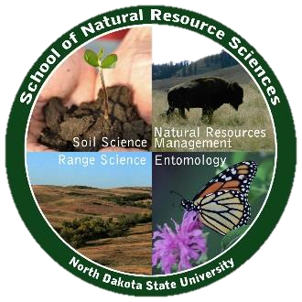Application materials must include 1) cover letter addressing each of the minimum and preferred qualifications 2) Curriculum Vitae 3) Official transcripts, and 4) Three professional references with contact information. Applicants must submit all materials through the NDSU Human Resources portal. The position will be open until filled and the start date is flexible with a targeted start date in early 2022. Questions can be directed to Torre Hovick at [torre.hovick@ndsu.edu](mailto:torre.hovick@ndsu.edu) or (701) 219.3086.

**Website for applications**: https://bit.ly/rangespecialist