2 MS Graduate Research Assistantships: Utah State University, USGS Utah Cooperative Fish and Wildlife Research Unit – Dr. Erica Stuber (erica.stuber@usu.edu) – in the Department of Wildland Resources: Mule Deer Space Use Projects
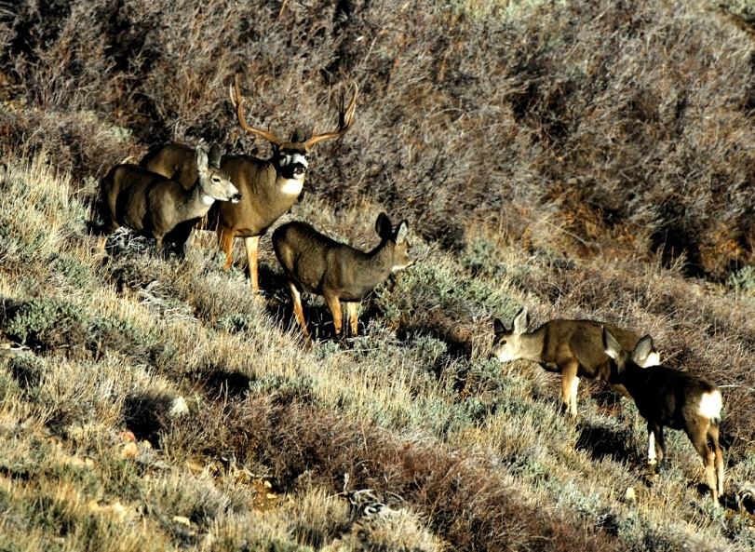
Project Description: Since 2006, the Utah Watershed Restoration Initiative has completed ~2,280 habitat restoration projects on ~1.9M acres of public and private land across Utah (wri.utah.gov). Many habitat restoration projects are implemented within the ranges of important game species, and represent changes to multiple potential resources used by wildlife (e.g., improving foraging resources and habitat quality).
The students will lead investigations into complementary research topics:
Project 1: How quickly do mule deer respond to habitat restoration in their patterns of space use? For how long do deer incorporate restored areas in their patterns of space use?

Project 2: What types of ‘ecological neighborhoods’ maximize the benefits of individual habitat restoration projects on mule deer density? At landscape-scales, what portfolios of multiple habitat restoration projects maximize fawn production?
Information from these projects will enable managers to prioritize locations to implement habitat restoration that are expected to provide the largest benefit by considering the timescale of species’ response to different environmental changes, and the habitat composition of the entire landscape in which active habitat restoration projects will be embedded.
Qualifications: B.S. degree in Wildlife Science, Ecology, Natural Resources, Statistical Ecology or other relevant discipline. Applicants must meet USU’s requirements for admission to either the Ecology or Wildlife Biology programs (https://qcnr.usu.edu/wild/graduate/future/overview). The ideal candidates would be respectful and inclusive team members, have the potential and motivation to develop strong quantitative skills, and the ability to work both in a team and independently. Previous experience in organizing and cleaning ecological data, GIS, conducting statistical analyses, written or oral presentation of scientific work, or prior undergraduate research experience is helpful but not required as these skills will be developed. Previous experience working with mammals is not necessary.
Funding: The students’ stipends ($20,000/yr) will be paid through expected 2.5yr Research Assistantships. Tuition will be provided and university-subsidized student medical insurance is provided with a reduced student co-pay.
To apply: Please send a single document containing: 1) A 1-pg cover letter describing why you want the position, the skills you would bring to the project, and the skills you are interested in developing during your MS. Please specify which project (1 or 2) you prefer, or whether you would like to be considered for both. 2) Your CV, or resume. 3) Unofficial transcripts from a US accredited undergraduate institution. 4) Contact information for 2 professional references to: Dr. Erica Stuber (erica.stuber@usu.edu), with the subject line: “Mule Deer MS Assistantship”. Closing: until filled. Start date: Fall semester 2021.
We strongly encourage applicants from underrepresented, or historically excluded groups including Black, Indigenous, People of Color, LGBTQ+, women, and first-generation college students to apply.

