Temporary Employment Opportunity
Mid May- Mid October 2023

with the
Water Quality
Planning Bureau

Water Quality Monitoring Field Technician
Do you like to work outside? Interested in water quality? DEQ’s Water Quality Monitoring and Assessment Section is seeking qualified and motivated people to collect water quality data in Montana’s watersheds this summer. Field technicians are based in Helena and travel and work across Montana. They learn and apply the State’s monitoring protocols to collect data for water quality assessment, status and trend analyses.
The term of these positions runs from mid-May to October.
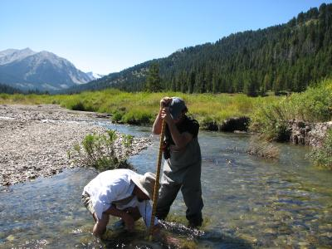
Duties include
- Data collection using established field protocols, including a variety of chemical, physical and biological parameter methods and use of instruments and sampling equipment
- Extensive travel to monitoring sites statewide (overnight stays for up to 5-6 days at time, lodging and camping coordination, driving and navigation responsibility, equipment packing)
- Data organization, various office tasks.

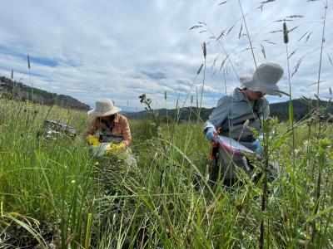

Qualifications
- Interest in water quality monitoring and assessment
- Flexible schedule (schedule is subject to change with minimal notice so this position does not accommodate extended periods of time off during the summer, limited times may be negotiated)
- Willingness to work long hours (often 10+ per day) and potentially on weekends, to work outside in unfavorable weather conditions, carry up to 40 lbs, and to sometimes hike and camp overnight
- Effective communication skills (typically crews of 1-2 people working daily together for a week)
- Take initiative to assist DEQ staff with all day-to-day activities;
- Ability to follow technical monitoring protocols (training provided)
- Valid driver’s license

Benefits
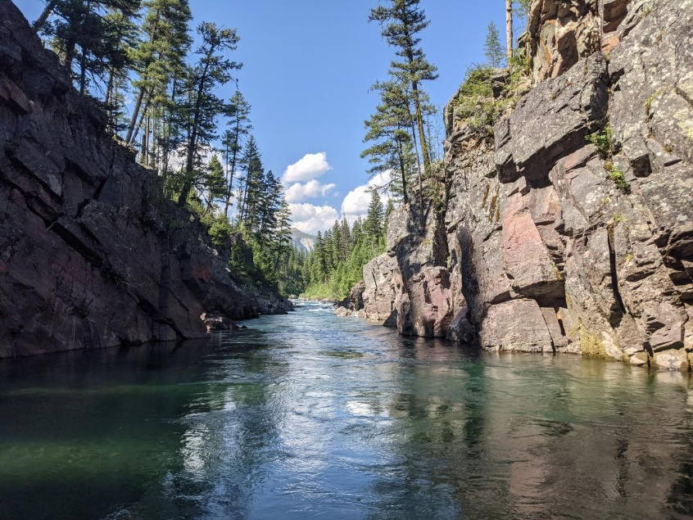
- Pays approximately $17/hr+ benefits with health insurance
- Meal per diem while in travel status
- Compensatory time (1.5) earned for overtime worked > 40 hours/week
- State vehicle and reimbursements of expenses provided for travel
To apply:
Please use the State Job application service to apply:
https://mtstatejobs.taleo.net/careersection/200/jobsearch.ftl?lang=en

Darrin Kron (444-4765) dkron@mt.gov with questions.

