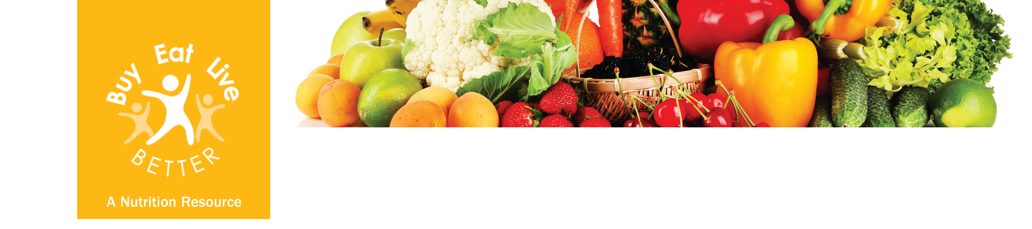

Breakfast bonanzas
- Orange juice and fortified cereal
- Whole wheat toaster waffles with frozen berries
- Whole wheat English muffin with peanut butter
- Oatmeal with sliced berries

Luscious lunches
- Lentil soup and whole wheat crackers
- Spinach salad with chickpeas
- Bean chili with a green salad
- Tuna sandwich with a fruit salad
- Veggie soup with whole wheat roll

Quick snacks
- Whole orange or banana
- Toasted soybeans
- Peanuts or pistachios
- Whole grain cereal and milk
- Tomato juice

Delightful dinner dishes
- Baked beans
- Steamed asparagus or beets
- Stir-fried broccoli
- Three bean salad
- Spinach and avocado salad
Folic acid during pregnancy
The CDC (Centers for Disease Control and Prevention) recommends that all women of child-bearing age consume 400 micrograms of folic acid each day. This is because half of US pregnancies are unplanned and folic acid can prevent birth defects that occur very early in pregnancy, before most women know that they are pregnant.
FOLIC ACID

Supplements can be an important way to get folic acid, but food offers the benefit of great taste! Get yourself into a good habit of including a variety of foods with folic acid in all meals. When you are grocery shopping, check the labels on bread and cereal products to choose those higher in folic acid. The meal and snack suggestions and the table below show examples of foods that provide at least 10% of the recommended daily amount of folic acid.

FOOD/SERVING SIZE | % DAILY VALUE
Spinach, 2 cups raw | 55%
Spinach, 1 cup cooked | 50%
Lentils, ½ cup cooked | 45%
Chickpeas, ½ cup cooked | 35%
Asparagus, ½ cup cooked | 30%
Orange juice, 1 cup | 27%
Peanuts (dry-roast), ⅓ cup | 25%
Pistachios (roasted), 1 oz. | 25%
Strawberries, 8 medium, raw | 20%
Wheat germ, ¼ cup | 20%
Enriched bread, 1 slice | 10%

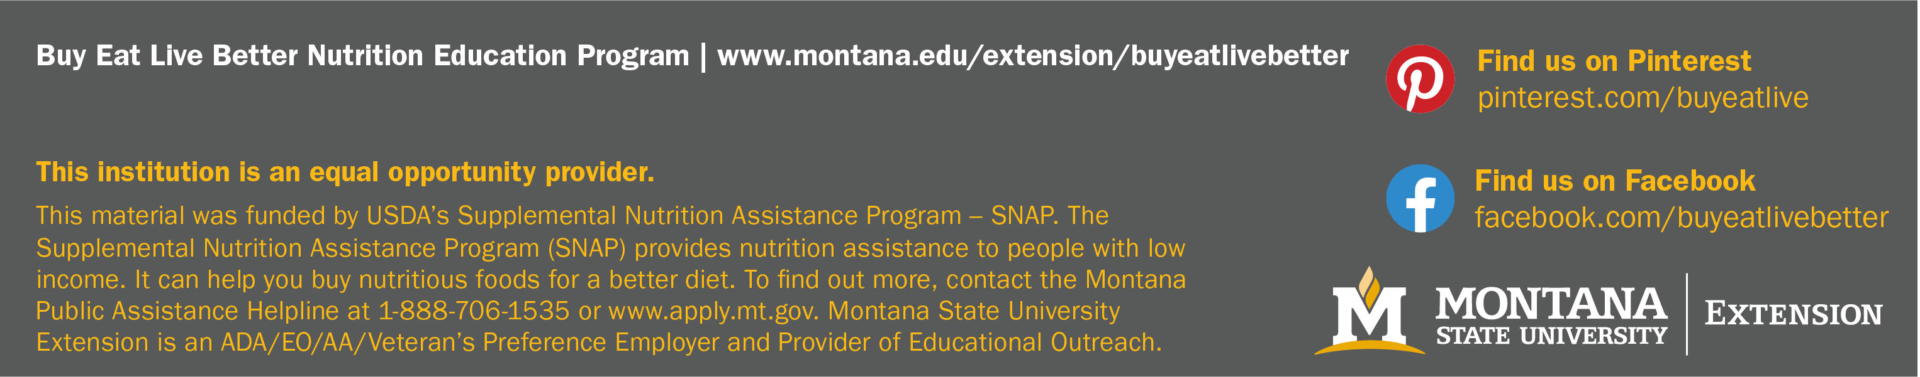
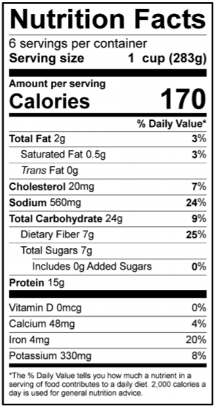
Lentil Chili
Yield: 6 Servings | Serving Size: 1 Cup
½ pound lean ground beef
1½ cups chopped onion
1 clove garlic, crushed
2 cups cooked, drained lentils (or canned, drained and rinsed)
1 (28 ounce) can or 2 (14.5 ounce) cans diced or crushed tomatoes
1 Tablespoon chili powder
1 teaspoon ground cumin (or more, to taste)
½ teaspoon salt

- In a large saucepan, brown beef over medium-high heat, breaking it into bite-sized pieces. Drain fat.
- Add onion and garlic and cook until softened.
- Add lentils, tomatoes, chili powder, cumin, and salt. Cook for about 1 hour until flavors are blended.
- Serve hot, topped with your favorite chili toppings.

Vegetarian White Bean Soup
Yield: 7 Servings | Serving Size: 2 Cups
2 small zucchini, quartered lengthwise and sliced
2 cloves garlic, diced
1 cup chopped onion
1 cup chopped celery
1 cup chopped carrot
2 Tablespoons vegetable oil
3 (14.5 ounce) cans low-sodium vegetable broth (or 6 cups prepared from bouillon)
4 cups cooked navy beans (or canned, drained and rinsed)
1 (14.5 ounce) can diced tomatoes, undrained
1 teaspoon dried thyme
1 teaspoon dried oregano
½ teaspoon pepper
½ teaspoon salt (or up to 1 teaspoon, as desired)

- In a large saucepan, sauté the zucchini, garlic, onion, celery, and carrot in oil for 5-7 minutes or until crisp-tender.
- Add the remaining ingredients. Bring to a boil. Reduce heat. Cover and simmer for 15 minutes or until vegetables are tender.

www.tasteofhome.com

