Checklist of Leasing Considerations
Draft
General procedures for establishing an equitable lease arrangement:
- Use the cost contributions approach to establishing an equitable crop share, cash, or flexible lease arrangement.
  - Share revenue in the same percentage as you share costs in the production process.
    - Must estimate the cost contributions of each party for the type of lease desired.
    - End result may deviate from the cost contributions final estimated shared revenue if the lease is a cash or flexible cash lease rather than a share lease.
    - The estimated cost share split is a good place to start when establishing a cash lease.
- Use a written lease to protect and maintain good relationships between all parties.

Provision a lease (a binding contract) should contain:
- Starting and ending dates
- Renewal and termination provisions
- Adequate description of the property including land and improvements
  - Including maps and/or other documents that detail physical boundaries and operational characteristics such as government programs, if desired.
- Specify production inputs, management and marketing to be provided by each party
  - Encourage the most profitable operation
  - How, when, and where each party will share in income and expenses
    - From primary enterprises (small grains, hay, cow-calf)
    - From secondary enterprises (aftermath grazing, straw)
- Specify how participation in and resulting benefits of government programs are handled between all parties for all crops and livestock enterprises on the operation.
- Specify responsibilities of each party
- Establish farming/ranching practices to be used
  - Tillage systems and crop rotations; organic or non-organic
  - Livestock stocking rates and associated grazing practices such as buffer zones
  - Habitat for wildlife or other conserving use
- Provide for control and use of non-farming/ranching related use rights.
  - Hunting, fishing, agro-tourism, or…
  - Who and how is additional liability with this activity covered
- Provide for new or needed capital improvements
  - Provide reimbursement to the tenant for unexhausted capital improvements
  - Provide for making capital improvements in lieu of rent
  - Caution in using tax depreciation methods for determining improvement life
- Provide terms for assignment and subleasing options of:
  - Farming and ranching related resources
  - Possible uses of buildings and improvements for other activities
- Provide terms for the death of one of the parties

Provision a lease (a binding contract) should contain: (continued)
- Encourage the optimum productive use of capital while maintaining the long term health of the resource.
- Established in a way that handles “material participation” for social security and “special use valuation” for estate tax purposes that meets the IRS test, as desired by all parties
- Provide legal protection for all parties for potential problem issues

Are you average and what does average look like for tenants?
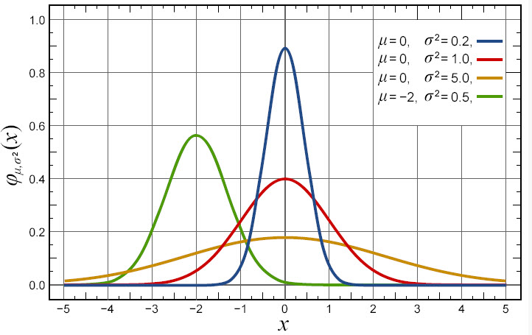
Does a 1/3 – 2/3 “traditional” crop share split reflect your situation? Many landlords and tenants rely on traditional lease arrangements to establish lease rates. These traditional split percentages were established form a history of lease arrangements among many different parties over a long period of time. While using these traditional split percentages is convenient, you must ask “is my operation and the way I farm really representative of these traditional splits?” If the answer is no, do not depend on traditional agreements to provide the correct compensation in a lease agreement.
1
2
3
4
Figure 1. Examples of four normal distributions.
B
A

Figure 1 provides an illustration of four normal distributions that are very different from each other. When you accept a traditional (normal) lease arrangement, what does that really mean for the possible profitability outcomes for a particular lease?
Several operational characteristics may make choosing a traditional 2/3 percentage split for the tenant a bad move. These would include an investment in a machinery and equipment compliment that is above the average, distribution #2 rather than distribution #1. Higher operating input costs due to poorer soil, point B on distribution #3 rather than point A. Greater variability in yield potential due to geographic location resulting in distribution #4 rather than distribution #3.

Sources of information (publications, forms, software)
- http://www.montana.edu/softwaredownloads/

