4-H Year: ________________

This Record Belongs to
County
Project Name & Level
Yrs in the Project Yrs in Level
My Photo
These are my project goals for this year.
Briefly describe three project goals for the coming year.
1.
2.
3.

I have evaluated my records and believe that they are accurate, complete and verify that this represents my own work.

4-H Club Member Date

I have reviewed this record book.

4-H Club Leader Date

Record ALL the activities you do in this 4-H project as you do them.
Carter County: Include 2 or more learning activities from your project manual. Fallon County: Level 1: 7 Activities are required out of project manual
Level 2 & Above: 5 activities are required- If activities are not from project manual they will need to approved by the Extension Office.

WHEN YOU DID IT… WHAT YOU DID… WHAT YOU LEARNED!
Date | What You Did | What You Learned

Project Story Write an educational summary that includes what you did, what you learned, what the hardest part was, what did you like best, if you accomplished your goals how did you accomplish them, and what is something that you would like to improve on and how that will affect your project in the future.

Record of Project Finances
Record as INCOME all money you receive from the sale of services and/or products from this non-animal project. All items need to be given a value even if they are not sold. Record as EXPENSES all the items you pay for with money to support this non-animal project. All items should have an expense even if they are donated.
Date | Description or Name of Item | Income or Value | Expense
Subtotals (this page)

Award Income- Include all the awards and show premiums you won for your project.
Item | Name of Fair or Show | Placing/Award | Value
Total Award Income

Financial Summary | Income | Expense
Subtotals from previous page
Awards Income
Total Income & Expenses
Total Income
Total Expenses
Profit or Loss
Subtract your income from your expenses. PROFIT is a positive amount and LOSS is a negative amount.

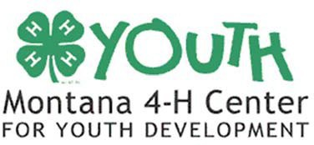
The U.S. Department of Agriculture (USDA), Montana State University and the Montana State University Extension Service prohibit discrimination in all of their programs and activities on the basis of race, color, national origin, gender, religion, age, disability, political beliefs, sexual orientation, and marital and family status.

